
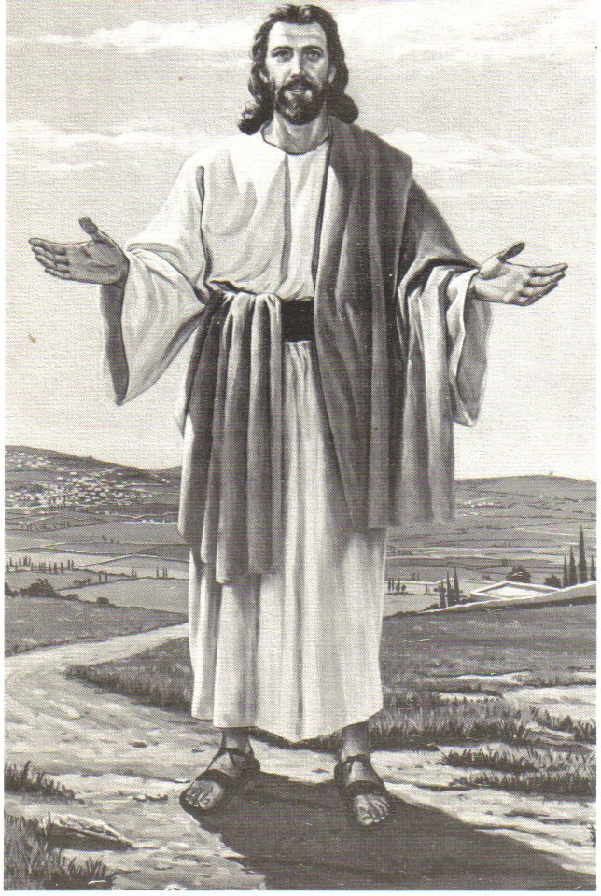
Monthly Newsletter of
BLESSED SAVIOR LUTHERAN CHURCH
2615 Shackelford Road, Florissant, MO 63031-2005 *314- 831-1300
www.blessedsavior-lcms.org * office@blessedsavior-lcms.org
+ + +

“Empowered by God’s Holy Word,
we joyfully share the love of Jesus with all people
through worship, teaching, fellowship, service and witnessing.”

----------------------------------------------------------------------------------------------------
JANUARY 2020

The light shines in the darkness and the darkness has not overcome it.
John 1: 5

Family of believers at Blessed Savior Lutheran—

This is a familiar passage from John’s prologue to his gospel. It also was read during service on Christmas Day. Just off the bat it can have more than one meaning: we just passed the shortest day of the year before Christmas, and now the days are getting longer again with more sunlight. The darkness of winter and cold cannot be completely dominant forever; warmth and light will return.

More importantly though, John writes about how Jesus IS the light of the world (which Jesus Himself says later on in the gospel) and He has come into our world and has not been overcome. Darkness, in John’s gospel, is one way of describing unbelievers and sin. Jesus was surrounded by sinners and people who wanted to do away with Him at every turn, yet none of them could thwart His great plan.

Now during January we will start the season of Epiphany, seeing exactly how Jesus is that light of the world. In the church I grew up in, the parament colors (the stole the pastor wears and the banners on the altar and pulpit) were orange. This helped separate Epiphany from the season after Pentecost and also emphasized the light aspect of Jesus’ ministry, being the one to guide us and illuminate us in our own darkness.

The high feast of Christmas may be over, so now what? That is just what the Epiphany season is about, seeing what a difference it made in the world once Jesus came in it, both in biblical times and today as well. See you in church as Jesus’ light illuminates us!

Blessed to serve—

Vicar Kevin Peterson





