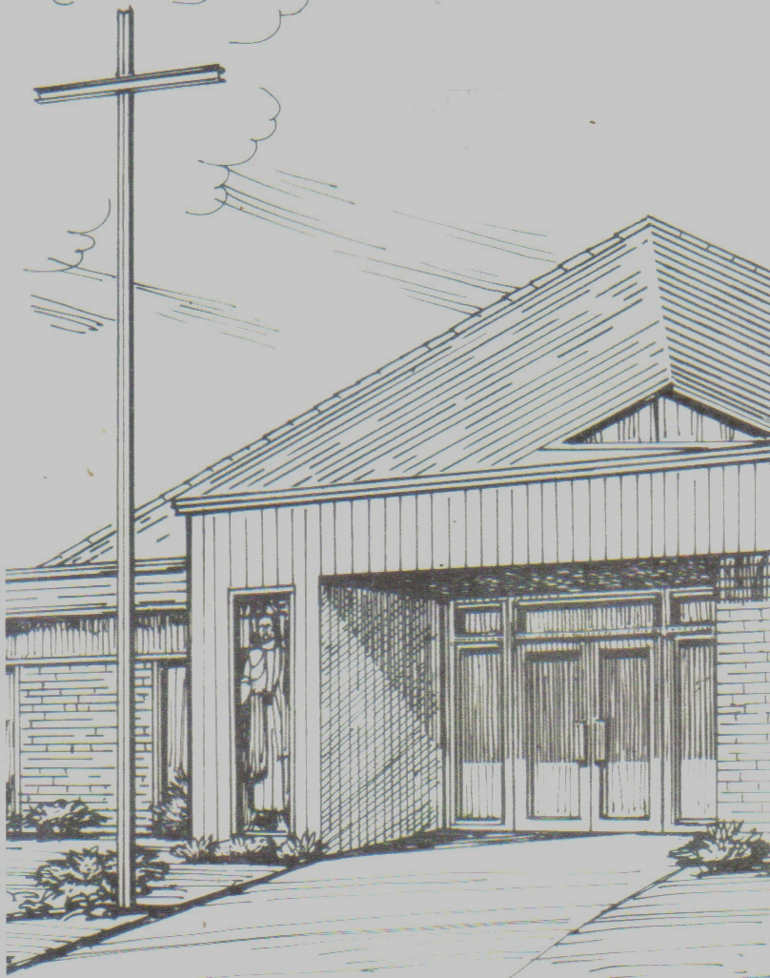

Monthly Newsletter of
BLESSED SAVIOR LUTHERAN CHURCH
2615 Shackelford Road, Florissant, MO 63031-2005 *314- 831-1300
www.blessedsavior-lcms.org * office@blessedsavior-lcms.org
+ + +

“Empowered by God’s Holy Word,
we joyfully share the love of Jesus with all people
through worship, teaching, fellowship, service and witnessing.”

----------------------------------------------------------------------------------------------------
MARCH 2019

Dear Saints of Blessed Savior,

Grace, Mercy and Peace to you from God our Father and the Lord Jesus Christ. Amen.

Romans 5:7-8 (ESV)
⁷ For one will scarcely die for a righteous person—though perhaps for a good person one would dare even to die— ⁸ but God shows his love for us in that while we were still sinners, Christ died for us.

The month of March is upon us. Which means, Spring is right around the corner and with it two things everyone loves! Warmer weather and baseball! However, while both of those things are great, this year March means the beginning of the Lenten Season. Which begins with Ash Wednesday on March 6th, the first Wednesday of March.
Lent is that time of the church year when we put away the “alleluias” and take time to humble ourselves. Often times through giving up something we love to eat or do, by attending worship service more during the week, or even sometimes fasting. Why do we do this? To remember that we are sinners. To remember that it was our sins that were the reason our Lord and Savior Jesus Christ suffered and died on the cross.
For it is as Paul tells us in chapter 5 of his letter to the Romans, Christ did not die for us because we were righteous and good. No! Instead, Christ died for us because we were sinners. Even more, Christ died for us because He loved us. “For God so loved the world, that he gave his only Son, that whoever believes in him should not perish but have eternal life.” (John 3:16). Our Lord and Savior made the ultimate sacrifice. He paid the ultimate price. Now, because of Him our sins are forgiven, we have been made righteous and we will one day all have eternal life with Him.
Therefore, I encourage you this Lenten season to join us for worship. Not just on Sundays, but also on Wednesday evenings. Join us these next six weeks as we study, “The Mountains of Life”. As we journey up and through the mountains of temptation, suffering, loyalty, sacrifice, and triumph. Join us as we climb these mountains and reflect upon the gifts our Lord and Savior bestows upon us by having already climbed them for us.
We pray, “Dear heavenly Father, thank you for loving us so much, that despite our sinful nature, you sent your Son into the world to die for our sins. Be with us these next six weeks as we humble ourselves and reflect upon the gifts that you have given us through Him. This Lenten season, give us a heart that is turned toward you in both worship and prayer. In Jesus Name. Amen.”

Yours in Christ,
Vicar Brown

Elders Corner
Why do we attend church?

- I believe that going to church is something that is extremely valuable and is something that should be practiced by anyone who claims to be a Christian. A Christian should regularly attend church. Not counting the times that you might miss for vacation or sickness or a particular work commitment, you should be in church. Church is something that you do collectively. To be a follower of Christ is not something that you do by yourself, it is something that you do together with other people. We are what the Bible calls the “family of God.” A family is by its very nature inter-dependent. What it means to be a part of a local church is that you’re inter-dependent with other people in your church.

Luke 14:6 says, “Jesus went back to Nazareth, where he’d been brought up and as usual he went to the meeting place on the Sabbath.” The Bible tells us that “as usual” or another translation of the Bible says, “As was His custom” Jesus went to the place of worship. This is in keeping with obeying one of the Ten Commandments, which is, “Observe the Sabbath by keeping it holy.” As followers of Christ, we follow Jesus’ example and instructions.

God’s Blessings
Terry Bossaller, Elder#4
-------------------------------------------------------------------------------------------------------------


Please join us on for our Mid Week Lenten Services:
March 6, 13, 20 & 27; April 3 & 10
4:30 p.m. & 6:30 p.m. (not 7 p.m.)

March 6
Ash Wednesday with Holy Communion
Dinner will be hosted by the Elders

Also…
April18 - Maundy Thursday will be at 4:30 & 6:30 p.m. with Holy Communion
April 19 - Good Friday will remain the same –
Treore from noon-3 p.m. and Tenebrae 7 p.m.

March 10th is Daylight Savings. Please be sure to move your clocks forward 1 hour. Also, on March 16th the Saturday Worship Service will change back to 6:00 p.m.

What happens on Ash Wednesday?
You may see something strange happening here in church on Ash Wednesday. You may come forward with your family and friends to receive the sign of the cross on your forehead. The strange part about all of this is that it will be done with the ashes from last year’s Palm Sunday palm branches.
Why do we do this?
Usually when someone gets dirty they realize that they need water to get clean. The ashes that are put on our foreheads in the shape of a cross remind us of our dirty sins that were piled on Jesus when he died on the cross for us. The ash cross on our forehead also reminds us of the first time the sign of the cross was made on our bodies at Holy Baptism. There, in the water of our baptism, we were washed clean with the blood of Jesus, and the dirt of our sins was washed away forever. The ashes of Ash Wednesday help to remind us of all of this.

PLEASE NOTE THE TIME CHANGE OF MID WEEK LENTEN SERVICES & MAUNDY THURSDAY WILL BE 6:30 P.M. INSTEAD OF 7:00 P.M.

Wednesday Lenten Services
4:30 p.m. & 6:30 p.m.
Dinner Served at 5:15 p.m.

March 6 – Ash Wednesday
March 13, 20 & 27 April, 3 & 10

SPECIAL SERVICES & EVENTS
April 13 – 10 a.m. Easter Egg Hunt
April 14 – 8 & 10:30 a.m. Palm Sunday w/ comm.
April 18 – Maundy Thursday 4:30 & 6:30 p.m.
April 19 – Good Friday
Treore Service – Noon to 3:00 p.m.
Tenebrae – 7:00 p.m.

April 21 –6:30 a.m. Sunrise Service w/ communion
7:45 a.m. Easter Breakfast
9:00 a.m. Balloon Lift Off
9:15 a.m. Sun. School, Adult Bible Classes
10:30 a.m. Worship Service w/communion

Why do we celebrate Lent for six weeks?

Don’t forget what Lent is all about! It is a time when we are reminded of what Jesus gave up for us, and a time when we look forward to and prepare for His death and resurrection!
We celebrate Lent for six weeks. Not counting Sundays, this adds up to forty days. These forty days remind us of Christ’s temptation in the wilderness (Matt. 4:1-11). There He was without food for forty days. We remember the temptation of the Israelites in the desert after the Lord had delivered them from Egypt. This lasted forty years (Num. 14:34). Finally, we can remember the story of Noah and his family. After forty days and forty nights in the ark, it finally stopped raining, and the Lord delivered them just as He promised. (Gen. 7:17).
During these forty days of Lent, we remember the faithfulness of God to His people and how His faithfulness is complete in Jesus Christ, our Savior. Jesus remains faithful to us, always being where He
promises to be: in His Word and Sacraments. Wow! What a Savior!

Lutheran Hour Ministries
Lenten Devotionals 2019
“People of the Passion”

Centuries before Christ, God was preparing the way for His Son’s arrival. From mankind’s original sin through the children of Israel’s on-again, off-again obedience, God was faithful, honoring His promise to Eve (genesis 3:15), which first pointed to Jesus. In People of the Passion, we see God working through the lives of ordinary people to achieve His ultimate aim: our salvation. There are prophets, priests, and kings, servants, soldiers, and civilians—each with a role in the high drama of Christ’s passion. Readers may see themselves in some of the people—ordinary individuals who, like us, need a Savior.

Lenten Devotionals by Lutheran Hour Ministries will be available in the Narthex on March 2nd. Please feel free to take one to a family member, neighbor or coworker.


March 2, 2019
6:00 p.m.

Gather your friends and family and join us for another night of trivia on Saturday, March 2 beginning at 6 p.m. The event will help support the Blessed Savior Youth group trip to Higher Things this summer. Tables of eight will be available. Cost is $15.00 per person which will include snacks and soft drinks. No alcohol is allowed. Mulligans will be available for purchase as well. The theme this year will be Mardi Gras. Donations of attendance prizes and baskets for a silent auction would be much appreciated. Please complete a registration form and place it in an envelope with your entry fee. Place the envelopes in the Senior High mailbox located next to the church office. For questions, please contact Cheryl Ehrhard at cheryl.ehrhard@gmail.com.



Order Your Easter Lily for the Altar
Sat., March 16 – Wed., April 7, 2019

Twenty lilies have been ordered! Starting March 16th, order forms will be available in fellowship hall. Please fill out the form along with $7.50/each. If you are writing a check, please make it out to Blessed Savior Lights.

Plastic Easter Eggs & Wrapped Candy will
be collected March 16 thru April 3

Cupcakes for Easter Egg Hunt needed by
Friday, April 12th 7:30 – 11:30 a.m. or
Saturday, April 13th by 9:00 a.m.

The Board of Outreach has scheduled the annual Easter Egg Hunt for Saturday April 13, 2019 at 10:00 AM. We had a terrific turnout last year and many visitors attended. This is a great opportunity for our congregation to reach out to the community and share God’s love with those who desperately need to hear the good news of salvation which is available to all. We as members of Blessed Savior take many things for granted so it seems difficult to comprehend that there are people who have never heard about Jesus Christ; this is an occasion to rectify such sad circumstances. The Board of Outreach appreciates your generosity in the donation of cupcakes, individually wrapped candy and plastic Easter eggs. (Best buy on plastic Easter eggs can be found at Dollar General and Dollar Tree. We ask that donations of plastic eggs and wrapped candy be placed on the designated table in the Fellowship Hall by Sunday, April 3. Cupcakes, please have here Friday, April 12 between 7:30 -11:30 or Saturday, April 13th by 9 a.m.


April 13, 2019 – 10:00 a.m.

Come and enjoy a fun time hunting for Easter eggs. Afterwards, come inside for cupcakes and drinks.

Please feel free to invite your family, friends, neighbors and co-workers.

COMMUNITY IS WELCOME

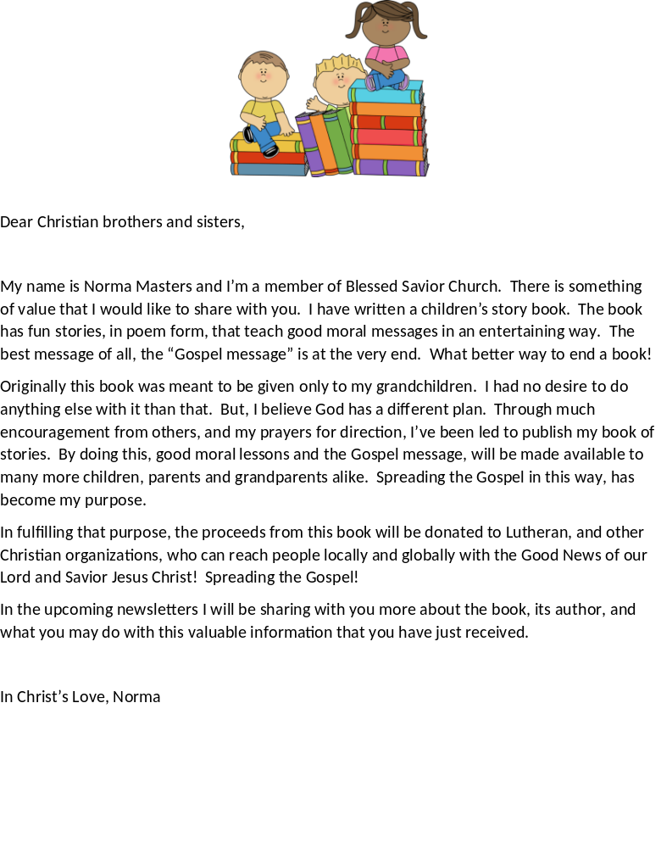

Dear brothers and sisters in Christ,

In the last Newsletter, I told you about a new, children’s story book which I am having published. The main purpose of this book, is to spread the “Gospel message”! The proceeds from this book, will be donated to, Lutheran Hour Ministries, World Relief and Human Care, and other Christian organizations that will do the same. Caring for people’s physical and spiritual needs everywhere!

In this Newsletter I will tell you about the book, the author, and how you may start to take part in sharing the “Good News”. So here we go!

About this book
Someone is tempted and must decide what to do. An ugly, grumpy caterpillar is shown her true beauty. A big, boastful bear finds out about humility. A sad, worried, fir tree learns to have a little faith. A patriotic firecracker explodes and leaves a message. These are just a few of the assortment of interesting characters and plots that you will read about in this book. You’ll learn lessons from their stories on honesty, humility, compassion, genuine love and more. So, if you like a book with meaningful messages and happy endings, then this book, is positively for you!

Meet the author
Christian Luv is the pen name of Norma Masters. Norma recognized that the entire journey of writing this book was all under God’s control and that it was a sincere act of Christian love. She believed, that because of this, “Christian Luv” had to be the name of the author that appeared on her book.
Norma lives in a suburb outside of St. Louis, Missouri. She was married for almost 47 years to her husband Nelson Masters, who passed away in 2017 of Alzheimer’s disease. She has four married, adult children and eleven grandchildren. The poems in this book were originally written in Norma’s youth. She brought them all together to review and update after she had become a widow. She intended to pass the good, moral messages found in them, down to her grandchildren. However, after being enthusiastically encouraged by others to publish her poems, the idea flourished into a children’s story book that you now see today. Her hope is, that children will not only enjoy reading this book, but that they will act on the valuable lessons found within it.

This book, was made extra special for Norma, when her fifteen year old granddaughter Paige became the illustrator.

How to Begin to Take Part
So here is how you may begin to take part, in helping people everywhere hear the Gospel!
Spread the “Word”, by spreading the word! Ask God, to guide what you say, as you tell everyone the news, about a wonderful, new children’s book, written by Christian Luv that is coming out soon! Then, tell them to tell everyone they know. If you are on Facebook or another social media, do the same thing. The purpose right now, is to get the news out that something wonderful is on its way! Continued…..

We want this to spread like a wild fire! If you are inspired to put into place, another way to accomplish this, please let me know.

I pray that God will bring our church together as a unified force, with a united purpose! And that is, to always serve Him! Please pray for God’s guidance and blessing on this mission project. Mark 16:15

In Christ’s Love, Norma

P.S. The name of the book cannot be reveled at this point, because it is subject to change until it goes into print! Hopefully in the next Newsletter I will be able to tell you the name of the book and where it may be purchased. This is all under God’s control and in His perfect timing. In the meantime, the following is a review of the manuscript.



God’s blessings. Norma

March Greeters

March Acolytes
03/03 E –
L – Emily Roeglin

03/10 E – Robert Lowrey
L – Sophia Zika

03/17 L- Meaghan Helmich

03/24 L- Alexa Daengsurisri

03/31 L – Robert Lowrey


ALTAR FLOWERS ARE NEEDED FOR:
March 10 & 17
Thank You!


Audrey Marguerite Ann Griffey
September 8, 1926 – January 13, 2019

Audrey was called to God’s heavenly rest from
her earthly home on Sunday, January 13. We remember Audrey’s family in our prayers as we extend our Christian sympathy.

03/03 E – Lynn & Martha Oth
L – Paula Bossaller
03/10 E – Betty Lipham
L – Mary Bremer
03/17 E – Debbie Haynes
L – Jeff & Donna Wiggins
03/24 E – Mike & Donna Kroehnke
L – Ben Hilderbrand
03/31 E - Paula Bossaller
L - Paula Bossaller

March Elder Greeter
03/03 E – Ray Ehrhard
L – Terry Bossaller
03/10 E – Mike Kroehnke
L – Dennis Henneman
03/17 E – Ray Ehrhard
L – Terry Bossaller
03/24 E – Mike Kroehnke
L – Dave McDermott
03/31 E – Ray Ehrhard
L - Wade Gergen

March Ushers Sunday Services
03/03 E – Team #1
L – Team #2
03/10 E – Team #1
L – Team #2
03/17 E – Team #1
L – Team #2
03/24 E –Team #1
L –Team #2
03/31 E – Team #1
L – Team #2

MARCH 

3/02 Kimberly Bossaller
3/03 Meaghan Helmich
3/04 Joshua Roeglin
3/06 Mary Bremer
3/08 Melva Schaper
3/10 Retha Taylor
3/13/00 Maria Koop
3/15 Patricia Janovsky
3/22 Elaine Turner
3/25 Joyce Glusenkamp
3/26 Barb Knehans
3/27 Eileen Montonye
3/31 Madalyn Beach

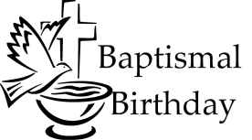

3/08 Nathan Lee
3/09 Esther Legoute’
3/13 Debbie Rhyne
3/13 Bill Lee
3/14/04 Joshua Roeglin
3/14 Joyce Wooliver
3/15 Michael Bossaller
3/15 Jennifer Eyman
3/16 Helen Boulch
3/20 Melva Schaper
3/20 John Walker
3/21 Lynn McKenna


3/2/13 Alex & Ashley Sloter


Daylight Savings
March 10, 2019

Don’t forget to change your clocks 1 hour ahead!
--------------------------------------------------------------------------------------------------------------------------------

The Lutheran Resale Shop

The Lutheran Resale Shop is having our semi-annual changeover on March 18th. We start at 10 am and go until 3 pm. We are offering $10 in merchandise to the first ten new volunteers to help us that day. If you volunteer you will be hanging new spring/summer clothing of all sizes. This can be a sit down or stand up job. Anyone is welcome to help. Bring your sack lunch and enjoy helping at a Shop that helps Lutherans of all ages. Our profits go to Lutheran Family and Children's Services and Lutheran Senior Services. Please call: Lutheran Resale Shop at 314-389-9970 to let us know you will be coming. We are located at 6701 W. Florissant, St. Louis, Missouri 63136.

---------------------------------------------------------------------------------------------------------------------------------------------------------------

Date: Friday, March 15, 2019
Registration: 11:30 a.m. in Koburg Hall
Lunch: Noon
Program: Gillian Bond, Director, Deaconess Program

Here Am I ... Send Me to Joyfully Serve (Isaiah 6:8 ESV)

The cost is $10.00 per person.
Please make check payable to Concordia March 1, 2019.

Please mail reservations with your check to:
Mary Jane Autry, 7609 Fleta St., St. Louis, MO 63123
Visitors and new members are always welcome!

March 2019
Sunday | Monday | Tuesday | Wednesday | Thursday | Friday | Saturday
 |  |  |  |  | 1 | 2 7AM MOBS BIBLE STUDY @DENNY’S  6 P.M. TRIVIA  5 PM WORSHIP SERVICE W/HOLY COMMUNION
3  8 & 10:30 AM SERVICE W/HOLY COMM  9:15 AM SUNDAY SCHOOL/BIBLE CLASSES & CONFIRMATION | 4 | 5 | 6  9:30 AM SUNSHINE  4:30 & 7 PM LENTEN SERVICE- ASH WED.  5:15 PM DINNER  6:00 PM ADULT BIBLE STUDY (MCKENNA) | 7 | 8  PASTOR & VICAR DAY WITH FAMILY | 9  7AM MOBS BIBLE STUDY @DENNY’S  5 PM WORSHIP SERVICE
10 MITE BOX  8 & 10:30 A.M. WORSHIP SERVICE  9:15 AM SUNDAY SCHOOL/BIBLE CLASSES & CONFIRMATION  Daylight Savings | 11  9:00 AM CIRCUIT MEETING | 12 | 13 9:30 AM ADULT BIBLE STUDY  4:30 & 7 PM LENTEN SERVICE  5:15 PM DINNER  6:00 PM ADULT BIBLE STUDY (MCKENNA) | 14  7:00 P.M. ELDERS  NEWSLETTER DEADLINE | 15  PASTOR & VICAR DAY WITH FAMILY | 16 7 AM MOBS BIBLE STUDY @DENNY’S  6 PM WORSHIP SER. W/COMMUNION
17 8 & 10:30 AM SERVICE W/HOLY COMM  9:15 AM SUNDAY SCHOOL/BIBLE CLASSES | 18 | 19 | 20 9:30 AM ADULT BIBLE STUDY  4:30 & 7 PM LENTEN SERVICE  5:15 PM DINNER  6:00 PM ADULT BIBLE STUDY (MCKENNA) | 21  7 PM BD. OF DIRECTORS. | 22  PASTOR & VICAR DAY WITH FAMILY | 23  7AM MOBS BIBLE STUDY @DENNY’S  6 PM WORSHIP SERVICE
24  8:00 & 10:30 A.M. WORSHIP SERVICE  9:15 AM SUNDAY SCHOOL/BIBLE CLASSES & CONFIRMATION  12 PM VOTERS | 25 | 26 | 27 9:30 AM ADULT BIBLE STUDY  4:30 & 7 PM LENTEN SERVICE  5:15 PM DINNER  6:00 PM ADULT BIBLE STUDY (MCKENNA) | 28 | 29  PASTOR & VICAR DAY WITH FAMILY | 30 7AM MOBS BIBLE STUDY @DENNY’S  NO 6 PM WORSHIP SERVICE
31  9:30 AM WORSHIP SERVICE  10:30 BRUNCH | 1 | 2 | 3 9:30 AM SUNSHINE  4:30 & 7:00 P,M. LENTEN  SERVICE  5:15 PM DINNER  6:00 PM ADULT BIBLE STUDY (MCKENNA) | 4 | 5  PASTOR & VICAR DAY WITH FAMILY | 6 7AM MOBS BIBLE STUDY @DENNY’S  6 P.M. WORSHIP SER. W/COMMUNION

