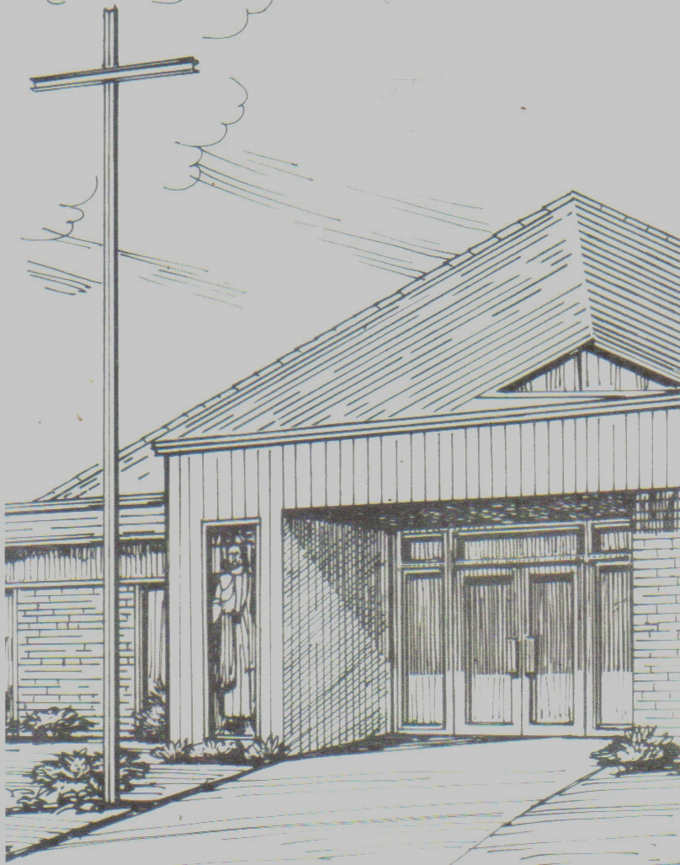
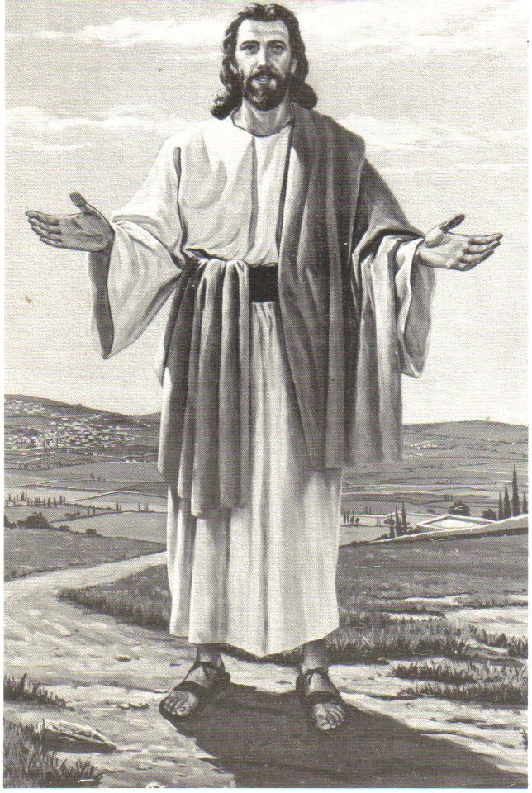
Monthly Newsletter of
BLESSED SAVIOR LUTHERAN CHURCH
2615 Shackelford Road, Florissant, MO 63031-2005 *314- 831-1300
www.blessedsavior-lcms.org * office@blessedsavior-lcms.org
+ + +

“Empowered by God’s Holy Word,
we joyfully share the love of Jesus with all people
through worship, teaching, fellowship, service and witnessing.”

----------------------------------------------------------------------------------------------------
APRIL 2020

Dear Family of God at Blessed Savior,

I pray, as always, that this newsletter finds you safe, healthy, faithful, and thankful -- and especially, BLESSED BY THE LORD.

1 Cor. 15:55-57
"Where, O death, is your victory?
Where, O death, is your sting?"

[56] The sting of death is sin, and the power of sin is the law. [57] But thanks be to God! He gives us the victory through our Lord Jesus Christ.

There are times in our lives when it is easy to shout the above Bible verses from the mountain tops. It’s a complete and utter rejection of “death” itself. It’s almost a “Ha! You have no power over me death” kind of attitude. On Easter Sunday, when we hear the loud and majestic music, we sing the joyful hymns and we shout, “Christ is Risen! He is Risen Indeed, Alleluia!” now that’s a time when the Bible verses really apply and make you feel tremendous.

But, there are times in life when we feel the “sting” of death. When a loved one dies, or gets sick, or things truly are looking hopeless and worthless, that is when we start to feel the “sting” of death. There are times in all of our lives when we are weighed down by our own sin and the sin of the world and we feel like we are drowning in sin, death, and disaster. This time in our world may seem to some like one of those times. St. Paul acknowledges those moments in verse 56. [56] The sting of death is sin, and the power of sin is the law.

However, St. Paul, by inspiration of the Holy Spirit, doesn’t stop there. [57] But thanks be to God! He gives us the victory through our Lord Jesus Christ. We have that victory! We can face any problem that comes our way because we have that victory!

In Christ,
Pastor Roeglin



