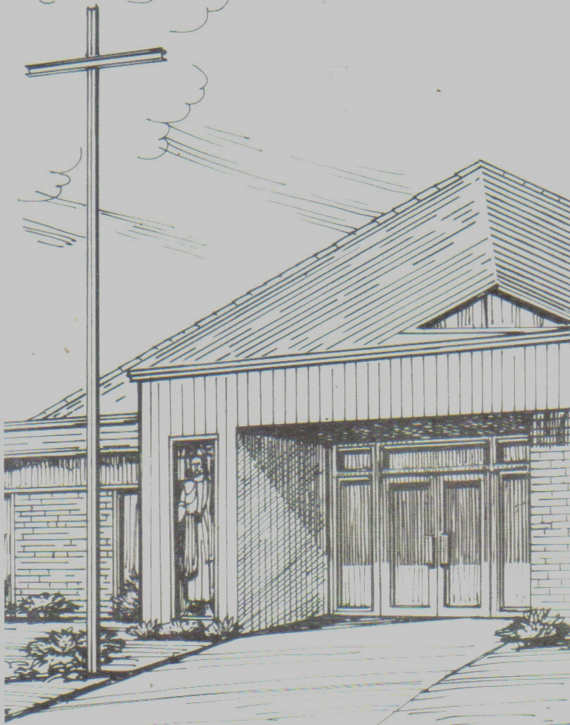

Monthly Newsletter of
BLESSED SAVIOR LUTHERAN CHURCH
2615 Shackelford Road, Florissant, MO 63031-2005 *314- 831-1300
www.blessedsavior-lcms.org * office@blessedsavior-lcms.org
+ + +

“Empowered by God’s Holy Word,
we joyfully share the love of Jesus with all people
through worship, teaching, fellowship, service and witnessing.”

----------------------------------------------------------------------------------------------------
MAY 2019

Dear Saints of Blessed Savior,

Grace, Mercy and Peace to you from God our Father and the Lord Jesus Christ. Amen.
Christ is risen! He is risen indeed! Alleluia!

Romans 6:4-5 (ESV)
⁴ We were buried therefore with him by baptism into death, in order that, just as Christ was raised from the dead by the glory of the Father, we too might walk in newness of life. ⁵ For if we have been united with him in a death like his, we shall certainly be united with him in a resurrection like his.

It’s May! The Blues are in the playoffs, the Cardinals are in first place, schools will soon be getting out for summer break and spring flowers are in full bloom! It’s an exciting month to live in St. Louis! It’s also an exciting month to be a Christian! For it is in this month that we get to continue the celebration that was started a few short weeks ago on Easter Sunday. We get to continue to celebrate the amazing event that is the resurrection of our Lord and Savior Jesus Christ!
That’s right! Easter isn’t over. Every Sunday of this month is considered to be a “Sunday of Easter.” Which means that we get to begin every worship service this month with the phrase, “Christ is risen! He is risen indeed! Alleluia!” A phrase that reflects the true joy that every baptized Christian finds in the death and resurrection of Jesus Christ.
A joy that the Apostle Paul describes for us in Romans 6:4-5. Which tells us that though we may suffer and die in this world, we have nothing to fear. For through the suffering, death and resurrection of our Lord and Savior Jesus Christ, and our baptism into His saving work, death has already been defeated. Therefore, death is no longer an end for us, but it is a beginning. A beginning of our new life with Christ Jesus and all our fellow believers. A new life where there is no suffering, there is no pain and there is no death. “For if we have been united with him in a death like his, we shall certainly be united with him in a resurrection like his.” - Romans 6:5. What a joyous reason to celebrate and proclaim at the top of our voices, “Alleluia!”, which means - “Praise the Lord!”
May this Easter season remind you of the joy that we have in the resurrection of our Lord and Savior and the new life that awaits us all.
We pray, “Dear heavenly Father, thank you for sending your Son Jesus Christ to die on the cross for all of our sins and raising him from that death on Easter morning. Lord, continue to remind us that His victory over sin, death and the devil, is also our victory over sin, death and the devil. Help us this Easter season to worship and celebrate with a joyful heart, always remembering the gift of eternal life that you have given to all who believe in your Son. In his name we pray. Amen.”
Yours in Christ,
Vicar Brown




