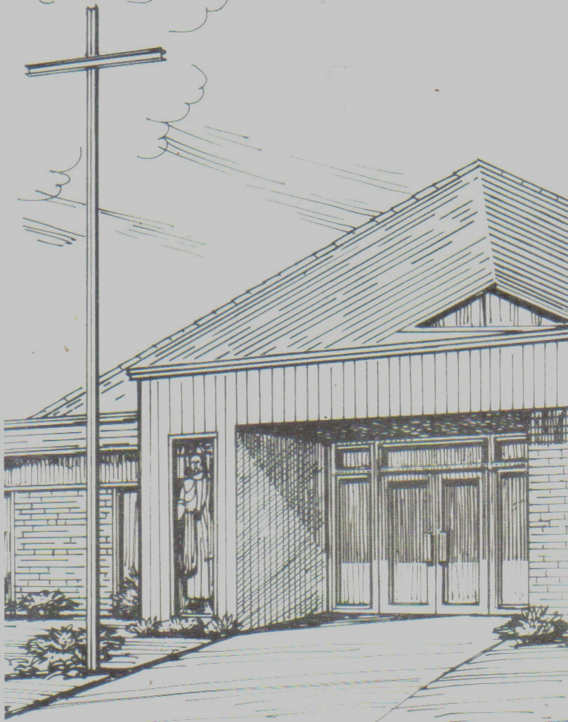

Monthly Newsletter of
BLESSED SAVIOR LUTHERAN CHURCH
2615 Shackelford Road, Florissant, MO 63031-2005 *314- 831-1300
www.blessedsavior-lcms.org * office@blessedsavior-lcms.org
+ + +

“Empowered by God’s Holy Word,
we joyfully share the love of Jesus with all people
through worship, teaching, fellowship, service and witnessing.”

----------------------------------------------------------------------------------------------------
JUNE 2019

Dear Family of God at Blessed Savior,

I pray, as always, that this newsletter finds you safe, healthy, faithful, and thankful -- and especially, BLESSED BY THE LORD.

“I always thank God for you because of His Grace given you in Christ Jesus.” 1 Cor. 1:4

I have been thanking God quite a bit in prayer lately. I have been thanking God, especially these past months, for you all: the saints of Blessed Savior. We have been Blessed with wonderful wonderful members who give of their time, talents and treasures to the Lord in service to the church.

The month of May is always a busy one with graduations and confirmations and finishing school years…etc. And yet many of us still found time to come to church (here or elsewhere in travels) to receive God’s wonderful gifts.

“I always thank God for you because of His Grace given you in Christ Jesus.” 1 Cor. 1:4

There are so many things for which to be thankful to God, and yet, so often we don’t. God has blessed us with life – twice. He Blessed us with life and eternal life won on the cross. He Blesses us with His presence. He gives us the faith we need to receive the salvation He gives us. He gives us His Word and Sacrament with which He strengthens our faith and gives us courage to spread His Love to others. There are so many things for which to be thankful to God.

I thank God for each and every one of you.

In Service of Jesus Christ,

Pastor Roeglin



