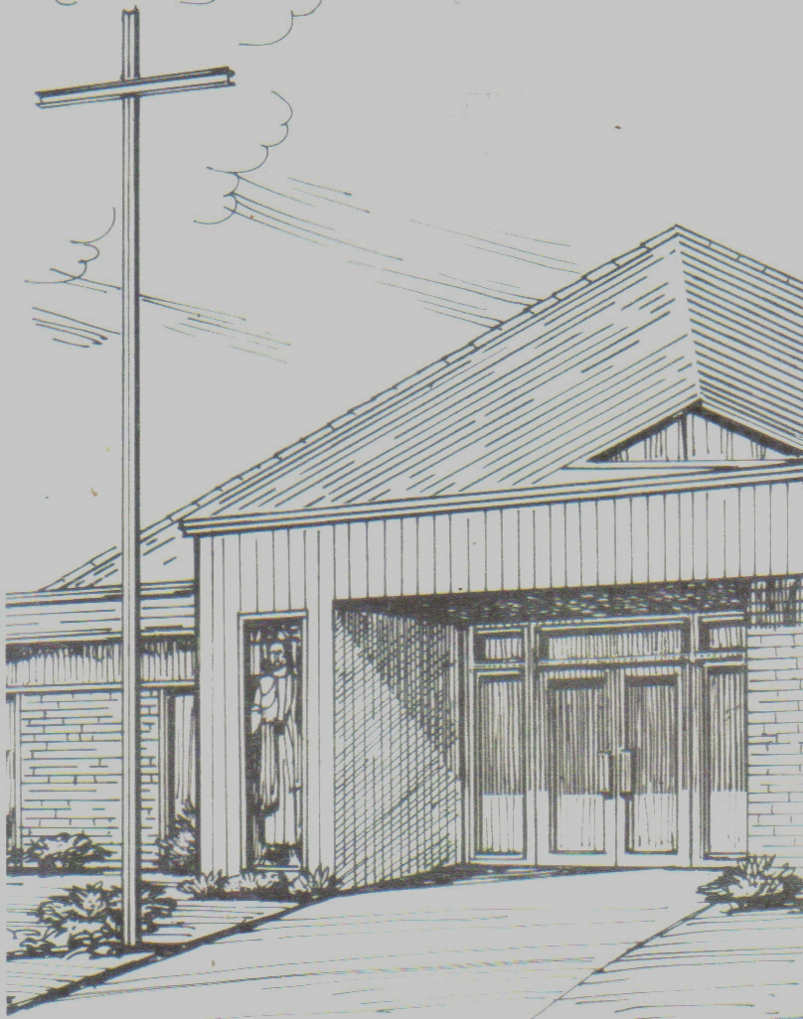

Monthly Newsletter of
BLESSED SAVIOR LUTHERAN CHURCH
2615 Shackelford Road, Florissant, MO 63031-2005 *314- 831-1300
www.blessedsavior-lcms.org * office@blessedsavior-lcms.org
+ + +

“Empowered by God’s Holy Word,
we joyfully share the love of Jesus with all people
through worship, teaching, fellowship, service and witnessing.”

----------------------------------------------------------------------------------------------------
SEPTEMBER 2019

Do not worry about your life, what you will eat, or about your body, what you will wear. For life is more than food and the body more than clothing. Consider the ravens, they neither sow nor reap, they have neither storehouse nor barn, and yet God feeds them. Of how much more value are you than they! And can any of you by worrying add a single hour to your span of life? If you then are not able to do so small a thing as that, why do you worry about the rest?
Luke 12: 22-26

Family of believers at Blessed Savior Lutheran—

Thank you for the warm greetings this past month! It has been a joy to meet many of you in church and get acquainted with my new surroundings here for my vicarage year at seminary! A lot has happened in just a month’s time and I know more will be happening in the future.

This text from Luke was used during worship service as the gospel lesson on August 11. The meaning is rather self-explanatory, with Jesus telling us that not only are we humans of much more value than the animals that roam this earth, but that God knows all the things we need to get through this life and promises to provide them for us. Any undue worrying, stress, and playing the ‘what if’ game are of no value. Jesus even describes adding one single hour to a person’s life span as a small thing from His perspective! If He considers that to be small, how much smaller are the needs we do worry about that are hypothetically within our control!

This first month I got a small taste of how undue stress gets us nowhere. On Monday August 12, the very day after this text was read, I came to the church in the morning to find a tiny drip in the roof had escalated to ceiling damage that soaked my chair, desk, and some personal items, including theology books and commentaries. Needless to say it was not the sight I wanted to see nor the way I wanted to spend my Monday morning, helping to clean that up and clear that room out! But through it all everyone I have talked to at my new church home has expressed both sympathy and helped in any way they can to transition me over to a makeshift office on the opposite side of the sanctuary for the time being. I have been very grateful at the effort that has been put in with giving me assistance during this time. It serves as a reminder to me that God provides a way in helping me accomplish what I need to do during my time here at Blessed Savior.

During this month I have gotten to accompany Pastor to visit some of the shut-ins at our congregation. For most of these visits I have been struck by how, even though they have some of the things to most be worried about by human standards, they appeared to be the most contented with their situation and how they recognize no matter what happens to them in this life, Jesus’ invitation for them to not worry is just as relevant as it is for us. My hope is the rest of us can take these words of Jesus to heart as we understand that unpredictable and disappointing things will happen in life, but none of them are a surprise to God and He is always there, guiding us along, and above all sustaining us in our baptisms and through His word, body and blood.

Blessed to serve—
Vicar Kevin Peterson


“LADIES LUNCHEON”
Sunday, September 29th after late service

MEET & GREET

All ladies are invited to meet our vicar’s wife, Angela Peterson and her daughter Chelsea. We will have a light lunch and get to know more about Angela and their journey to the seminary. So we know how much food to get, there will be a sign up sheet in fellowship hall. If anyone has any questions, please call Paula in the church office.



