Hymn of Invocation: 400 Brightest and Best of the Stars of the Morning LSB 400
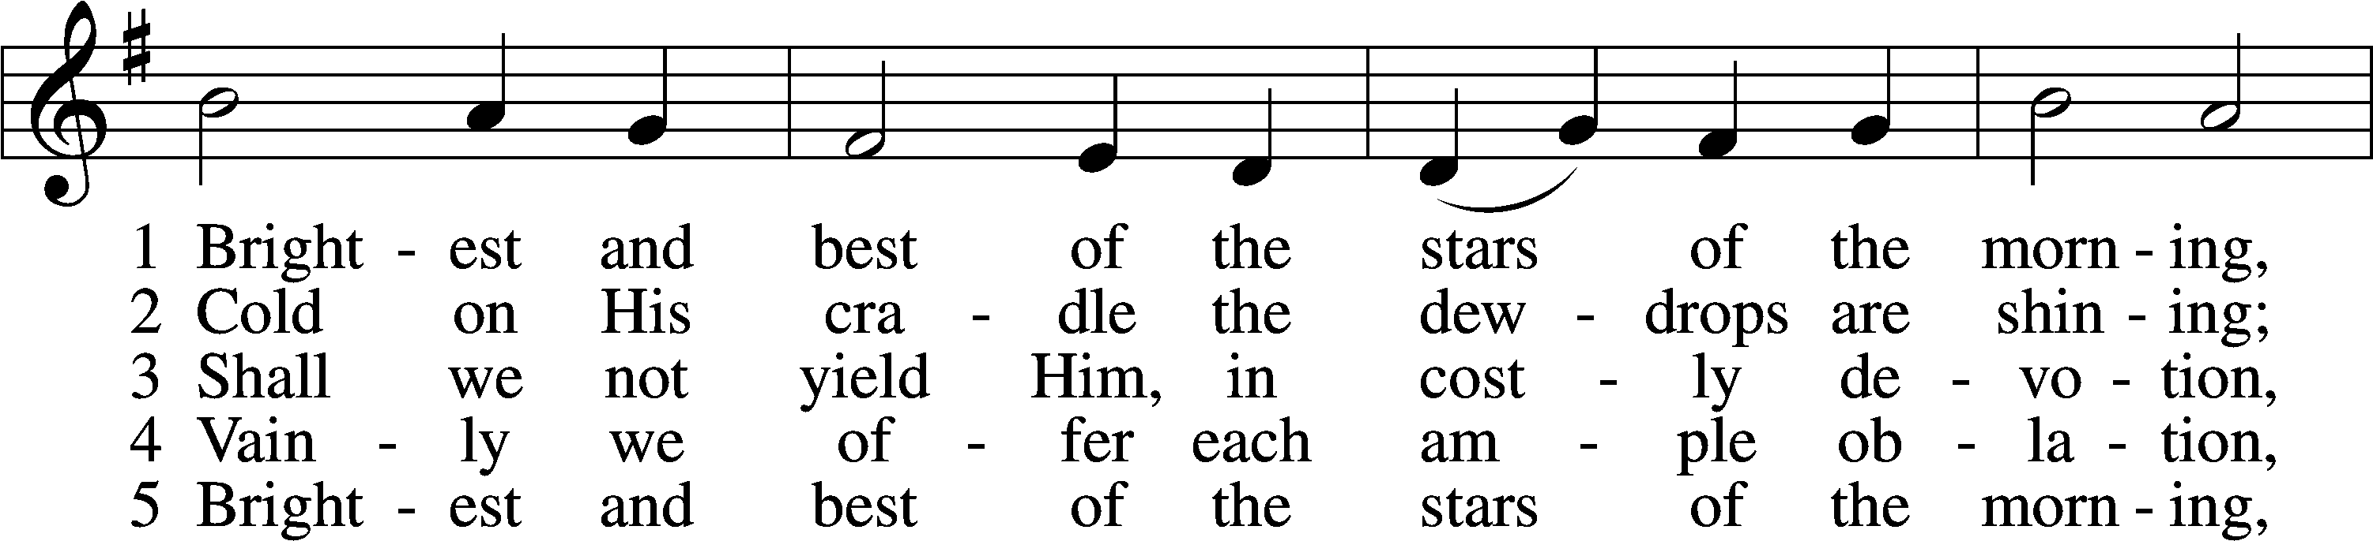
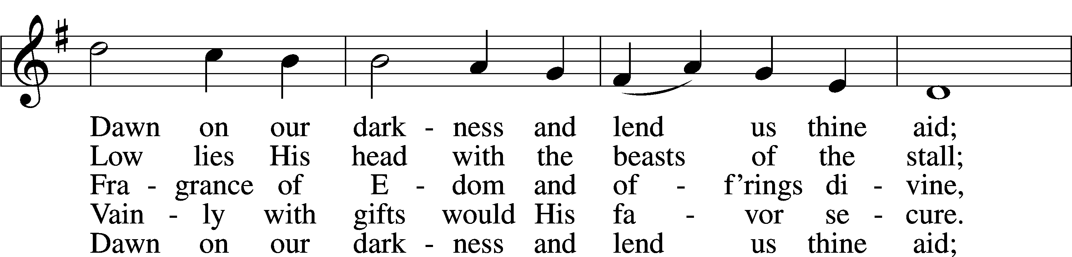
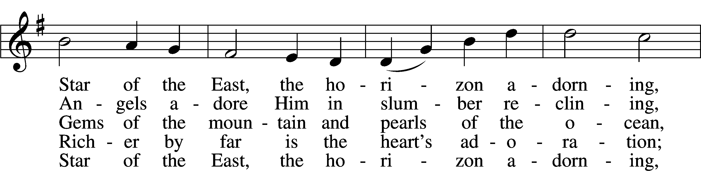
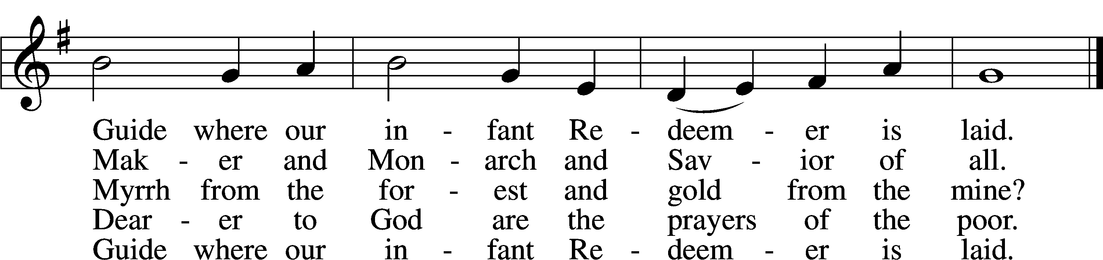
Text: Reginald Heber, 1783–1826, alt.
Tune: James P. Harding, 1850–1911, adapt.
Text and tune: Public domain

Hymn of the Day: 395 O Morning Star, How Fair and Bright LSB 395
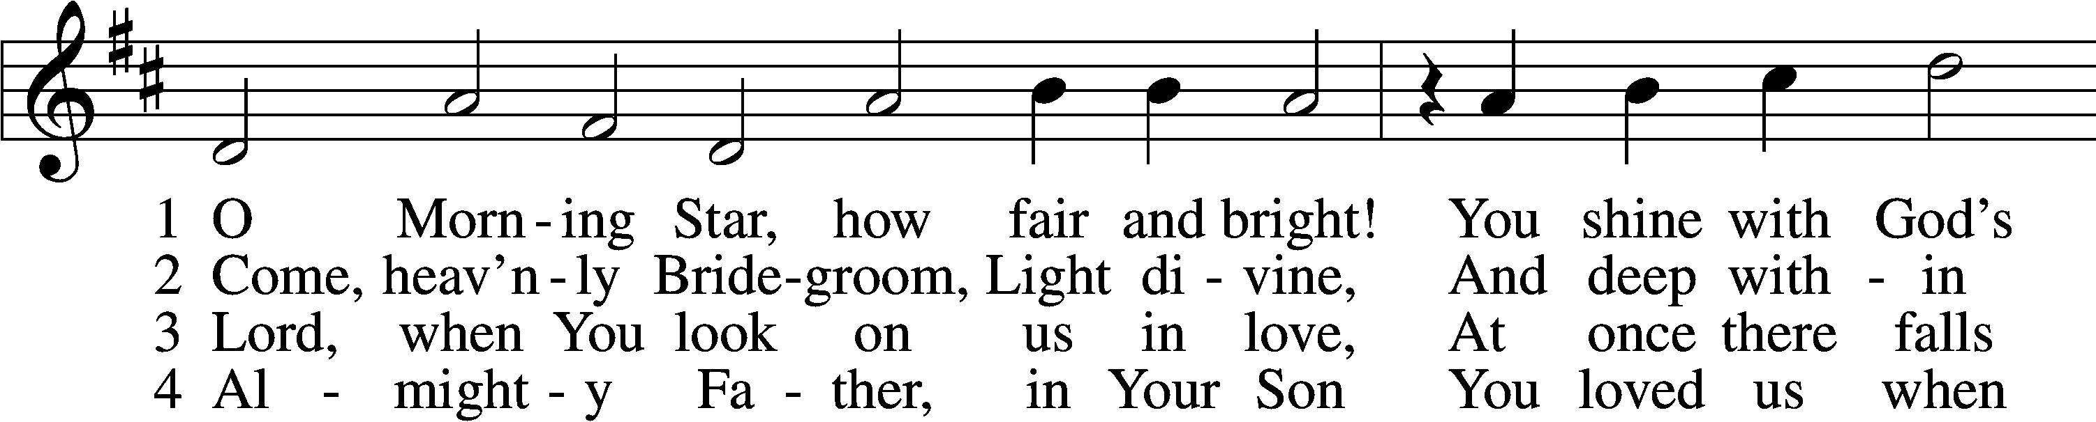
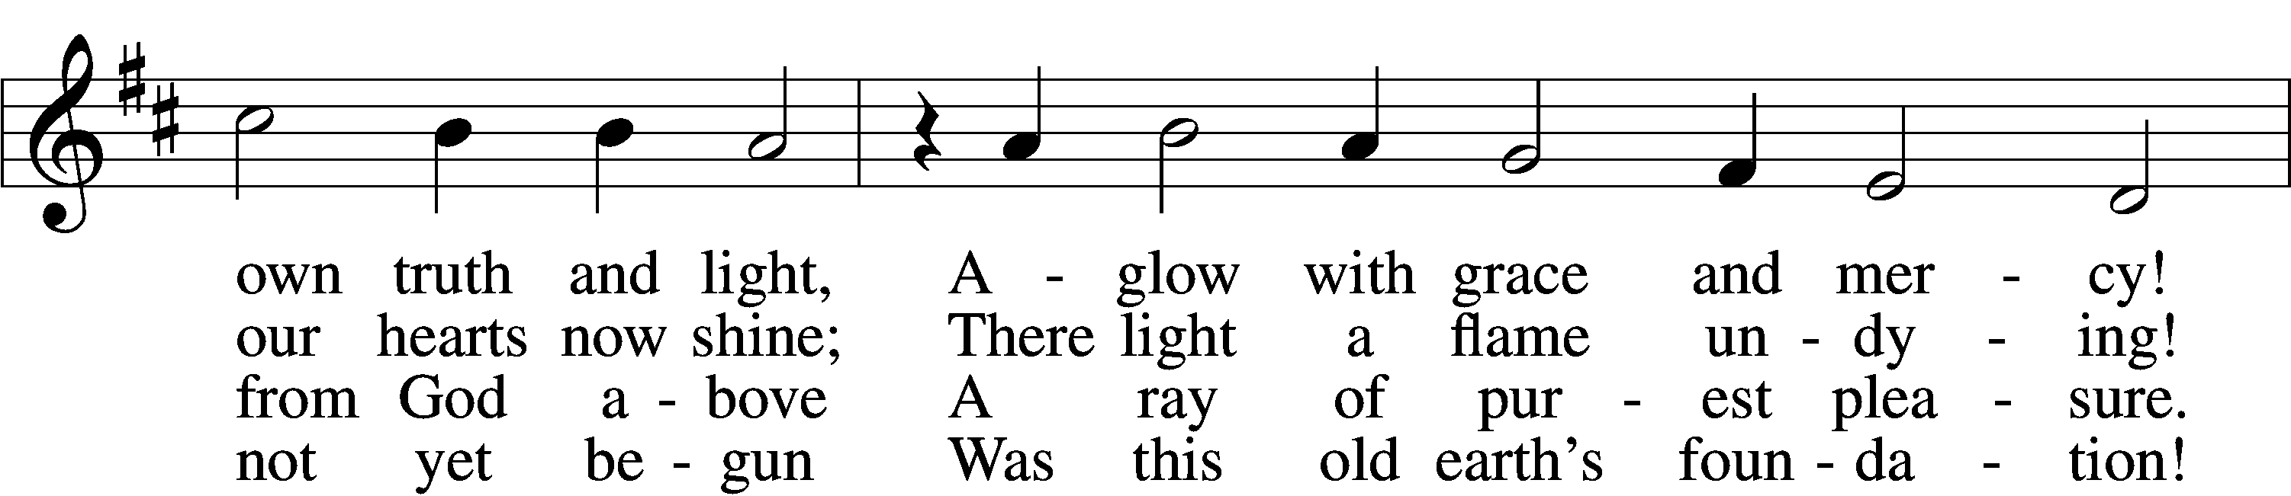
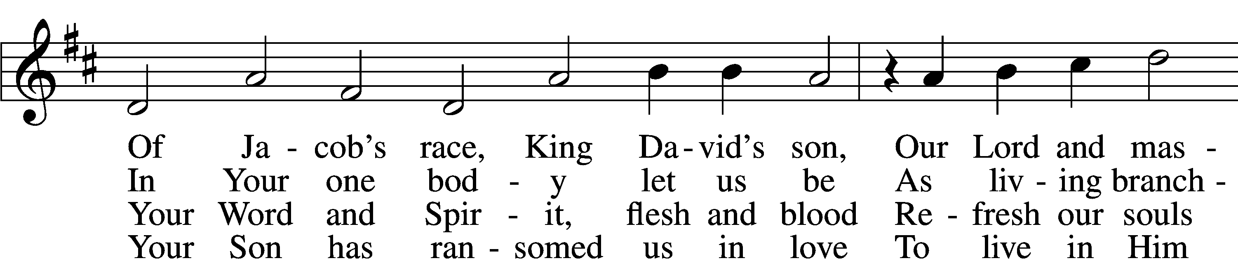
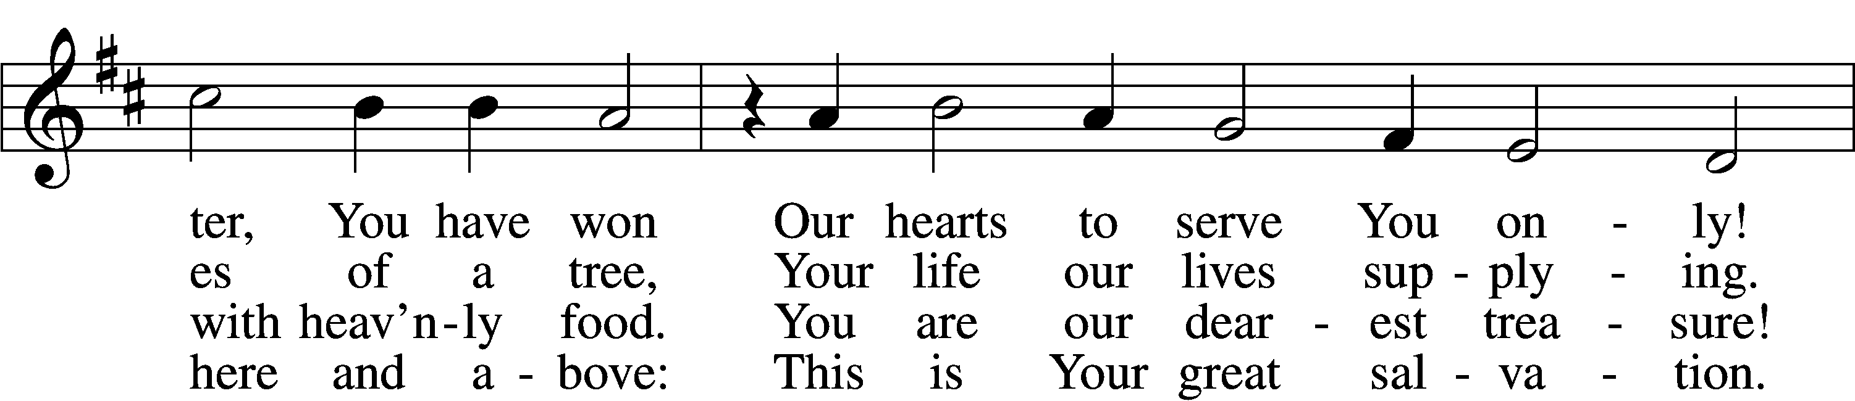
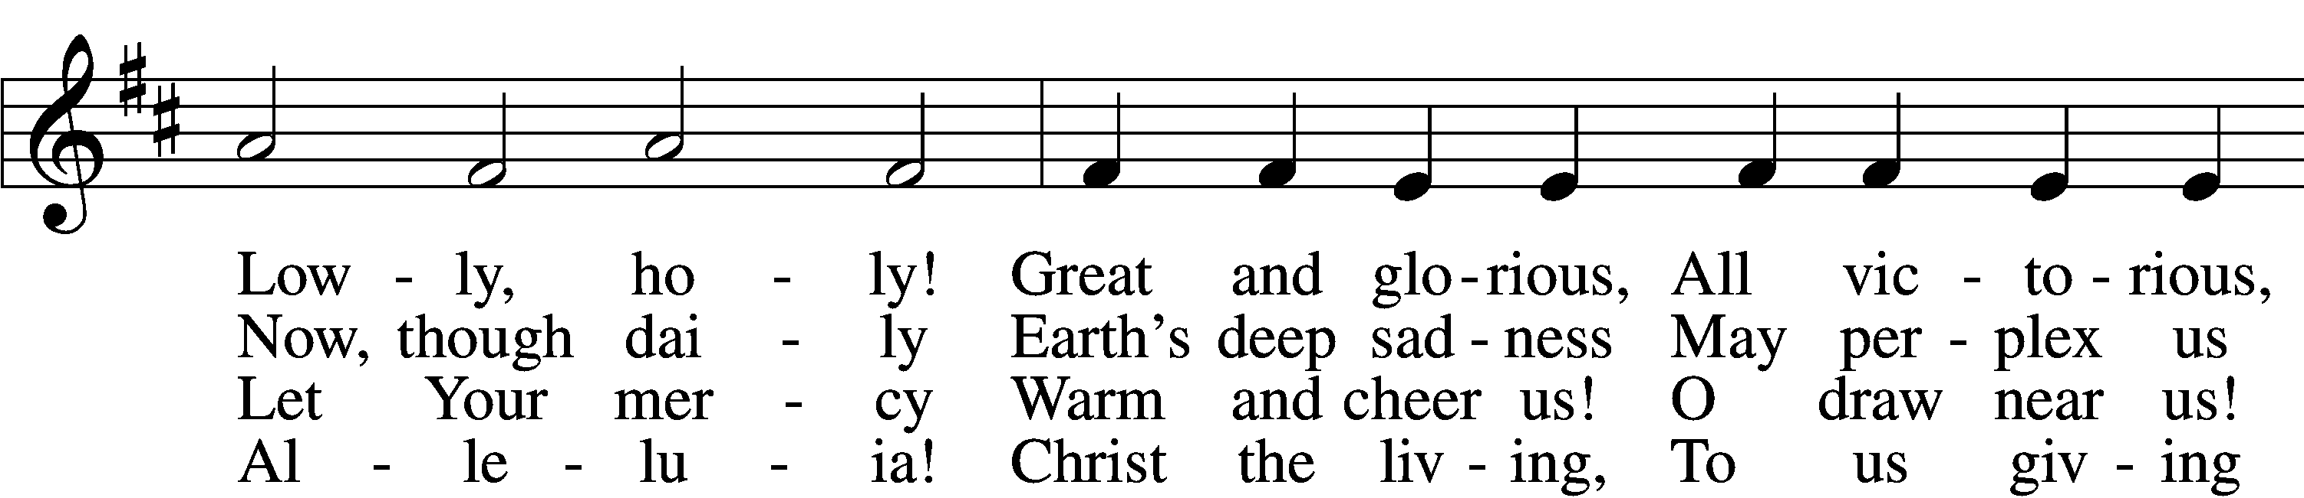
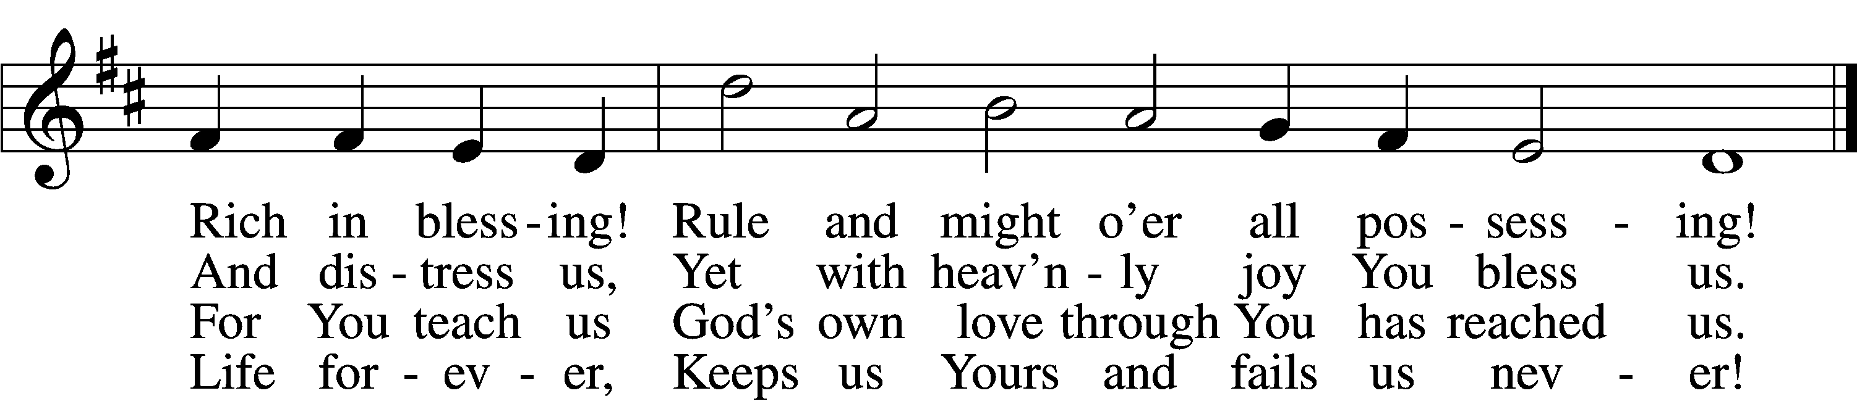

5 O let the harps break forth in sound!
Our joy be all with music crowned,
Our voices gladly blending!
For Christ goes with us all the way—
Today, tomorrow, ev’ry day!
His love is never ending!
Sing out! Ring out!
Jubilation!
Exultation!
Tell the story!
Great is He, the King of Glory!

6 What joy to know, when life is past,
The Lord we love is first and last,
The end and the beginning!
He will one day, oh, glorious grace,
Transport us to that happy place
Beyond all tears and sinning!
Amen! Amen!
Come, Lord Jesus!
Crown of gladness!
We are yearning
For the day of Your returning!
Text: tr. Lutheran Book of Worship, 1978, alt.
Text and tune: Philipp Nicolai, 1556–1608
Text: © 1978 Lutheran Book of Worship. Used by permission: LSB Hymn License no. 110003344
Tune: Public domain

Distribution Hymn: 533 Jesus Has Come and Brings Pleasure LSB 533
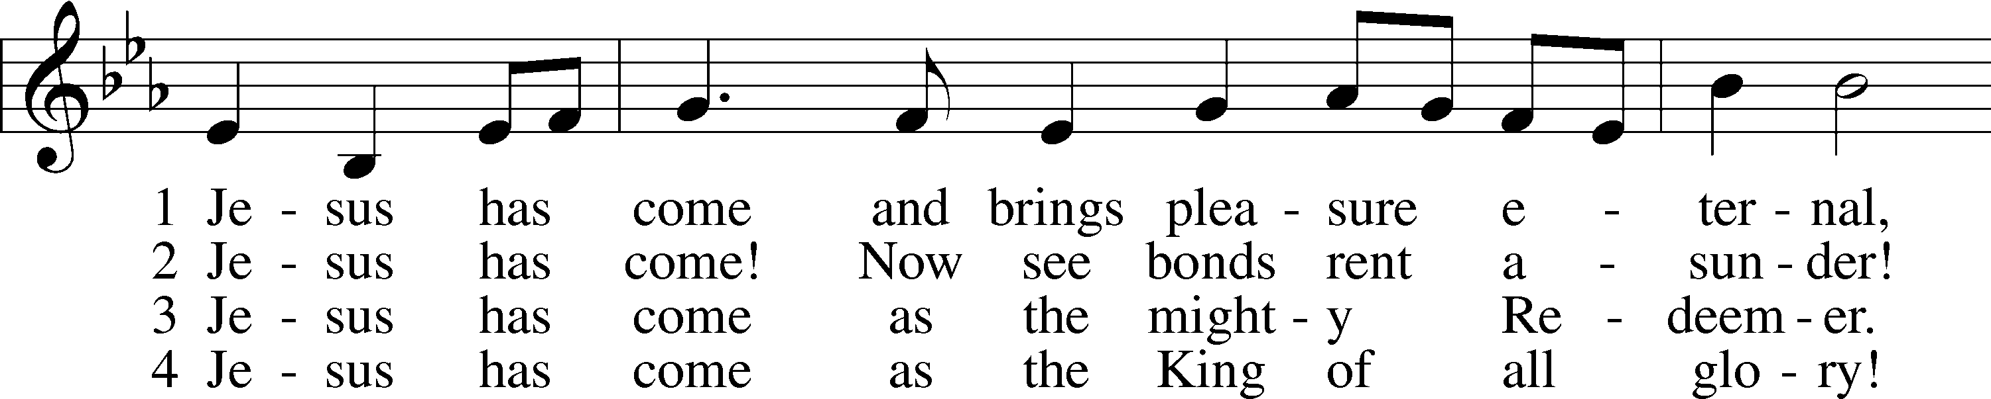
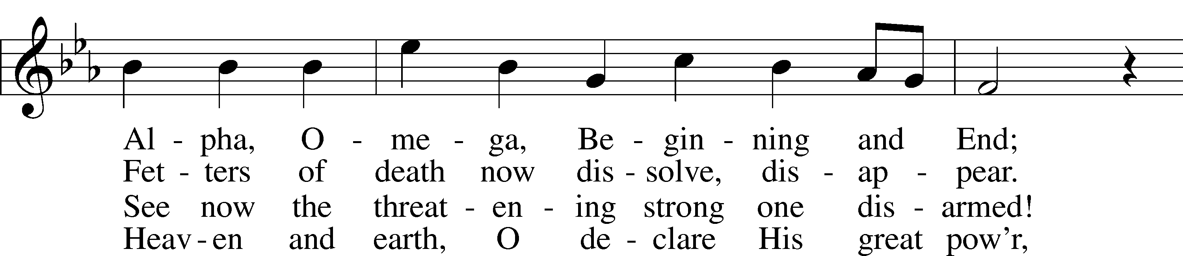
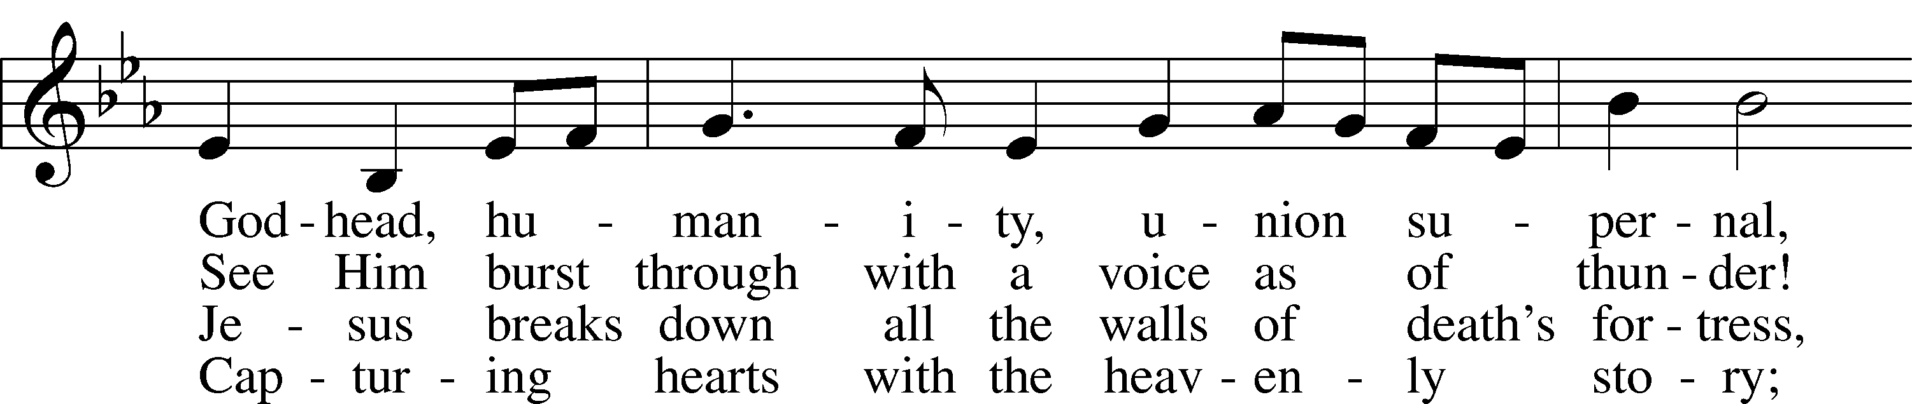
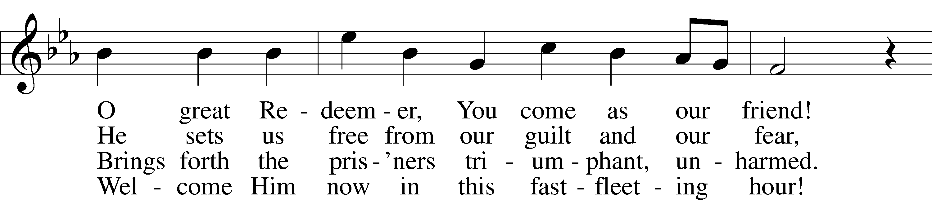
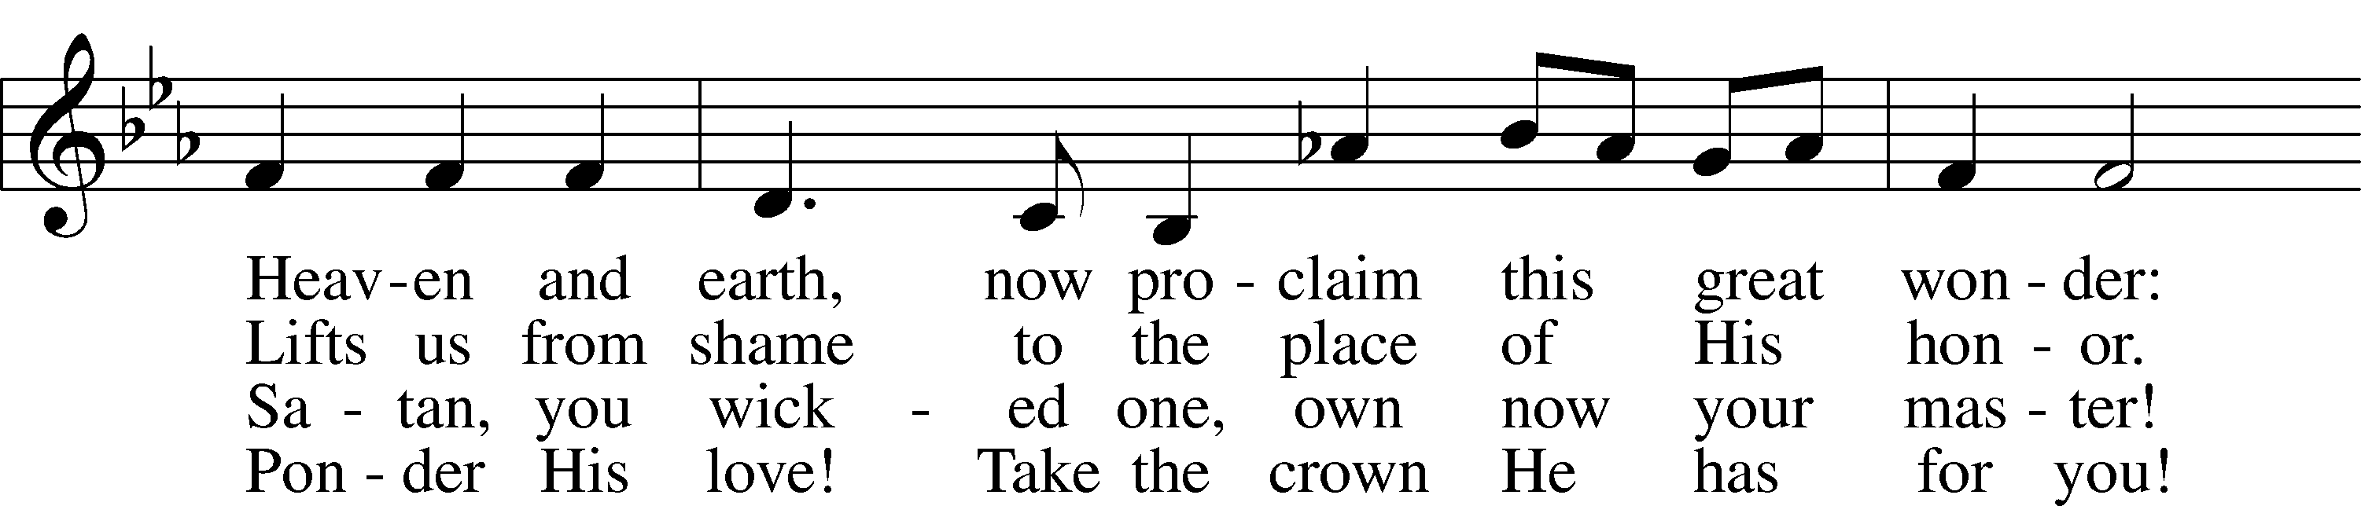
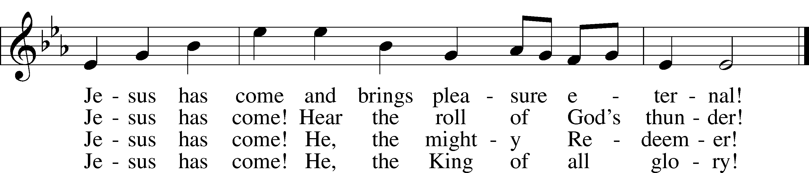
Text: Johann Ludwig Conrad Allendorf, 1693–1773; tr. Oliver C. Rupprecht, 1903–2000, alt.
Tune: Cöthen, c. 1733
Text: © 1982 Concordia Publishing House. Used by permission: LSB Hymn License no. 110003344
Tune: Public domain

Distribution Hymn: 832 Jesus Shall Reign LSB 832
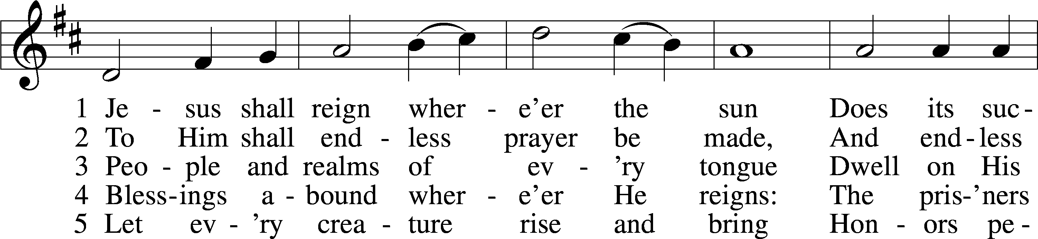
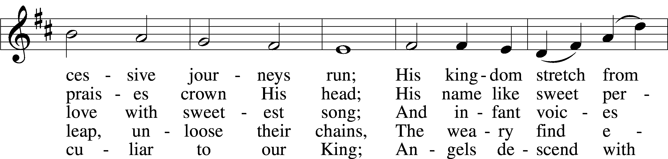
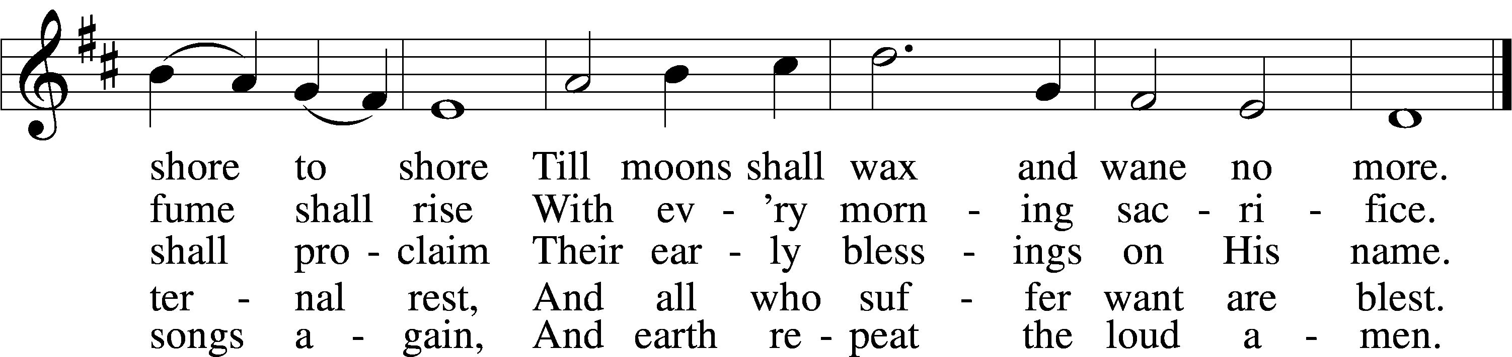
Text: Isaac Watts, 1674–1748, alt.
Tune: attr. John C. Hatton, d. 1793
Text and tune: Public domain

Distribution Hymn: 411 I Want to Walk as a Child of the Light LSB 411
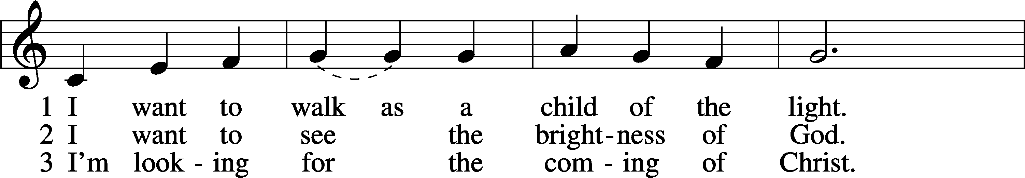
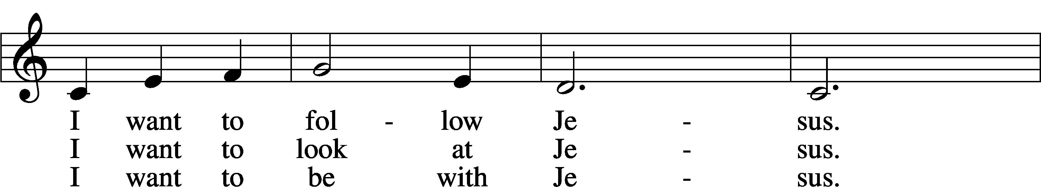
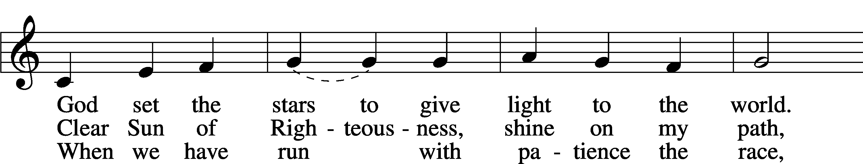
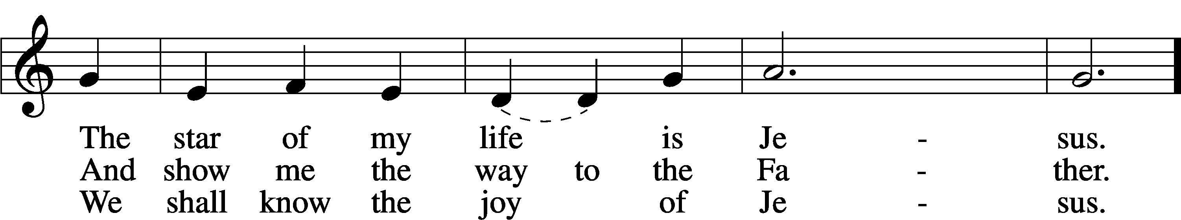
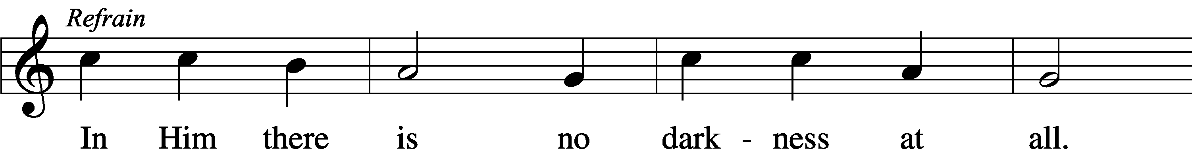
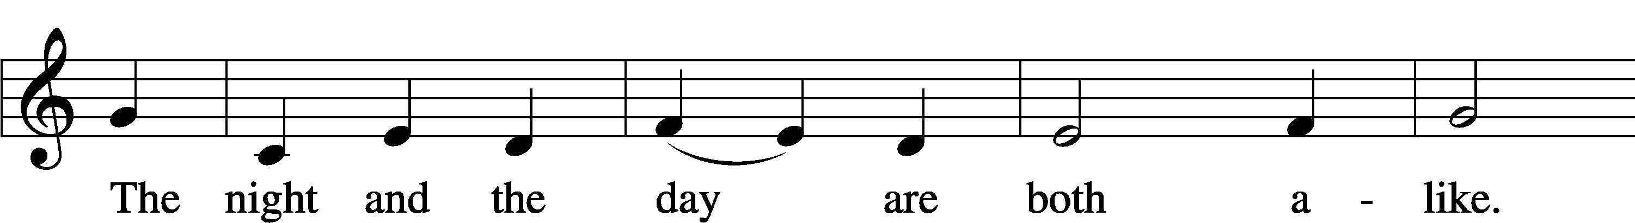
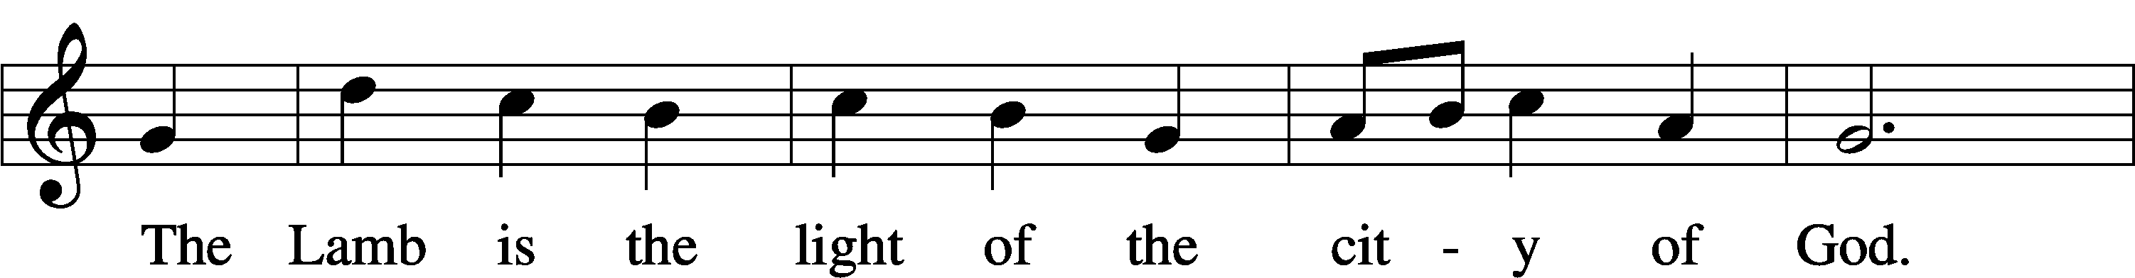
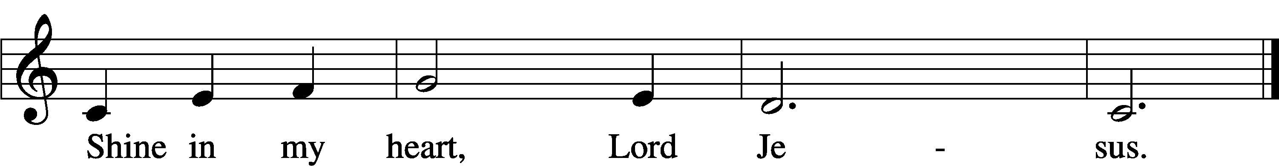
Text and tune: Kathleen Thomerson, 1934
Text and tune: © 1970, 1975 Celebration. Used by permission: LSB Hymn License no. 110003344

Hymn to Depart: 397 As with Gladness Men of Old LSB 397
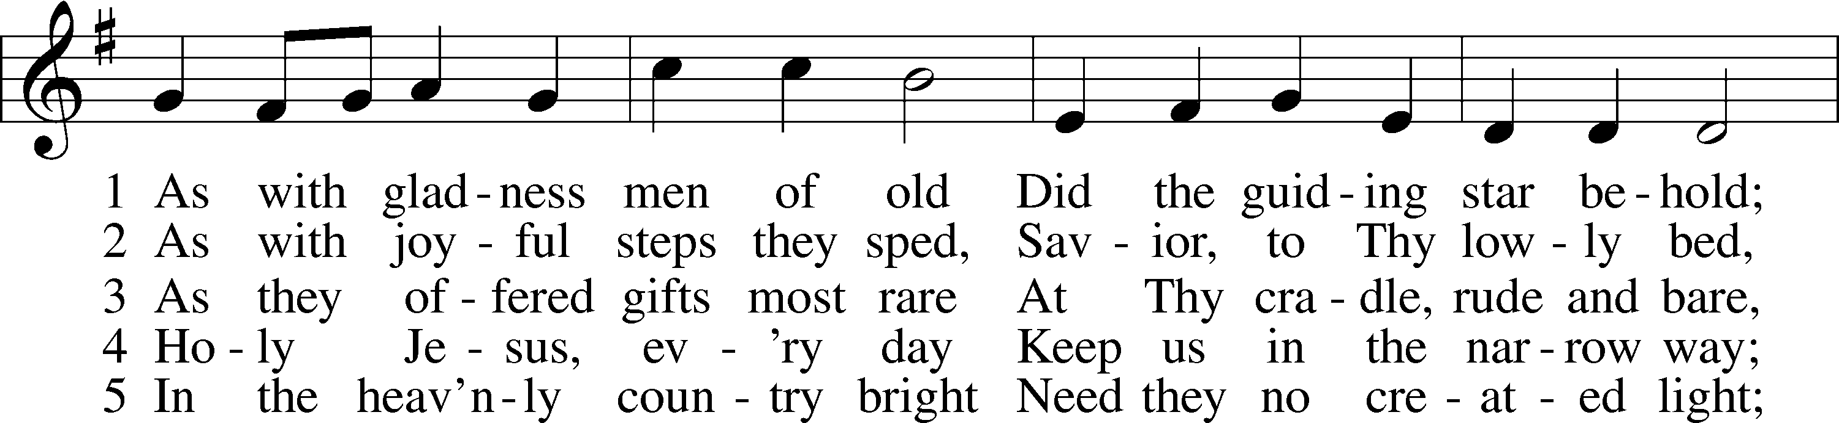
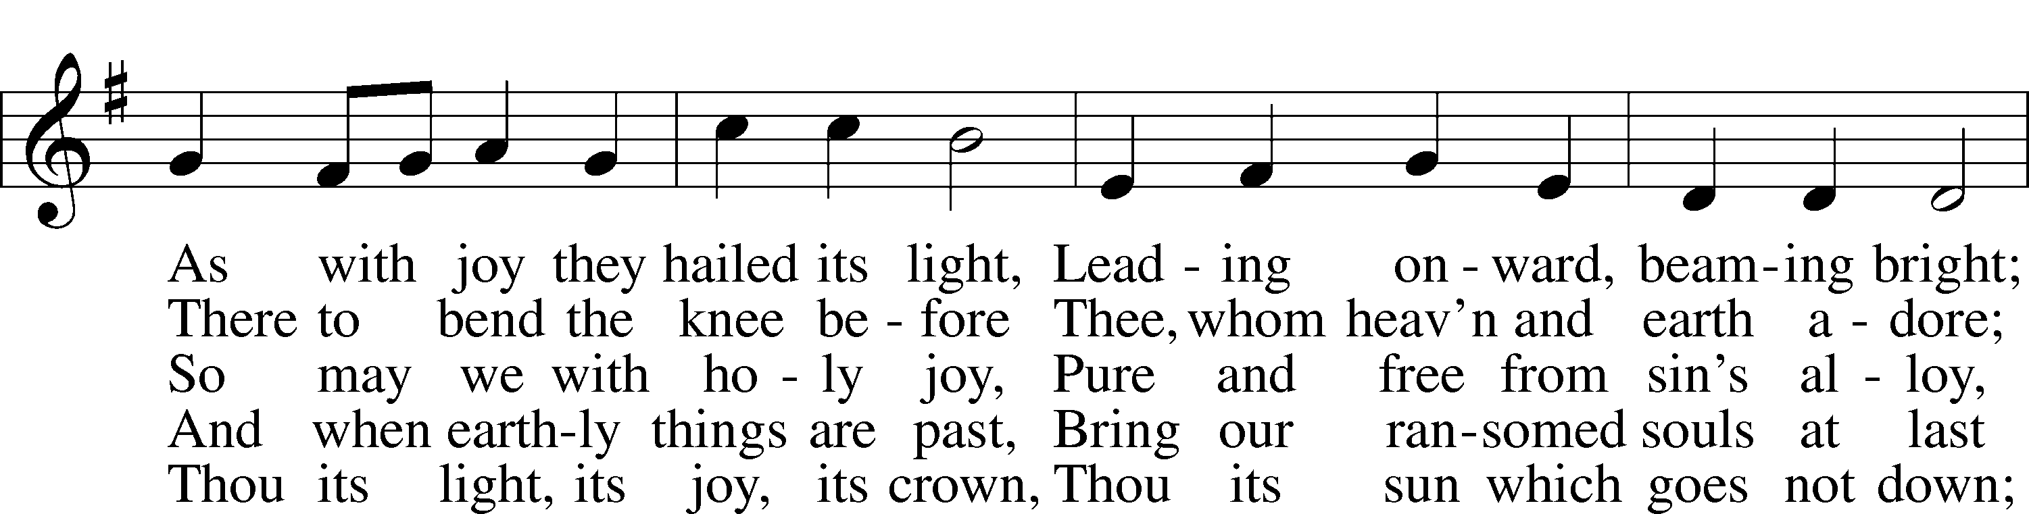
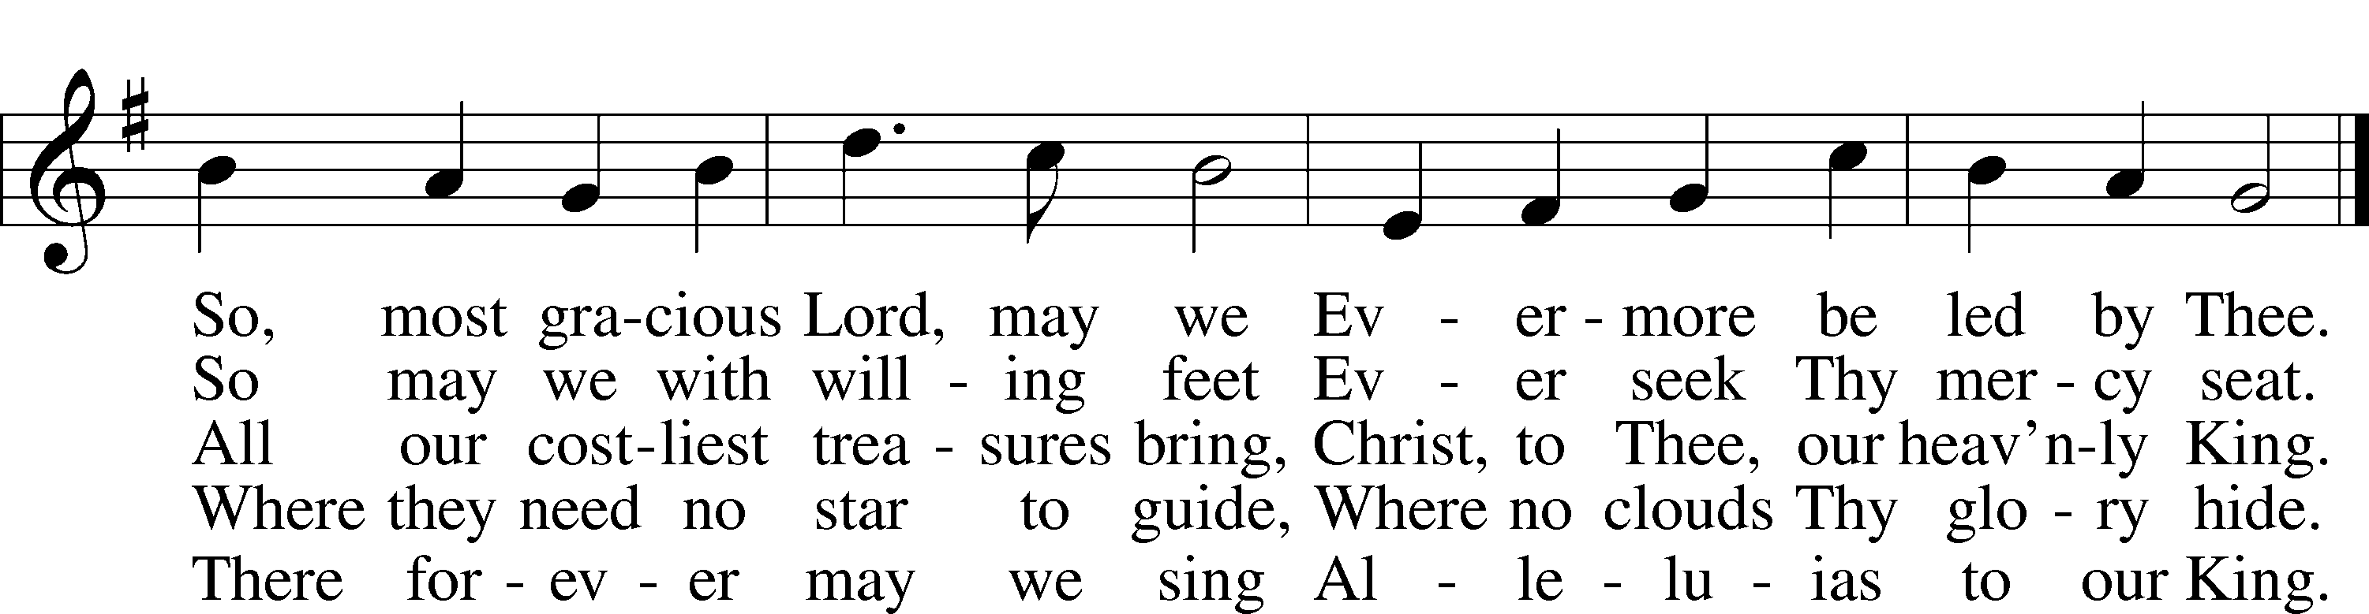
Text: William C. Dix, 1837–98, alt.
Tune: Conrad Kocher, 1786–1872
Text and tune: Public domain

