Opening Hymn “O God, My Faithful God” # 696
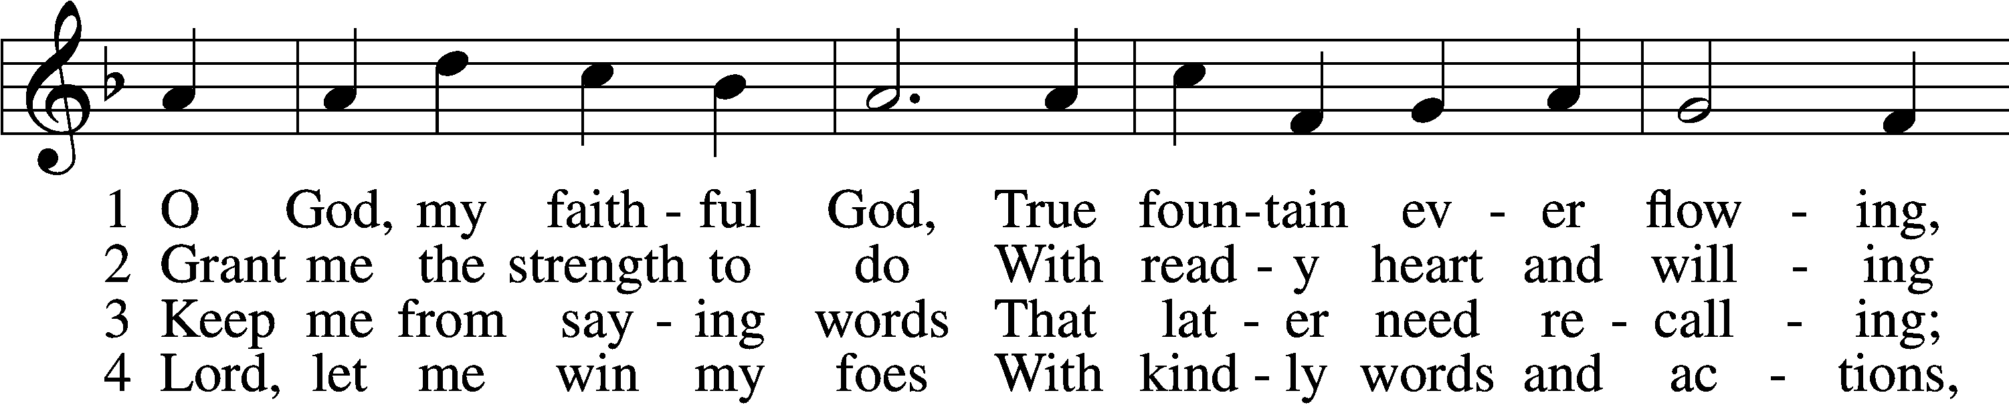
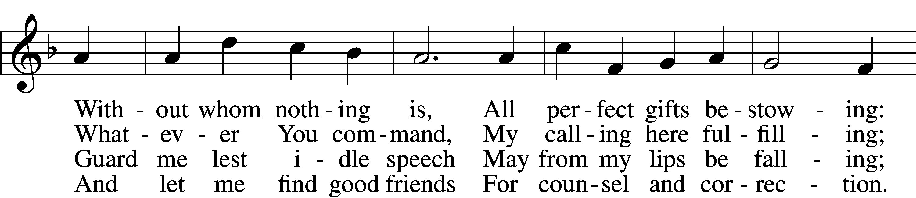
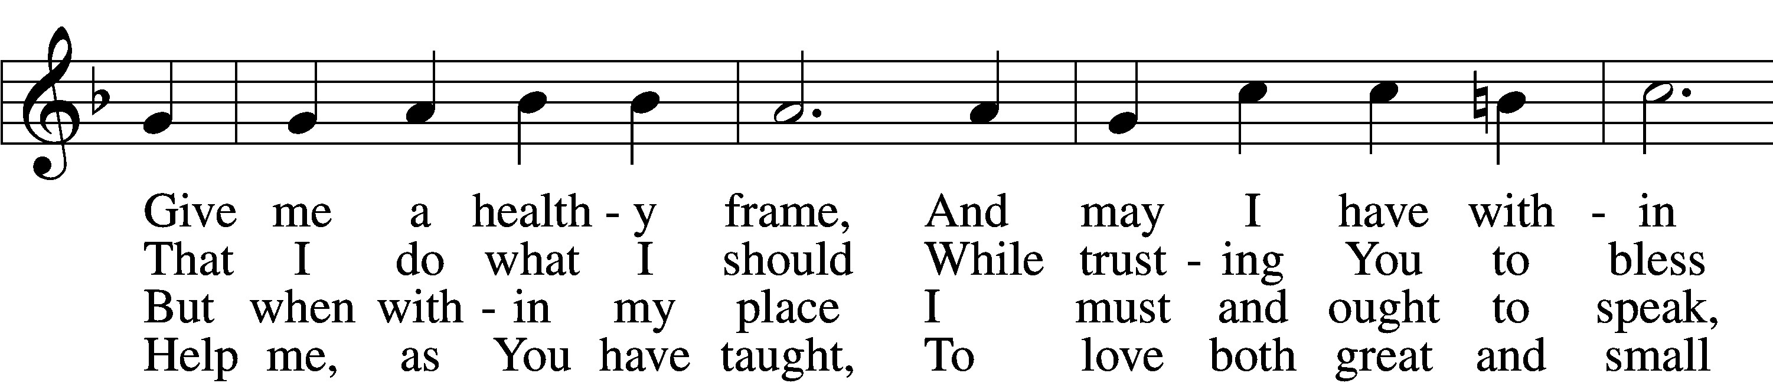
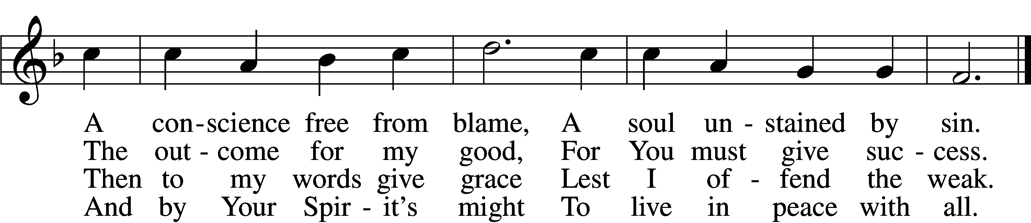

5 Let me depart this life
Confiding in my Savior;
By grace receive my soul
That it may live forever;
And let my body have
A quiet resting place
Within a Christian grave;
And let it sleep in peace.

6 And on that final day
When all the dead are waking,
Stretch out Your mighty hand,
My deathly slumber breaking.
Then let me hear Your voice,
Redeem this earthly frame,
And bid me to rejoice
With those who love Your name.
Text: Johann Heermann, 1585–1647; tr. Catherine Winkworth, 1827–78, alt.
Tune: Neu-vermehrtes . . . Gesangbuch, 1693, 3rd ed., Meiningen
Text and tune: Public domain

Sermon Hymn “Son of God, Eternal Savior” # 842
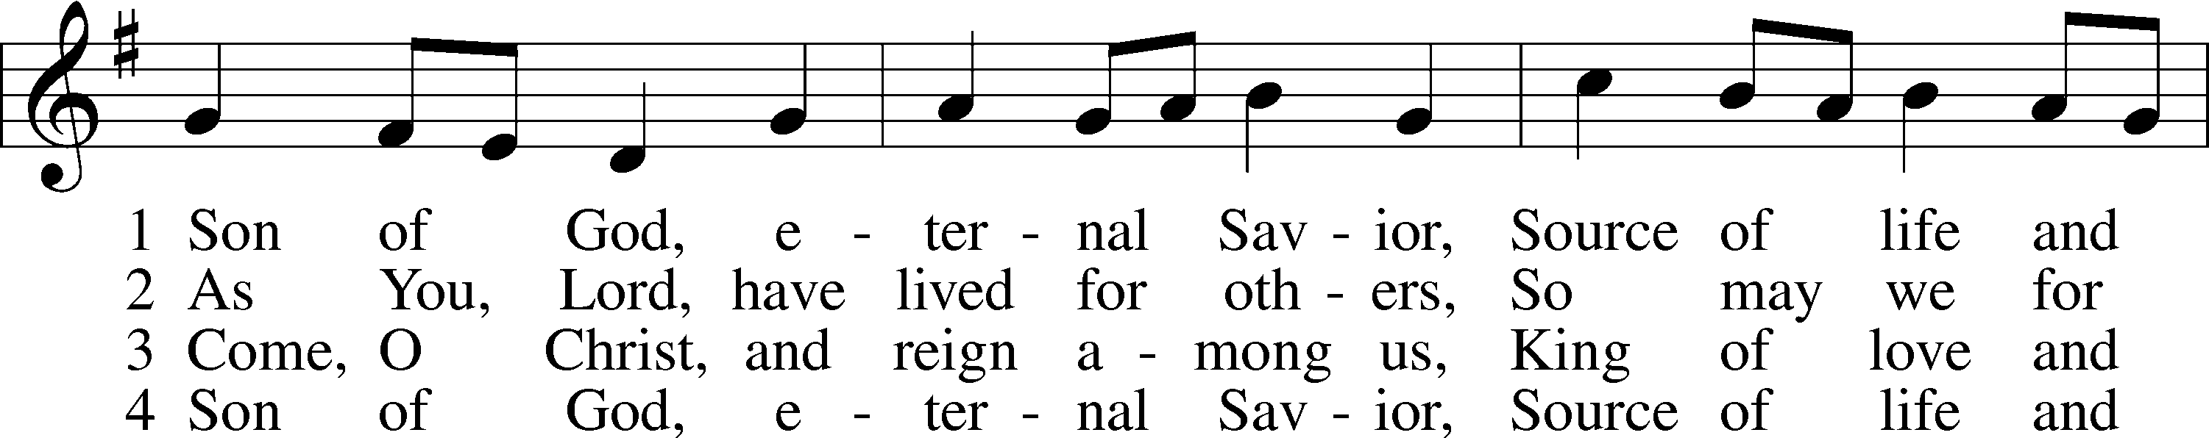
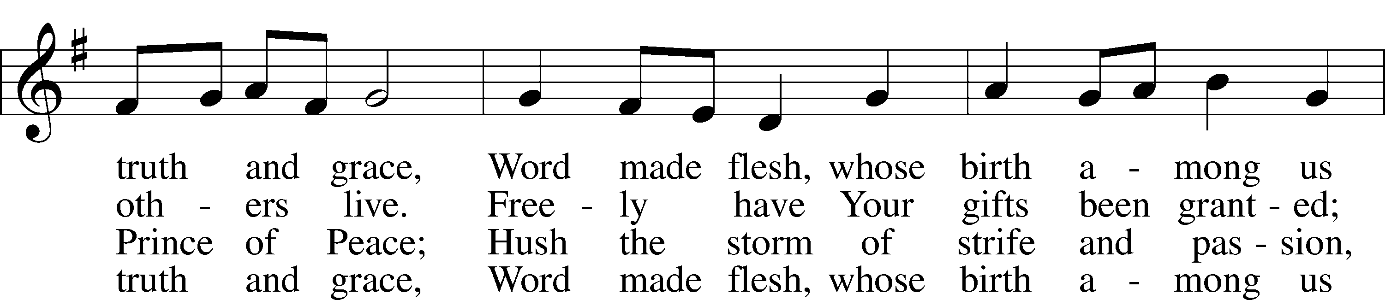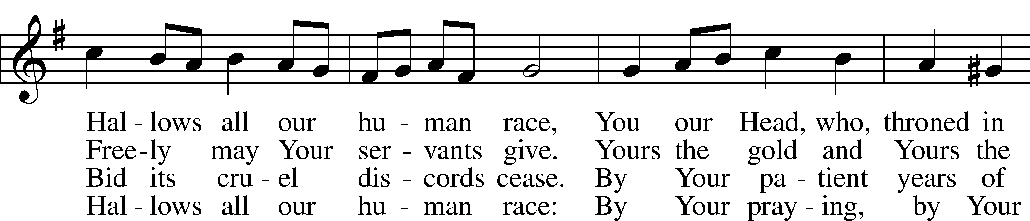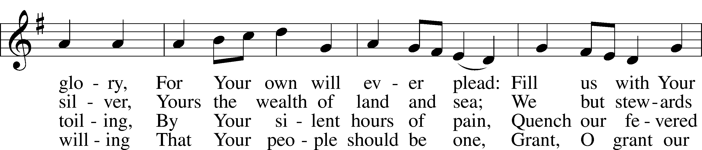
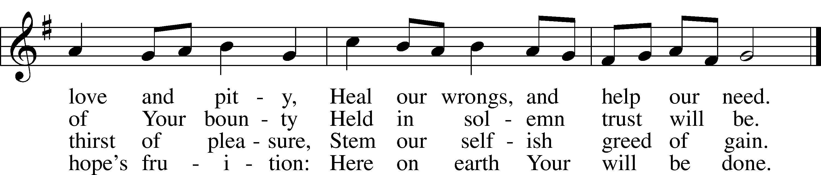
Text: Somerset T. C. Lowry, 1855–1932, alt.
Tune: Oude en Nieuwe Hollantse . . . Contradanseu, c. 1710, Amsterdam
Text and tune: Public domain

Closing Hymn “Where Charity and Love Prevail” # 845
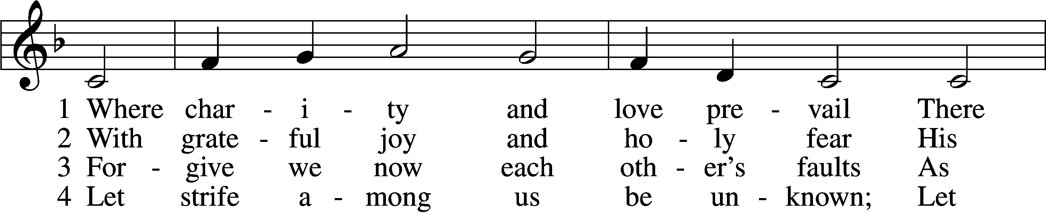
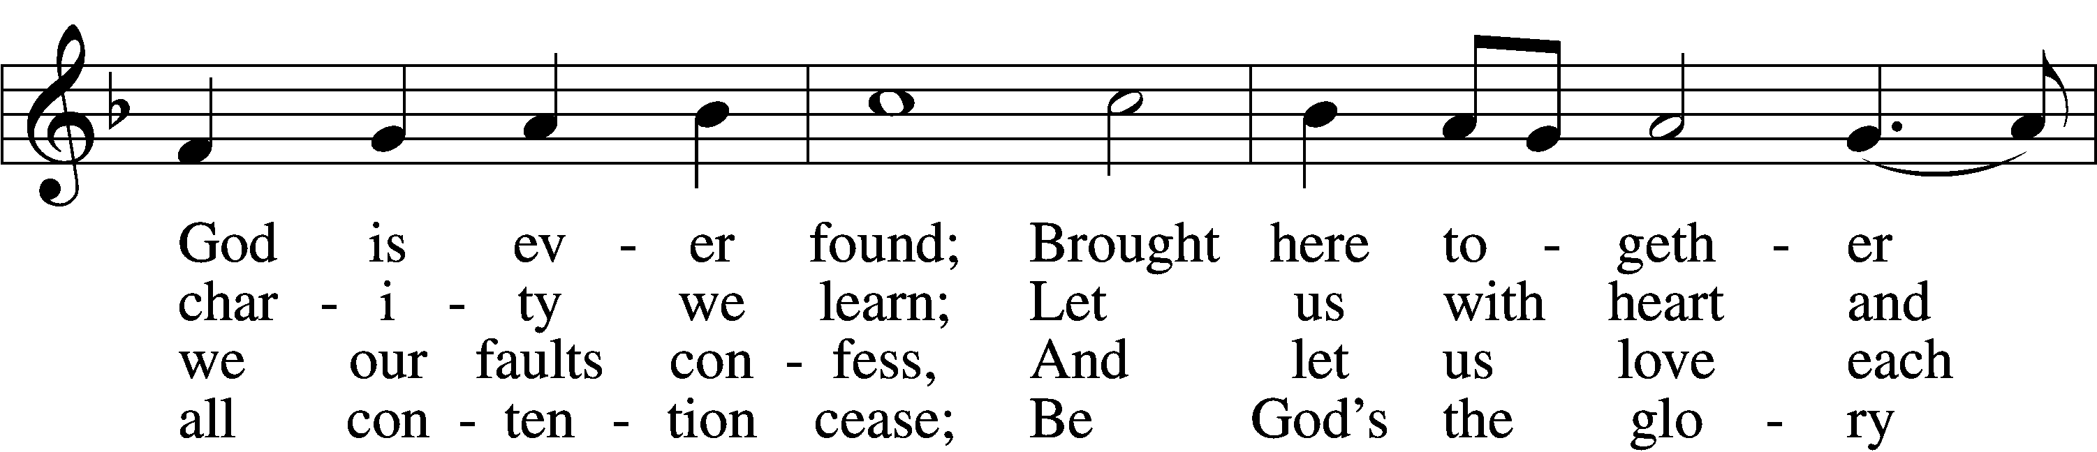
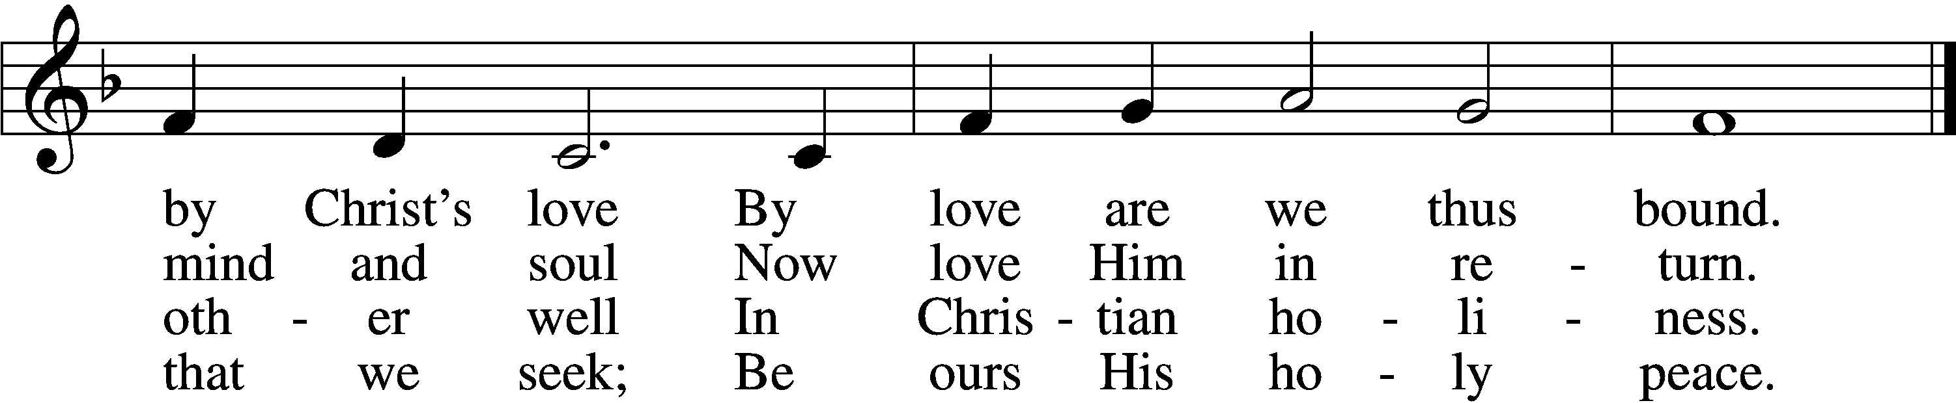

5 Let us recall that in our midst
Dwells Christ, His only Son;
As members of His body joined
We are in Him made one.

6 For love excludes no race or clan
That names the Savior’s name;
His family embraces all
Whose Father is the same.
Text: Latin, c. 9th cent.; tr. Omer E. Westendorf, 1916–97, alt.
Tune: Lucius Chapin, 1760–1842
Text: © 1960 World Library Publications. Used by permission: LSB Hymn License no. 110003344
Tune: Public domain

