Blessed Savior Lutheran Church
Florissant, Missouri

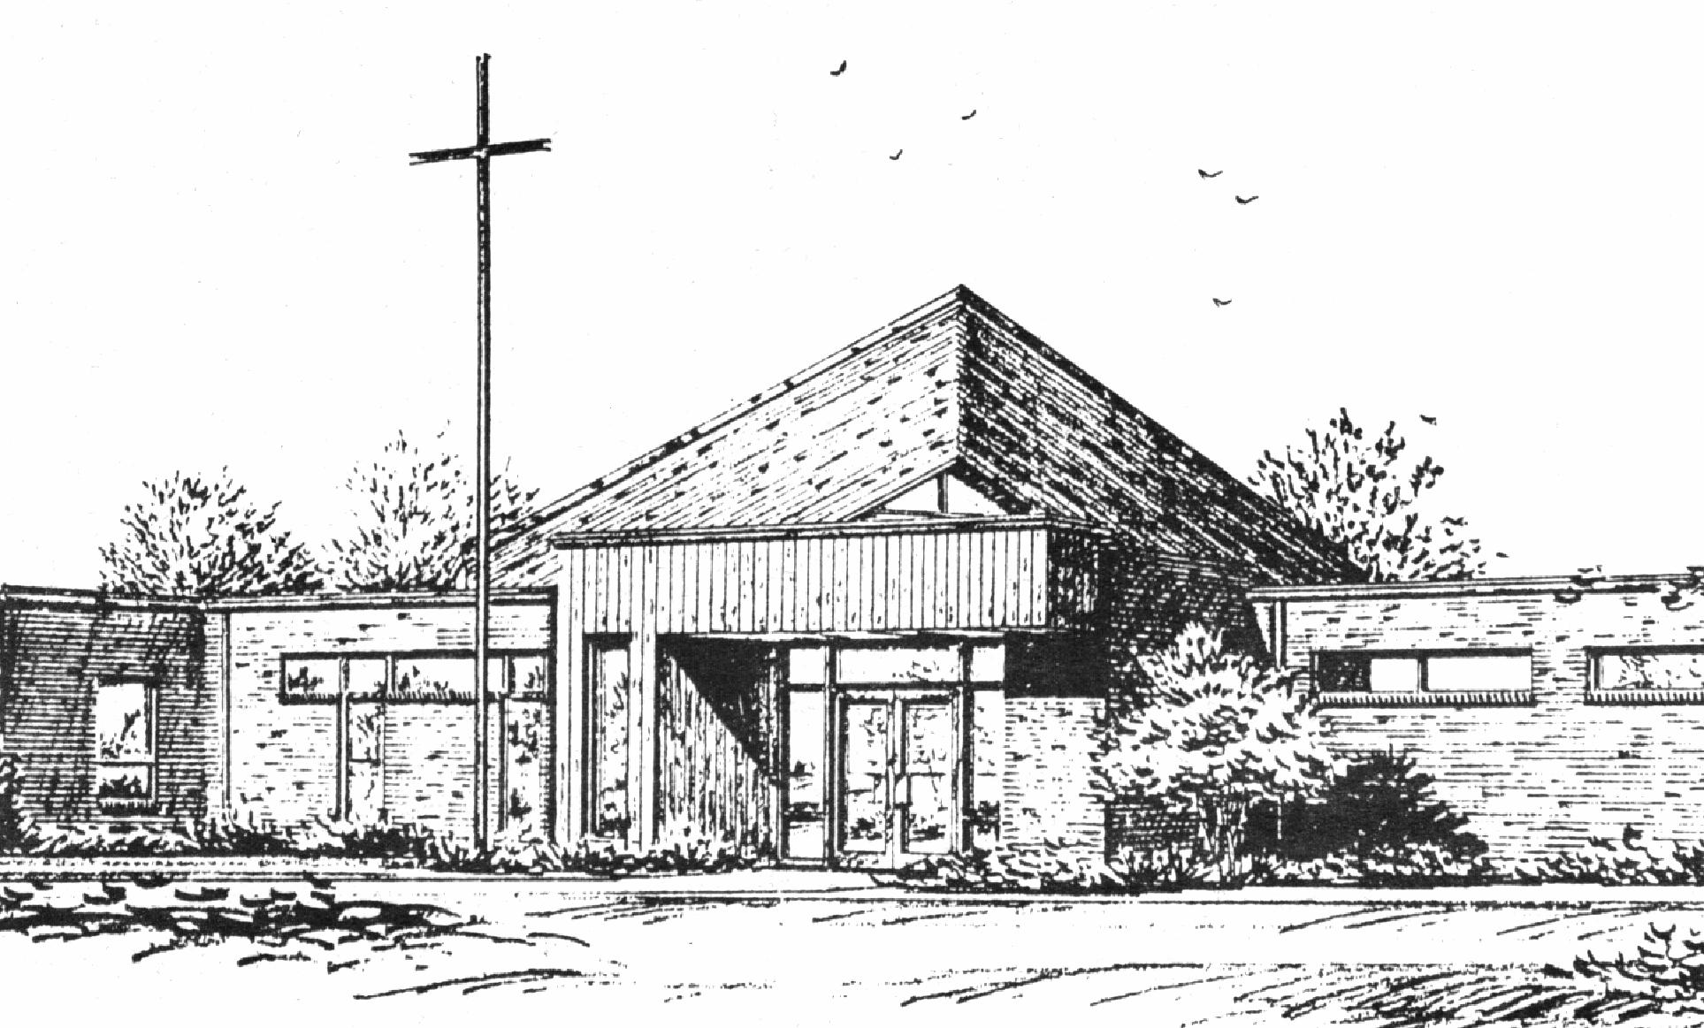
“Empowered by God’s Holy Word,
we joyfully share the love of Jesus with all people;
through worship, teaching, fellowship,
service and witnessing.”

Fourth Sunday after the Epiphany
January 28, 2024

The Lutheran Church-Missouri Synod

BLESSED SAVIOR LUTHERAN CHURCH
2615 Shackelford Road
Florissant, Missouri 63031-2005
Telephone: 831-1300
www.blessedsavior-lcms.org
Pastor Matthew Roeglin
+ + + + + + + + + + + +
Fourth Sunday after the Epiphany
Sunday, January 28, 2024

WE WELCOME YOU to our worship service this morning. We pray God’s rich blessings upon you as you hear His Word and praise His holy name. We ask our members and visitors to please use the friendship pad found on the pew. Kindly hand the friendship pad to the person sitting next to you. The Ushers will collect them after the service. Thank You.

THIS WORSHIP FOLDER / CHURCH BULLETIN is prepared for your convenience and contains the entire order of worship with all spoken and sung responses. However, if you are more comfortable using the hymnal, you may use the order of worship found in the front pages of Lutheran Service Book where all the melodies are shown for the sung responses of the congregation.

Divine Service 3 p.184

Greeting of Peace The people may greet one another in the name of the Lord, saying, “Peace be with you,” as a sign of reconciliation and of the unity of the Spirit in the bond of peace. (Matt. 5:22-24; Eph. 4:1-3).

Opening Hymn
“O God, My Faithful God” # 696

Stand

Confession and Absolution
The sign of the cross may be made by all in remembrance of their Baptism.

P In the name of the Father and of the T Son and of the Holy Spirit.
C Amen.

P Beloved in the Lord! Let us draw near with a true heart and confess our sins unto God our Father, beseeching Him in the name of our Lord Jesus Christ to grant us forgiveness.

P Our help is in the name of the Lord,
C who made heaven and earth.
P I said, I will confess my transgressions unto the Lord,
C and You forgave the iniquity of my sin.

Silence for reflection on God’s Word and for self-examination.

P O almighty God, merciful Father,
C I, a poor, miserable sinner, confess unto You all my sins and iniquities with which I have ever offended You and justly deserved Your temporal and eternal punishment. But I am heartily sorry for them and sincerely repent of them, and I pray You of Your boundless mercy and for the sake of the holy, innocent, bitter sufferings and death of Your beloved Son, Jesus Christ, to be gracious and merciful to me, a poor, sinful being.

P Upon this your confession, I, by virtue of my office, as a called and ordained servant of the Word, announce the grace of God unto all of you, and in the stead and by the command of my Lord Jesus Christ I forgive you all your sins in the name of the Father and of the T Son and of the Holy Spirit.
C Amen.

Stand

Service of the Word
Introit Psalm 32:1–2, 5–7; antiphon: v. 10
Many are the sorrows of the | wicked,*
but steadfast love surrounds the one who trusts | in the Lord.
Blessèd is the one whose transgression is for- | given,*
whose sin is | covered.
Blessèd is the man against whom the Lord counts no in- | iquity,*
and in whose spirit there is | no deceit.
I acknowledged my sin to you, and I did not cover my in- | iquity;*
I said, “I will confess my transgressions to the Lord,” and you forgave the iniquity | of my sin.
Therefore let everyone who is godly offer prayer to you at a time when you | may be found;*
surely in the rush of great waters, they shall not | reach him.
You are a hiding place for me; you preserve me from | trouble;*
you surround me with shouts of de- | liverance.
Glory be to the Father and | to the Son
and to the Holy | Spirit;
as it was in the be- | ginning,
is now, and will be forever. | Amen.
Many are the sorrows of the | wicked,*
but steadfast love surrounds the one who trusts | in the Lord.

Kyrie p. 186
C Lord, have mercy upon us.
Christ, have mercy upon us.
Lord, have mercy upon us.

Gloria in Excelsis p. 187
P Glory be to God on high:
C and on earth peace, goodwill toward men.
We praise Thee, we bless Thee, we worship Thee,
we glorify Thee, we give thanks to Thee, for Thy great glory.
O Lord God, heav’nly King, God the Father Almighty.
O Lord, the only-begotten Son, Jesus Christ;
O Lord God, Lamb of God, Son of the Father,
that takest away the sin of the world, have mercy upon us.
Thou that takest away the sin of the world, receive our prayer.
Thou that sittest at the right hand of God the Father, have mercy upon us.
For Thou only art holy; Thou only art the Lord.
Thou only, O Christ, with the Holy Ghost,
art most high in the glory of God the Father. Amen.

Salutation and Collect of the Day
P The Lord be with you.
C And with thy spirit.

P Let us pray.

C Almighty God, You know we live in the midst of so many dangers that in our frailty we cannot stand upright. Grant strength and protection to support us in all dangers and carry us through all temptations; through Jesus Christ, Your Son, our Lord, who lives and reigns with You and the Holy Spirit, one God, now and forever. Amen.

Sit
Old Testament Reading Deuteronomy 18:15–20
15“The Lord your God will raise up for you a prophet like me from among you, from your brothers—it is to him you shall listen— 16just as you desired of the Lord your God at Horeb on the day of the assembly, when you said, ‘Let me not hear again the voice of the Lord my God or see this great fire any more, lest I die.’ 17And the Lord said to me, ‘They are right in what they have spoken. 18I will raise up for them a prophet like you from among their brothers. And I will put my words in his mouth, and he shall speak to them all that I command him. 19And whoever will not listen to my words that he shall speak in my name, I myself will require it of him. 20But the prophet who presumes to speak a word in my name that I have not commanded him to speak, or who speaks in the name of other gods, that same prophet shall die.’”

A This is the Word of the Lord.
C Thanks be to God.

Gradual Psalm 117:1–2a; 96:8
C Praise the Lord, all nations!
Extol him, all peoples!
For great is his steadfast love toward us,
and the faithfulness of the Lord endures forever.
Ascribe to the Lord the glory due his name;
bring an offering, and come into his courts!

Epistle 1 Corinthians 8:1–13
1Concerning food offered to idols: we know that “all of us possess knowledge.” This “knowledge” puffs up, but love builds up. 2If anyone imagines that he knows something, he does not yet know as he ought to know. 3But if anyone loves God, he is known by God.
4Therefore, as to the eating of food offered to idols, we know that “an idol has no real existence,” and that “there is no God but one.” 5For although there may be so-called gods in heaven or on earth—as indeed there are many “gods” and many “lords”— 6yet for us there is one God, the Father, from whom are all things and for whom we exist, and one Lord, Jesus Christ, through whom are all things and through whom we exist.
7However, not all possess this knowledge. But some, through former association with idols, eat food as really offered to an idol, and their conscience, being weak, is defiled. 8Food will not commend us to God. We are no worse off if we do not eat, and no better off if we do. 9But take care that this right of yours does not somehow become a stumbling block to the weak. 10For if anyone sees you who have knowledge eating in an idol’s temple, will he not be encouraged, if his conscience is weak, to eat food offered to idols? 11And so by your knowledge this weak person is destroyed, the brother for whom Christ died. 12Thus, sinning against your brothers and wounding their conscience when it is weak, you sin against Christ. 13Therefore, if food makes my brother stumble, I will never eat meat, lest I make my brother stumble.

A This is the Word of the Lord.
C Thanks be to God.

Stand

Alleluia p. 190
C Alleluia. Alleluia. Alleluia.

Holy Gospel Mark 1:21–28
P The Holy Gospel according to St. Mark, the first chapter.
C Glory be to Thee, O Lord.

21They went into Capernaum, and immediately on the Sabbath Jesus entered the synagogue and was teaching. 22And they were astonished at his teaching, for he taught them as one who had authority, and not as the scribes. 23And immediately there was in their synagogue a man with an unclean spirit. And he cried out, 24“What have you to do with us, Jesus of Nazareth? Have you come to destroy us? I know who you are—the Holy One of God.” 25But Jesus rebuked him, saying, “Be silent, and come out of him!” 26And the unclean spirit, convulsing him and crying out with a loud voice, came out of him. 27And they were all amazed, so that they questioned among themselves, saying, “What is this? A new teaching with authority! He commands even the unclean spirits, and they obey him.” 28And at once his fame spread everywhere throughout all the surrounding region of Galilee.

P This is the Gospel of the Lord.
C Praise be to Thee, O Christ.

Apostles’ Creed p.192
C I believe in God, the Father Almighty,
maker of heaven and earth.

And in Jesus Christ, His only Son, our Lord,
who was conceived by the Holy Spirit,
born of the virgin Mary,
suffered under Pontius Pilate,
was crucified, died and was buried.
He descended into hell.
The third day He rose again from the dead.
He ascended into heaven
and sits at the right hand of God the Father Almighty.
From thence He will come to judge the living and the dead.

I believe in the Holy Spirit,
the holy Christian Church,
the communion of saints,
the forgiveness of sins,
the resurrection of the body,
and the life T everlasting. Amen.

Sit
New Member
Children's Message
Sermon Hymn “Son of God, Eternal Savior” # 842
Sermon
Offering
Stand
Offertory p. 192
C Create in me a clean heart, O God, and renew a right spirit within me.
Cast me not away from Thy presence, and take not Thy Holy Spirit from me.
Restore unto me the joy of Thy salvation, and uphold me with Thy free spirit. Amen.

Prayer of the Church
After each petition of the prayers:
P | Lord, In Your mercy.
C | Hear our prayer.
After the final petition:
P | One God, now and forever.
C | Amen.

Lord’s Prayer p. 196
C Our Father who art in heaven,
hallowed be Thy name,
Thy kingdom come,
Thy will be done on earth as it is in heaven;
give us this day our daily bread;
and forgive us our trespasses as we forgive those who trespass against us;
and lead us not into temptation,
but deliver us from evil.
For Thine is the kingdom and the power and the glory forever and ever. Amen.

Benediction p. 202
P The Lord bless you and keep you.
The Lord make His face shine upon you and be gracious unto you.
The Lord lift up His countenance upon you and T give you peace.
C Amen, amen, amen.

Closing Hymn “Where Charity and Love Prevail” # 845

Acknowledgments
Unless otherwise indicated, Scripture quotations are from the ESV® Bible (The Holy Bible, English Standard Version®), copyright © 2001 by Crossway, a publishing ministry of Good News Publishers. Used by permission. All rights reserved.
Created by Lutheran Service Builder © 2024 Concordia Publishing House.

Announcements
After the announcements, please stand for the closing Doxology.
Doxology #805
Praise God, from whom all blessings flow;
Praise Him, all creatures here below;
Praise Him above, ye heav’nly host:
Praise Father, Son, and Holy Ghost. Amen.

Go and Serve the Lord
Acknowledgments Unless otherwise indicated, all scripture quotations are from The Holy Bible, English Standard Version, copyright © 2001 by Crossway Bibles, a division of Good News Publishers. Used by permission. All rights reserved. Created by Lutheran Service Builder © 2006 Concordia Publishing House.

The Liturgist & Preacher: Pastor Matthew Roeglin
The Acoloyte: Sunday 9:30 a.m. Madalyn Beach
The Sound System: Bradley Taylor & Justin Grimes
The Organist: Mrs. Donna Boyd

Altar Flowers- are placed by the Hall sisters in celebration of their sister, Denise Jollenbeck’s birthday and for the many blessings God has bestowed upon her. Love, Donna, Darlene, Dawn & Debbie.

New Member – If you have time, please welcome and introduce yourself to Chris Robertson after the church service.

2024 Altar Flower Chart – is up in the back of church. Flowers are $45.00 (2). Altar flowers are needed for Feb. 18 & 25.

Prayers for our Church and Community Week of Jan. 21 (front), and Jan. 28, 2024 (on the back). Each week we pray for members of our Church and our Community. At the end of the service the Ushers will pass out the new prayer list.

2024 Offering Envelopes – are on the table in back of church.

A special Thank You to those who helped take down the greens: Pastor & Danny Roeglin, Paula & Terry Bossaller
Justin Grimes, Mike & Donna Kroehnke, Sue Johnston, Shirley McCabe & Donna Boyd. Many Thanks!

Grace Chapel Lutheran School, located at 10015 Lance Dr., Bellefontaine Neighbors, MO 63137, will host a Valentine’s Craft and Vendors Fair on Saturday, February 3, 2024 from 10 AM – 2 PM. Participating vendors include Aeire Lane, Norwex, Pampered Chef, Touchstone Crystal, PS Spa, Scentsy, Lila Rose, and Thirty-One to name a few! All are welcome! Come to shop…stay for the food!

BLESSED SAVIOR’S CALENDAR
January 28, 2024 – February 4, 2024

TODAY: 8:15 a.m. Adult Bible Study – McKenna
Sunday 9:30 a.m. Worship Service
10:45 a.m. Adult Bible Study w/Pastor,
Jan. 28 Sunday School & High School

MONDAY:
Jan. 29

TUESDAY:
Jan. 30

WEDNESDAY: 2:30 p.m. Pastor’s Adult Bible Study
Jan. 31 6:00 p.m. Bible Study (McKenna)

THURSDAY:
Feb. 01

FRIDAY:
Feb. 02 Pastor – Day with family

SATURDAY:
Feb. 03

NEXT 8:15 a.m. Adult Bible Study (McKenna)
SUNDAY 9:30 a.m. Worship Service w/Holy Communion
10:45 a.m. Adult Bible Class (Pastor)
Feb. 04 10:45 a.m. Sunday School & High School

Jan. 28 4th Sunday after the Epiphany Mark 1:22 “And they were astonished at his teaching, for he taught them as one who had authority, and not as the scribes.” Authority is a word we are sometimes afraid of and don’t like to hear. But that’s just our sinful flesh talking. Jesus’ authority is something we need. We need Him to show us what to believe and how to live, for Jesus’ authority is always connected to his love.

Our Response to God’s Love – Jan. 21, 2024
Sunday (9:30)………… 36
Sem Students/family......
Visitors…………..…
Communed….32
Total……………... 36
Sunday School………… 1
Sun. School/Bible Staff.. 5
Bible Study/Youth……...
Bible Study/Y.Adults….
Bible Study I ………… 7
Bible Study II ……….. 7
Adult/Confirm…….
Wednesday Morning ….

General Offerings…. $ 3,529.00 Misc. – Initial Offerings $ 35.00
Total response for week of: Jan 21, 2024 $ 3,564.00
Weekly Budget Needed $- 3,800.00
Deficit $- 236.00

Blessings Upon Blessings
Anniversary Campaign- Update
Wk of 1/21/24 YTD
Debt Reduction $ 10.00 $ 3,980.00
Improvement/Banners $ 0.00 $ 1,535.00
$ 10.00 $ 5,515.00

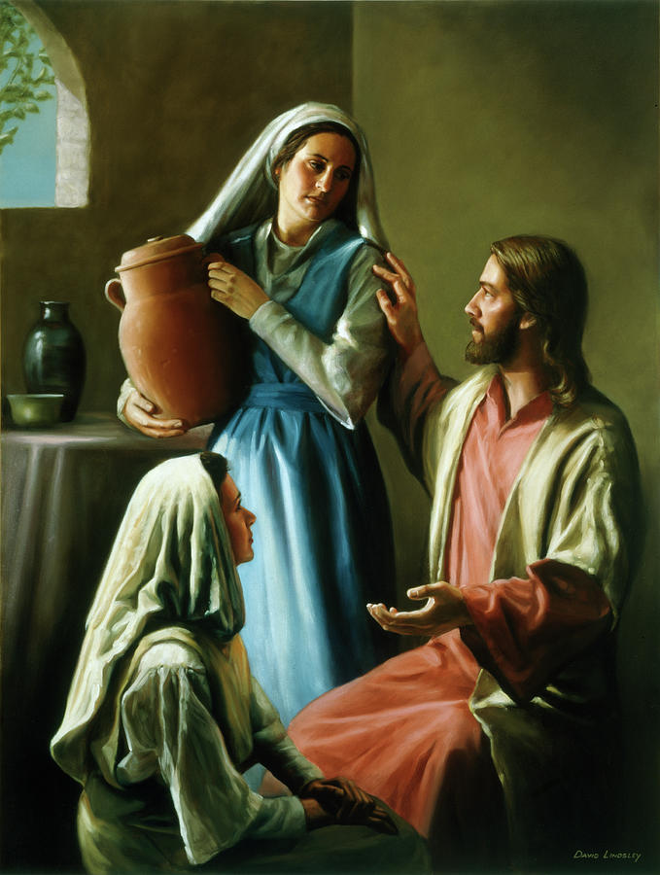
Hello everyone, from “Lights - LWML”, our new, official ladies’ group. At our last meeting, lots of things were put into place. We were able to establish our name, our board members, and the date and time for our meetings. And thanks to the ladies who volunteered to help, we were also able to form a much-needed, “Funeral Luncheon” committee.
At our next luncheon meeting (Feb. 4th at noon) we will be updating our constitution, doing a Valentine's craft, and much more. Hope you will add your name to the sign-up sheet at the back of the church, and join us for a fun afternoon of Christian fellowship and accomplishing God’s will for His church!

LUNCH
&
LEARN
As part of our outreach to our neighbors, we are presenting a free series of Lunch & Learn* events designed to inform our community on topics essential to their physical, financial, mental, and spiritual wellbeing. You are also invited to attend, of course, and wholeheartedly encouraged to invite your family, friends, and neighbors to these events.

The topic of our next presentation will be:
Surviving an Active Shooter Attack
Saturday, February 10, 2024, 10am – 12pm
As difficult as it may be to discuss active shooter attacks, we must not ignore the possibility. Though these attacks are rare when compared to other forms of violence, they are so horrific that we cannot afford to be ill-prepared to deal with them. This class will show you how to vastly improve your safety and the safety of others in the event that you become involved in an active shooting. It goes beyond the familiar Run/Hide/Fight principles used in most active shooter training to include practical advice on how to apply those principles in the unlikely but tragic event that you need them.
Our Next Presentation:
Stop the Bleed (Trauma Care)
Saturday, March 9, 2024, 10am – 12pm
These events will be facilitated by Brian McKenna, a retired police officer and law enforcement trainer who specializes in training police officers and the public in how to be prepared to
survive violent encounters.

Each of these events is free to attend, with a free light lunch to follow. If you would like to attend, please RSVP Blessed Savior Church at 314-831-1300 by Tuesday, February 8, 2024, as seating is limited. If so inclined, please bring a non-perishable food item to help support our local TEAM food bank.

* Lunch provided by a Thrivent Action Team grant
Our Special Prayers and Intercessions
Ron - hospitalized
Steve Haynes – heart issues
Nancy Stocker – health issues
Ted Stocker- health issues
Jim Laughlin – open heart surgery
Kim – cancer
Mary S. – cancer
Jeannie Firoved – health issues
Sara – health
Tiffany Connor – health issues
Connor Stretch – Health issues
Mike – Liver failure
Andrew – Guidance
Wanda Johnston – recovering from hip
Surgery
Sue VanAuken - grief

Kyle – renewal of faith
Heather – strengthening of faith
Pastor Struve- hospitalized
Marge Struve – health issues
Pastor Eric Carlson – Leukemia
Anneliese Wenger – health issues
Charlotte Taggert – health issues
Jessica Parish – MS
Rita Kirk – health issues
Mary Peacock – health
Debbie – home recovering
Jean Aurich – health issues
Lindsay – health
Wendy DeSanto – health issues
Patti Henneman – health issues
Laurie Moore – health issues
William – health issues
Doris Boyd – health issues
David Kuhl – health
Mike Wilder – cancer
Tom Murphy – health
Kelly - health
Retha Taylor – health
Caitlyn – health

Serving in our Armed Forces – Andrew Mack, Paul Hackett, Jay Warren, Michael Rice, Caleb McElyea, Jeff Throgmorton, Adam Guercio, Chance Glover, Cody Guercio, Danny Chung, Zayne Glatz, Alanna Kreppert, James Adelhardt, Sean Bentrup, Wesley Peach, Jordan Rolf, Anne Heintzelman, Austin Dreckshage, Ken Leppert II, Shelby Croghan & Richard Vengels.

*Please note: Those who are named in our special prayers and intercessions list are placed there by members of our congregation. St. Paul tells us in 1Timothy 2:1-2: “I urge, then, first of all, that requests, prayers, intercessions and thanksgivings be made for everyone – for kings and all those in authority, that we may live peaceful and quiet lives in all godliness and holiness. This is good, and pleases God our Savior.” Those named remain joyfully in our prayers until the person who requested our prayers removes them or until the Lord resolves their need. Therefore, as St. Paul tells us in Philippians 4:6 “Do not be anxious about anything, but in everything, by prayer and petition, with thanksgiving, present your request to God.

