Opening Hymn “Rise, Shine, You People” # 825
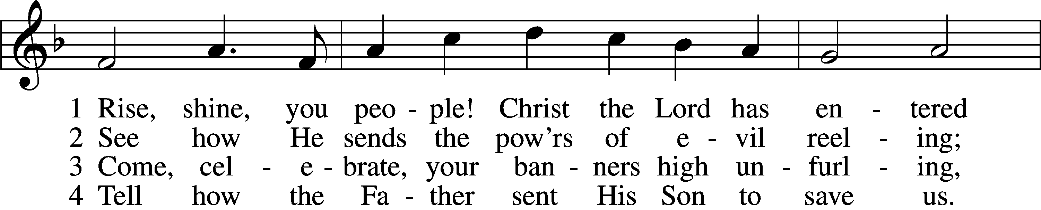
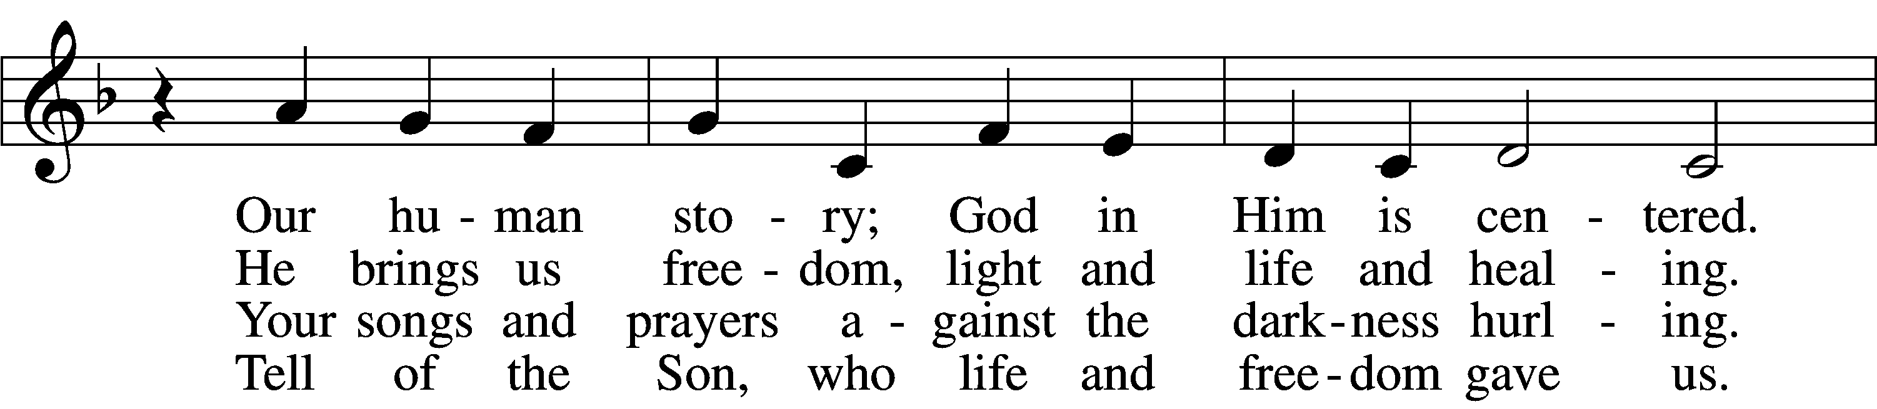
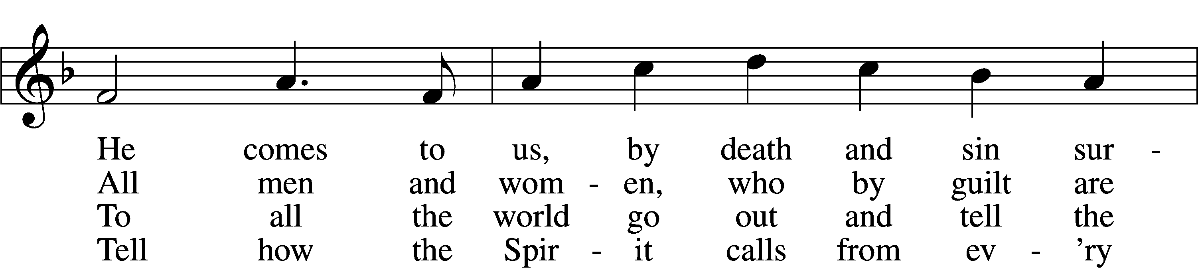
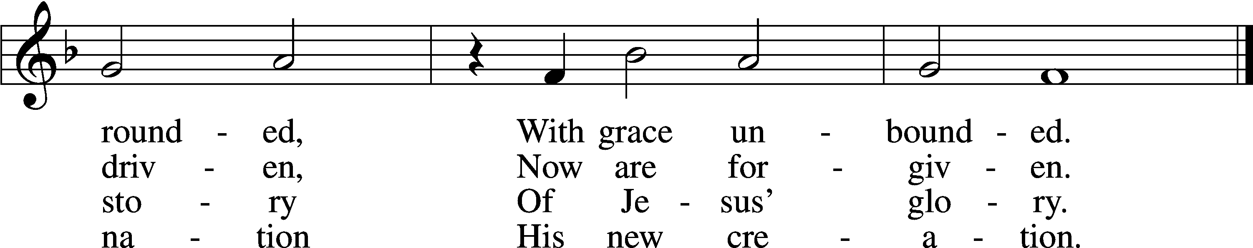
Text: Ronald A. Klug, 1939, alt.
Tune: Dale Wood, 1934–2003
Text and tune: © 1974 Augsburg Publishing House, admin. Augsburg Fortress. Used by permission: LSB Hymn License no. 110003344

Sermon Hymn “Hail to the Lord’s Anointed” # 398
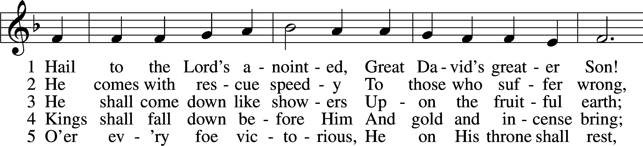
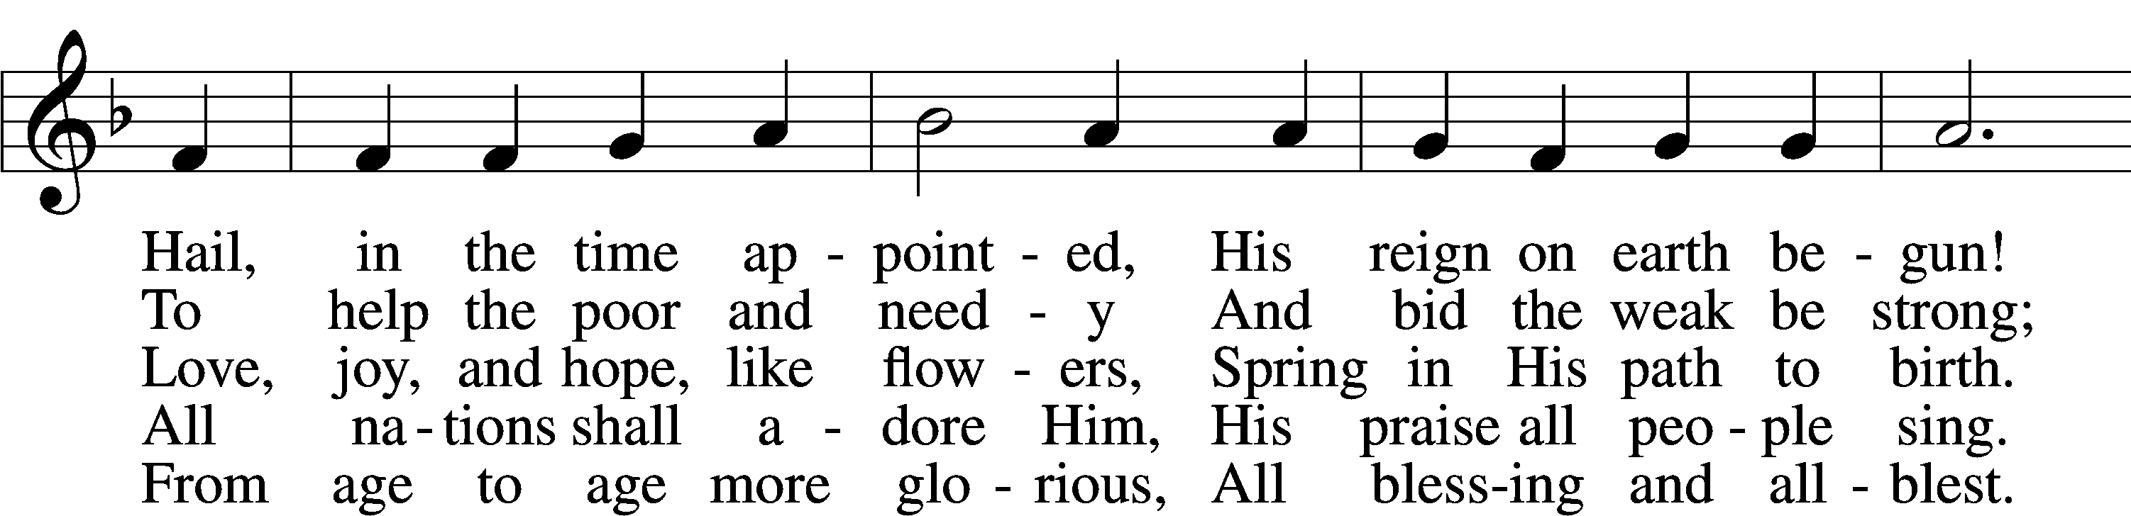
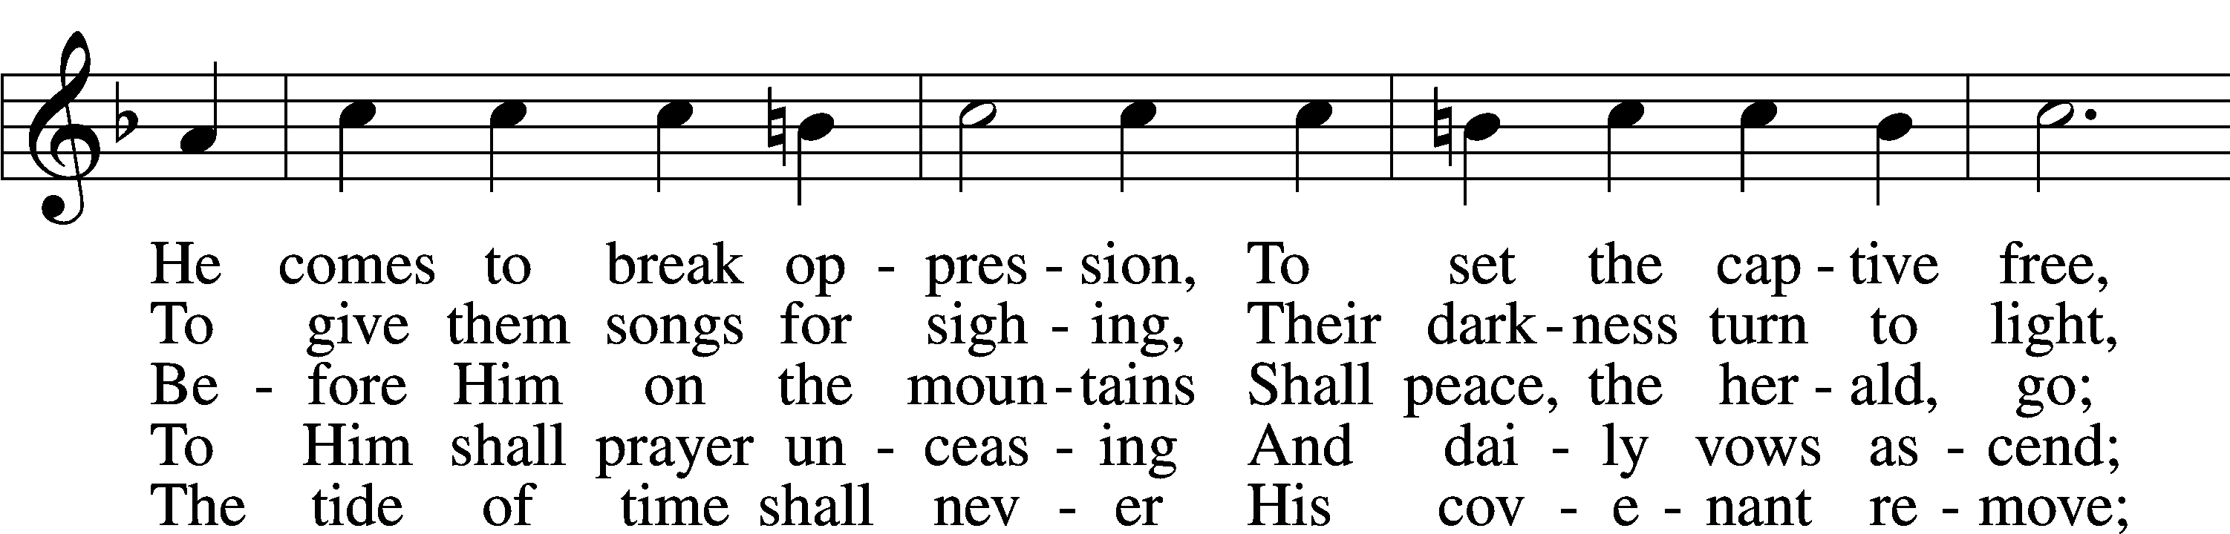
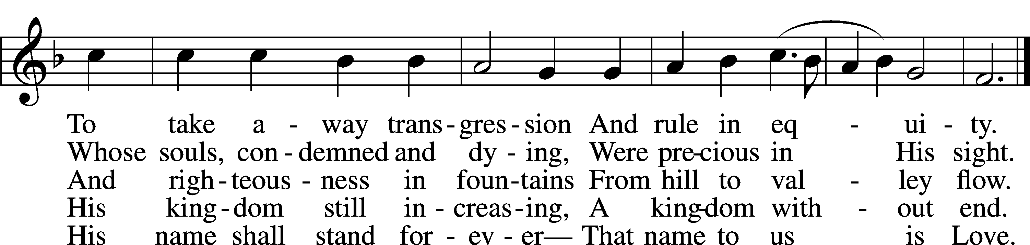

Text: James Montgomery, 1771–1854, alt.
Tune: Leonhart Schröter, c. 1532–c. 1601
Text and tune: Public domain

Distribution Hymn “Praise the Almighty” # 797
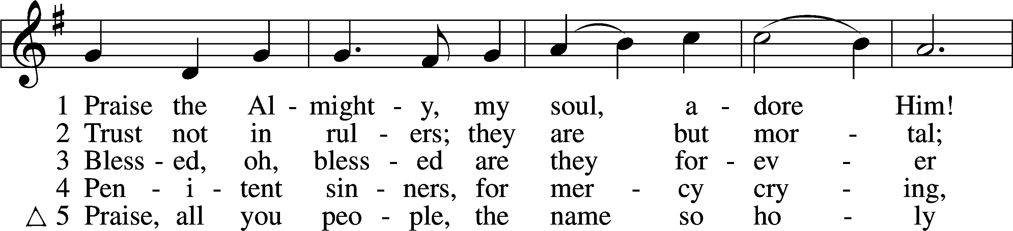
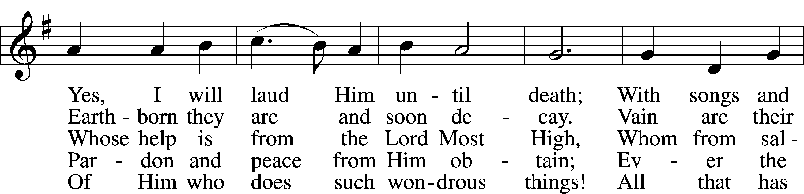
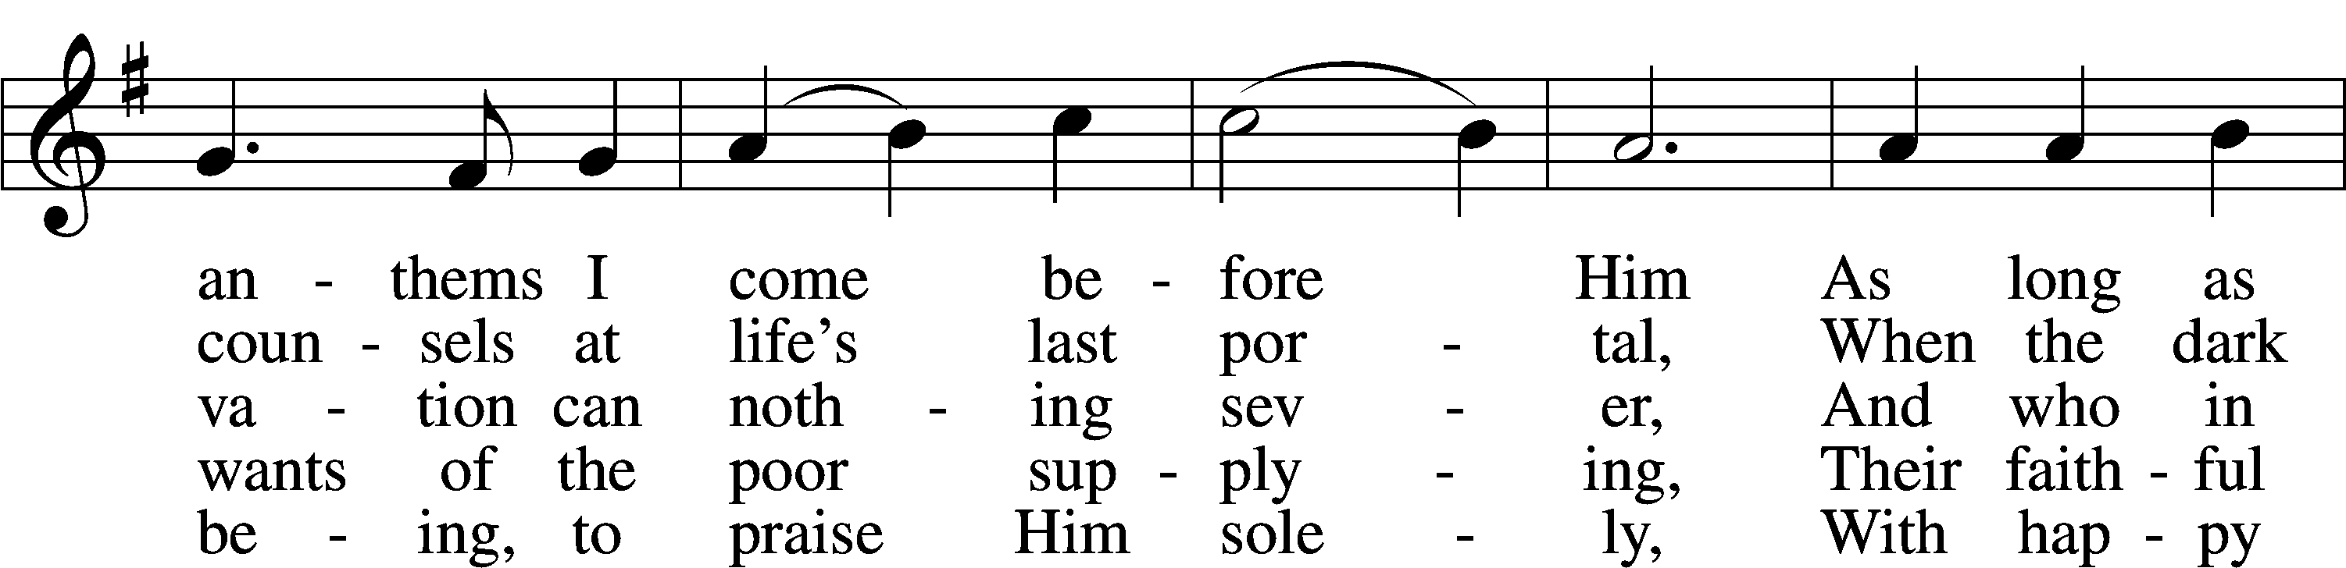
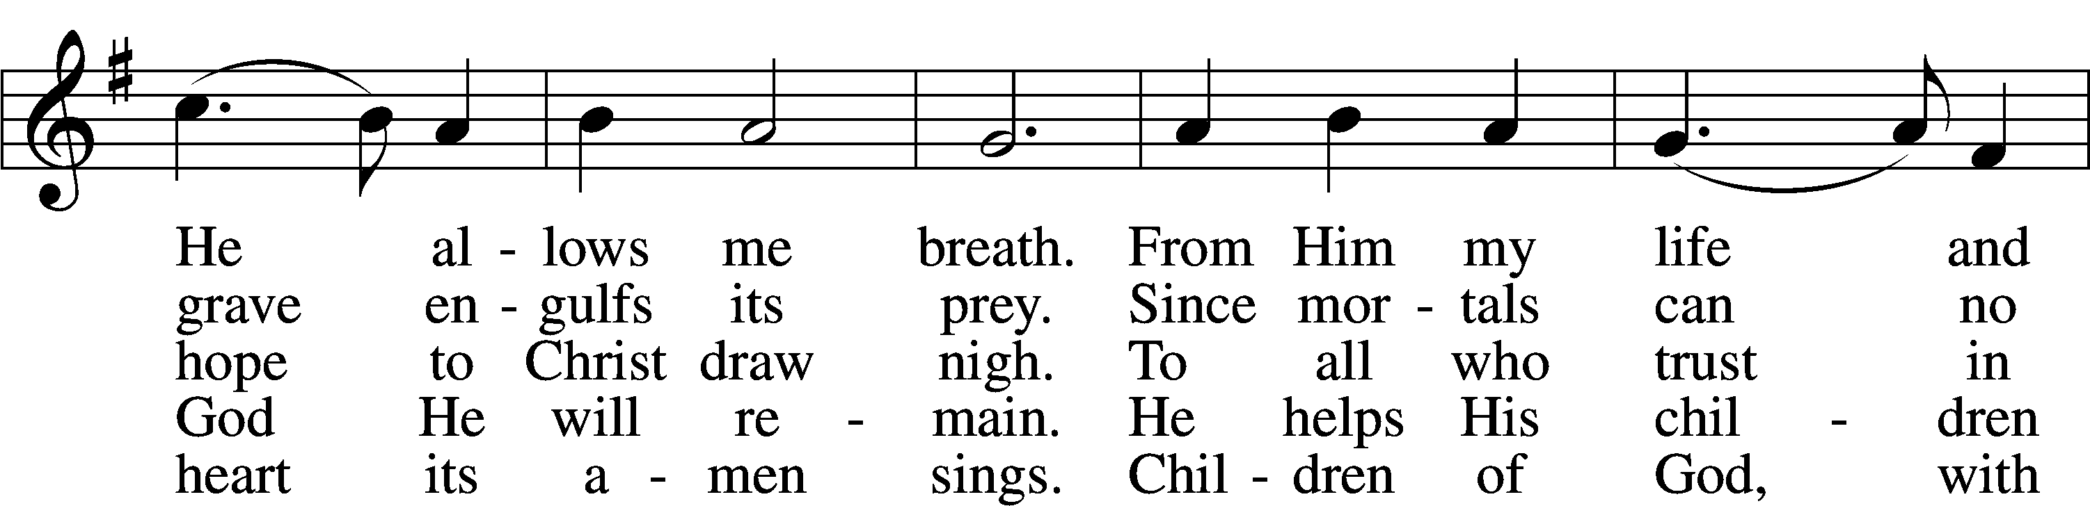
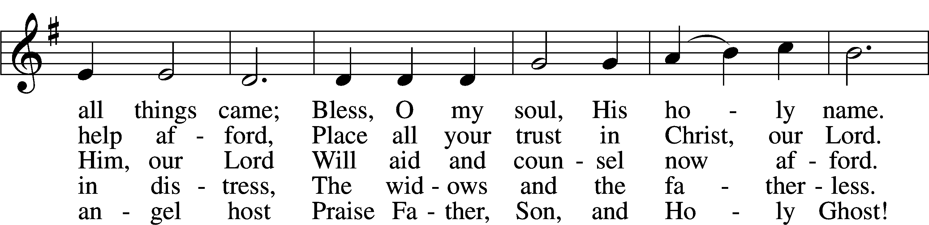
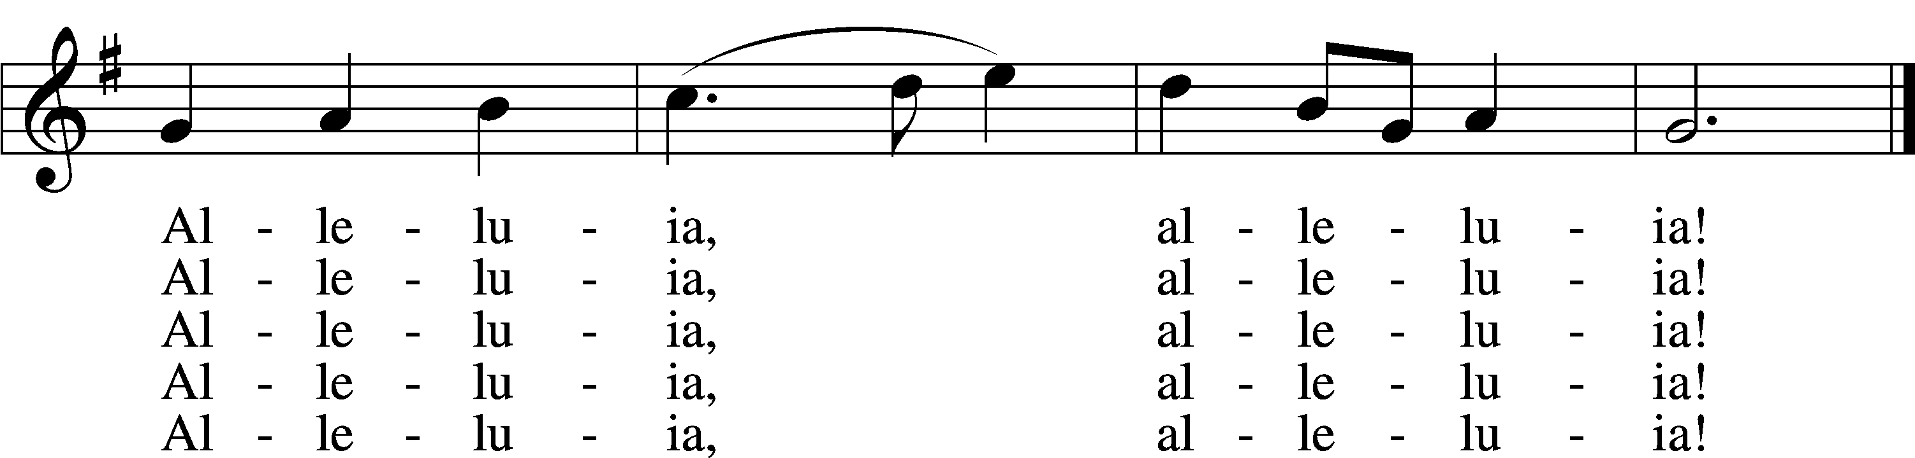
Text: Johann Daniel Herrnschmidt, 1675–1723; tr. Alfred E. R. Brauer, 1866–1949, alt.
Tune: New-vermehrte Christliche Seelenharpf, 1665, Ansbach
Text and tune: Public domain
Distribution Hymn “Praise to the Lord, the Almighty” # 790
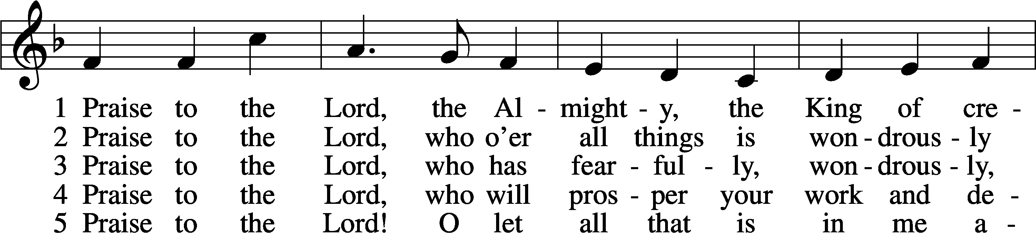
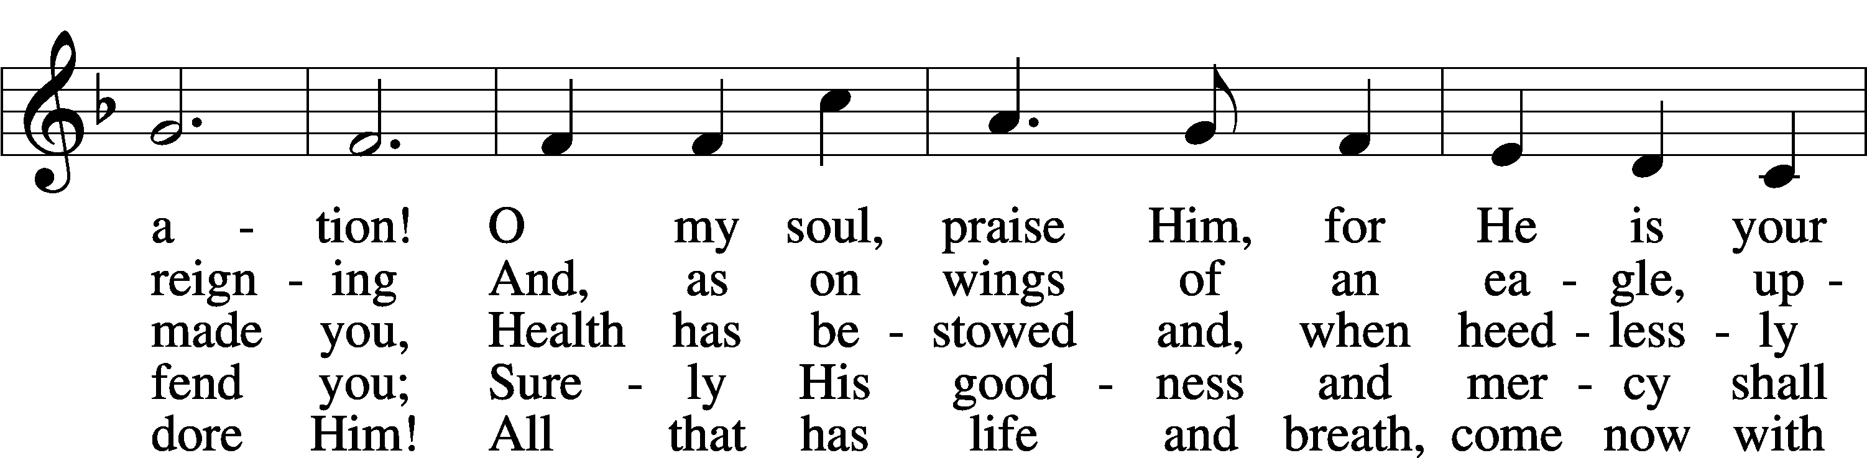
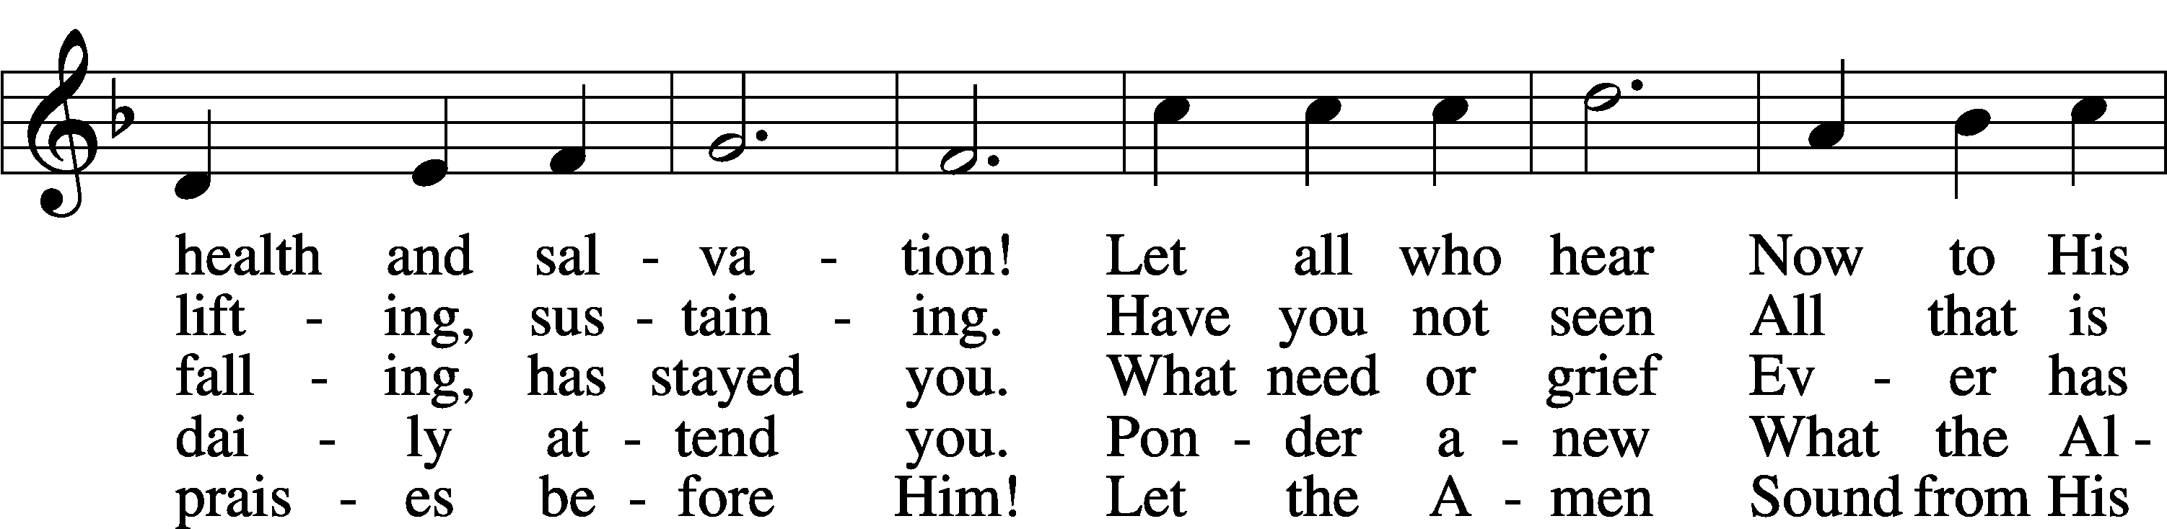
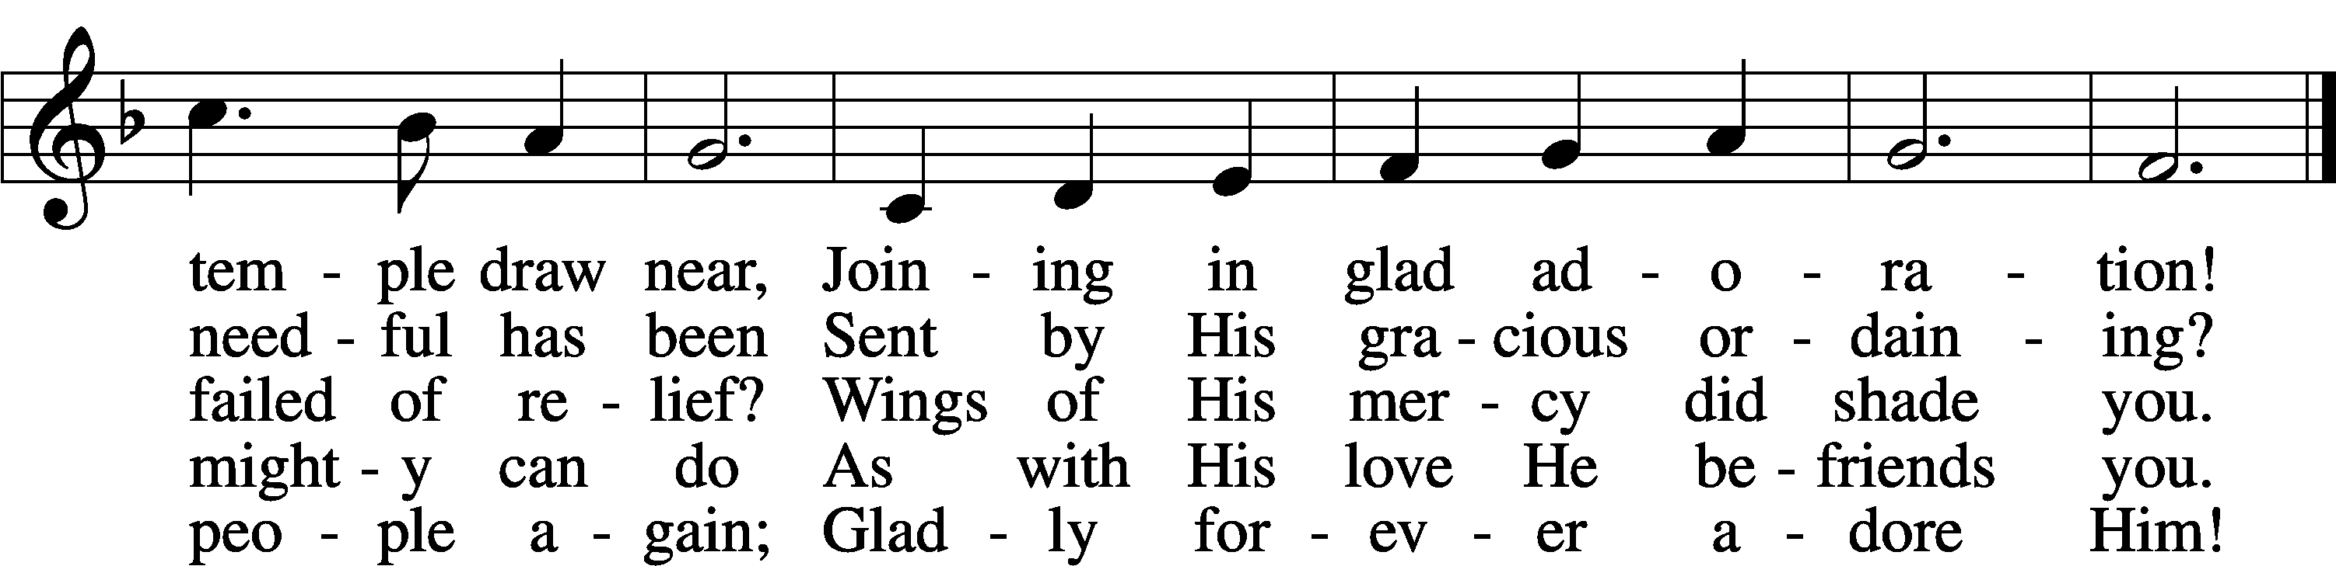
Text: Joachim Neander, 1650–80; tr. Catherine Winkworth, 1827–78, alt.
Tune: Ander Theil Des Erneuerten Gesang-Buchs, 1665, Stralsund
Text and tune: Public domain

Distribution Hymn “Praise the One Who Breaks the Darkness “ # 849

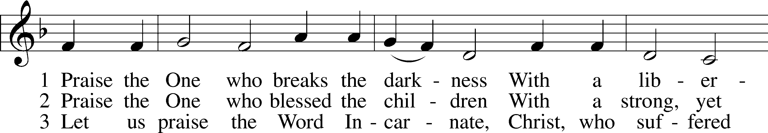

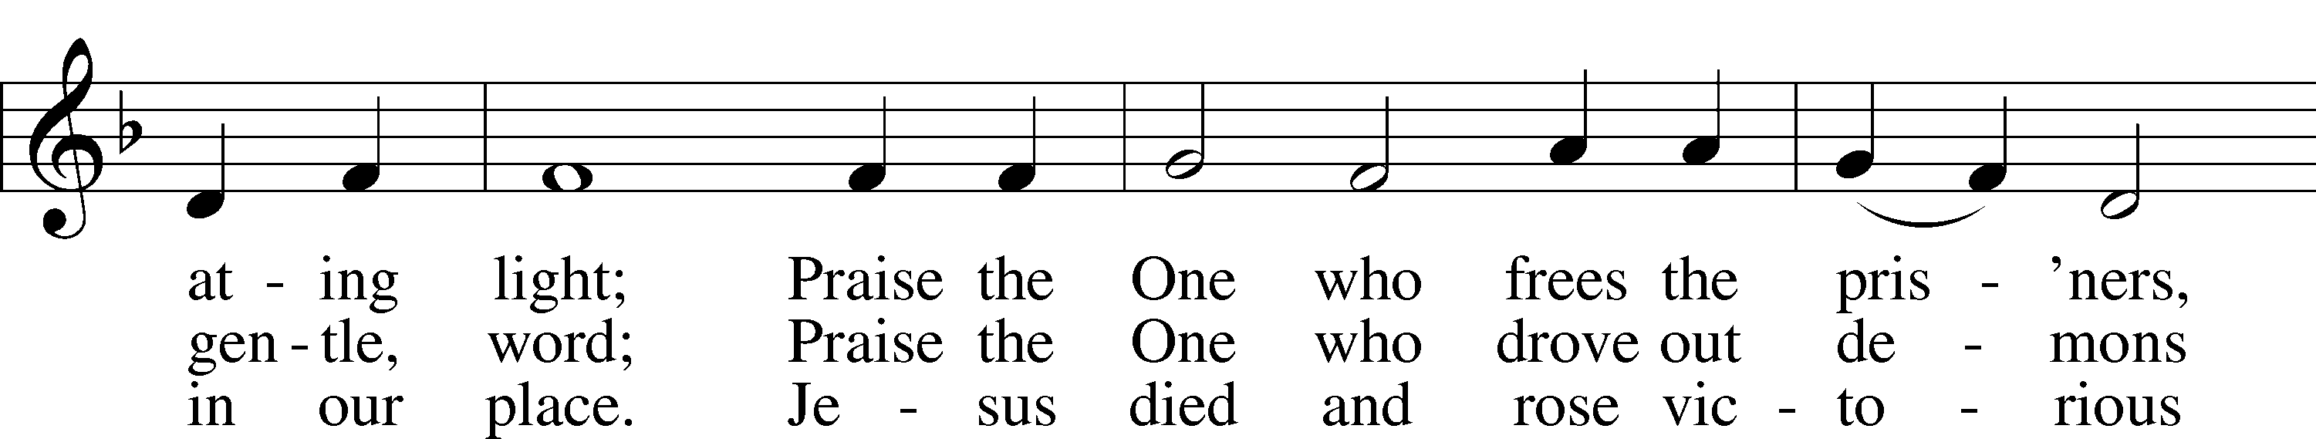

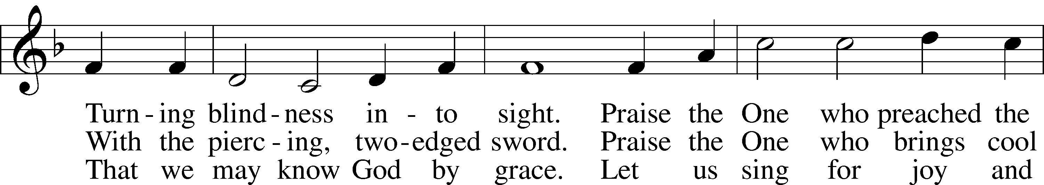
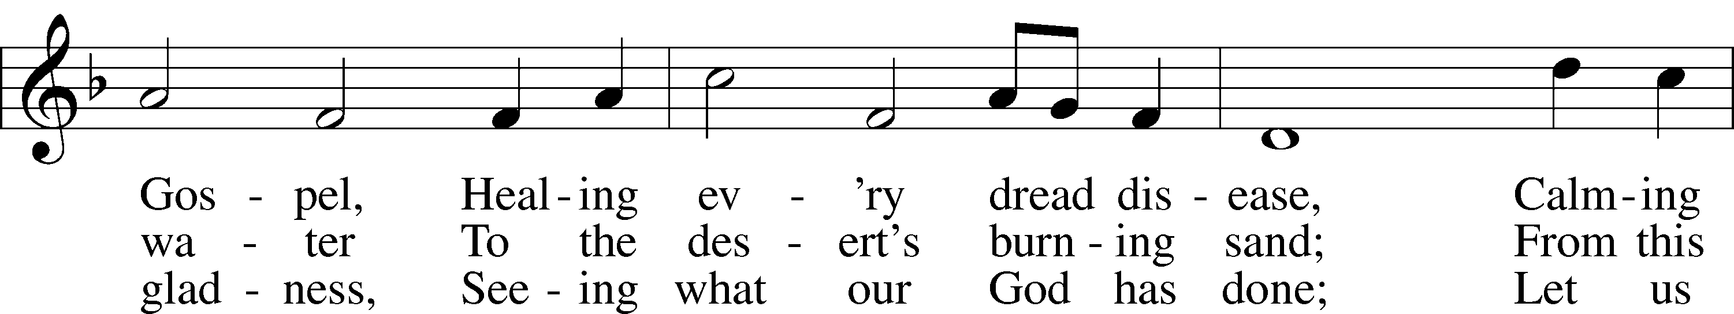
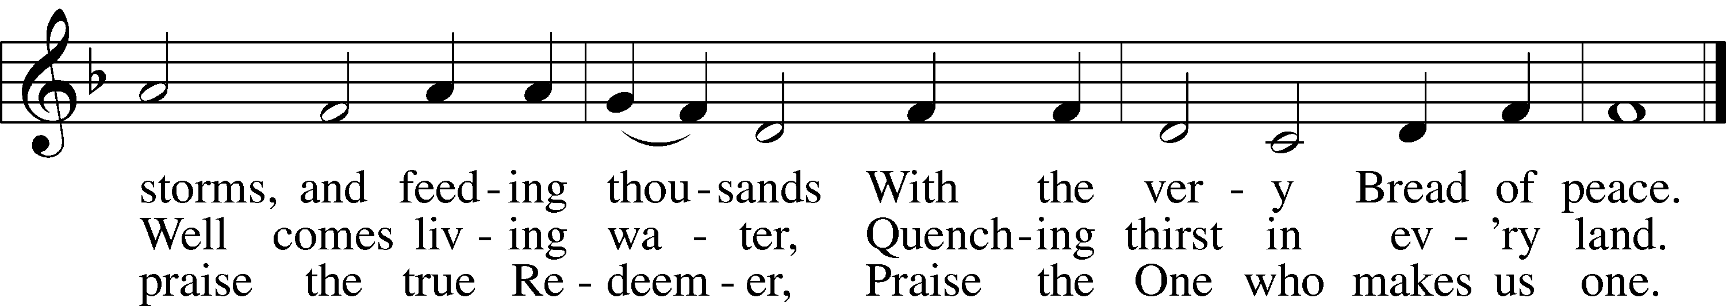
Text: Rusty Edwards, 1955
Tune: The Sacred Harp, 1844, Philadelphia
Text: © 1987 Hope Publishing Co. Used by permission: LSB Hymn License no. 110003344
Tune: Public domain

Closing Hymn “Thy Strong Word” # 578 verses 1-6
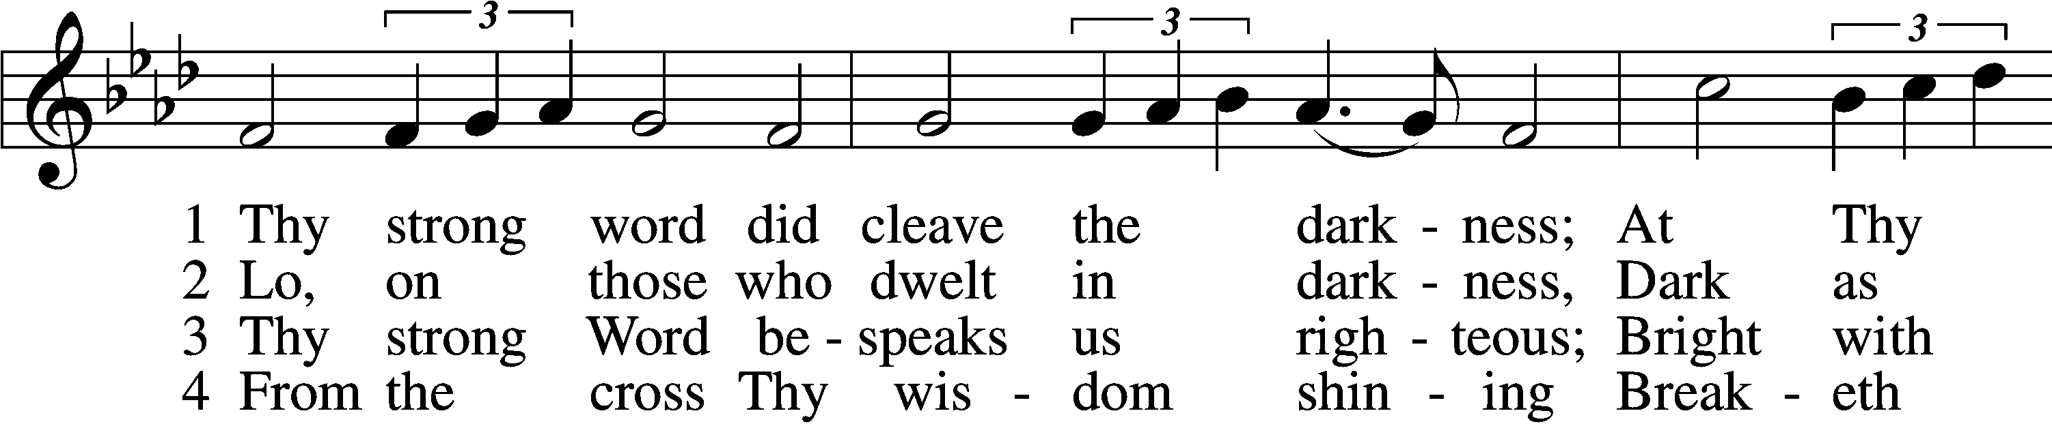
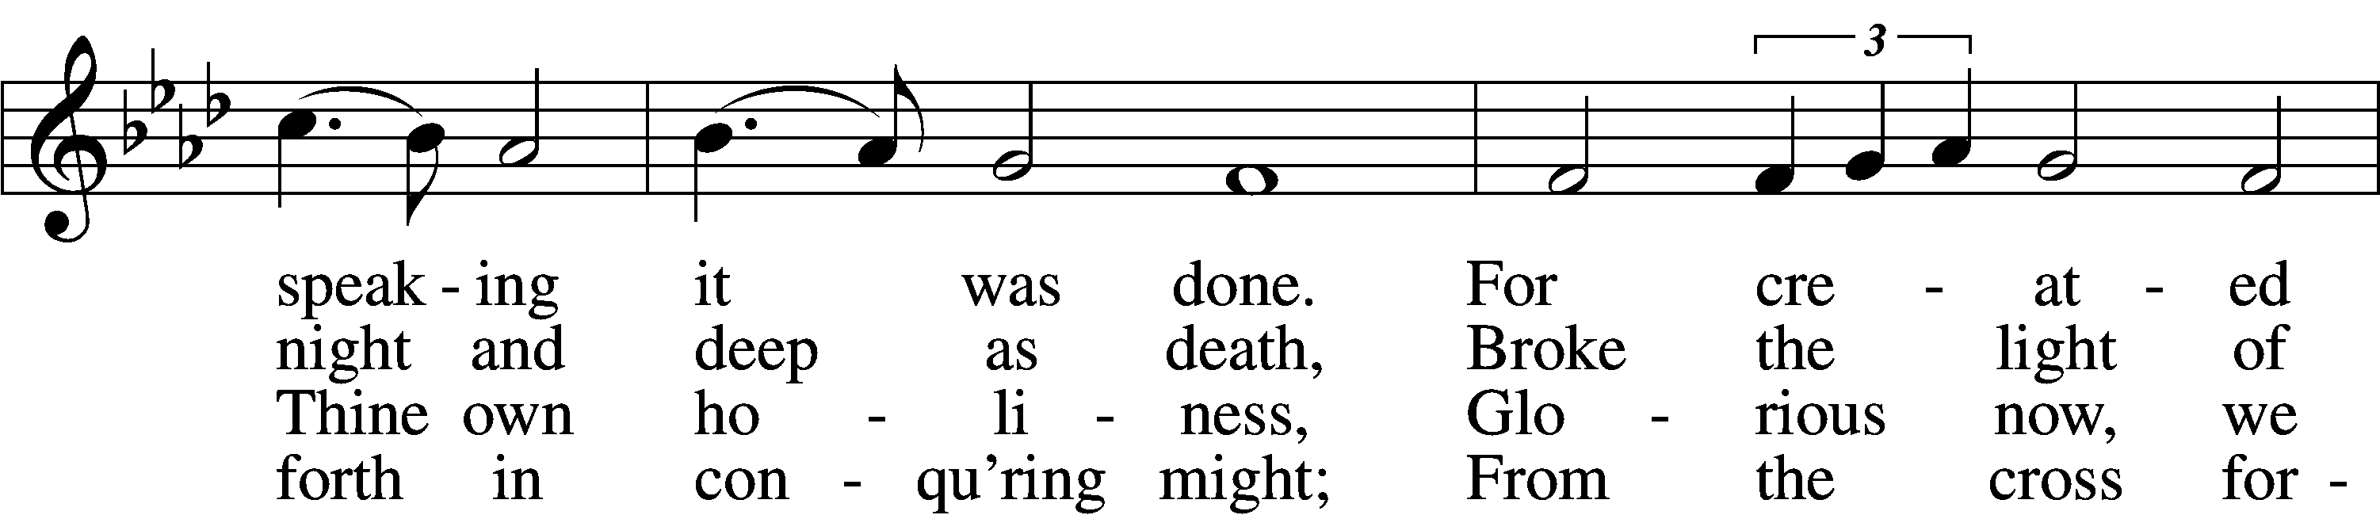
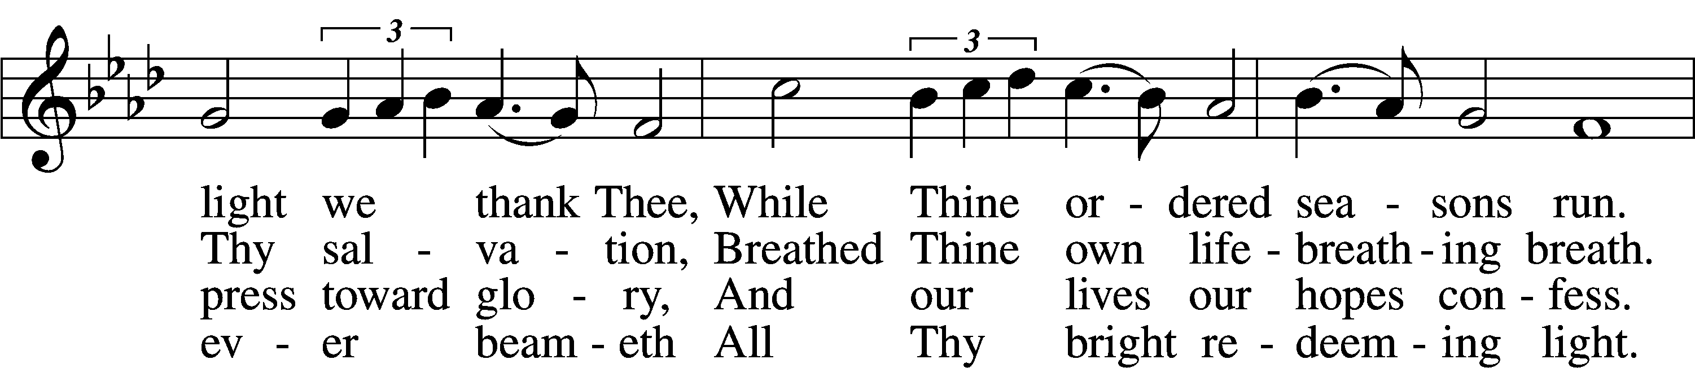
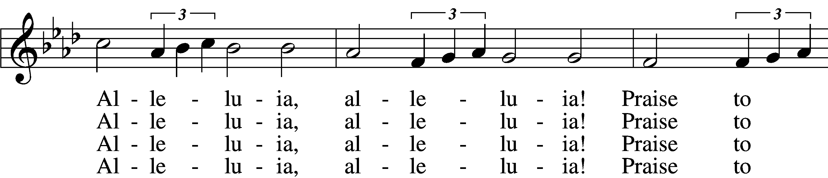
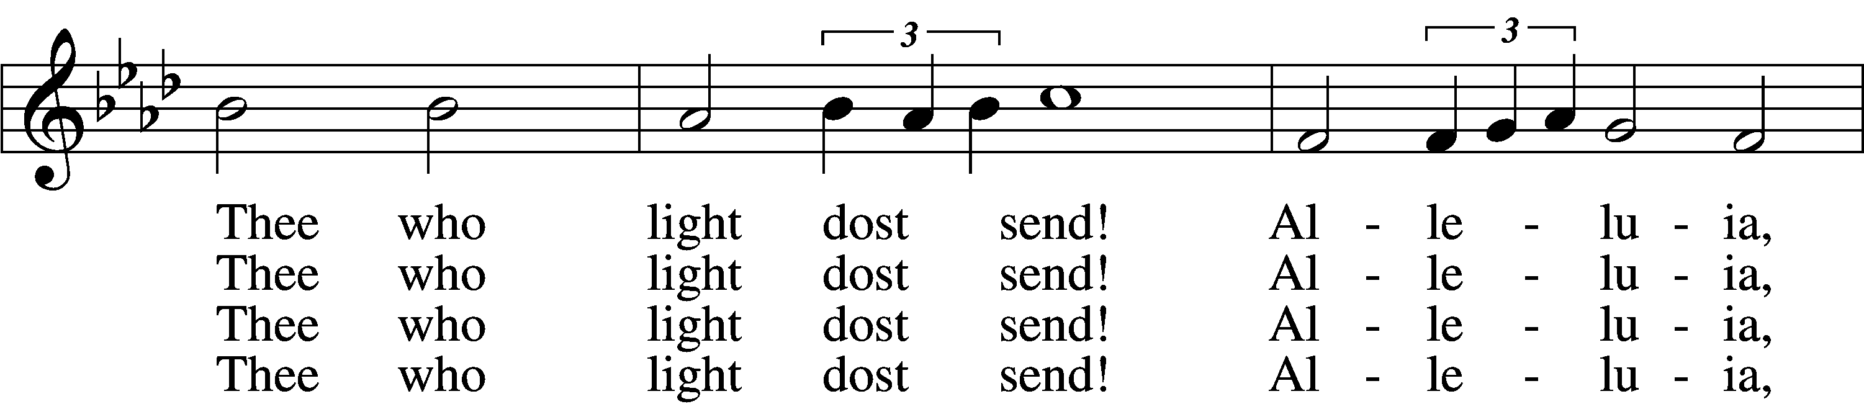
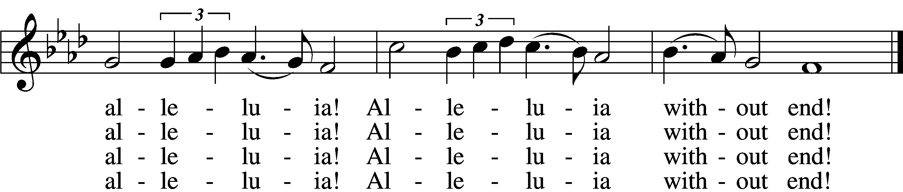

Continue….

Closing Hymn “Thy Strong Word” # 578

5 Give us lips to sing Thy glory,
Tongues Thy mercy to proclaim,
Throats that shout the hope that fills us,
Mouths to speak Thy holy name.
Alleluia, alleluia!
May the light which Thou dost send
Fill our songs with alleluias,
Alleluias without end!

D 6 God the Father, light-creator,
To Thee laud and honor be.
To Thee, Light of Light begotten,
Praise be sung eternally.
Holy Spirit, light-revealer,
Glory, glory be to Thee.
Mortals, angels, now and ever
Praise the holy Trinity!
Text: Martin H. Franzmann, 1907–76
Tune: Thomas J. Williams, 1869–1944
Text: © 1969 Concordia Publishing House. Used by permission: LSB Hymn License no. 110003344
Tune: Public domain

