Hymn “If Thou But Trust in God to Guide Thee” # 750
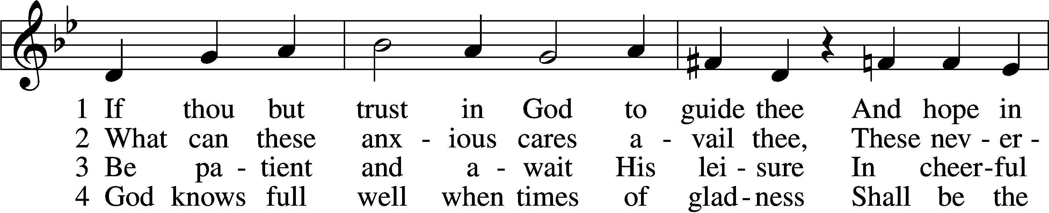
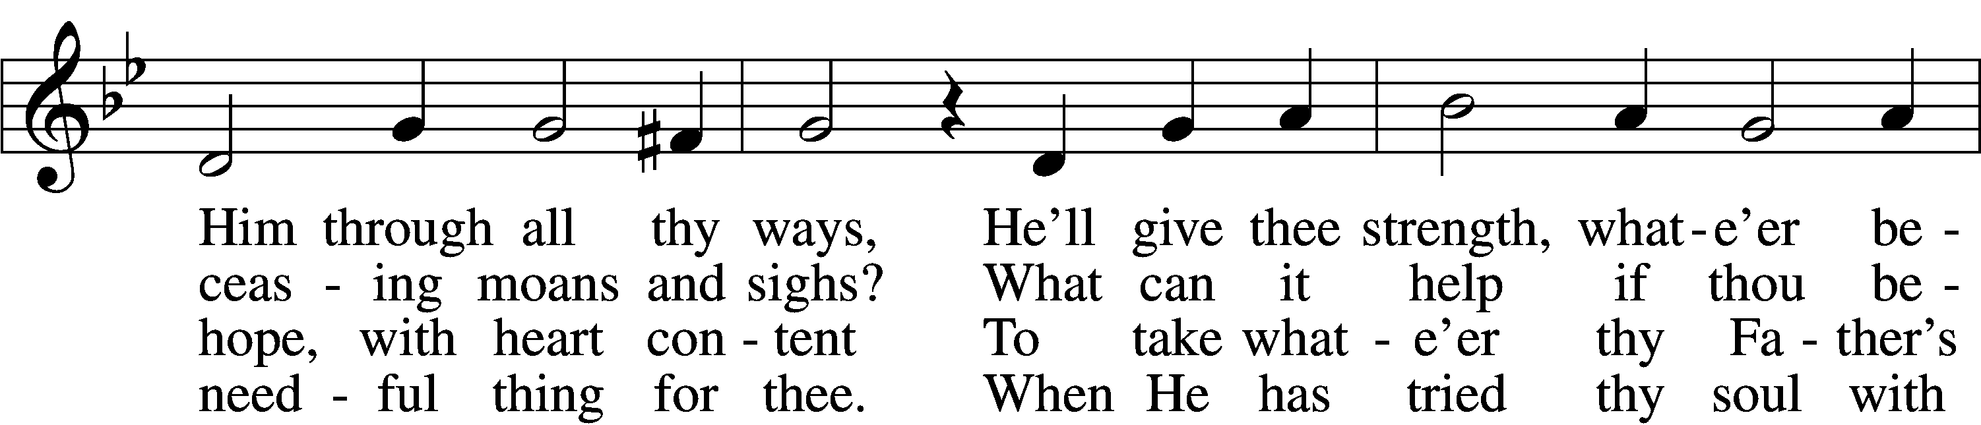
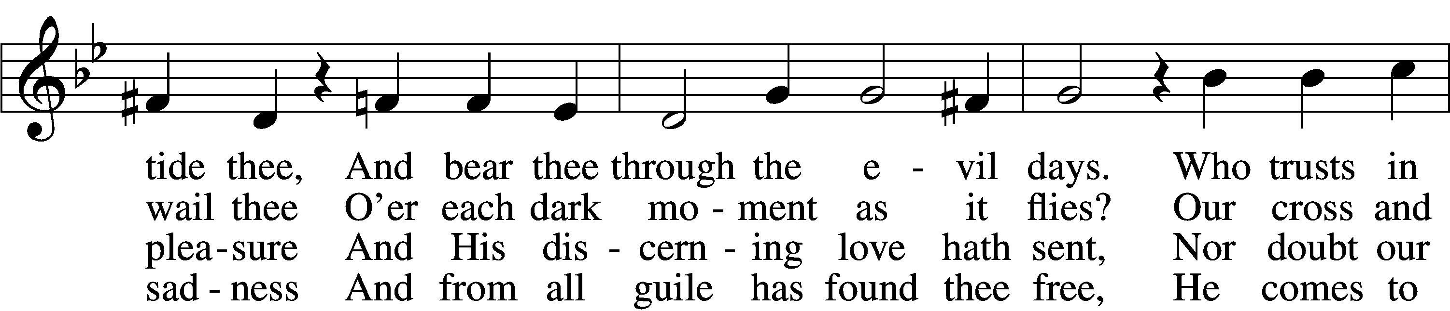
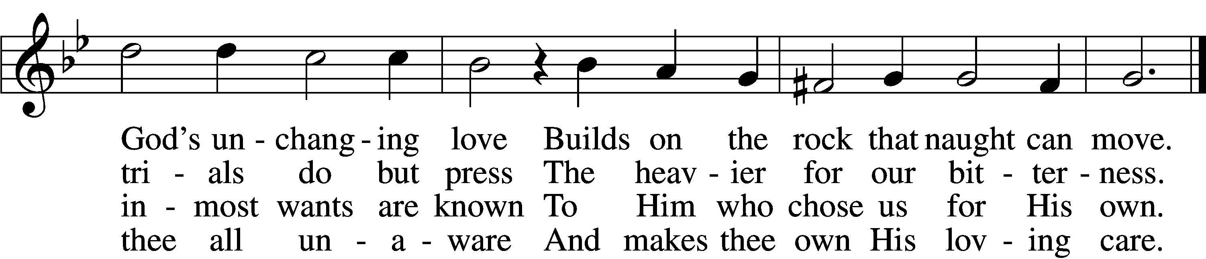

5 Nor think amid the fiery trial
That God hath cast thee off unheard,
That he whose hopes meet no denial
Must surely be of God preferred.
Time passes and much change doth bring
And sets a bound to ev’rything.

6 All are alike before the Highest;
’Tis easy for our God, we know,
To raise thee up, though low thou liest,
To make the rich man poor and low.
True wonders still by Him are wrought
Who setteth up and brings to naught.

7 Sing, pray, and keep His ways unswerving,
Perform thy duties faithfully,
And trust His Word; though undeserving,
Thou yet shalt find it true for thee.
God never yet forsook in need
The soul that trusted Him indeed.
Text: tr. Catherine Winkworth, 1827–78, alt.
Text and tune: Georg Neumark, 1621–81
Text and tune: Public domain

Hymn “All Praise to Thee, My God, This Night” # 883
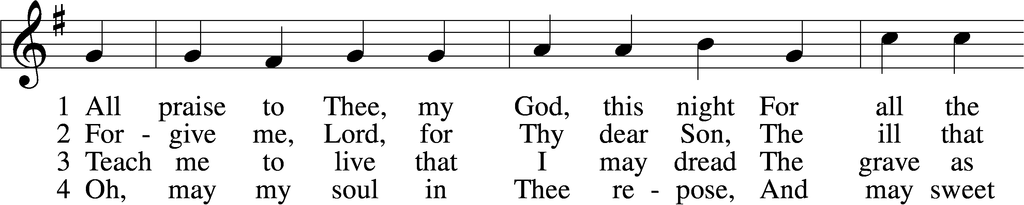
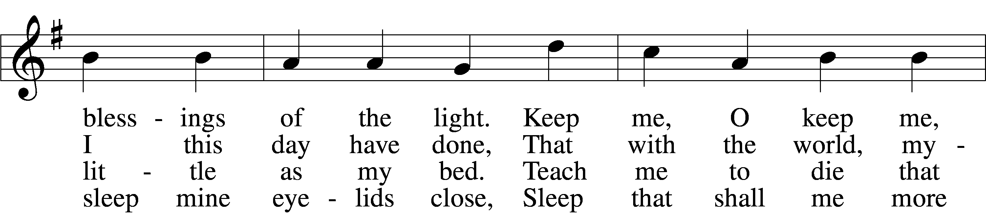
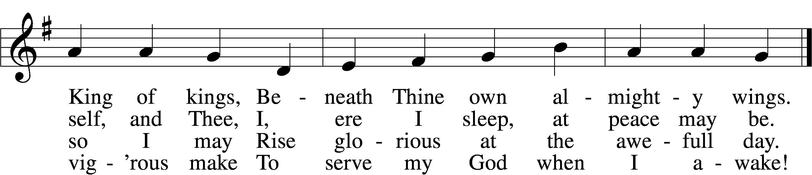

5 When in the night I sleepless lie,
My soul with heav’nly thoughts supply;
Let no ill dreams disturb my rest,
No pow’rs of darkness me molest.

D 6 Praise God, from whom all blessings flow;
Praise Him, all creatures here below;
Praise Him above, ye heav’nly host:
Praise Father, Son, and Holy Ghost.
Text: Thomas Ken, 1637–1711, alt.
Tune: Thomas Tallis, c. 1505–1585
Text and tune: Public domain

Hymn “Lamb of God” # 550
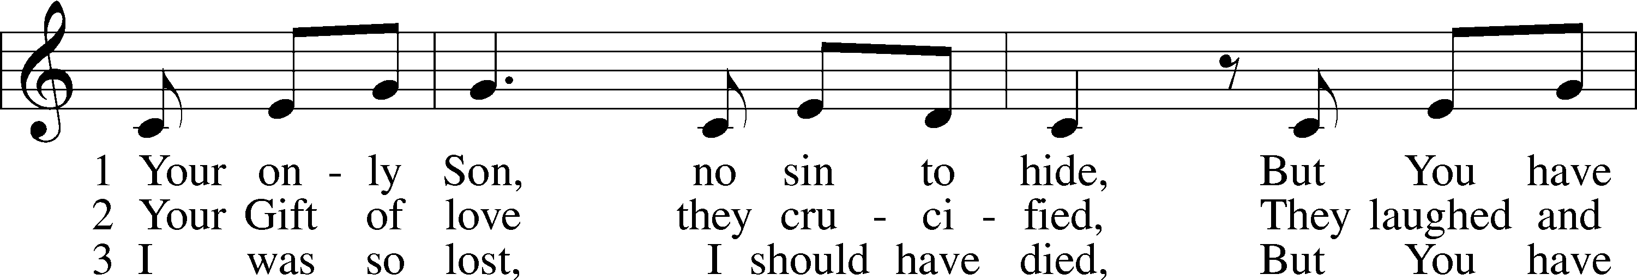
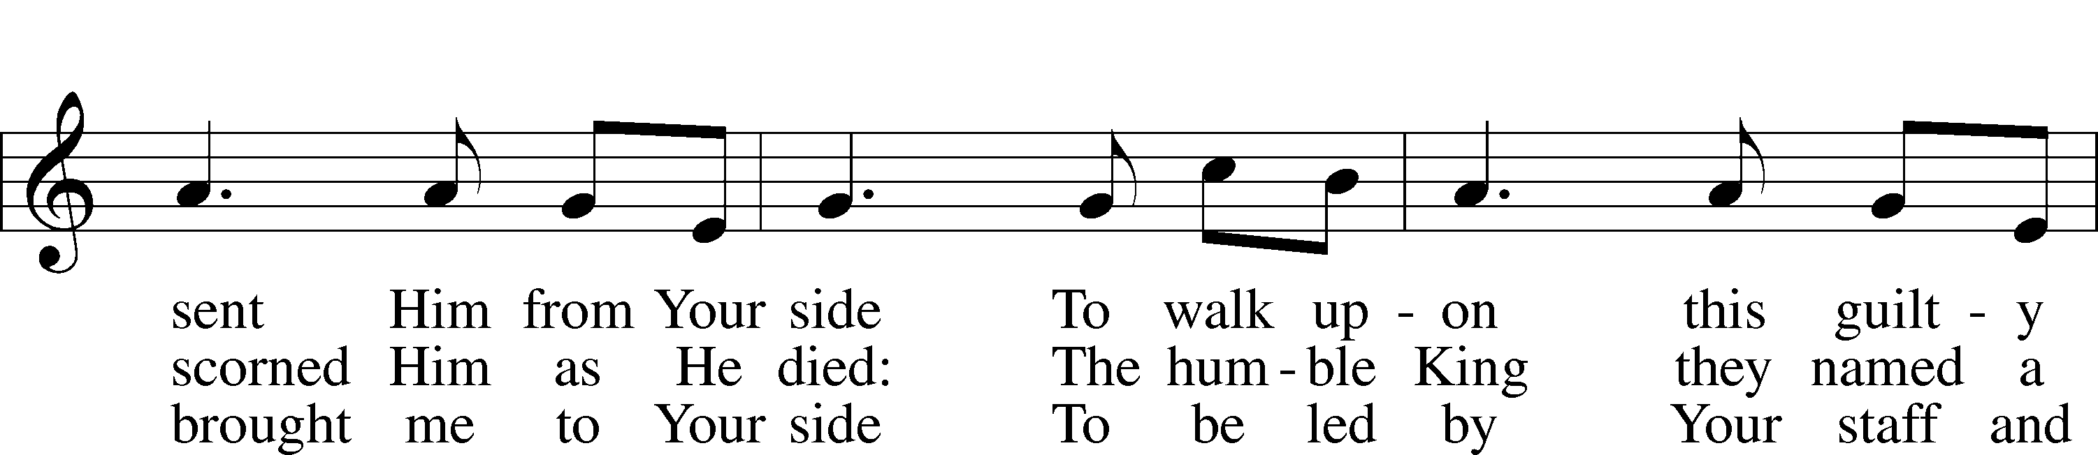
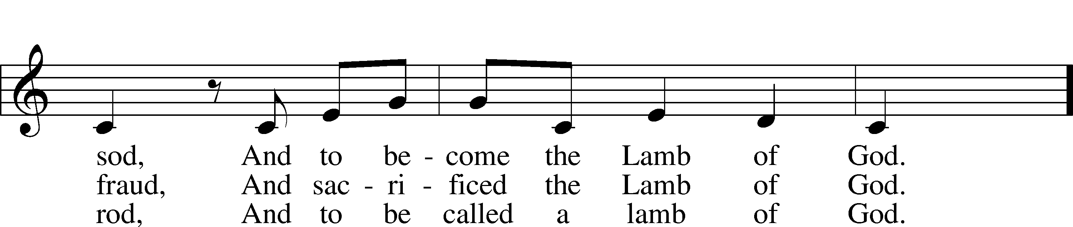
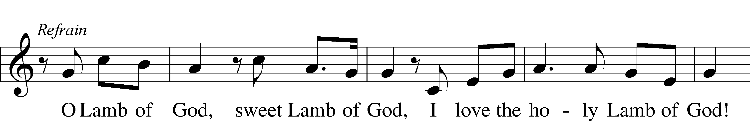

Text and tune: Twila Paris, 1958
Text and tune: © 1985 Straightway Music, admin. EMI. Used by permission: LSB Hymn License no. 110003344

