### Blessed Savior Lutheran Church

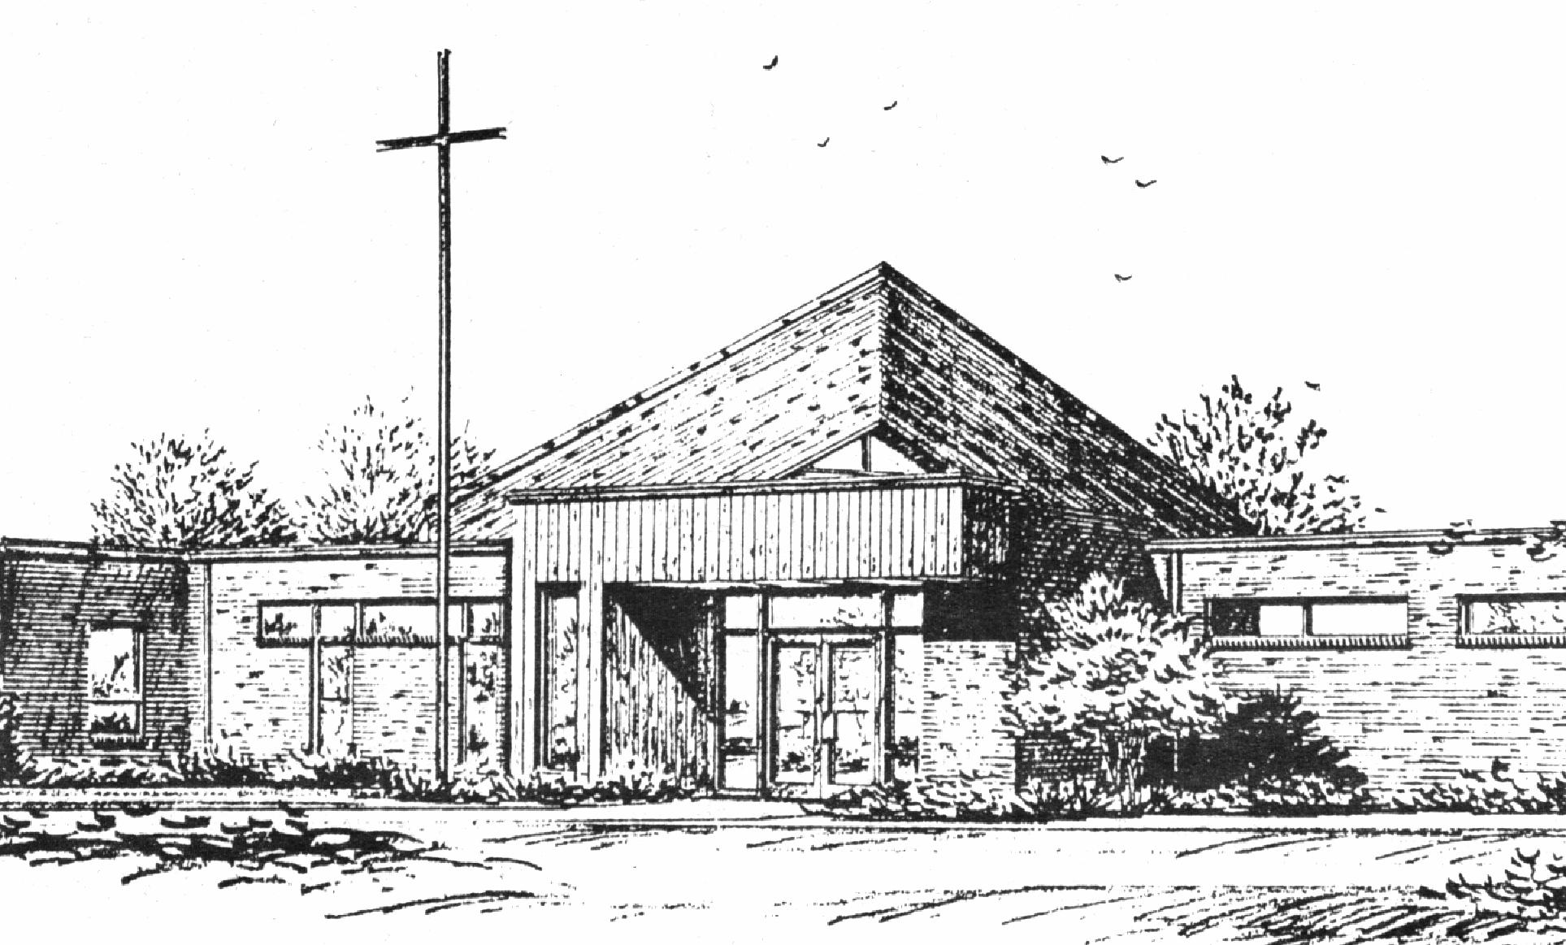

*“Empowered by God’s Holy Word,*

*we joyfully share the love of Jesus with all people;*

*through worship, teaching, fellowship,*

*service and witnessing.”*

**You Meant it for Evil,**

**But God Meant it for Good**

**February 21, 2024**

Faith for a Complicated World

***(Luke 23:1-25)***



Lutheran Church Missouri Synod

Rev. Matthew Roeglin, Pastor 314-479-1470

pastor@blessedsavior-lcms.org

Church Office: 7:30 AM – 11:30 AM Monday-Friday 314-831-1300

2615 Shackelford Rd. Florissant, MO Fax 314-831-3444

Website: www.blessedsavior-lcms.org

Church Email: office@blessedsavior-lcms.org

Divine Services: Sunday 9:30 AM; Wednesday 6:30 PM

**WE WELCOME YOU** to our worship service this evening. We pray God’s rich blessings upon you as you hear His Word and praise His holy name. We ask our members and visitors to please use the friendship pad found on the pew. Kindly hand the friendship pad to the person sitting next to you. The Ushers will collect them after the service. Thank You.

**THIS WORSHIP FOLDER / CHURCH BULLETIN** is prepared for your convenience and contains the entire order of worship with all spoken and sung responses. However, if you are more comfortable using the hymnal, you may use the order of worship found in the front pages of Lutheran Service Book where all the melodies are shown for the sung responses of the congregation.

**INDIVIDUAL HEARING ASSISTANCE SETS** are available for those with impaired hearing. Please ask an usher for assistance.

**LARGE PRINT BULLETINS** are available in the narthex.

**THANK YOU FOR YOUR SERVICE**

Preacher: Pastor Ruback- Grace Chapel

Organist/Pianist: Mrs. Donna Boyd

*(Please silence your cell phones)*

Service of Prayer and Preaching *p.260*

*Opening Hymn*

*“If Thou But Trust in God to Guide Thee”* # 750

Stand

*Opening Versicles p.260*

L This is the day which the Lord has made;

C **let us rejoice and be glad in it.**

L From the rising of the sun to its setting,

C **the name of the Lord is to be praised.**

L Return to the Lord, your God, for He is gracious and merciful,

C **slow to anger, and abounding in steadfast love, and repents of evil.**

L Jesus said: If any man would come after Me,

C **let him deny himself and take up his cross and follow Me.**

L Christ was wounded for our transgressions.

C **He was bruised for our iniquities.**

L From the rising of the sun to its setting,

C **the name of the Lord is to be praised.**

C **Glory be to the Father and to the Son and to the Holy Spirit;**  
**as it was in the beginning, is now, and will be forever. Amen.**

*Old Testament Canticle* p. 261

C **The Lord God is my strength and my song, and He has become my salvation.**

**With joy will you draw water from the wells of salvation.**

**And you will say in that day:**

**“Give thanks to the Lord, call upon His name,**

**make known His deeds among the peoples,**

**proclaim that His name is exalted.”**

**The Lord God is my strength and my song, and He has become my salvation.**

**Sing praises to the Lord, for He has done gloriously;**

**let this be made known in all the earth.**

**Shout, and sing for joy, O inhabitants of Zion, for great in your midst is the Holy One of Israel.**

**The Lord God is my strength and my song, and He has become my salvation.**

**Glory be to the Father and to the Son**

**and to the Holy Spirit;**

**as it was in the beginning,**

**is now, and will be forever. Amen.**

**The Lord God is my strength and my song, and He has become my salvation.**

Sit

Readings From Holy Scripture

*Reading* Micah 6:1–8

L A reading from Micah, the sixth chapter.

1Hear what the Lord says:  
Arise, plead your case before the mountains,  
 and let the hills hear your voice.  
2Hear, you mountains, the indictment of the Lord,  
 and you enduring foundations of the earth,  
for the Lord has an indictment against his people,  
 and he will contend with Israel.  
3“O my people, what have I done to you?  
 How have I wearied you? Answer me!  
4For I brought you up from the land of Egypt  
 and redeemed you from the house of slavery,  
and I sent before you Moses,  
 Aaron, and Miriam.  
5O my people, remember what Balak king of Moab devised,  
 and what Balaam the son of Beor answered him,  
and what happened from Shittim to Gilgal,  
 that you may know the saving acts of the Lord.”

6“With what shall I come before the Lord,  
 and bow myself before God on high?  
Shall I come before him with burnt offerings,  
 with calves a year old?  
7Will the Lord be pleased with thousands of rams,  
 with ten thousands of rivers of oil?  
Shall I give my firstborn for my transgression,  
 the fruit of my body for the sin of my soul?”  
8He has told you, O man, what is good;  
 and what does the Lord require of you  
but to do justice, and to love kindness,  
 and to walk humbly with your God?

L This is the Word of the Lord.

C **Thanks be to God.**

*Reading* Colossians 2:6–15

6Therefore, as you received Christ Jesus the Lord, so walk in him, 7rooted and built up in him and established in the faith, just as you were taught, abounding in thanksgiving.

8See to it that no one takes you captive by philosophy and empty deceit, according to human tradition, according to the elemental spirits of the world, and not according to Christ. 9For in him the whole fullness of deity dwells bodily, 10and you have been filled in him, who is the head of all rule and authority. 11In him also you were circumcised with a circumcision made without hands, by putting off the body of the flesh, by the circumcision of Christ, 12having been buried with him in baptism, in which you were also raised with him through faith in the powerful working of God, who raised him from the dead. 13And you, who were dead in your trespasses and the uncircumcision of your flesh, God made alive together with him, having forgiven us all our trespasses, 14by canceling the record of debt that stood against us with its legal demands. This he set aside, nailing it to the cross. 15He disarmed the rulers and authorities and put them to open shame, by triumphing over them in him.

*Reading* Luke 23:1–25

1Then the whole company of them arose and brought him before Pilate. 2And they began to accuse him, saying, “We found this man misleading our nation and forbidding us to give tribute to Caesar, and saying that he himself is Christ, a king.” 3And Pilate asked him, “Are you the King of the Jews?” And he answered him, “You have said so.” 4Then Pilate said to the chief priests and the crowds, “I find no guilt in this man.” 5But they were urgent, saying, “He stirs up the people, teaching throughout all Judea, from Galilee even to this place.”

6When Pilate heard this, he asked whether the man was a Galilean. 7And when he learned that he belonged to Herod’s jurisdiction, he sent him over to Herod, who was himself in Jerusalem at that time. 8When Herod saw Jesus, he was very glad, for he had long desired to see him, because he had heard about him, and he was hoping to see some sign done by him. 9So he questioned him at some length, but he made no answer. 10The chief priests and the scribes stood by, vehemently accusing him. 11And Herod with his soldiers treated him with contempt and mocked him. Then, arraying him in splendid clothing, he sent him back to Pilate. 12And Herod and Pilate became friends with each other that very day, for before this they had been at enmity with each other.

13Pilate then called together the chief priests and the rulers and the people, 14and said to them, “You brought me this man as one who was misleading the people. And after examining him before you, behold, I did not find this man guilty of any of your charges against him. 15Neither did Herod, for he sent him back to us. Look, nothing deserving death has been done by him. 16I will therefore punish and release him.”

18But they all cried out together, “Away with this man, and release to us Barabbas”— 19a man who had been thrown into prison for an insurrection started in the city and for murder. 20Pilate addressed them once more, desiring to release Jesus, 21but they kept shouting, “Crucify, crucify him!” 22A third time he said to them, “Why, what evil has he done? I have found in him no guilt deserving death. I will therefore punish and release him.” 23But they were urgent, demanding with loud cries that he should be crucified. And their voices prevailed. 24So Pilate decided that their demand should be granted. 25He released the man who had been thrown into prison for insurrection and murder, for whom they asked, but he delivered Jesus over to their will.

*Responsory p.263*

L We have an advocate with the Father; Jesus Christ, the Righteous One.

C **He was delivered up to death; He was delivered for the sins of the people.**

L Blessed is the one whose transgression is forgiven, whose sin is covered.

C **He was delivered up to death; He was delivered for the sins of the people.**

L We have an advocate with the Father; Jesus Christ, the Righteous One.

C **He was delivered up to death; He was delivered for the sins of the people.**

Stand

*Ten Commandments p.264*

C **You shall have no other gods.**

**You shall not misuse the name of the Lord your God.**

**Remember the Sabbath day by keeping it holy.**

**Honor your father and your mother.**

**You shall not murder.**

**You shall not commit adultery.**

**You shall not steal.**

**You shall not give false testimony against your neighbor.**

**You shall not covet your neighbor’s house.**

**You shall not covet your neighbor’s wife, or his manservant or maidservant, his ox or donkey, or anything that belongs to your neighbor.**

*Apostles’ Creed*

C **I believe in God, the Father Almighty,**

**maker of heaven and earth.**

**And in Jesus Christ, His only Son, our Lord,**

**who was conceived by the Holy Spirit,**

**born of the virgin Mary,**

**suffered under Pontius Pilate,**

**was crucified, died and was buried.**

**He descended into hell.**

**The third day He rose again from the dead.**

**He ascended into heaven**

**and sits at the right hand of God the Father Almighty.**

**From thence He will come to judge the living and the dead.**

**I believe in the Holy Spirit,**

**the holy Christian Church,**

**the communion of saints,**

**the forgiveness of sins,**

**the resurrection of the body,**

**and the life** T **everlasting. Amen.**

*Lord’s Prayer p.264*

C **Our Father who art in heaven,**

**hallowed be Thy name,**

**Thy kingdom come,**

**Thy will be done on earth**

**as it is in heaven;**

**give us this day our daily bread;**

**and forgive us our trespasses**

**as we forgive those**

**who trespass against us;**

**and lead us not into temptation,**

**but deliver us from evil.**

**For Thine is the kingdom**

**and the power and the glory**

**forever and ever. Amen.**

Sit

*Sermon*

*Hymn* *“All Praise to Thee, My God, This Night”* # 883

*Offering*

Stand

*Prayer p.265*

L In peace let us pray to the Lord:

C **Lord, have mercy.**

L For the gift of divine peace and of pardon, with all our heart and with all our mind, let us pray to the Lord:

C **Lord, have mercy.**

L For the holy Christian Church, here and scattered throughout the world, and for the proclamation of the Gospel and the calling of all to faith, let us pray to the Lord:

C **Lord, have mercy.**

L For this nation, for our cities and communities, and for the common welfare of us all, let us pray to the Lord:

C **Lord, have mercy.**

L For seasonable weather and for the fruitfulness of the earth, let us pray to the Lord:

C **Lord, have mercy.**

L For those who labor, for those whose work is difficult or dangerous, and for all who travel, let us pray to the Lord:

C **Lord, have mercy.**

L For all those in need, for the hungry and homeless, for the widowed and orphaned, and for all those in prison, let us pray to the Lord:

C **Lord, have mercy.**

L For the sick and dying and for all those who care for them, let us pray to the Lord:

C **Lord, have mercy.**

L Finally, for these and for all our needs of body and soul, let us pray to the Lord:

C **Lord, have mercy. Christ, have mercy. Lord, have mercy.**

*Collect of the Day*

L O Lord God, You led Your ancient people through the wilderness and brought them to the promised land. Guide the people of Your Church that following our Savior we may walk through the wilderness of this world toward the glory of the world to come; through Jesus Christ, Your Son, our Lord, who lives and reigns with You and the Holy Spirit, one God, now and forever.

C **Amen.**

*Collect for the Word p.265*

L Blessed Lord, You have caused all Holy Scriptures to be written for our learning. Grant that we may so hear them, read, mark, learn, and take them to heart that, by the patience and comfort of Your holy Word, we may embrace and ever hold fast the blessed hope of everlasting life; through Jesus Christ, Your Son, our Lord, who lives and reigns with You and the Holy Spirit, one God, now and forever.

C **Amen.**

*Morning Prayer*

C **I thank You, my heavenly Father, through Jesus Christ, Your dear Son, that You have kept me this night from all harm and danger; and I pray that You would keep me this day also from sin and every evil, that all my doings and life may please You. For into Your hands I commend myself, my body and soul, and all things. Let Your holy angel be with me, that the evil foe may have no power over me. Amen.**

*Hymn* *“Lamb of God”* # 550

*Blessing p.267*

L Let us bless the Lord.

C **Thanks be to God.**

L The almighty and merciful Lord, the Father, the T Son, and the Holy Spirit, bless and preserve us.

C **Amen.**

Acknowledgments

Service of Prayer and Preaching from Lutheran Service Book

Unless otherwise indicated, Scripture quotations are from the ESV® Bible (The Holy Bible, English Standard Version®), copyright © 2001 by Crossway, a publishing ministry of Good News Publishers. Used by permission. All rights reserved.

Created by Lutheran Service Builder © 2024 Concordia Publishing House.