Opening Hymn “God’s Own Child, I Gladly Say It” # 594
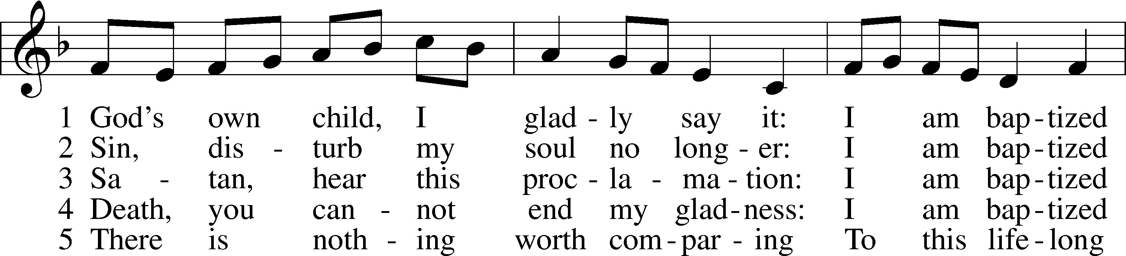
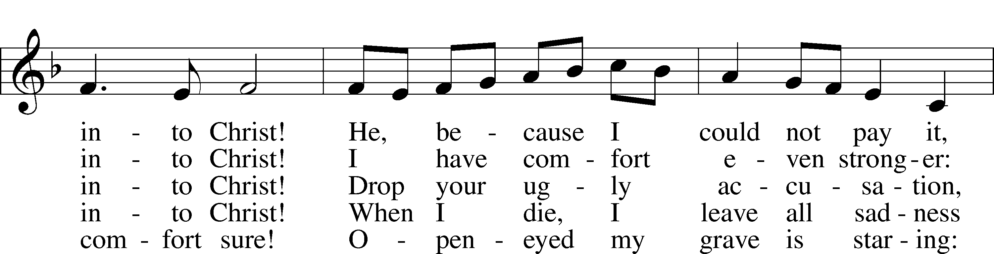
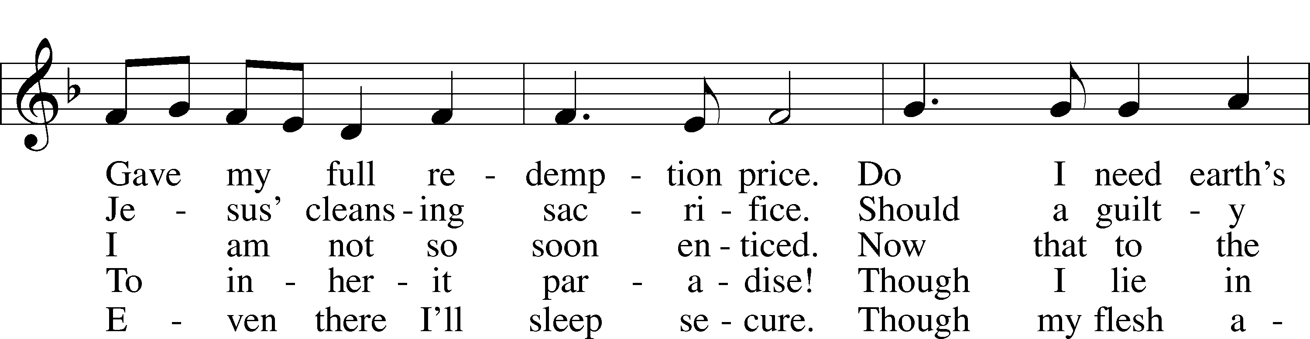
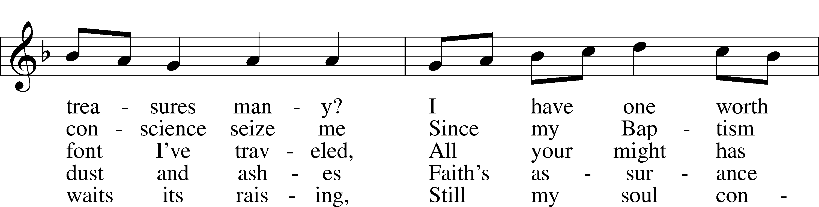
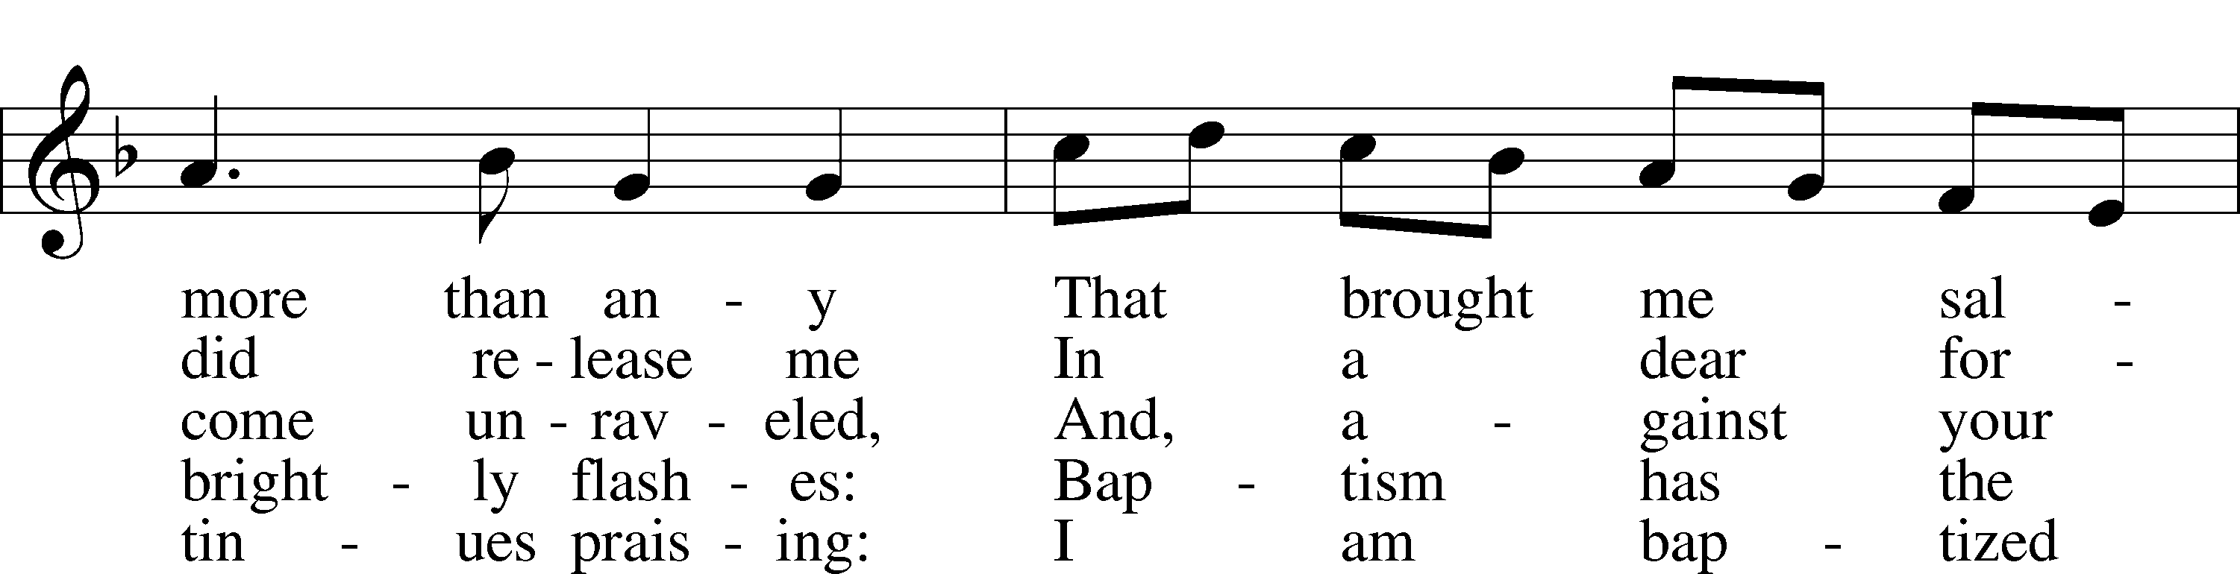
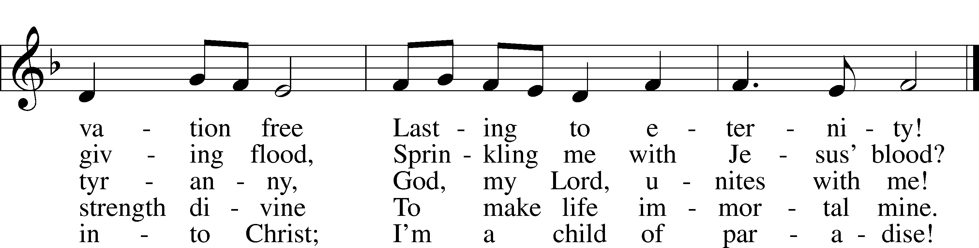
Text: Erdmann Neumeister, 1671–1756; tr. Robert E. Voelker, 1957
Tune: Johann Caspar Bachofen, 1695–1755, alt.
Text: © 1991 Robert E. Voelker. Used by permission: LSB Hymn License no. 110003344
Tune: Public domain

Sermon Hymn “My Song Is Love Unknown” # 430
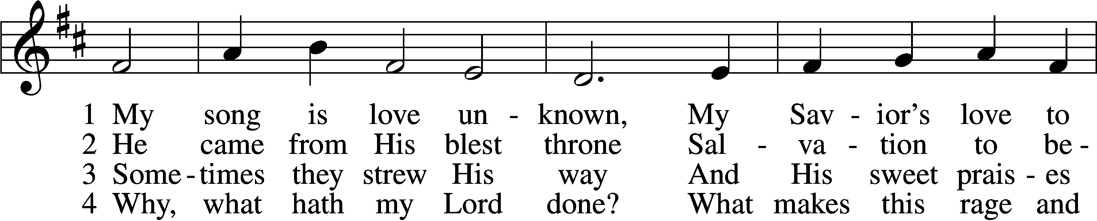
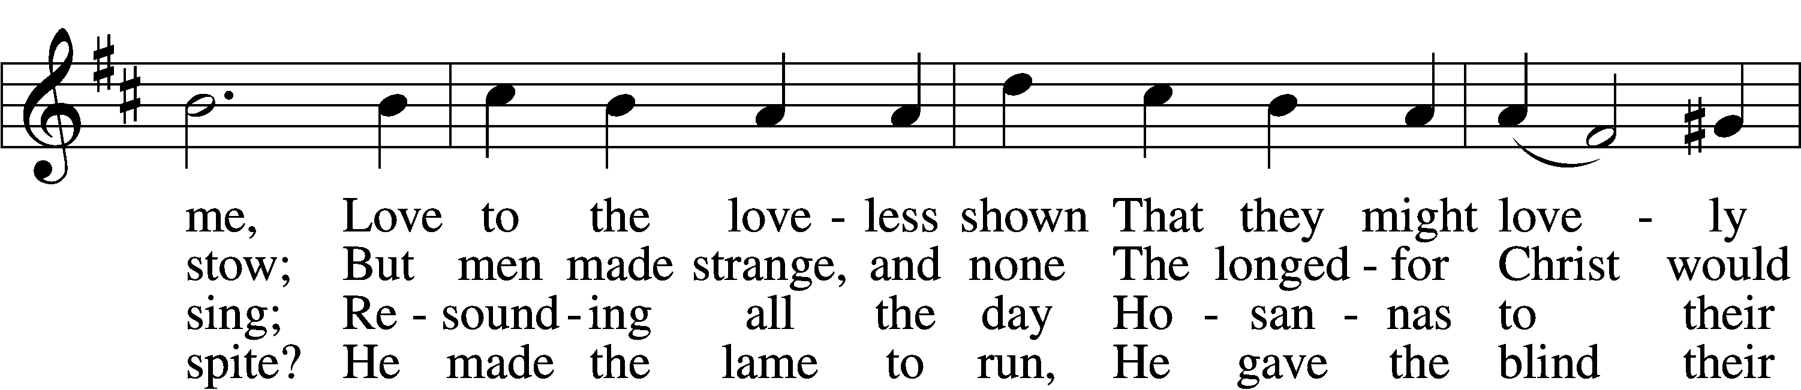
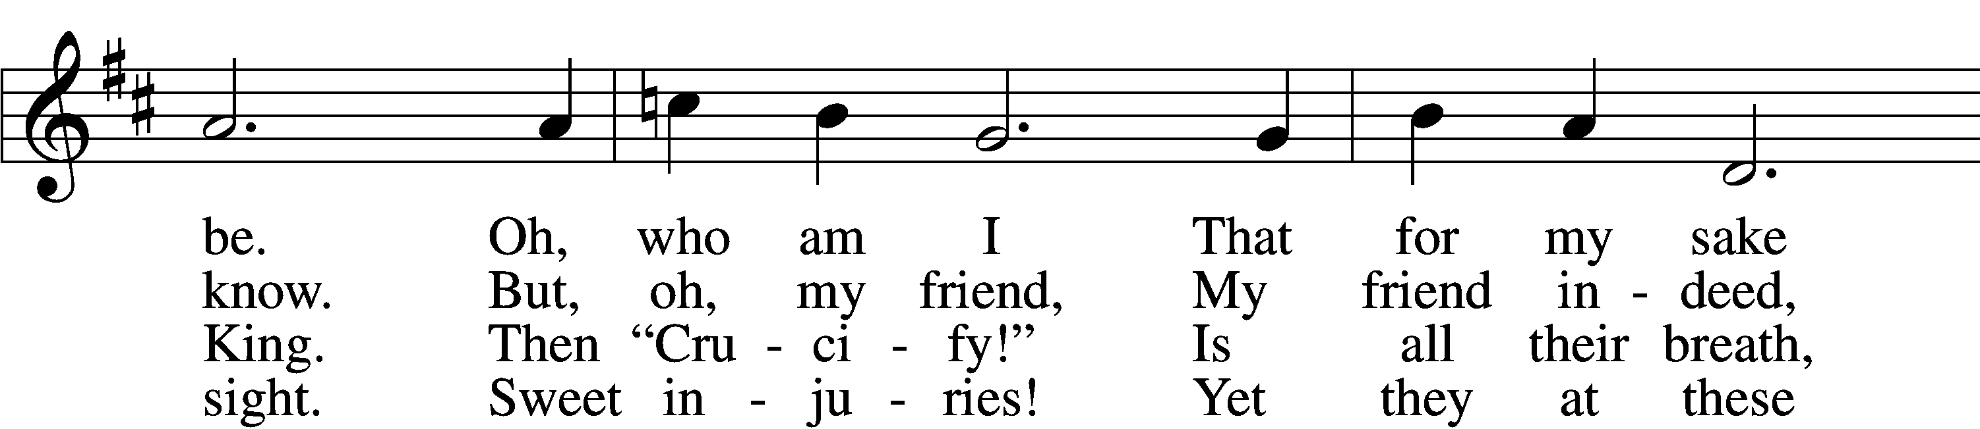
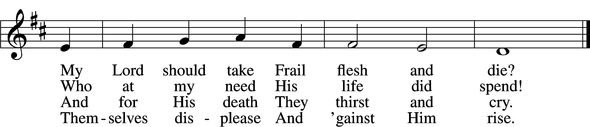

5 They rise and needs will have
My dear Lord made away;
A murderer they save,
The Prince of Life they slay.
Yet cheerful He
To suff’ring goes
That He His foes
From thence might free.

6 In life no house, no home
My Lord on earth might have;
In death no friendly tomb
But what a stranger gave.
What may I say?
Heav’n was His home
But mine the tomb
Wherein He lay.

7 Here might I stay and sing,
No story so divine!
Never was love, dear King,
Never was grief like Thine.
This is my friend,
In whose sweet praise
I all my days
Could gladly spend!
Text: Samuel Crossman, c. 1624–1683
Tune: John N. Ireland, 1879–1962
Text: Public domain
Tune: © John Ireland Trust. Used by permission: LSB Hymn License no. 110003344

Distribution Hymn “Let Us Ever Walk with Jesus” # 685
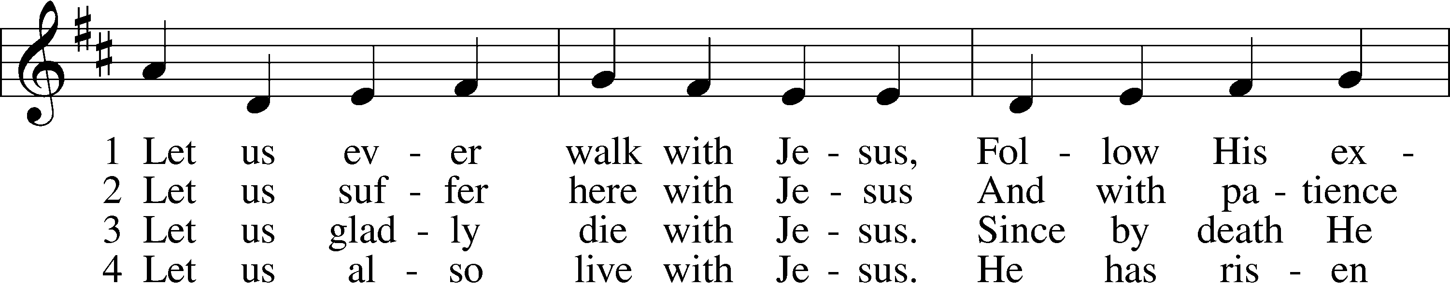
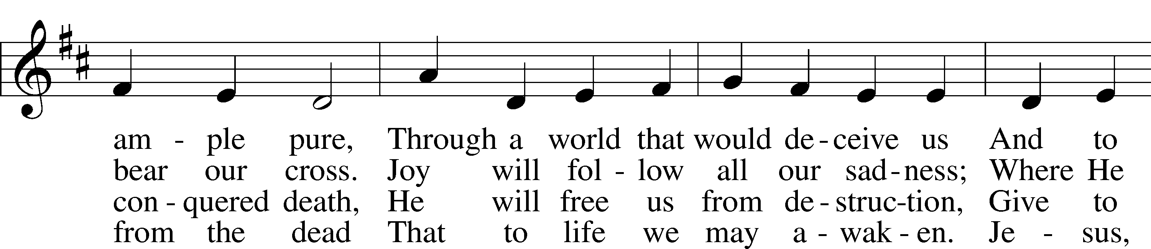
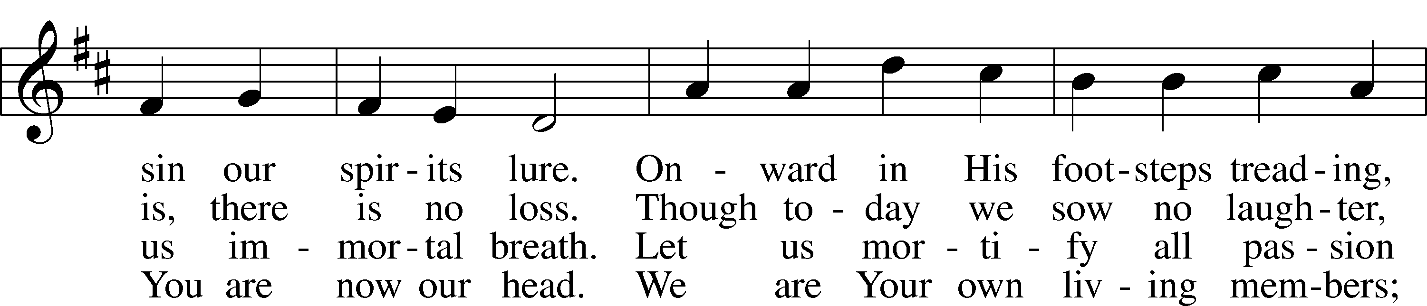
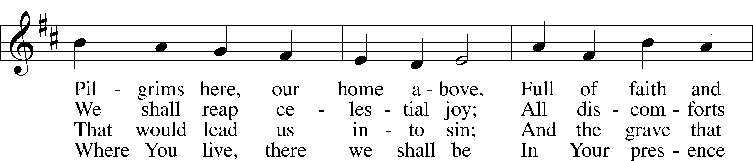
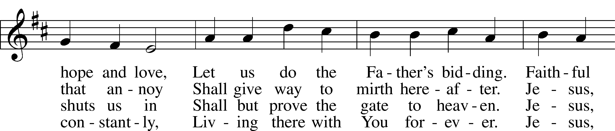
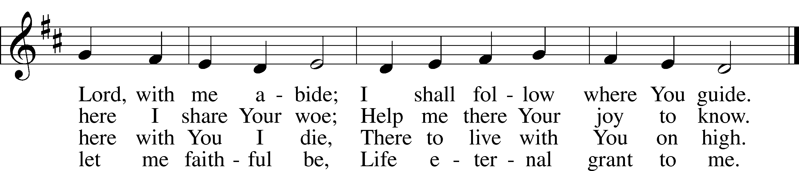
Text: Sigismund von Birken, 1626–81; tr. Lutheran Book of Worship, 1978, alt.
Tune: Georg G. Boltze, 18th cent.
Text: © 1978 Lutheran Book of Worship. Used by permission: LSB Hymn License no. 110003344
Tune: Public domain

Distribution Hymn “Glory Be to Jesus” # 433
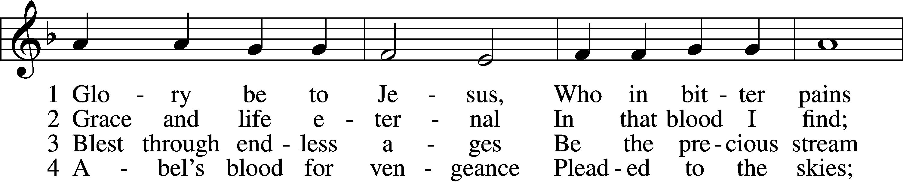
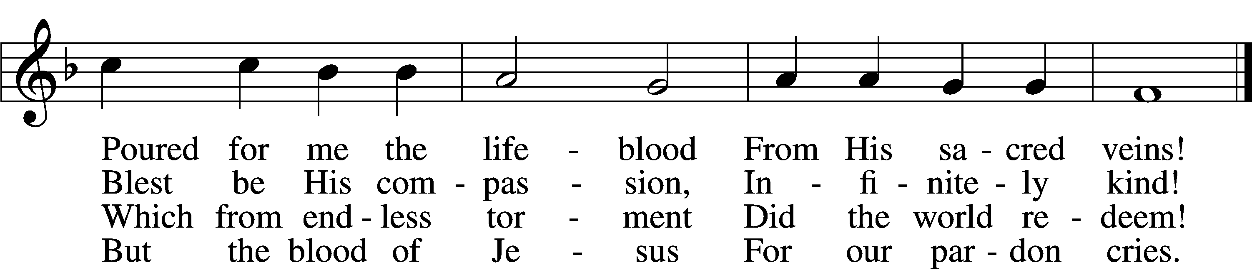

5 Oft as earth exulting
Wafts its praise on high,
Angel hosts rejoicing
Make their glad reply.

6 Lift we, then, our voices,
Swell the mighty flood;
Louder still and louder
Praise the precious blood!
Text: Italian, c. 18th cent.; tr. Edward Caswall, 1814–78, alt.
Tune: Friedrich Filitz, 1804–76
Text and tune: Public domain

Distribution Hymn “In the Cross of Christ I Glory” # 427
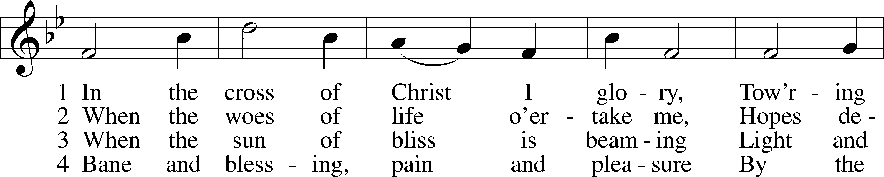
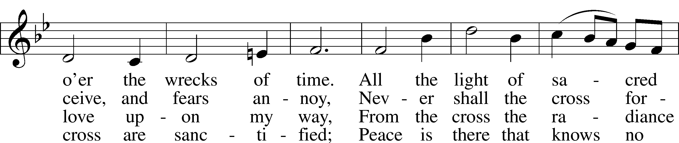

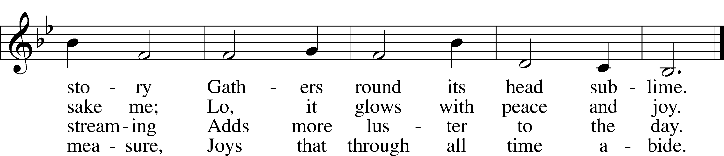

Text: John Bowring, 1792–1872
Tune: Ithamar Conkey, 1815–67
Text and tune: Public domain

Closing Hymn “Jesus, I Will Ponder Now” # 440
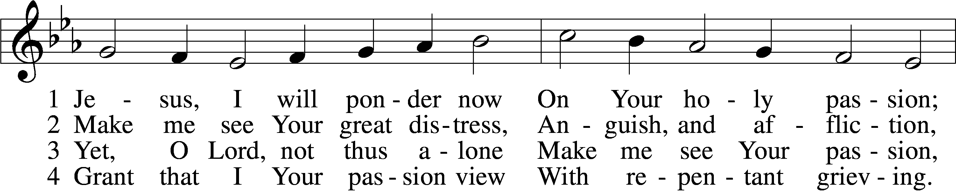
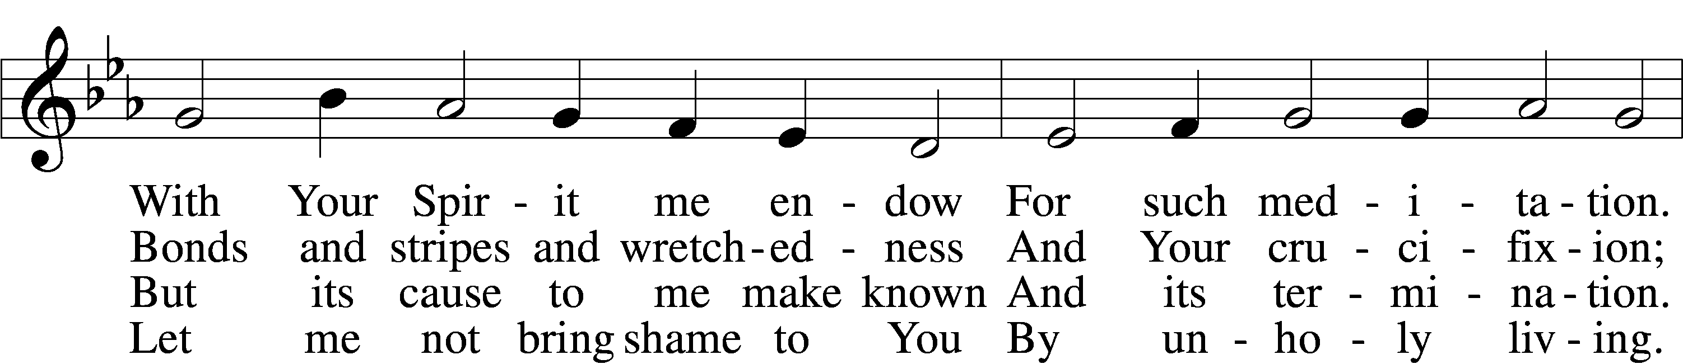
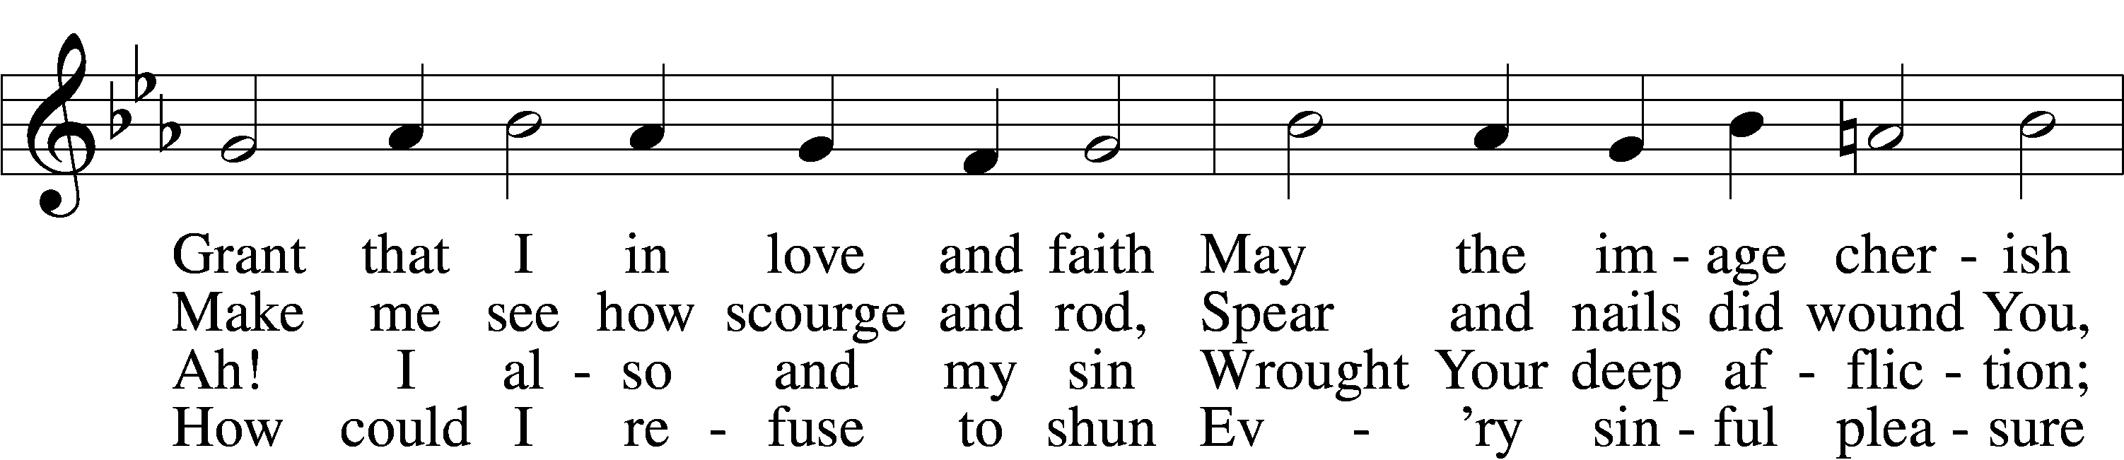
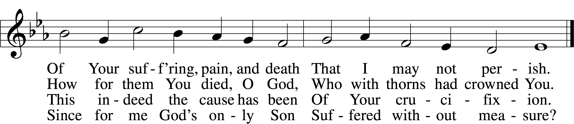

5 If my sins give me alarm
And my conscience grieve me,
Let Your cross my fear disarm;
Peace of conscience give me.
Help me see forgiveness won
By Your holy passion.
If for me He slays His Son,
God must have compassion!

6 Graciously my faith renew;
Help me bear my crosses,
Learning humbleness from You,
Peace mid pain and losses.
May I give You love for love!
Hear me, O my Savior,
That I may in heav’n above
Sing Your praise forever.
Text: Sigismund von Birken, 1626–81; tr. August Crull, 1845–1923, alt.
Tune: Melchior Vulpius, c. 1570–1615
Text and tune: Public domain

