Blessed Savior Lutheran Church

**Florissant, Missouri**

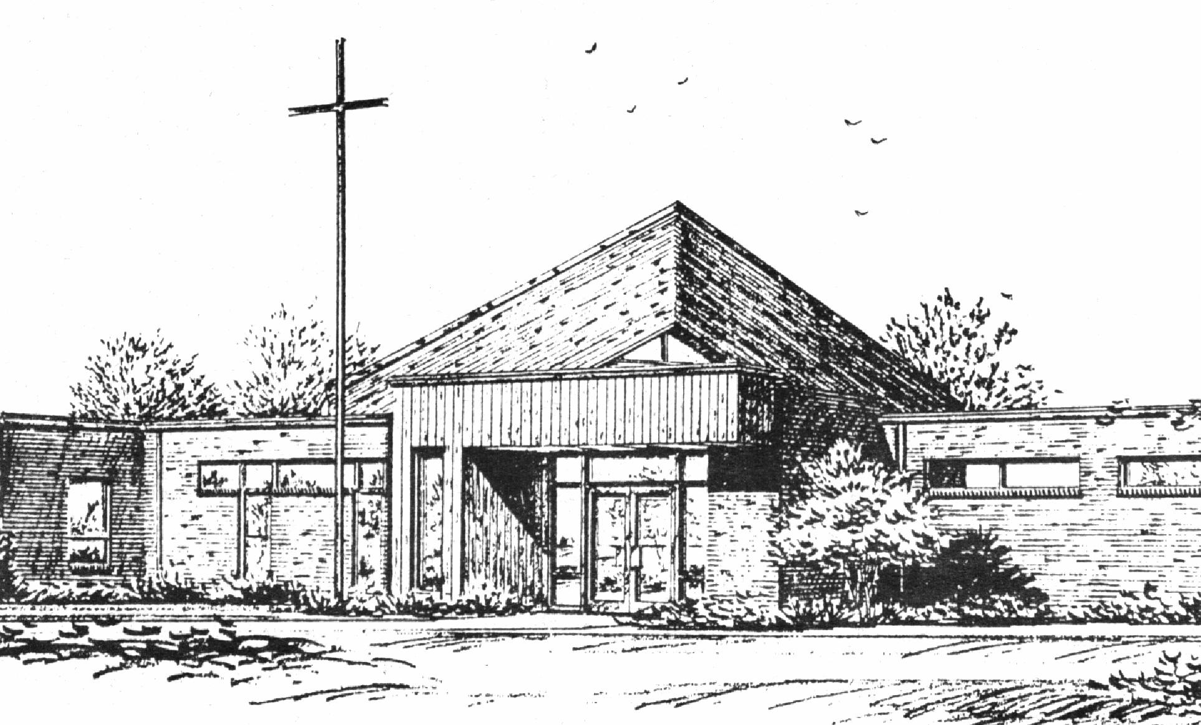

*“Empowered by God’s Holy Word,*

*we joyfully share the love of Jesus with all people;*

*through worship, teaching, fellowship,*

*service and witnessing.”*

*Fifth Sunday in Lent*

*March 17, 2024*

The Lutheran Church-Missouri Synod

**BLESSED SAVIOR LUTHERAN CHURCH**

2615 Shackelford Road

Florissant, Missouri 63031-2005

Telephone: 831-1300

[www.blessedsavior-lcms.org](http://www.blessedsavior-lcms.org)

Pastor Matthew Roeglin

**+ + + + + + + + + + + +**

**Fifth Sunday in Lent**

**Sunday, March 17, 2024**

**WE WELCOME YOU** to our worship service this morning. We pray God’s rich blessings upon you as you hear His Word and praise His holy name. We ask our members and visitors to please use the friendship pad found on the pew. Kindly hand the friendship pad to the person sitting next to you. The Ushers will collect them after the service. Thank You.

**HOLY COMMUNION** will be offered during our worship services this week. You are encouraged to prepare for communion by meditating on the Christian Questions and Answers located on pages 329 & 330 in the front of the hymnal.

We rejoice in this celebration of the **LORD’S** Supper as the Lord Jesus indeed comes to us in a very intimate manner, giving to us His true Body & Blood in and with the bread and wine in this sacred meal. St. Paul writes*, “A man ought to examine himself before he eats of the bread and drinks of the cup. For anyone who eats and drinks without recognizing the body of the Lord eats and drinks judgment on himself.”* (1 Corinthians 11:28-29) It is out of love and care for every individual that comes to the Lord’s Supper that we ask those who are not instructed in the faith and/or doubt the presence of the Body and Blood of Jesus in this Sacrament to speak to the pastor before attending the Lord’s Supper. Members of churches that belong to the Lutheran Church- Missouri Synod, believing and confessing as we do, are invited to partake in the Lord’s Supper with us. We practice close communion and ask that ALL guests who desire to commune; kindly speak to the Pastor before the service. Please respect our position of love in this matter of pastoral care, BSLC.

**THIS WORSHIP FOLDER / CHURCH BULLETIN** is prepared for your convenience and contains the entire order of worship with all spoken and sung responses. However, if you are more comfortable using the hymnal, you may use the order of worship found in the front pages of Lutheran Service Book where all the melodies are shown for the sung responses of the congregation.

*Divine Service 4* *p.203*

*Greeting of Peace* The people may greet one another in the name of the Lord, saying, “Peace be with you,” as a sign of reconciliation and of the unity of the Spirit in the bond of peace. (Matt. 5:22-24; Eph. 4:1-3).

*Opening Hymn*

# ***“God’s Own Child, I Gladly Say It”*** *#594*

Stand

# Confession and Absolution

The sign of the cross may be made by all in remembrance of their Baptism.

P In the name of the Father and of the T Son and of the Holy Spirit.

C **Amen.**

P Our help is in the name of the Lord,

C **who made heaven and earth.**

P If You, O Lord, kept a record of sins, O Lord, who could stand?

C **But with You there is forgiveness; therefore You are feared.**

P Since we are gathered to hear God’s Word, call upon Him in prayer and praise, and receive the body and blood of our Lord Jesus Christ in the fellowship of this altar, let us first consider our unworthiness and confess before God and one another that we have sinned in thought, word, and deed, and that we cannot free ourselves from our sinful condition. Together as His people let us take refuge in the infinite mercy of God, our heavenly Father, seeking His grace for the sake of Christ, and saying: God, be merciful to me, a sinner.

C **Almighty God, have mercy upon us, forgive us our sins, and lead us to everlasting life. Amen.**

P Almighty God in His mercy has given His Son to die for you and for His sake forgives you all your sins. As a called and ordained servant of Christ, and by His authority, I therefore forgive you all your sins in the name of the Father and of the T Son and of the Holy Spirit.

C **Amen.**

# Service of the Word *(Spoken)*

*Introit* Psalm 116:1–4, 8; antiphon: Psalm 43:1

Vindicate me, O God, and defend my cause against an ungodly | people,*  
 **from the deceitful and unjust man de- | liver me!**I love the Lord, because | he has heard*  
 **my voice and my pleas for | mercy.**Because he inclined his | ear to me,*  
 **therefore I will call on him as long | as I live.**The snares of death encompassed me; the pangs of Sheol laid | hold on me;*  
 **I suffered distress and | anguish.**Then I called on the name | of the Lord:*  
 **“O Lord, I pray, deliv- | er my soul!”**For you have delivered my | soul from death,*  
 **my eyes from tears, my feet from | stumbling.  
Glory be to the Father and | to the Son**  
 **and to the Holy | Spirit;**  
**as it was in the be- | ginning,**  
 **is now, and will be forever. | Amen.**  
Vindicate me, O God, and defend my cause against an ungodly | people,*  
 **from the deceitful and unjust man de- | liver me!**

*Kyrie* p. 204

C **Lord, have mercy;**

**Christ, have mercy;**

**Lord, have mercy.**

*Salutation and Collect of the Day p.205*

P The Lord be with you.

C **And also with you.**

P Let us pray.

C **Almighty God, by Your great goodness mercifully look upon Your people that we may be governed and preserved evermore in body and soul; through Jesus Christ, Your Son, our Lord, who lives and reigns with You and the Holy Spirit, one God, now and forever. Amen.**

Sit

*Old Testament Reading* Jeremiah 31:31–34

31“Behold, the days are coming, declares the Lord, when I will make a new covenant with the house of Israel and the house of Judah, 32not like the covenant that I made with their fathers on the day when I took them by the hand to bring them out of the land of Egypt, my covenant that they broke, though I was their husband, declares the Lord. 33But this is the covenant that I will make with the house of Israel after those days, declares the Lord: I will put my law within them, and I will write it on their hearts. And I will be their God, and they shall be my people. 34And no longer shall each one teach his neighbor and each his brother, saying, ‘Know the Lord,’ for they shall all know me, from the least of them to the greatest, declares the Lord. For I will forgive their iniquity, and I will remember their sin no more.”

A This is the Word of the Lord.

C **Thanks be to God.**

*Gradual* Hebrews 12:2

C **O come, let us fix our eyes on Jesus,  
 the founder and perfecter of our faith,  
who for the joy that was set before him endured the cross, despising the shame,  
 and is seated at the right hand of the throne of God.**

*Epistle* Hebrews 5:1–10

1Every high priest chosen from among men is appointed to act on behalf of men in relation to God, to offer gifts and sacrifices for sins. 2He can deal gently with the ignorant and wayward, since he himself is beset with weakness. 3Because of this he is obligated to offer sacrifice for his own sins just as he does for those of the people. 4And no one takes this honor for himself, but only when called by God, just as Aaron was.

5So also Christ did not exalt himself to be made a high priest, but was appointed by him who said to him,

“You are my Son,  
 today I have begotten you”;

6as he says also in another place,

“You are a priest forever,  
 after the order of Melchizedek.”

7In the days of his flesh, Jesus offered up prayers and supplications, with loud cries and tears, to him who was able to save him from death, and he was heard because of his reverence. 8Although he was a son, he learned obedience through what he suffered. 9And being made perfect, he became the source of eternal salvation to all who obey him, 10being designated by God a high priest after the order of Melchizedek.

A This is the Word of the Lord.

C **Thanks be to God.**

Stand

*Holy Gospel* Mark 10:32–45

P The Holy Gospel according to St. Mark, the tenth chapter.

C **Glory to You, O Lord.**

32And they were on the road, going up to Jerusalem, and Jesus was walking ahead of them. And they were amazed, and those who followed were afraid. And taking the twelve again, he began to tell them what was to happen to him, 33saying, “See, we are going up to Jerusalem, and the Son of Man will be delivered over to the chief priests and the scribes, and they will condemn him to death and deliver him over to the Gentiles. 34And they will mock him and spit on him, and flog him and kill him. And after three days he will rise.”

35And James and John, the sons of Zebedee, came up to him and said to him, “Teacher, we want you to do for us whatever we ask of you.” 36And he said to them, “What do you want me to do for you?” 37And they said to him, “Grant us to sit, one at your right hand and one at your left, in your glory.” 38Jesus said to them, “You do not know what you are asking. Are you able to drink the cup that I drink, or to be baptized with the baptism with which I am baptized?” 39And they said to him, “We are able.” And Jesus said to them, “The cup that I drink you will drink, and with the baptism with which I am baptized, you will be baptized, 40but to sit at my right hand or at my left is not mine to grant, but it is for those for whom it has been prepared.” 41And when the ten heard it, they began to be indignant at James and John. 42And Jesus called them to him and said to them, “You know that those who are considered rulers of the Gentiles lord it over them, and their great ones exercise authority over them. 43But it shall not be so among you. But whoever would be great among you must be your servant, 44and whoever would be first among you must be slave of all. 45For even the Son of Man came not to be served but to serve, and to give his life as a ransom for many.”

P This is the Gospel of the Lord.

C **Praise to You, O Christ.**

*Nicene Creed*

C **I believe in one God,**

**the Father Almighty,**

**maker of heaven and earth**

**and of all things visible and invisible.**

**And in one Lord Jesus Christ,**

**the only-begotten Son of God,**

**begotten of His Father before all worlds,**

**God of God, Light of Light,**

**very God of very God,**

**begotten, not made,**

**being of one substance with the Father,**

**by whom all things were made;**

**who for us men and for our salvation came down from heaven**

**and was incarnate by the Holy Spirit of the virgin Mary**

**and was made man;**

**and was crucified also for us under Pontius Pilate.**

**He suffered and was buried.**

**And the third day He rose again according to the Scriptures**

**and ascended into heaven**

**and sits at the right hand of the Father.**

**And He will come again with glory to judge both the living and the dead,**

**whose kingdom will have no end.**

**And I believe in the Holy Spirit,**

**the Lord and giver of life,**

**who proceeds from the Father and the Son,**

**who with the Father and the Son together is worshiped and glorified,**

**who spoke by the prophets.**

**And I believe in one holy Christian and apostolic Church,**

**I acknowledge one Baptism for the remission of sins,**

**and I look for the resurrection of the dead**

**and the life** T **of the world to come. Amen.**

Sit

*Children's Message*

*Sermon Hymn* *“My Song Is Love Unknown”* # 430

*Sermon*

*Offering*

Stand

*Offertory* *We Give Thee But Thine Own* #781

C **We give thee but Thine own, Whate’er the gift may be; All that we have is Thine alone, A trust, O Lord, from Thee.**

**May we Thy bounties thus, as stewards true receive, And gladly, as Thou blessest us, to Thee our first-fruits give!**

*Prayer of the Church*

*After each petition of the prayers:*

|  |  |
| --- | --- |
| P | Lord, In Your mercy. |
| C | **Hear our prayer.** |

*After the final petition:*

|  |  |
| --- | --- |
| P | Through Jesus Christ, our Lord. |
| C | **Amen.** |

# Service of the Sacrament

*Preface* p. 208

P The Lord be with you.

C **And also with you.**

P Lift up your hearts.

C **We lift them to the Lord.**

P Let us give thanks to the Lord our God.

C **It is right to give Him thanks and praise.**

P It is truly good, right, and salutary that we should at all times and in all places give thanks to You, O Lord, holy Father, almighty and everlasting God, for the countless blessings You so freely bestow on us and all creation. Above all, we give thanks for Your boundless love shown to us when You sent Your only-begotten Son, Jesus Christ, into our flesh and laid on Him our sin, giving Him into death that we might not die eternally. Because He is now risen from the dead and lives and reigns to all eternity, all who believe in Him will overcome sin and death and will rise again to new life. Therefore with angels and archangels and with all the company of heaven we laud and magnify Your glorious name, evermore praising You and saying:

*Sanctus* p. 208

C **Holy, holy, holy Lord God of Sabaoth adored;**

**Heav’n and earth with full acclaim shout the glory of Your name.**

**Sing hosanna in the highest, sing hosanna to the Lord;**

**Truly blest is He who comes in the name of the Lord!**

Text: Stephen P. Starke

*Prayer of Thanksgiving p.209*

P Blessed are You, O Lord our God, king of all creation, for You have had mercy on us and given Your only-begotten Son that whoever believes in Him should not perish but have eternal life.

At Your command, Abraham prepared to offer his son Isaac as a sacrifice on the mountain; yet, in mercy You provided a ram as a substitute. We give You thanks that on Calvary You spared not Your only Son but sent Him to offer His life as a ransom for many.

As we eat and drink His body and blood, grant us, like Abraham our father, to trust in Your promise now fulfilled in Christ, the Lamb of God, who takes away the sin of the world.

Hear us as we pray in His name and as He has taught us:

*Lord’s Prayer*

C **Our Father who art in heaven,**

**hallowed be Thy name,** **Thy kingdom come,**

**Thy will be done on earth** **as it is in heaven;**

**give us this day our daily bread;**

**and forgive us our trespasses**

**as we forgive those**

**who trespass against us;**

**and lead us not into temptation,**

**but deliver us from evil.**

**For Thine is the kingdom**

**and the power and the glory**

**forever and ever. Amen.**

*The Words of Our Lord*

P Our Lord Jesus Christ, on the night when He was betrayed, took bread, and when He had given thanks, He broke it and gave it to the disciples and said: “Take, eat; this is My T body, which is given for you. This do in remembrance of Me.”

In the same way also He took the cup after supper, and when He had given thanks, He gave it to them, saying: “Drink of it, all of you; this cup is the new testament in My T blood, which is shed for you for the forgiveness of sins. This do, as often as you drink it, in remembrance of Me.”

*Pax Domini p.209*

P The peace of the Lord be with you always.

C **Amen.**

*Agnus Dei* p. 210

C **1 O Jesus Christ, true Lamb of God,**

**You take the sin of the world away;**

**O Jesus Christ, true Lamb of God,**

**Have mercy on us, Lord, we pray.**

**2 O Jesus Christ, true Lamb of God,**

**You take the sin of the world away;**

**Have mercy on us, Jesus Christ,**

**And grant us peace, O Lord, we pray.**

Text: Stephen P. Starke

Sit

*Distribution*

*Distribution Hymns*

*“Let Us Ever Walk with Jesus”* # 685

*“Glory Be to Jesus”* # 433

*“In the Cross of Christ I Glory”* # 427

Stand

*Nunc Dimittis* p. 211

C **1 O Lord, now let Your servant**

**Depart in heav’nly peace,**

**For I have seen the glory**

**Of Your redeeming grace:**

**A light to lead the Gentiles**

**Unto Your holy hill,**

**The glory of Your people,**

**Your chosen Israel.**

**2 All glory to the Father,**

**All glory to the Son,**

**All glory to the Spirit,**

**Forever Three in One;**

**For as in the beginning,**

**Is now, shall ever be,**

**God’s triune name resounding**

**Through all eternity.**

*Post-Communion Collect p.212*

A Let us pray.

We give thanks to You, almighty God, that You have refreshed us through this salutary gift, and we implore You that of Your mercy You would strengthen us through the same in faith toward You and in fervent love toward one another; through Jesus Christ, Your Son, our Lord, who lives and reigns with You and the Holy Spirit, one God, now and forever.

C **Amen.**

*Benedicamus* p. 212

A Let us bless the Lord.

C **Thanks be to God.**

*Benediction*

P The Lord bless you and keep you.

The Lord make His face shine on you and be gracious to you.

The Lord look upon you with favor and T give you peace.

C **Amen.**

*Closing Hymn* *“Jesus, I Will Ponder Now”* # 440

Acknowledgments

Unless otherwise indicated, Scripture quotations are from the ESV® Bible (The Holy Bible, English Standard Version®), copyright © 2001 by Crossway, a publishing ministry of Good News Publishers. Used by permission. All rights reserved.

Created by Lutheran Service Builder © 2024 Concordia Publishing House.

***Announcements***

*After the announcements, please stand for the closing hymn.*

**“God Loved the World So That He Gave”***#571*

God loved the world so that He gave

His only Son the lost to save,

That all who would in Him believe

Should everlasting life receive.

***Go and Serve the Lord***

*Acknowledgments* Unless otherwise indicated, all scripture quotations are from *The Holy Bible, English Standard Version*, copyright © 2001 by Crossway Bibles, a division of Good News Publishers. Used by permission. All rights reserved. Created by Lutheran Service Builder © 2006 Concordia Publishing House.

The Liturgist & Preacher: Pastor Matthew Roeglin

The Acoloyte: Sunday 9:30 a.m. Madalyn Beach

The Sound System: Retha Taylor & Emily Roeglin

The Organist: Substitute Organist Service

**Altar Flowers-** are placed by Christopher Robertson to the Glory of God the Father, Son & Holy Spirit.

**Easter Lily & Hydrangea Order Forms** are on the table in back of church. **There are 6 flowers left**. There are 5 Lilies and 1 Pink Hydrangea left. The cost is $9.00. If you are writing a check, please make it out to Blessed Savior Lights.

**Easter Cupcakes** – Please remember to bring your cupcakes on Friday, March 22 from 7:30 – 11:30 a.m. or Saturday, March 23 at 9:00 a.m. Thank you.

**Easter Egg Hunt** – Saturday, March 23 at 10:00 a.m. Please invite your family, friends and co-workers.

**COMMUNITY IS WELCOME**

**The Easter Potluck Breakfast** will be on Easter Sunday, March 31st at 8:00 a.m. Please sign up on the table in back of church for what you would like to bring and how many will be attending.

**BLESSED SAVIOR’S CALENDAR**

**March 17, 2024 – March 24, 2024**

TODAY:

***Sunday* 8:15 a.m. Adult Bible Study – McKenna**

**9:30 a.m. Worship Service w/Holy Communion**

**10:45 a.m. Adult Bible Study w/Pastor,**

**Mar. 17 Sunday School & High School**

MONDAY:

**Mar. 18**

TUESDAY:

**Mar. 19**

WEDNESDAY: **NO** **2:30 p.m. Pastor’s Adult Bible Study**

**(Pastor’s Bible Study will start back up on April 3)**

**NO 5:30 p.m. Dinner**

**Mar. 20 6:30 p.m. Mid-Week Lenten Service**

THURSDAY:

**Mar. 21**

FRIDAY:

**Mar. 22 Pastor – Day with family**

SATURDAY: 9:00 a.m. Drop Off Cupcakes

**Mar. 23 10:00 a.m. Easter Egg Hunt**

**NEXT**

***SUNDAY* 8:15 a.m. Adult Bible Study (McKenna)**

**Palm Sunday 9:30 a.m. Worship Service W/Holy Communion**

**Confirmation 10:45 a.m. Adult Bible Class (Pastor)**

**Mar. 24 10:45 a.m. Sunday School & High School**

**Prayers for our Church and Community** **Week of March 17th & 24th.** The Ushers will hand you a copy after the service.

**Maundy Thursday** **March 28**

**7:00 p.m.**

**with Holy Communion**

The name for this day comes from the Latin word "mandatum," meaning "commandment." It refers to the two "new" commandments our Lord gave to His disciples on this day. The first is "love one another," and the second is "do this in remembrance of Me." In the early church, Maundy Thursday was also the day on which those who had fallen away from the Church were restored to full fellowship with other believers after having observed the 40-day penitential season of Lent. Today we are reminded of the reconciliation we have because of Christ’s body and blood given for the forgiveness of our sin, and the example of self-giving love shown by our Lord as He washed the feet of His disciples.

This service is the "first act" or portion of what the early Church observed as "the triduum," a three-day observance of the events of our Lord's suffering, death, and resurrection. Even though Christians come and go during these three days, the worship services from now through the great Vigil of Easter are considered to be one continuous service.

**Good Friday – Treore Service**

**Friday, March 29**

**Noon – 3:00 p.m.**

**“Seven Last Words of Christ”**

**Call to Worship NOON**

**12:05 p.m. “Father, Forgive Them” Rev. Matthew Roeglin**

**12:30 p.m. “Today You will be with Me” Vicar Brett Arrasmith**

**12:55 p.m. “Woman, Behold Your Son” Rev. Ellory Glenn**

**1:20 p.m. “My God, My God, why has” Rev. Eric Stacy**

**1:45 pm “I Thirst” Rev. Martin Dressler**

**2:10 pm “It is Finished” Rev. Robert Brown**

**2:35 pm “Father, into Thy hands” Rev. Nathan Ruback**

**Come and Go to Fit Your Schedule**

**Public Cordially Invited**



**Good Friday – Tenebrae Service**

**“Service of Darkness”**

**March 29, 2024**

**7:00 p.m.**

This service is a time of somber reflection as we approach the mystery of Jesus’ death on the cross. We remember that Jesus’ death is celebrated because of the forgiveness of sins and life that flow from Him and His cross to us for our salvation. The message of Jesus’ cross is the message of Scripture, it was planned by God, proclaimed by the prophets, and fulfilled in Christ.

Part of the service is patterned after the ancient office of "Tenebrae", which means darkness. This service reminds us of the terrible reality of our sin, which caused our Savior, Jesus to die for us. As the Passion account is read, the candles will be extinguished one by one and the lights will dim, causing the chancel to become increasingly dark. This is to symbolize our Lord's death for our sin and remind us of the darkness, the spiritual darkness that Jesus, the Light of the word, had come to overcome.

The removal of the Christ Candle, near the close of the service, signifies Jesus’, true man and True God, death and burial. The "strepitus", the loud noise of the shutting of a book, that is heard near the end of the service symbolizes the closing and sealing of the tomb. The Christ Candle is not extinguished at any time during the service, as it is symbolic of the eternal light of God's love given us in His Son Jesus. Though evil had its hour, the Light of God's love continues to burn to all eternity.

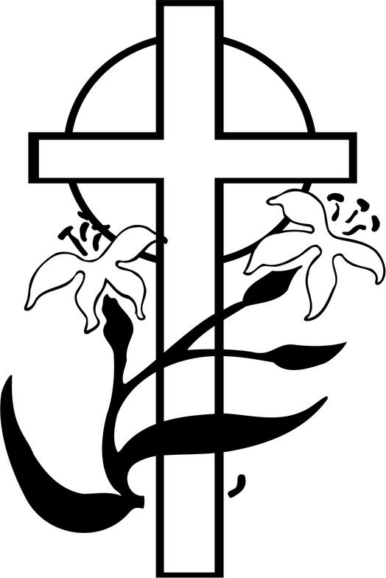

**Sunday, March 31, 2024**

**8:00 a.m. Easter Breakfast (Potluck)**

**9:30 a.m. Worship Service w/Holy Communion**

**NO Bible Classes & Sunday School**

**March 17 5th Sunday in Lent Mark 10:45**

**“For even the Son of Man came not to be served but to serve, and to give his life as a ransom for many.”** Jesus gives everything He has: He gives Himself. That self-giving is the model for our giving in all aspects of our lives. In our family, in our church, and in the world at large, Jesus calls us to follow His example of self-giving. We can only do this if we are connected to His self-giving in faith.

**Our Response to God’s Love – March 10, 2024**

Lent ……… 19

Sunday (9:30)………… 39

Sem Students/family......

Visitors…………..…

Communed….

Total……………... 58

Sunday School…………

Sun. School/Bible Staff.. 4

Bible Study/Youth……...

Bible Study/Y.Adults….

Bible Study I ………… 8

Bible Study II ………… 7

Adult/Confirm…….

Wednesday Morning ….

General Offerings…. $ 2,634.00  *Misc. – Lent 3/06/24* $ 469.00

Total response for week of: **Mar 10** $ 3,103.00

Weekly Budget Needed $- 3,800.00

**Deficit** $- 697.00

**Blessings Upon Blessings**

Anniversary Campaign- Update

Wk of 3/10/24 YTD

Debt Reduction $ 0.00 $ 4,160.00

Improvement/Banners $ 20.00 $ 1,595.00

$ 20.00 $ 5,755.00

**Our Special Prayers and Intercessions**

Steve Haynes – heart issues

Nancy Stocker – health issues

Ted Stocker- health issues

Jim Laughlin – open heart surgery

Kim – cancer

Mary S. – cancer

Jeannie Firoved – health issues

Sara – health

Tiffany Connor – health issues

Connor Stretch – Health issues

Mike – Liver failure

Andrew – Guidance

Wanda Johnston – recovering from hip

Surgery

David Hogenmiller – health

Rev. Gary Shack – health

Jim Grimes – health issues

Cheryl Ehrhard – recovering- knee surgery

Kyle – renewal of faith

Heather – strengthening of faith

Pastor Struve- hospitalized

Marge Struve – health issues

Pastor Eric Carlson – Leukemia

Anneliese Wenger – health issues

Charlotte Taggert – health issues

Jessica Parish – MS

Rita Kirk – health issues

Mary Peacock – health

Debbie – home recovering

Lindsay – health

Wendy DeSanto – health issues

Patti Henneman – health issues

Laurie Moore – health issues

William – health issues

Doris Boyd – health issues

David Kuhl – health

Mike Wilder – cancer

Tom Murphy – health

Kelly - health

Retha Taylor – health

Caitlyn – health

**Serving in our Armed Forces** – Andrew Mack, Paul Hackett, Jay Warren, Michael Rice, Caleb McElyea, Jeff Throgmorton, Adam Guercio, Chance Glover, Cody Guercio, Danny Chung, Zayne Glatz, Alanna Kreppert, James Adelhardt, Sean Bentrup, Wesley Peach, Jordan Rolf, Anne Heintzelman, Austin Dreckshage, Ken Leppert II, Shelby Croghan & Richard Vengels.

**\*Please note: Those who are named in our special prayers and intercessions list are placed there by members of our congregation. St. Paul tells us in 1Timothy 2:1-2: “I urge, then, first of all, that requests, prayers, intercessions and thanksgivings be made for everyone – for kings and all those in authority, that we may live peaceful and quiet lives in all godliness and holiness. This is good, and pleases God our Savior.”** Those named remain joyfully in our prayers until the person who requested our prayers removes them or until the Lord resolves their need. Therefore, as St. Paul tells us in Philippians 4:6 “Do not be anxious about anything, but in everything, by prayer and petition, with thanksgiving, present your request to God.