### Blessed Savior Lutheran Church

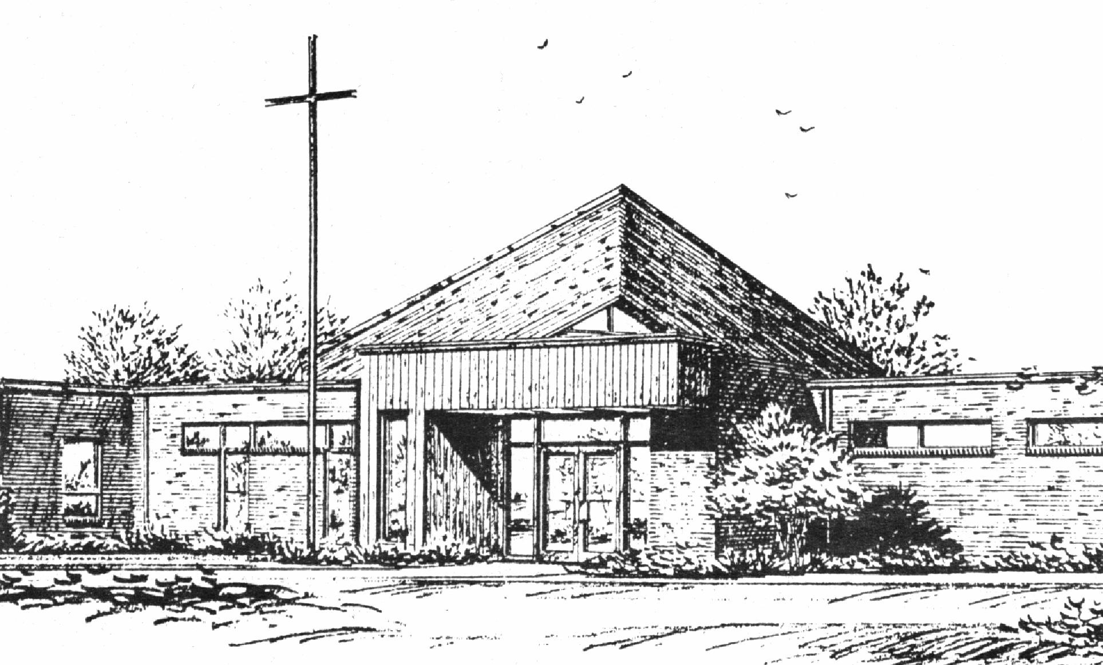

*“Empowered by God’s Holy Word,*

*we joyfully share the love of Jesus with all people;*

*through worship, teaching, fellowship,*

*service and witnessing.”*

**You Meant it for Evil,**

**But God Meant it for Good**

**March 20, 2024**

When you see such Blind Ignorance,

What do you Think?

***(Luke 22:63-23:1)***



Lutheran Church Missouri Synod

Rev. Matthew Roeglin, Pastor 314-479-1470

pastor@blessedsavior-lcms.org

Church Office: 7:30 AM – 11:30 AM Monday-Friday 314-831-1300

2615 Shackelford Rd. Florissant, MO Fax 314-831-3444

Website: www.blessedsavior-lcms.org

Church Email: office@blessedsavior-lcms.org

Divine Services: Sunday 9:30 AM; Wednesday 6:30 PM

**WE WELCOME YOU** to our worship service this evening. We pray God’s rich blessings upon you as you hear His Word and praise His holy name. We ask our members and visitors to please use the friendship pad found on the pew. Kindly hand the friendship pad to the person sitting next to you. The Ushers will collect them after the service. Thank You.

**THIS WORSHIP FOLDER / CHURCH BULLETIN** is prepared for your convenience and contains the entire order of worship with all spoken and sung responses. However, if you are more comfortable using the hymnal, you may use the order of worship found in the front pages of Lutheran Service Book where all the melodies are shown for the sung responses of the congregation.

**INDIVIDUAL HEARING ASSISTANCE SETS** are available for those with impaired hearing. Please ask an usher for assistance.

**LARGE PRINT BULLETINS** are available in the narthex.

**THANK YOU FOR YOUR SERVICE**

Preacher: Rev. Robert Briggs

Lutheran Senior Services

Organist/Pianist: Mrs. Donna Boyd

*(Please silence your cell phones)*

Service of Prayer and Preaching *p.260*

*Opening Hymn*

*“Lord, ‘tis not that I did choose Thee”*  *#573*

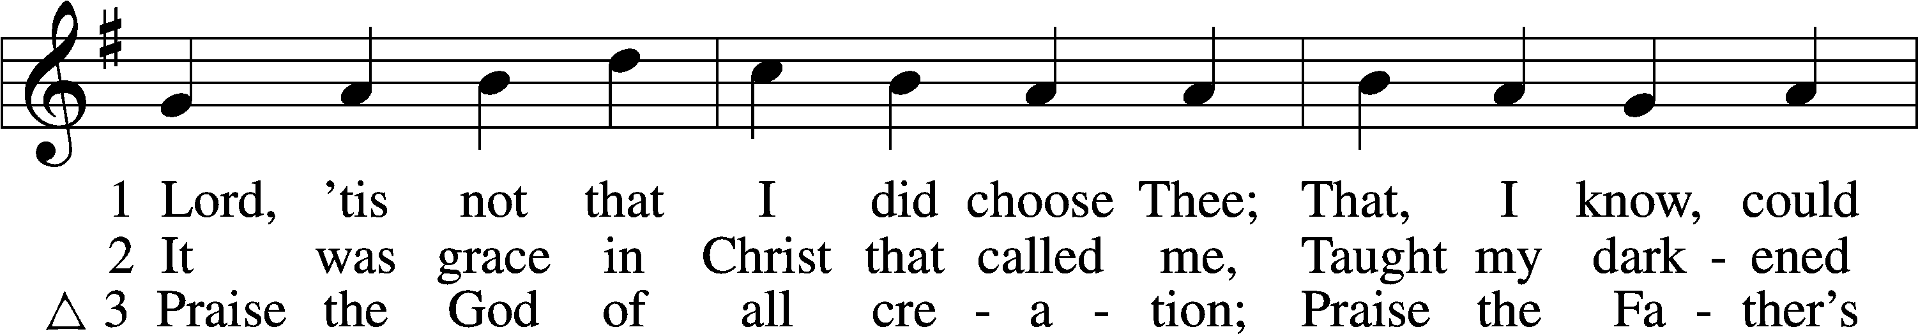

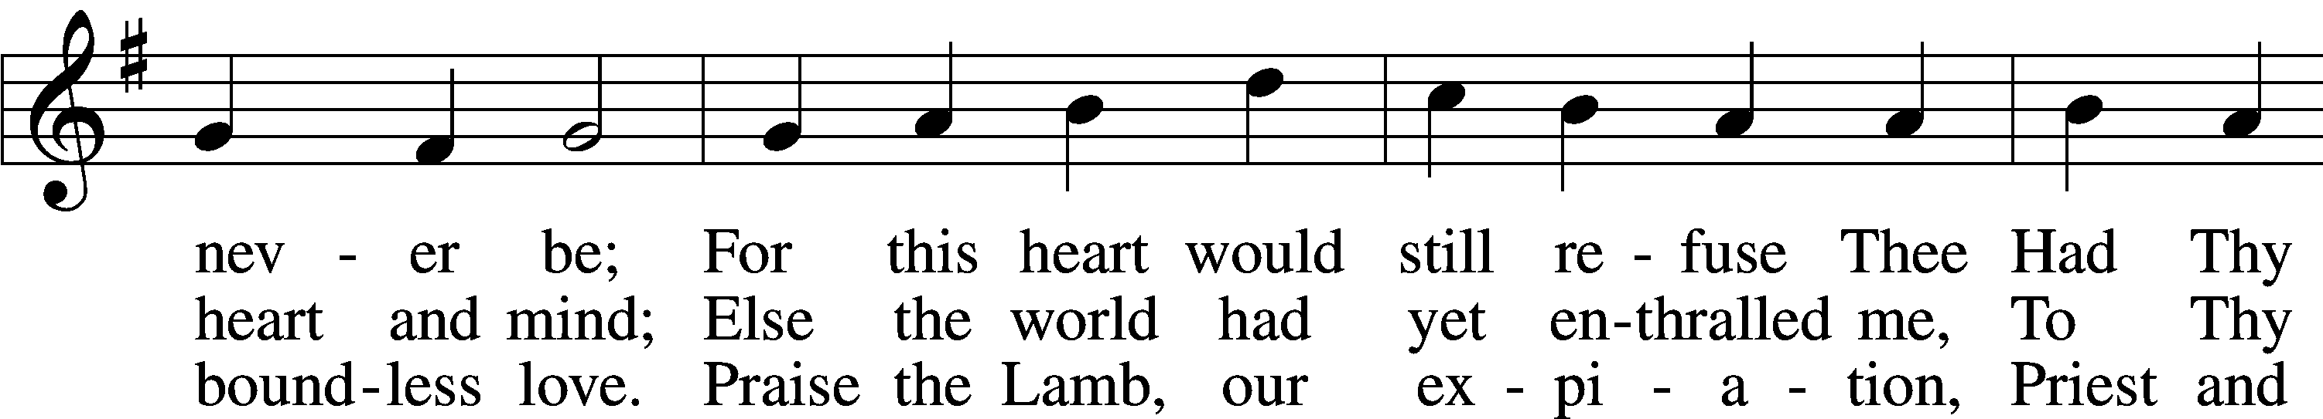

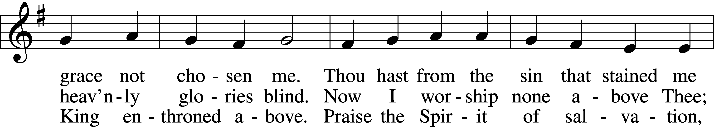

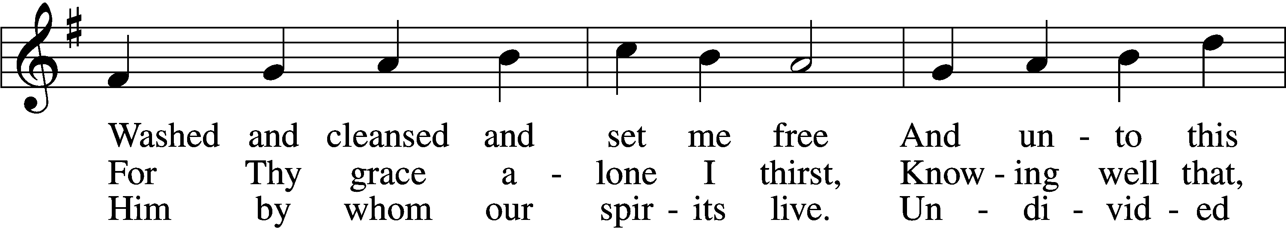

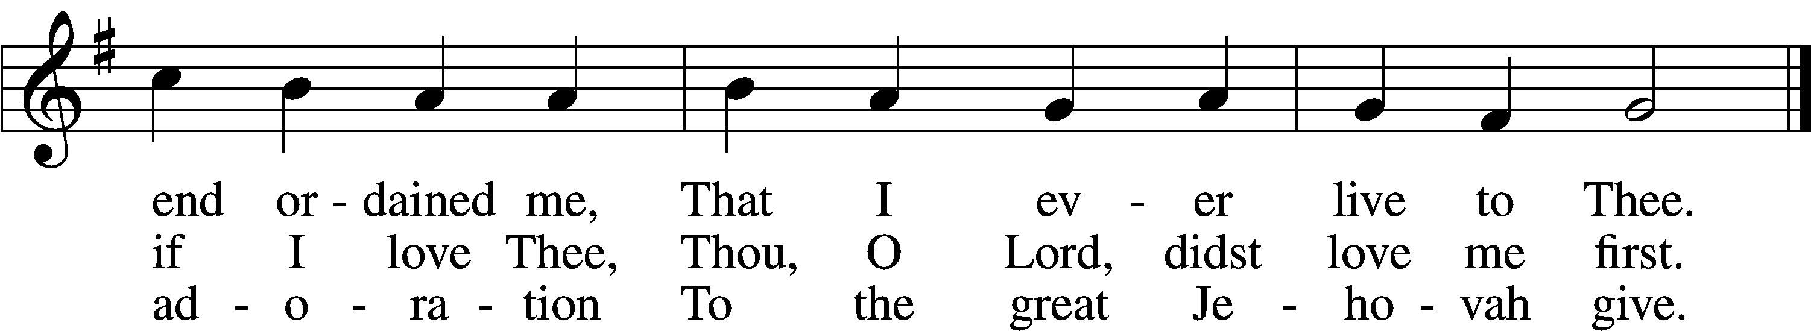

Text: Josiah Conder, 1789–1855, alt.  
Tune: Erbaulicher Musicalischer Christen-Schatz, 1745, Basel  
Text and tune: Public domain

Stand

*Opening Versicles p.260*

L This is the day which the Lord has made;

C **let us rejoice and be glad in it.**

L From the rising of the sun to its setting,

C **the name of the Lord is to be praised.**

L Return to the Lord, your God, for He is gracious and merciful,

C **slow to anger, and abounding in steadfast love, and repents of evil.**

L Jesus said: If any man would come after Me,

C **let him deny himself and take up his cross and follow Me.**

L Christ was wounded for our transgressions.

C **He was bruised for our iniquities.**

L From the rising of the sun to its setting,

C **the name of the Lord is to be praised.**

C **Glory be to the Father and to the Son and to the Holy Spirit;**  
**as it was in the beginning, is now, and will be forever. Amen.**

*Hymn*

*“Oh, for a Thousand Tongues to Sing”* # 528 sts. 1–2, 6–7

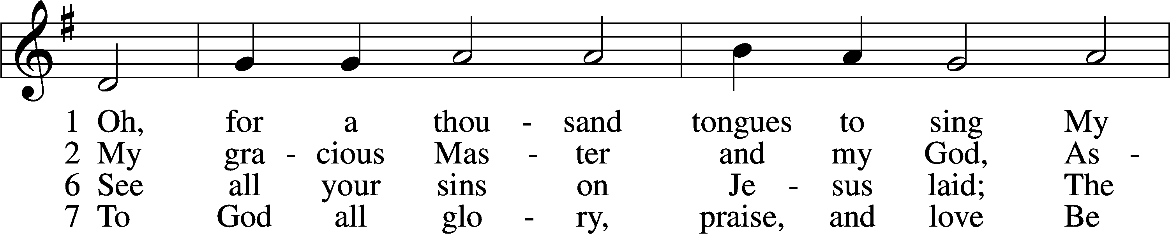

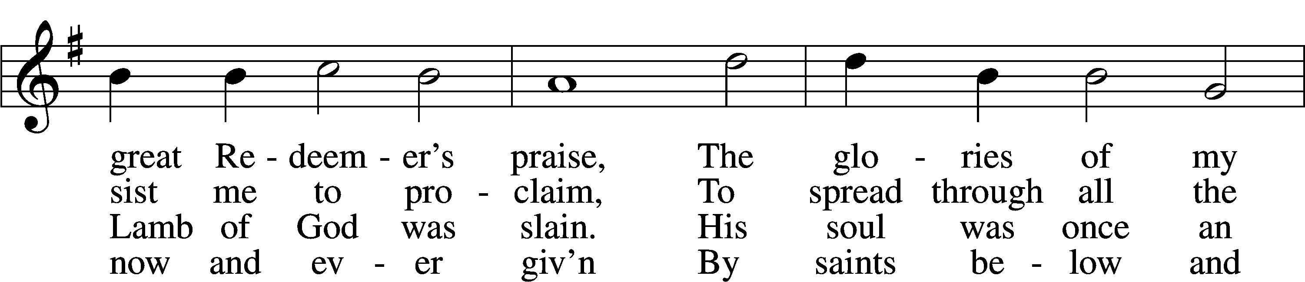

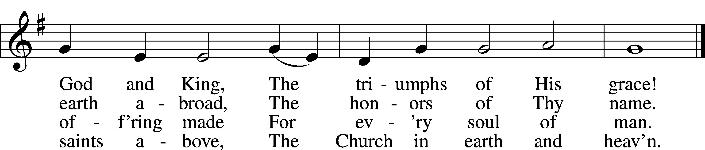

Text: Charles Wesley, 1707–88, alt.  
Tune: Carl G. Gläser, 1784–1829  
Text and tune: Public domain

Sit

Readings From Holy Scripture

*Reading* Hosea 4:1–6

L A reading from Hosea, the fourth chapter.

1Hear the word of the Lord, O children of Israel,  
 for the Lord has a controversy with the inhabitants of the land.  
There is no faithfulness or steadfast love,  
 and no knowledge of God in the land;  
2there is swearing, lying, murder, stealing, and committing adultery;  
 they break all bounds, and bloodshed follows bloodshed.  
3Therefore the land mourns,  
 and all who dwell in it languish,  
and also the beasts of the field  
 and the birds of the heavens,  
 and even the fish of the sea are taken away.  
4Yet let no one contend,  
 and let none accuse,  
 for with you is my contention, O priest.  
5You shall stumble by day;  
 the prophet also shall stumble with you by night;  
 and I will destroy your mother.  
6My people are destroyed for lack of knowledge;  
 because you have rejected knowledge,  
 I reject you from being a priest to me.  
And since you have forgotten the law of your God,  
 I also will forget your children.

L This is the Word of the Lord.

C **Thanks be to God.**

*Reading* 1 Corinthians 2:6–16

L A reading from 1 Corinthians, chapter 2.

6Yet among the mature we do impart wisdom, although it is not a wisdom of this age or of the rulers of this age, who are doomed to pass away. 7But we impart a secret and hidden wisdom of God, which God decreed before the ages for our glory. 8None of the rulers of this age understood this, for if they had, they would not have crucified the Lord of glory. 9But, as it is written,

“What no eye has seen, nor ear heard,  
 nor the heart of man imagined,  
what God has prepared for those who love him”—

10these things God has revealed to us through the Spirit. For the Spirit searches everything, even the depths of God. 11For who knows a person’s thoughts except the spirit of that person, which is in him? So also no one comprehends the thoughts of God except the Spirit of God. 12Now we have received not the spirit of the world, but the Spirit who is from God, that we might understand the things freely given us by God. 13And we impart this in words not taught by human wisdom but taught by the Spirit, interpreting spiritual truths to those who are spiritual.

14The natural person does not accept the things of the Spirit of God, for they are folly to him, and he is not able to understand them because they are spiritually discerned. 15The spiritual person judges all things, but is himself to be judged by no one. 16“For who has understood the mind of the Lord so as to instruct him?” But we have the mind of Christ.

L O Lord, have mercy on us.

C **Thanks be to God.**

*Reading* Luke 22:63—23:1

L A reading from Luke, chapter 22.

63Now the men who were holding Jesus in custody were mocking him as they beat him. 64They also blindfolded him and kept asking him, “Prophesy! Who is it that struck you?” 65And they said many other things against him, blaspheming him.

66When day came, the assembly of the elders of the people gathered together, both chief priests and scribes. And they led him away to their council, and they said, 67“If you are the Christ, tell us.” But he said to them, “If I tell you, you will not believe, 68and if I ask you, you will not answer. 69But from now on the Son of Man shall be seated at the right hand of the power of God.” 70So they all said, “Are you the Son of God, then?” And he said to them, “You say that I am.” 71Then they said, “What further testimony do we need? We have heard it ourselves from his own lips.”

1Then the whole company of them arose and brought him before Pilate.

L O Lord, have mercy on us.

C **Thanks be to God.**

*Responsory p.263*

L We have an advocate with the Father; Jesus Christ, the Righteous One.

C **He was delivered up to death; He was delivered for the sins of the people.**

L Blessed is the one whose transgression is forgiven, whose sin is covered.

C **He was delivered up to death; He was delivered for the sins of the people.**

L We have an advocate with the Father; Jesus Christ, the Righteous One.

C **He was delivered up to death; He was delivered for the sins of the people.**

Stand

Catechism p.264

*Ten Commandments*

C **You shall have no other gods.**

**You shall not misuse the name of the Lord your God.**

**Remember the Sabbath day by keeping it holy.**

**Honor your father and your mother.**

**You shall not murder.**

**You shall not commit adultery.**

**You shall not steal.**

**You shall not give false testimony against your neighbor.**

**You shall not covet your neighbor’s house.**

**You shall not covet your neighbor’s wife, or his manservant or maidservant, his ox or donkey, or anything that belongs to your neighbor.**

*Apostles’ Creed*

C **I believe in God, the Father Almighty,**

**maker of heaven and earth.**

**And in Jesus Christ, His only Son, our Lord,**

**who was conceived by the Holy Spirit,**

**born of the virgin Mary,**

**suffered under Pontius Pilate,**

**was crucified, died and was buried.**

**He descended into hell.**

**The third day He rose again from the dead.**

**He ascended into heaven**

**and sits at the right hand of God the Father Almighty.**

**From thence He will come to judge the living and the dead.**

**I believe in the Holy Spirit,**

**the holy Christian Church,**

**the communion of saints,**

**the forgiveness of sins,**

**the resurrection of the body,**

**and the life** T **everlasting. Amen.**

*Lord’s Prayer*

C **Our Father who art in heaven,**

**hallowed be Thy name,**

**Thy kingdom come,**

**Thy will be done on earth**

**as it is in heaven;**

**give us this day our daily bread;**

**and forgive us our trespasses**

**as we forgive those**

**who trespass against us;**

**and lead us not into temptation,**

**but deliver us from evil.**

**For Thine is the kingdom**

**and the power and the glory**

**forever and ever. Amen.**

Sit

*Sermon*

*Hymn* *“O God of Light”* # 836

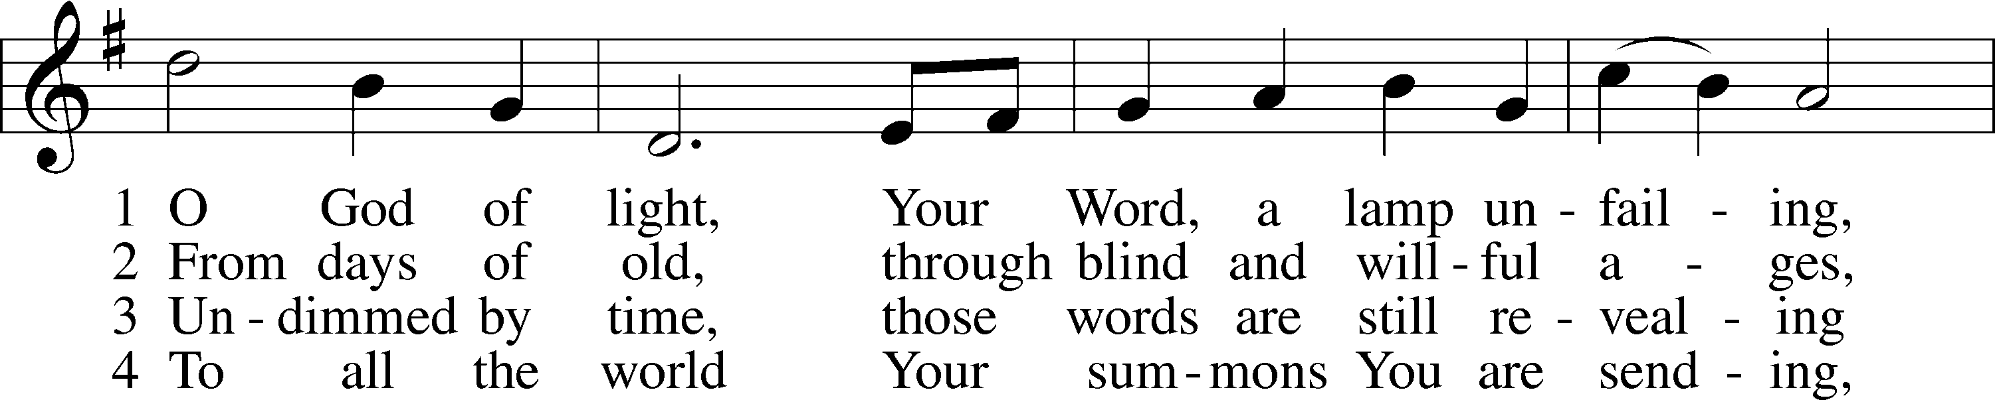

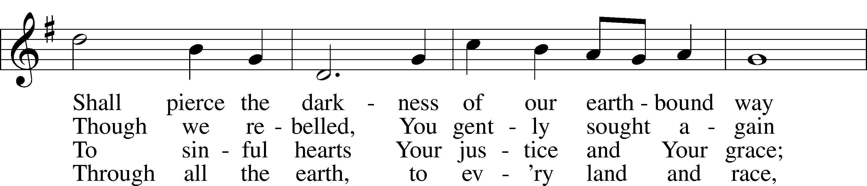

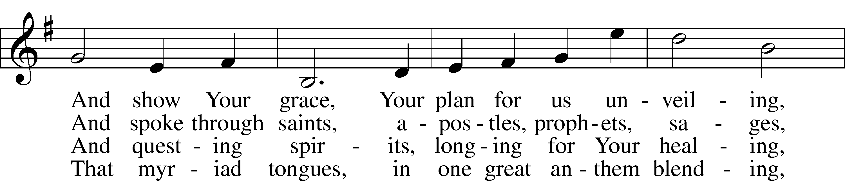

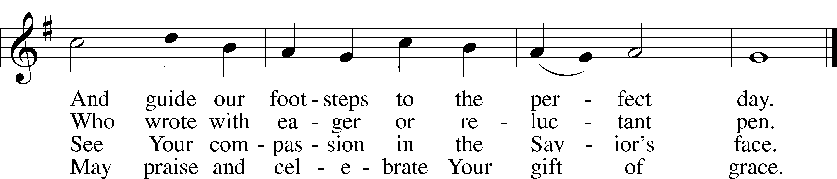

Text: Sarah E. Taylor, 1883–1954, alt.  
Tune: H. Barrie Cabena, 1933  
Text: © 1952, renewed 1980 The Hymn Society, admin. Hope Publishing Co. Used by permission: LSB Hymn License no. 110003344  
Tune: © 1978 Lutheran Book of Worship. Used by permission: LSB Hymn License no. 110003344

*Offering*

Stand

*Prayer p.265*

L In peace let us pray to the Lord:

C **Lord, have mercy.**

L For the gift of divine peace and of pardon, with all our heart and with all our mind, let us pray to the Lord:

C **Lord, have mercy.**

L For the holy Christian Church, here and scattered throughout the world, and for the proclamation of the Gospel and the calling of all to faith, let us pray to the Lord:

C **Lord, have mercy.**

L For this nation, for our cities and communities, and for the common welfare of us all, let us pray to the Lord:

C **Lord, have mercy.**

L For seasonable weather and for the fruitfulness of the earth, let us pray to the Lord:

C **Lord, have mercy.**

L For those who labor, for those whose work is difficult or dangerous, and for all who travel, let us pray to the Lord:

C **Lord, have mercy.**

L For all those in need, for the hungry and homeless, for the widowed and orphaned, and for all those in prison, let us pray to the Lord:

C **Lord, have mercy.**

L For the sick and dying and for all those who care for them, let us pray to the Lord:

C **Lord, have mercy.**

L Finally, for these and for all our needs of body and soul, let us pray to the Lord:

C **Lord, have mercy. Christ, have mercy. Lord, have mercy.**

*Collect of the Day*

L Almighty God, by Your great goodness mercifully look upon Your people that we may be governed and preserved evermore in body and soul; through Jesus Christ, Your Son, our Lord, who lives and reigns with You and the Holy Spirit, one God, now and forever.

C **Amen.**

*Collect for the Word p.265*

L Blessed Lord, You have caused all Holy Scriptures to be written for our learning. Grant that we may so hear them, read, mark, learn, and take them to heart that, by the patience and comfort of Your holy Word, we may embrace and ever hold fast the blessed hope of everlasting life; through Jesus Christ, Your Son, our Lord, who lives and reigns with You and the Holy Spirit, one God, now and forever.

C **Amen.**

Evening Prayer

C **I thank You, my heavenly Father, through Jesus Christ, Your dear Son, that You have graciously kept me this day; and I pray that You would forgive me all my sins where I have done wrong, and graciously keep me this night. For into Your hands I commend myself, my body and soul, and all things. Let Your holy angel be with me, that the evil foe may have no power over me. Amen.**

*Hymn* *“Lamb of God”* # 550

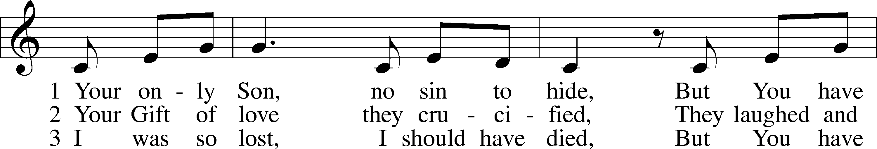

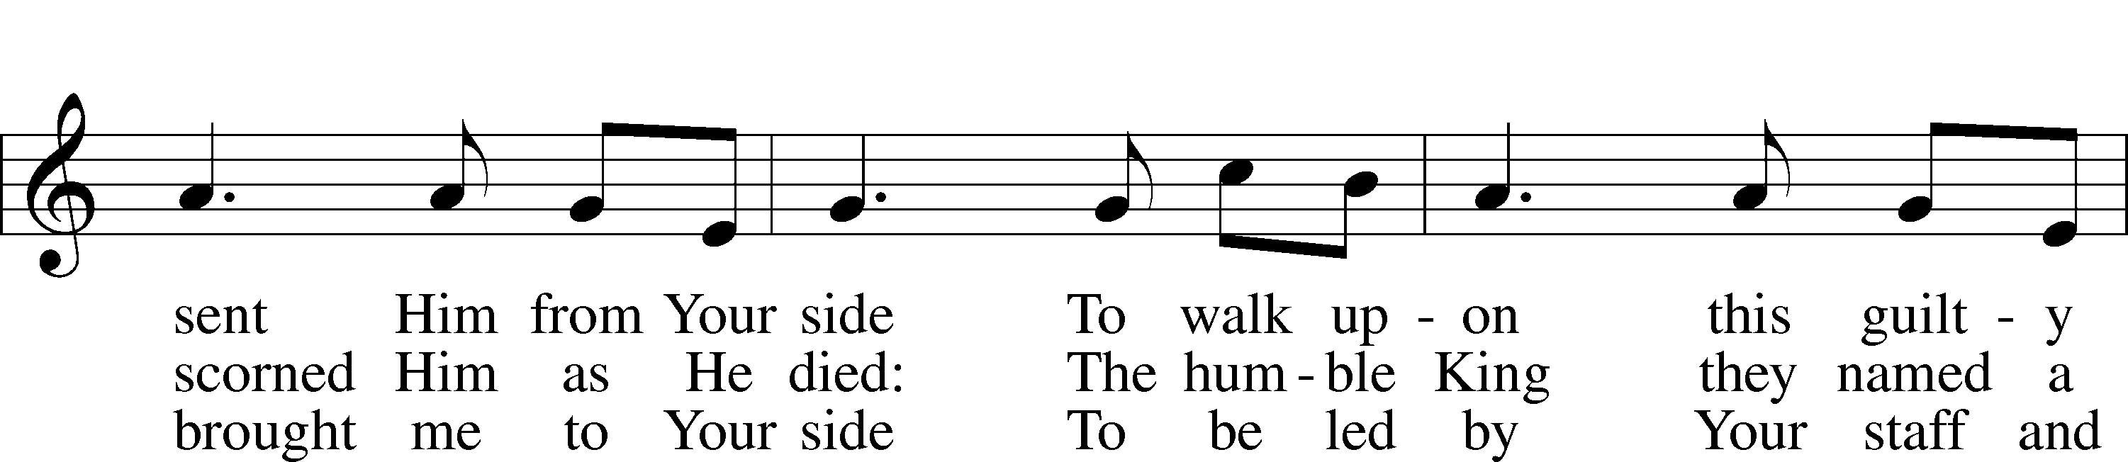

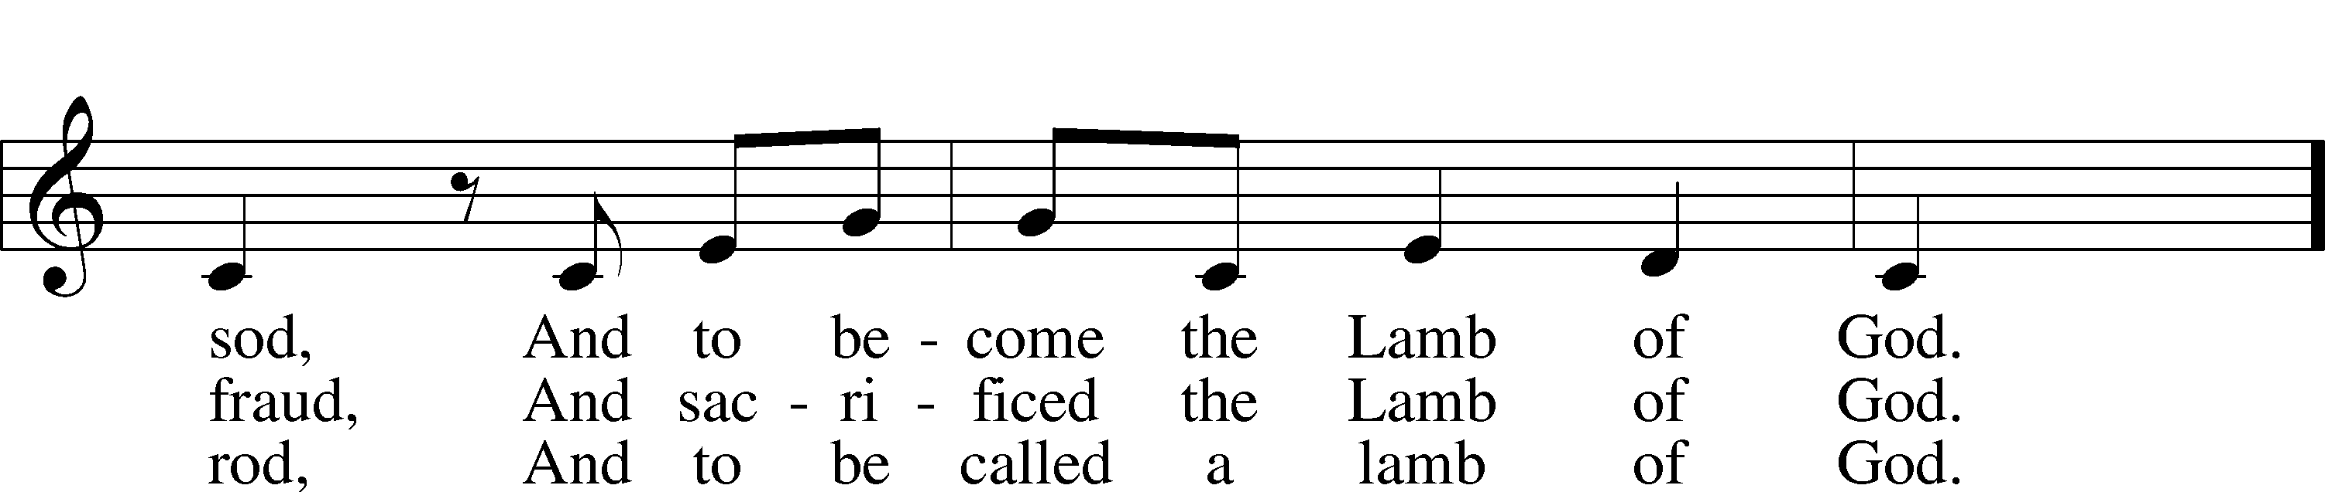

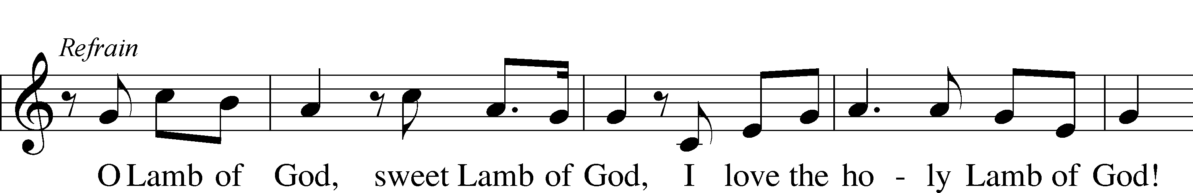

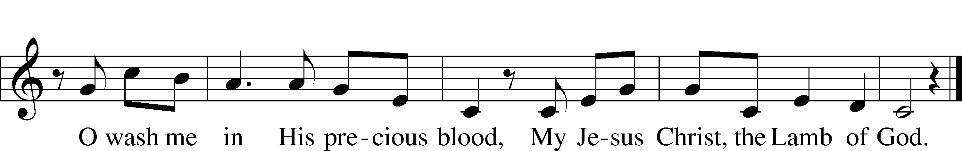

Text and tune: Twila Paris, 1958  
Text and tune: © 1985 Straightway Music, admin. EMI. Used by permission: LSB Hymn License no. 110003344

*Blessing*

L Let us bless the Lord.

C **Thanks be to God.**

L The almighty and merciful Lord, the Father, the T Son, and the Holy Spirit, bless and preserve us.

C **Amen.**

*Closing Hymn* *“Christ, Mighty Savior”* # 881

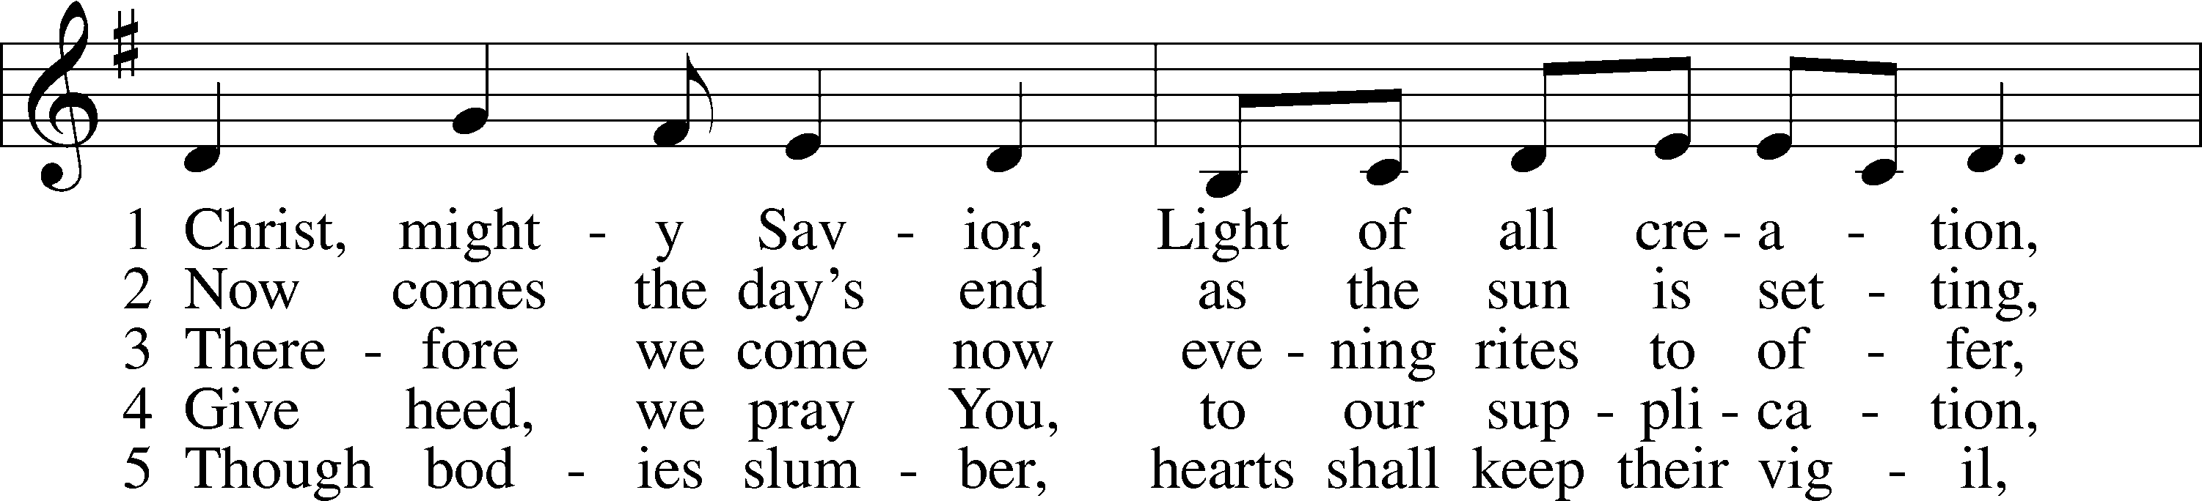

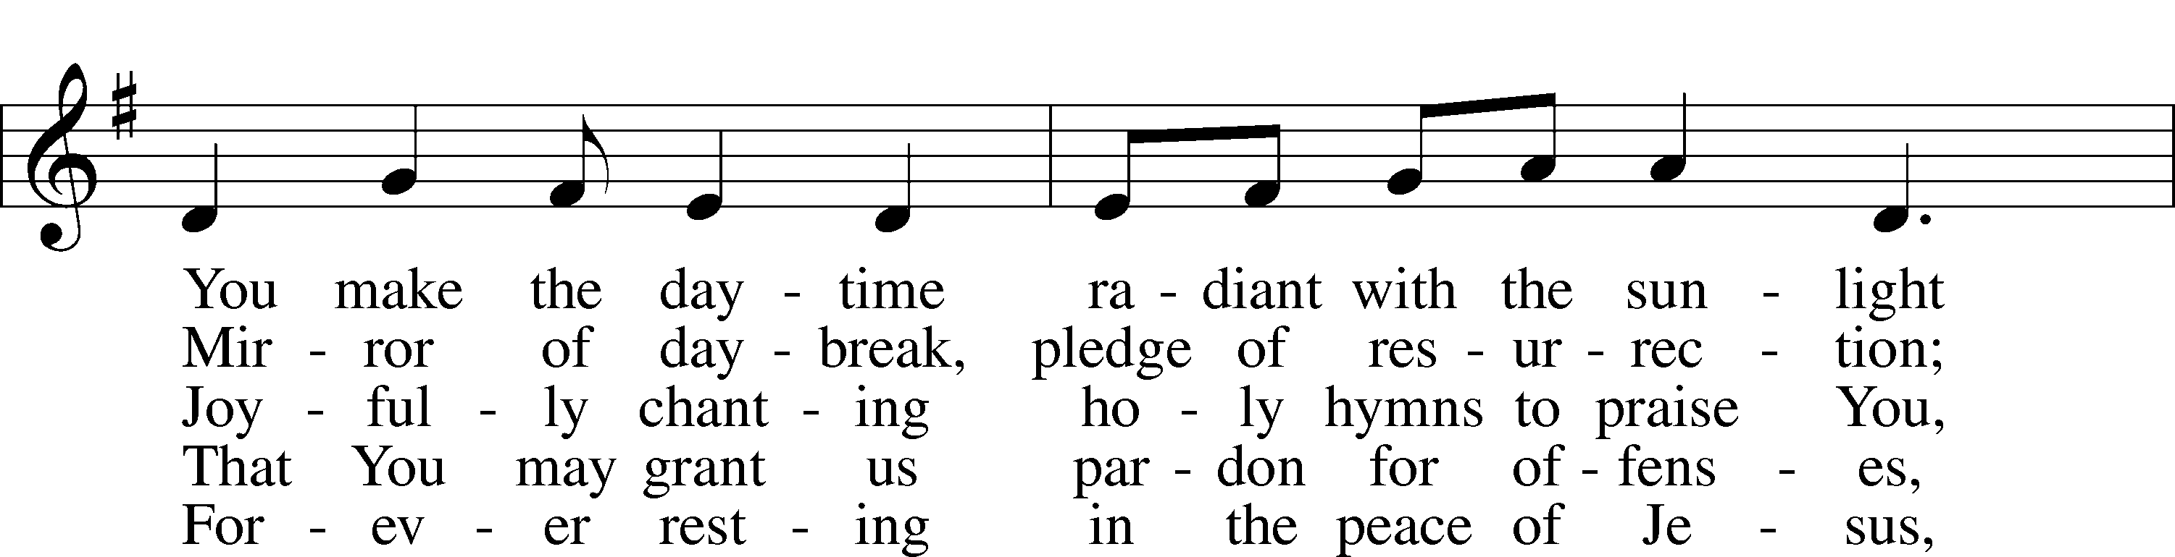

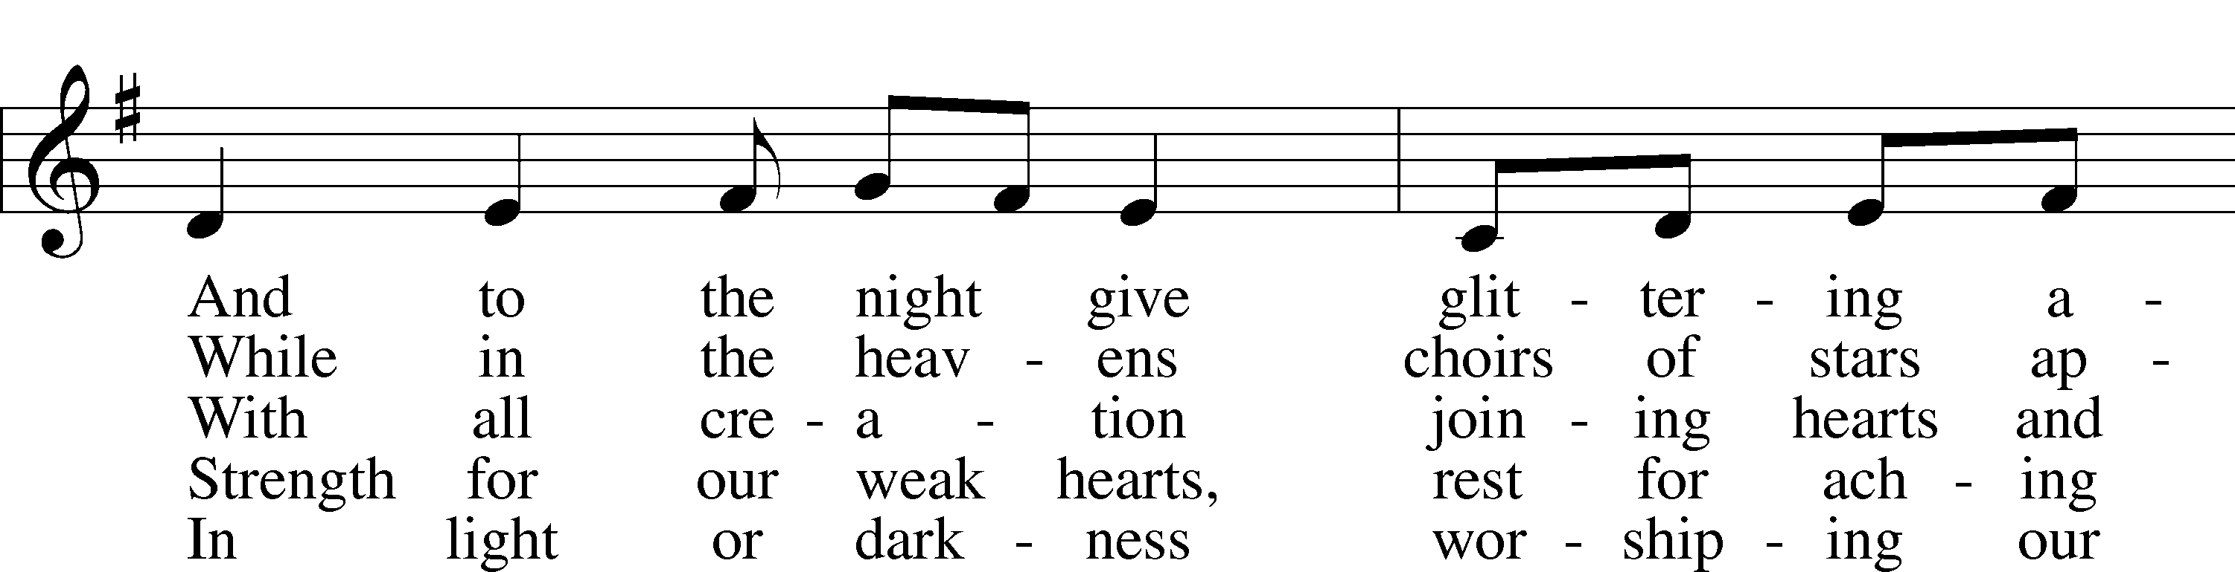

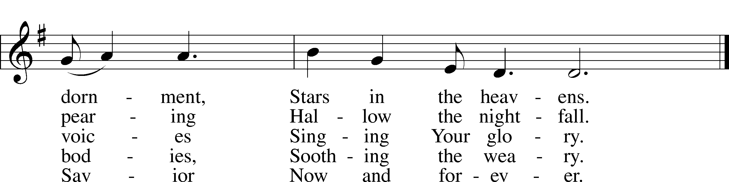

Text: Latin, c. 7th cent.; tr. Alan McDougall, 1895–1966; rev. Anne K. LeCroy, 1927–2016  
Tune: Richard W. Dirksen, 1921–2003  
Text: © 1982 The United Methodist Publishing House, admin. Music Services (ASCAP). Used by permission: LSB Hymn License no. 110003344  
Tune: © 1984 Washington National Cathedral. Used by permission: LSB Hymn License no. 110003344

Acknowledgments

Service of Prayer and Preaching from Lutheran Service Book

Unless otherwise indicated, Scripture quotations are from the ESV® Bible (The Holy Bible, English Standard Version®), copyright © 2001 by Crossway, a publishing ministry of Good News Publishers. Used by permission. All rights reserved.

Created by Lutheran Service Builder © 2024 Concordia Publishing House.