Blessed Savior Lutheran Church
Florissant, Missouri

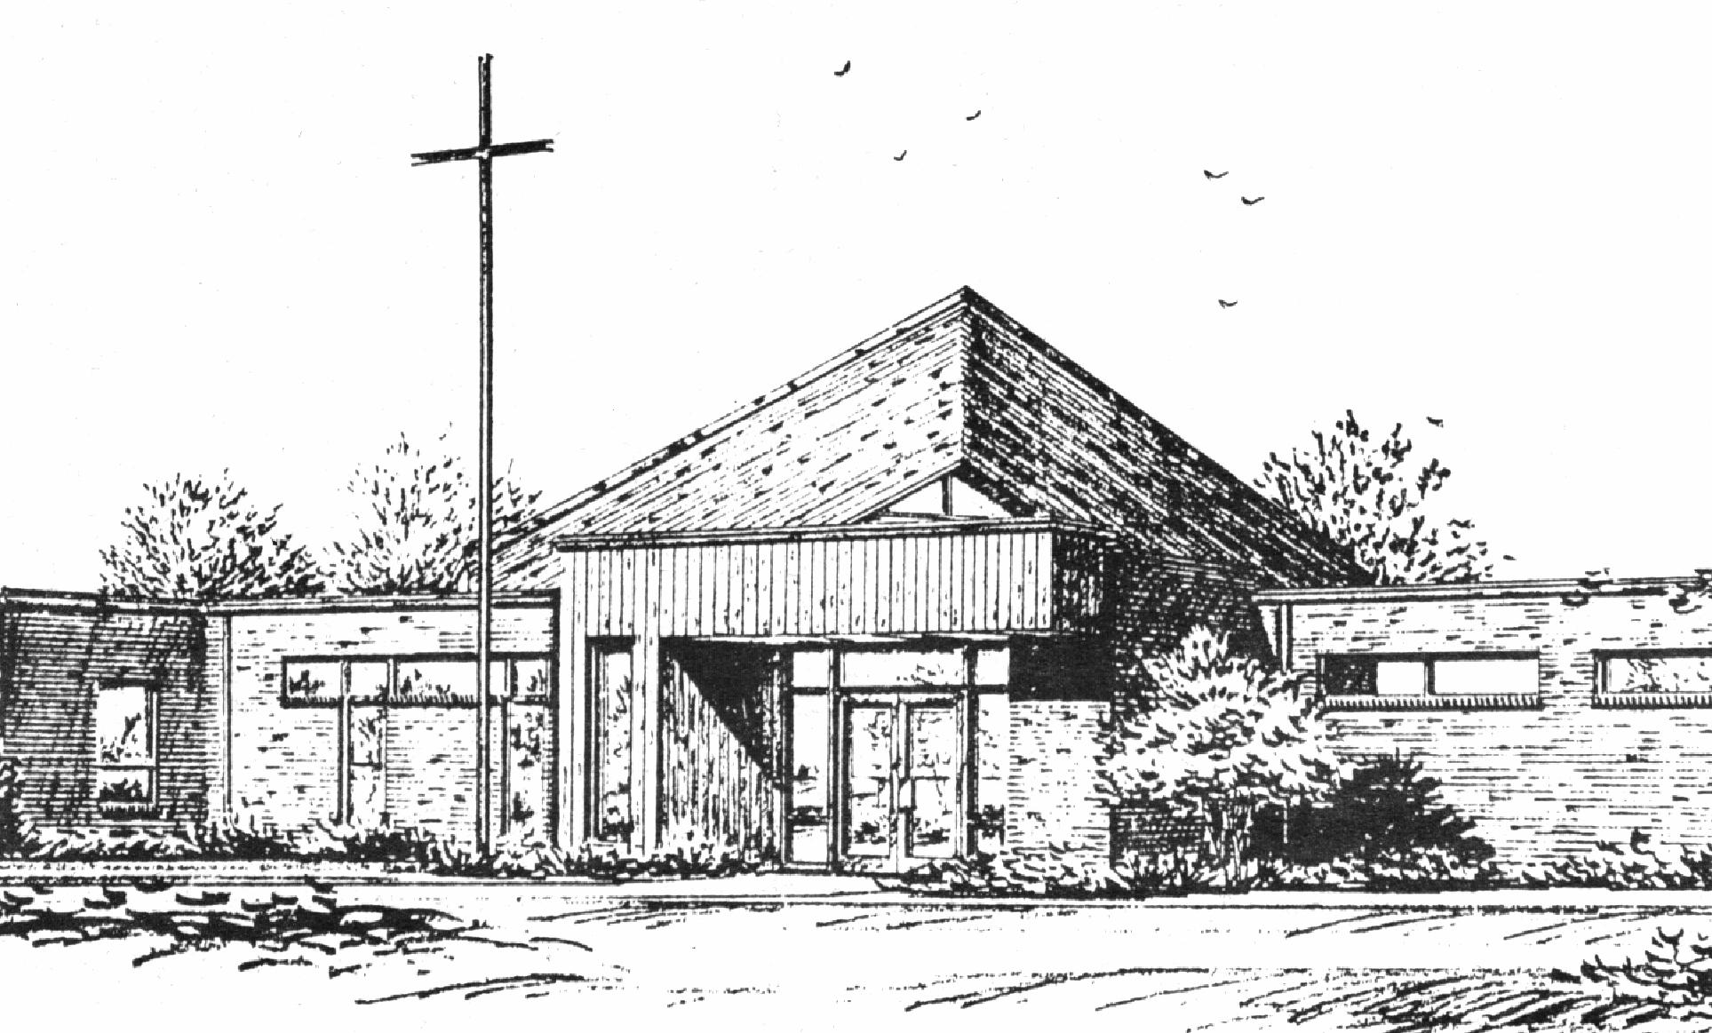
“Empowered by God’s Holy Word,
we joyfully share the love of Jesus with all people;
through worship, teaching, fellowship,
service and witnessing.”

The Resurrection of Our Lord
March 31, 2024

The Lutheran Church-Missouri Synod

BLESSED SAVIOR LUTHERAN CHURCH
2615 Shackelford Road
Florissant, Missouri 63031-2005
Telephone: 831-1300
www.blessedsavior-lcms.org
Pastor Matthew Roeglin
+ + + + + + + + + + + +
The Resurrection of Our Lord
Sunday, March 31, 2024

WE WELCOME YOU to our worship service this morning. We pray God’s rich blessings upon you as you hear His Word and praise His holy name. We ask our members and visitors to please use the friendship pad found on the pew. Kindly hand the friendship pad to the person sitting next to you. The Ushers will collect them after the service. Thank You.

HOLY COMMUNION will be offered during our worship services this week. You are encouraged to prepare for communion by meditating on the Christian Questions and Answers located on pages 329 & 330 in the front of the hymnal.
We rejoice in this celebration of the LORD’S Supper as the Lord Jesus indeed comes to us in a very intimate manner, giving to us His true Body & Blood in and with the bread and wine in this sacred meal. St. Paul writes, “A man ought to examine himself before he eats of the bread and drinks of the cup. For anyone who eats and drinks without recognizing the body of the Lord eats and drinks judgment on himself.” (1 Corinthians 11:28-29) It is out of love and care for every individual that comes to the Lord’s Supper that we ask those who are not instructed in the faith and/or doubt the presence of the Body and Blood of Jesus in this Sacrament to speak to the pastor before attending the Lord’s Supper. Members of churches that belong to the Lutheran Church- Missouri Synod, believing and confessing as we do, are invited to partake in the Lord’s Supper with us. We practice close communion and ask that ALL guests who desire to commune; kindly speak to the Pastor before the service. Please respect our position of love in this matter of pastoral care, BSLC.

THIS WORSHIP FOLDER / CHURCH BULLETIN is prepared for your convenience and contains the entire order of worship with all spoken and sung responses. However, if you are more comfortable using the hymnal, you may use the order of worship found in the front pages of Lutheran Service Book where all the melodies are shown for the sung responses of the congregation.

Divine Service 1 p.151

Greeting of Peace The people may greet one another in the name of the Lord, saying, “Peace be with you,” as a sign of reconciliation and of the unity of the Spirit in the bond of peace (Matt. 5:22-24; Eph. 4:1-3)

Opening Hymn “Jesus Christ Is Risen Today” # 457
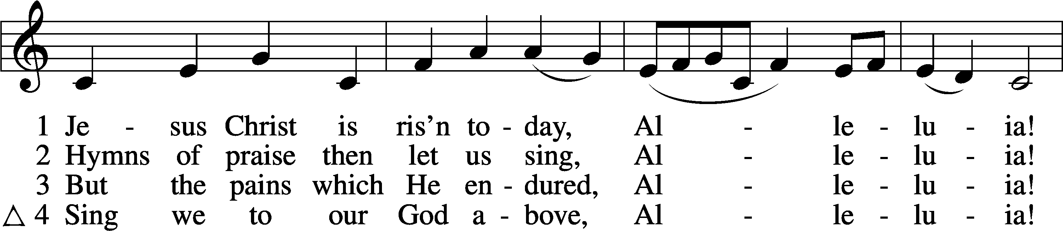
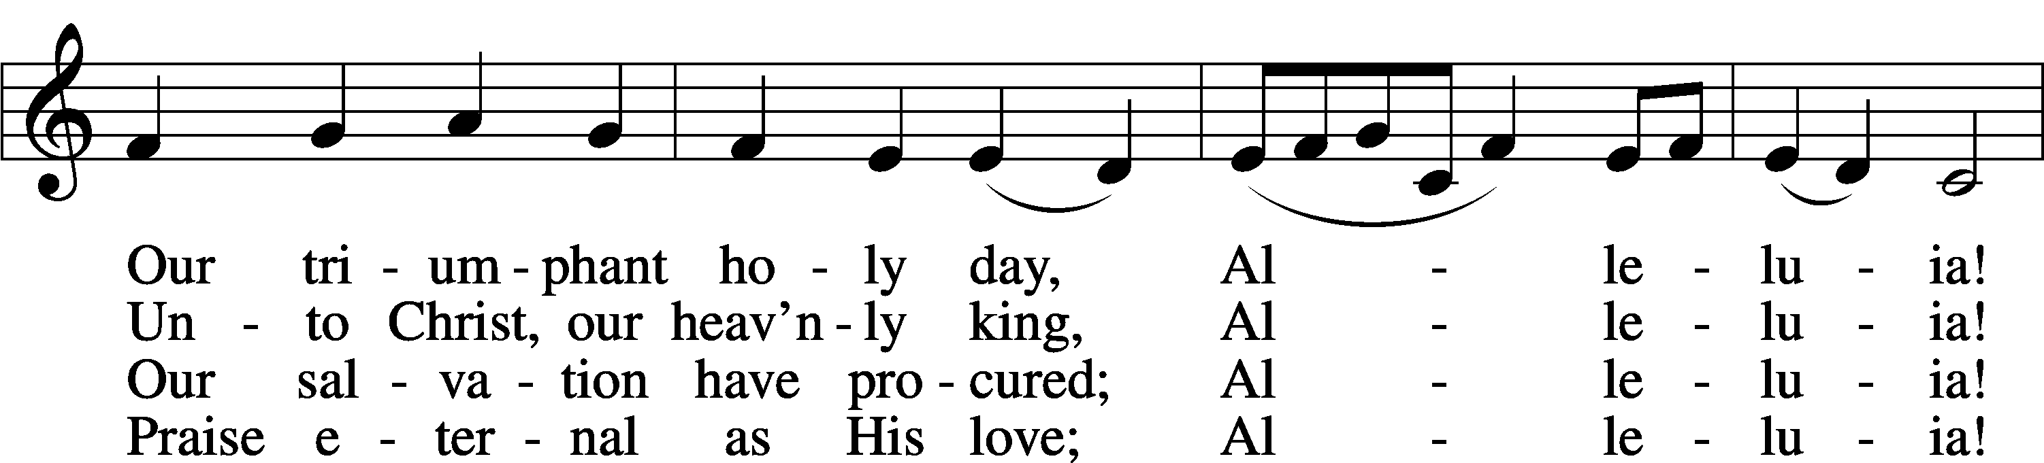
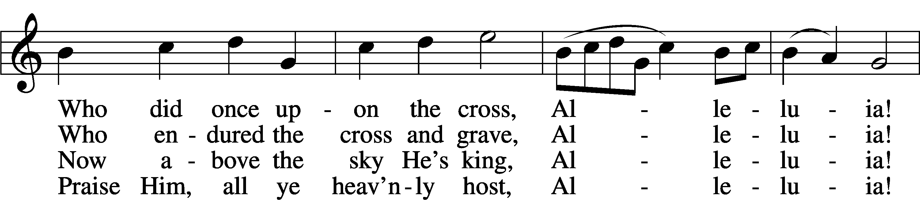
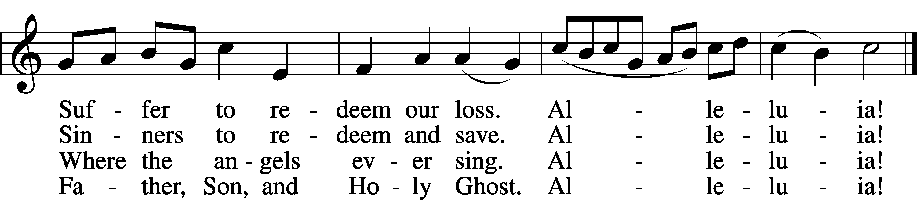
Text: tr. Lyra Davidica, 1708, London, alt.; (sts. 1–3): Latin, 14th cent.; (st. 4): Charles Wesley, 1707–88
Tune: Lyra Davidica, 1708, London
Text and tune: Public domain

Stand
Confession and Absolution
The sign of the cross may be made by all in remembrance of their Baptism.

P In the name of the Father and of the T Son and of the Holy Spirit.
C Amen.

P If we say we have no sin, we deceive ourselves, and the truth is not in us.
C But if we confess our sins, God, who is faithful and just, will forgive our sins and cleanse us from all unrighteousness.

Silence for reflection on God’s Word and for self-examination.

P Let us then confess our sins to God our Father.
C Most merciful God, we confess that we are by nature sinful and unclean. We have sinned against You in thought, word, and deed, by what we have done and by what we have left undone. We have not loved You with our whole heart; we have not loved our neighbors as ourselves. We justly deserve Your present and eternal punishment. For the sake of Your Son, Jesus Christ, have mercy on us. Forgive us, renew us, and lead us, so that we may delight in Your will and walk in Your ways to the glory of Your holy name. Amen.

P Almighty God in His mercy has given His Son to die for you and for His sake forgives you all your sins. As a called and ordained servant of Christ, and by His authority, I therefore forgive you all your sins in the name of the Father and of the T Son and of the Holy Spirit.
C Amen.

Service of the Word
Introit Exodus 15:2a, 6, 13, 17–18; antiphon: v. 1b
I will sing to the Lord, for he has triumphed | gloriously;*
the horse and his rider he has thrown in- | to the sea.
The Lord is my strength | and my song,*
and he has become my sal- | vation.
Your right hand, O Lord, glorious | in power,*
your right hand, O Lord, shatters the | enemy.
You have led in your steadfast love the people whom you | have redeemed;*
you have guided them by your strength to your ho- | ly abode.
You will bring them in and plant them on your own | mountain,*
the place, O Lord, which you have made for | your abode,
the sanctuary, O Lord, which your hands have es- | tablished.*
The Lord will reign forever and | ever.
Glory be to the Father and | to the Son
and to the Holy | Spirit;
as it was in the be- | ginning,
is now, and will be forever. | Amen.
I will sing to the Lord, for he has triumphed | gloriously;*
the horse and his rider he has thrown in- | to the sea.

Kyrie p. 152
A In peace let us pray to the Lord.
C Lord, have mercy.
A For the peace from above and for our salvation let us pray to the Lord.
C Lord, have mercy.
A For the peace of the whole world, for the well-being of the Church of God, and for the unity of all let us pray to the Lord.
C Lord, have mercy.
A For this holy house and for all who offer here their worship and praise let us pray to the Lord.
C Lord, have mercy.
A Help, save, comfort, and defend us, gracious Lord.
C Amen.

Hymn of Praise “This Is the Feast” p. 155
C This is the feast of victory for our God.
Alleluia, alleluia, alleluia.

Worthy is Christ, the Lamb who was slain,
whose blood set us free to be people of God.
This is the feast of victory for our God.
Alleluia, alleluia, alleluia.

Power, riches, wisdom, and strength,
and honor, blessing, and glory are His.
This is the feast of victory for our God.
Alleluia, alleluia, alleluia.

Sing with all the people of God, and join in the hymn of all creation:
Blessing, honor, glory, and might be to God and the Lamb forever. Amen.

This is the feast of victory for our God.
Alleluia, alleluia, alleluia.

For the Lamb who was slain has begun His reign. Alleluia.
This is the feast of victory for our God.
Alleluia, alleluia, alleluia.

Salutation and Collect of the Day
P The Lord be with you.
C And also with you.

P Let us pray.
C Almighty God the Father, through Your only-begotten Son, Jesus Christ, You have overcome death and opened the gate of everlasting life to us. Grant that we, who celebrate with joy the day of our Lord’s resurrection, may be raised from the death of sin by Your life-giving Spirit; through Jesus Christ, our Lord, who lives and reigns with You and the Holy Spirit, one God, now and forever. Amen.

Sit
Old Testament Reading Isaiah 65:17–25
17“Behold, I create new heavens
and a new earth,
and the former things shall not be remembered
or come into mind.
18But be glad and rejoice forever
in that which I create;
for behold, I create Jerusalem to be a joy,
and her people to be a gladness.
19I will rejoice in Jerusalem
and be glad in my people;
no more shall be heard in it the sound of weeping
and the cry of distress.
20No more shall there be in it
an infant who lives but a few days,
or an old man who does not fill out his days,
for the young man shall die a hundred years old,
and the sinner a hundred years old shall be accursed.
21They shall build houses and inhabit them;
they shall plant vineyards and eat their fruit.
22They shall not build and another inhabit;
they shall not plant and another eat;
for like the days of a tree shall the days of my people be,
and my chosen shall long enjoy the work of their hands.
23They shall not labor in vain
or bear children for calamity,
for they shall be the offspring of the blessed of the Lord,
and their descendants with them.
24Before they call I will answer;
while they are yet speaking I will hear.
25The wolf and the lamb shall graze together;
the lion shall eat straw like the ox,
and dust shall be the serpent’s food.
They shall not hurt or destroy
in all my holy mountain,”
says the Lord.
A This is the Word of the Lord.
C Thanks be to God.

Gradual adapt. from Matthew 28:7; Hebrews 2:7; Psalm 8:6
C Christ has risen from the dead. God the Father has crowned him with glory and honor. He has given him dominion over the works of his hands; he has put all things under his feet.
Epistle 1 Corinthians 15:19–26
19If in this life only we have hoped in Christ, we are of all people most to be pitied.
20But in fact Christ has been raised from the dead, the firstfruits of those who have fallen asleep. 21For as by a man came death, by a man has come also the resurrection of the dead. 22For as in Adam all die, so also in Christ shall all be made alive. 23But each in his own order: Christ the firstfruits, then at his coming those who belong to Christ. 24Then comes the end, when he delivers the kingdom to God the Father after destroying every rule and every authority and power. 25For he must reign until he has put all his enemies under his feet. 26The last enemy to be destroyed is death.

A This is the Word of the Lord.
C Thanks be to God.
Stand
Festival Alleluia

Holy Gospel Luke 24:1–12
P The Holy Gospel according to St. Luke, the twenty-fourth chapter.
C Glory to You, O Lord.

1On the first day of the week, at early dawn, they went to the tomb, taking the spices they had prepared. 2And they found the stone rolled away from the tomb, 3but when they went in they did not find the body of the Lord Jesus. 4While they were perplexed about this, behold, two men stood by them in dazzling apparel. 5And as they were frightened and bowed their faces to the ground, the men said to them, “Why do you seek the living among the dead? 6He is not here, but has risen. Remember how he told you, while he was still in Galilee, 7that the Son of Man must be delivered into the hands of sinful men and be crucified and on the third day rise.” 8And they remembered his words, 9and returning from the tomb they told all these things to the eleven and to all the rest. 10Now it was Mary Magdalene and Joanna and Mary the mother of James and the other women with them who told these things to the apostles, 11but these words seemed to them an idle tale, and they did not believe them. 12But Peter rose and ran to the tomb; stooping and looking in, he saw the linen cloths by themselves; and he went home marveling at what had happened.

P This is the Gospel of the Lord.
C Praise to You, O Christ.

Festival Alleluia

Nicene Creed
C I believe in one God, the Father Almighty,
maker of heaven and earth and of all things visible and invisible.

And in one Lord Jesus Christ, the only-begotten Son of God, begotten of His Father before all worlds, God of God, Light of Light, very God of very God, begotten, not made, being of one substance with the Father, by whom all things were made; who for us men and for our salvation came down from heaven and was incarnate by the Holy Spirit of the virgin Mary and was made man;
and was crucified also for us under Pontius Pilate. He suffered and was buried. And the third day He rose again according to the Scriptures and ascended into heaven and sits at the right hand of the Father. And He will come again with glory to judge both the living and the dead, whose kingdom will have no end.

And I believe in the Holy Spirit, the Lord and giver of life, who proceeds from the Father and the Son,
who with the Father and the Son together is worshiped and glorified, who spoke by the prophets. And I believe in one holy Christian and apostolic Church, I acknowledge one Baptism for the remission of sins, and I look for the resurrection of the dead and the life T of the world to come. Amen.

Choir Anthem “Crown Him Lord this Easter Day”
Sit
Children's Message
Sermon Hymn “This Joyful Eastertide” # 482
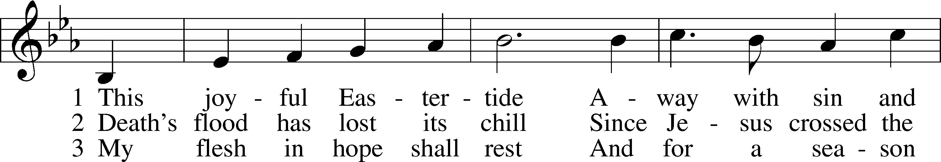
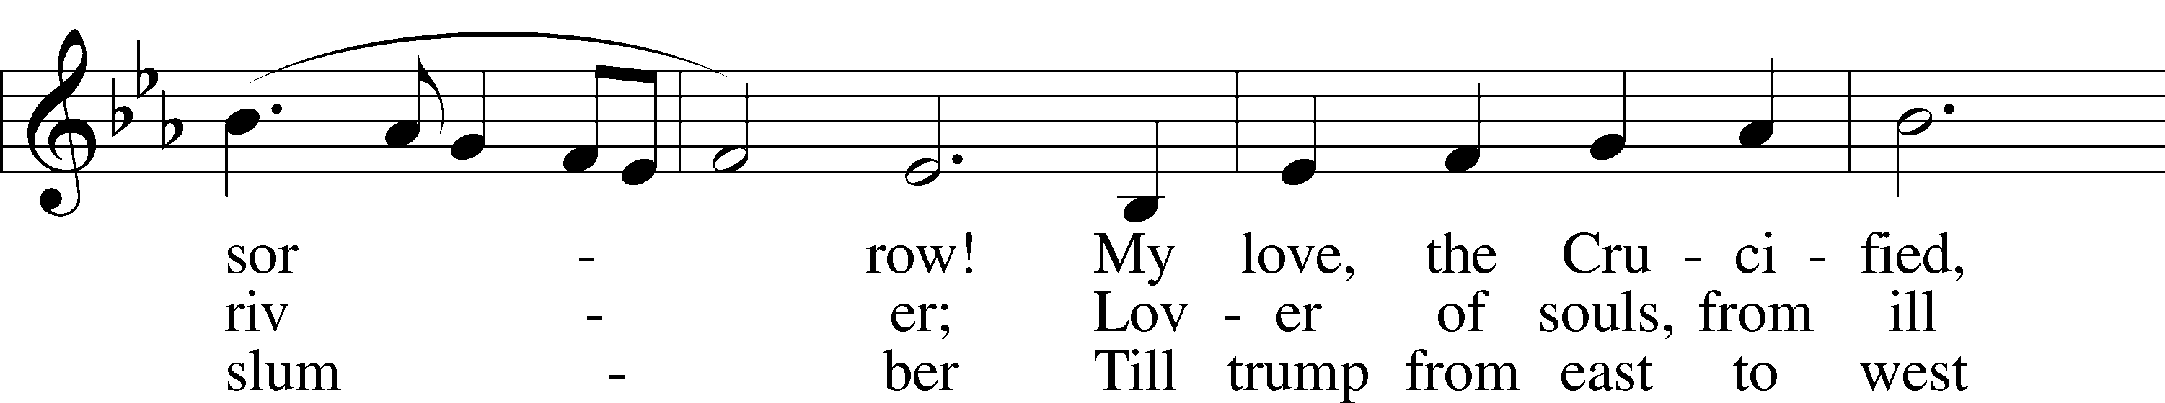
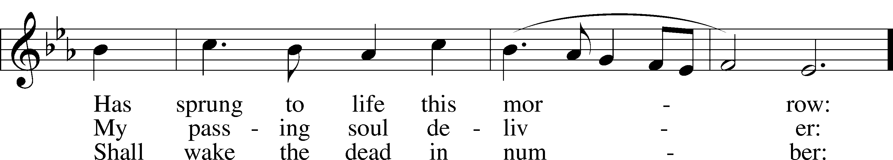
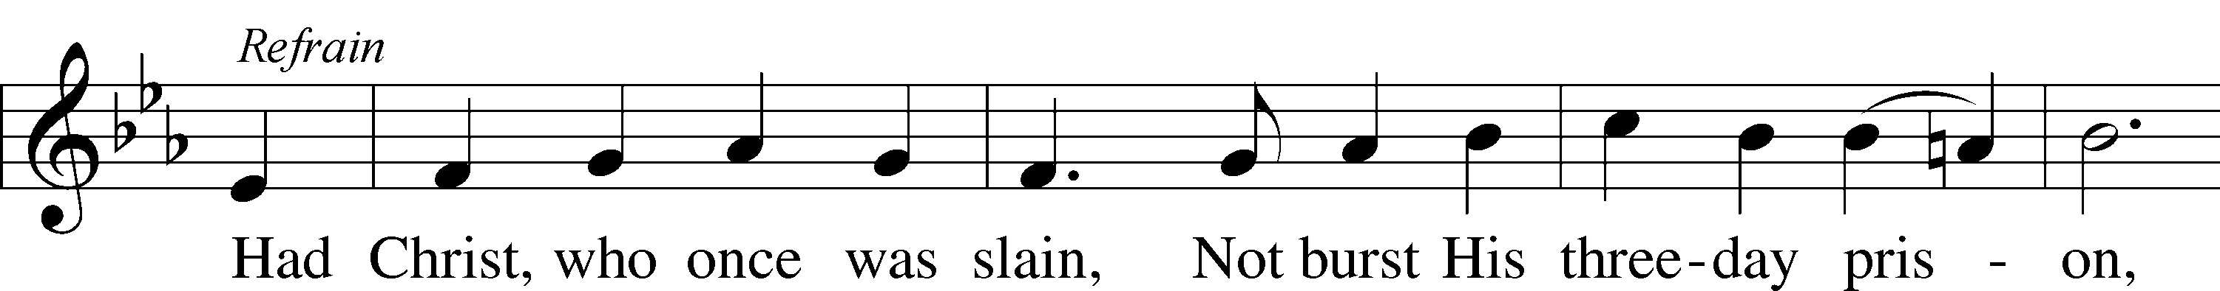
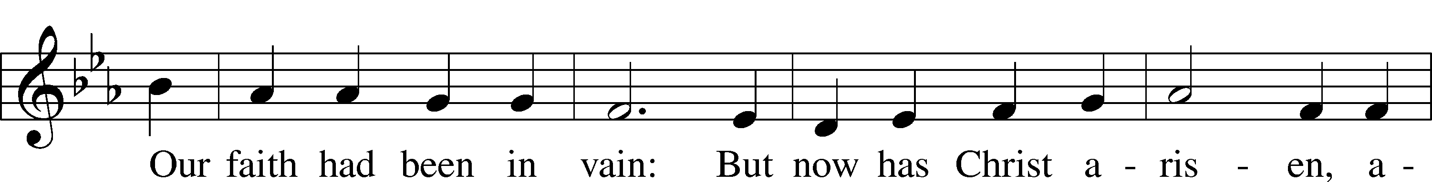
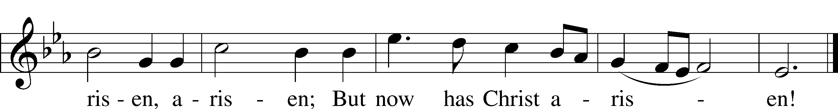
Text: George R. Woodward, 1848–1934
Tune: Davids Psalmen, 1684, Amsterdam
Text and tune: Public domain
Sermon
Responsive Hymn “Alleluia! Jesus Is Risen” # 474
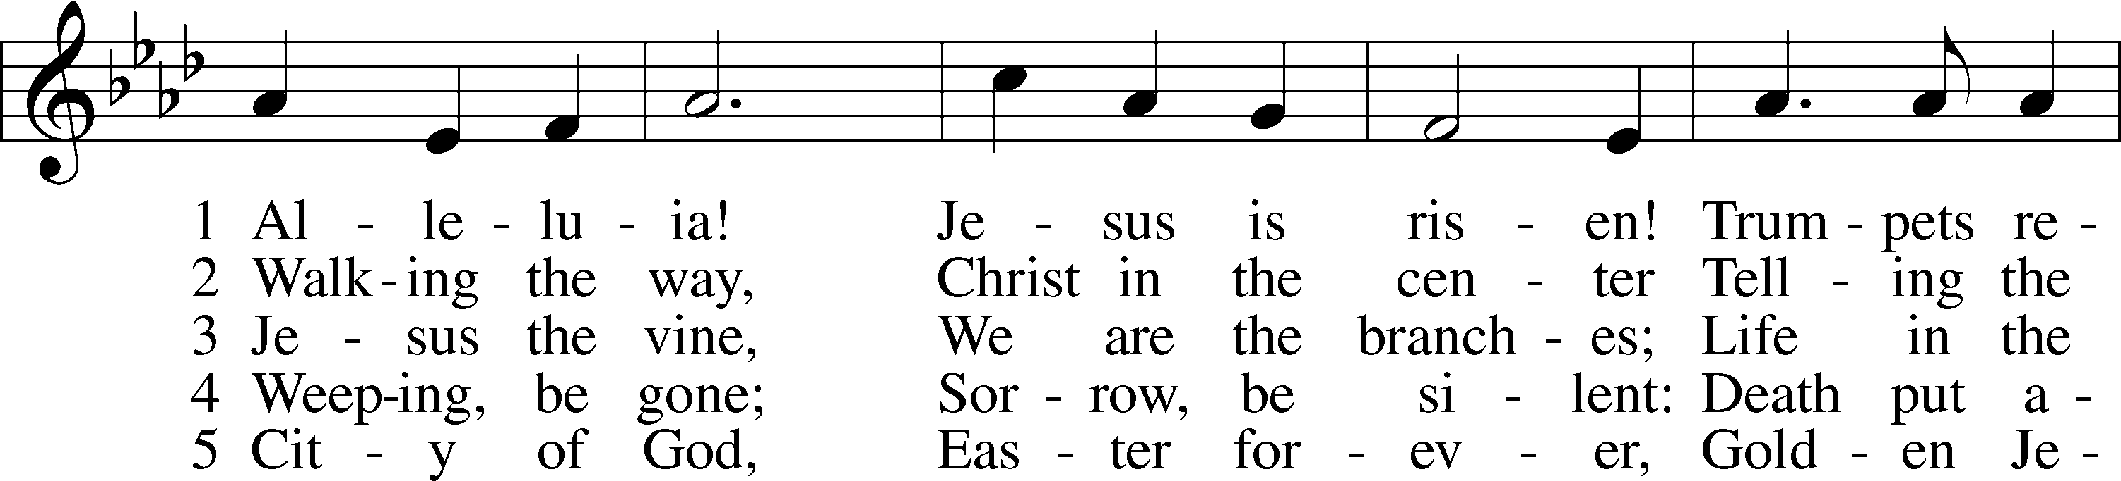
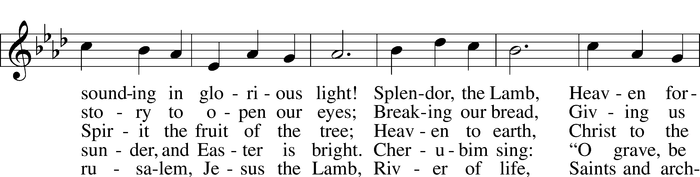
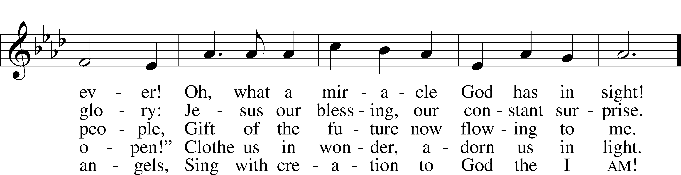
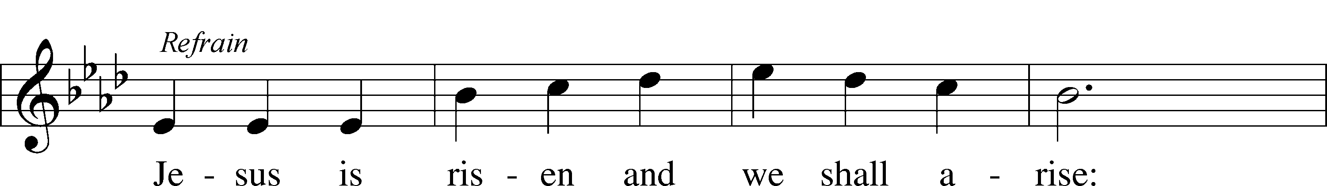
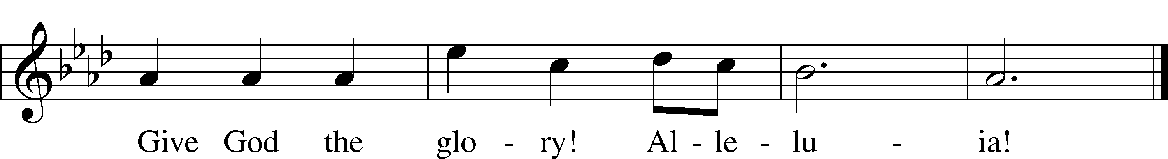
Text: © 1995 Augsburg Fortress. Used by permission: LSB Hymn License no. 110003344
Tune: © 1968 Augsburg Publishing House. Used by permission: LSB Hymn License no. 110003344

Offering
Stand
Offertory p. 159
C What shall I render to the Lord for all His benefits to me?
I will offer the sacrifice of thanksgiving and will call on the name of the Lord.
I will take the cup of salvation and will call on the name of the Lord.
I will pay my vows to the Lord now in the presence of all His people,
in the courts of the Lord’s house, in the midst of you, O Jerusalem.

Prayer of the Church
After each petition of the prayers:
P | Lord, in Your mercy.
C | Hear our prayer.
After the final petition:
P | One God, now and forever.
C | Amen.

Service of the Sacrament
Preface p. 160
P The Lord be with you.
C And also with you.

P Lift up your hearts.
C We lift them to the Lord.

P Let us give thanks to the Lord our God.
C It is right to give Him thanks and praise.

P It is truly good, right, and salutary that we should at all times and in all places give thanks to You, holy Lord, almighty Father, everlasting God. And most especially are we bound to praise You on this day for the glorious resurrection of Your Son, Jesus Christ, the very Paschal Lamb, who was sacrificed for us and bore the sins of the world. By His dying He has destroyed death, and by His rising again He has restored to us everlasting life. Therefore with Mary Magdalene, Peter and John, and with all the witnesses of the resurrection, with angels and archangels, and with all the company of heaven we laud and magnify Your glorious name, evermore praising You and saying:

Sanctus p. 161
C Holy, holy, holy Lord God of pow’r and might:
Heaven and earth are full of Your glory.
Hosanna. Hosanna.
Hosanna in the highest.
Blessed is He who comes in the name of the Lord.
Hosanna in the highest.

Prayer of Thanksgiving p. 161
P Blessed are You, Lord of heaven and earth, for You have had mercy on those whom You created and sent Your only-begotten Son into our flesh to bear our sin and be our Savior. With repentant joy we receive the salvation accomplished for us by the all-availing sacrifice of His body and His blood on the cross.

Gathered in the name and the remembrance of Jesus, we beg You, O Lord, to forgive, renew, and strengthen us with Your Word and Spirit. Grant us faithfully to eat His body and drink His blood as He bids us do in His own testament. Gather us together, we pray, from the ends of the earth to celebrate with all the faithful the marriage feast of the Lamb in His kingdom, which has no end. Graciously receive our prayers; deliver and preserve us. To You alone, O Father, be all glory, honor, and worship, with the Son and the Holy Spirit, one God, now and forever.
C Amen.

Lord’s Prayer p. 162
P Lord, remember us in Your kingdom and teach us to pray:
C Our Father who art in heaven,
hallowed be Thy name,
Thy kingdom come,
Thy will be done on earth
as it is in heaven;
give us this day our daily bread;
and forgive us our trespasses
as we forgive those
who trespass against us;
and lead us not into temptation,
but deliver us from evil.
For Thine is the kingdom
and the power and the glory
forever and ever. Amen.

The Words of Our Lord p.162
P Our Lord Jesus Christ, on the night when He was betrayed, took bread, and when He had given thanks, He broke it and gave it to the disciples and said: “Take, eat; this is My T body, which is given for you. This do in remembrance of Me.”

In the same way also He took the cup after supper, and when He had given thanks, He gave it to them, saying: “Drink of it, all of you; this cup is the new testament in My T blood, which is shed for you for the forgiveness of sins. This do, as often as you drink it, in remembrance of Me.”

Pax Domini p. 163
P The peace of the Lord be with you always.
C Amen.

Agnus Dei p. 163
C Lamb of God, You take away the sin of the world; have mercy on us.
Lamb of God, You take away the sin of the world; have mercy on us.
Lamb of God, You take away the sin of the world; grant us peace.

Sit
Distribution
Distribution Hymns
Distribution Hymns
“Christ Has Arisen, Alleluia” # 466
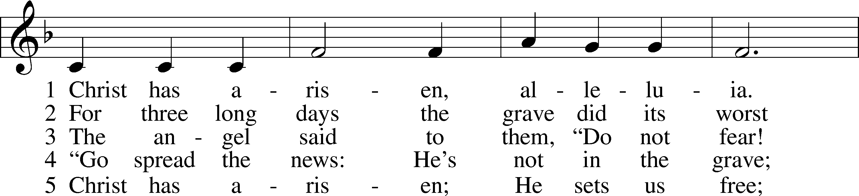
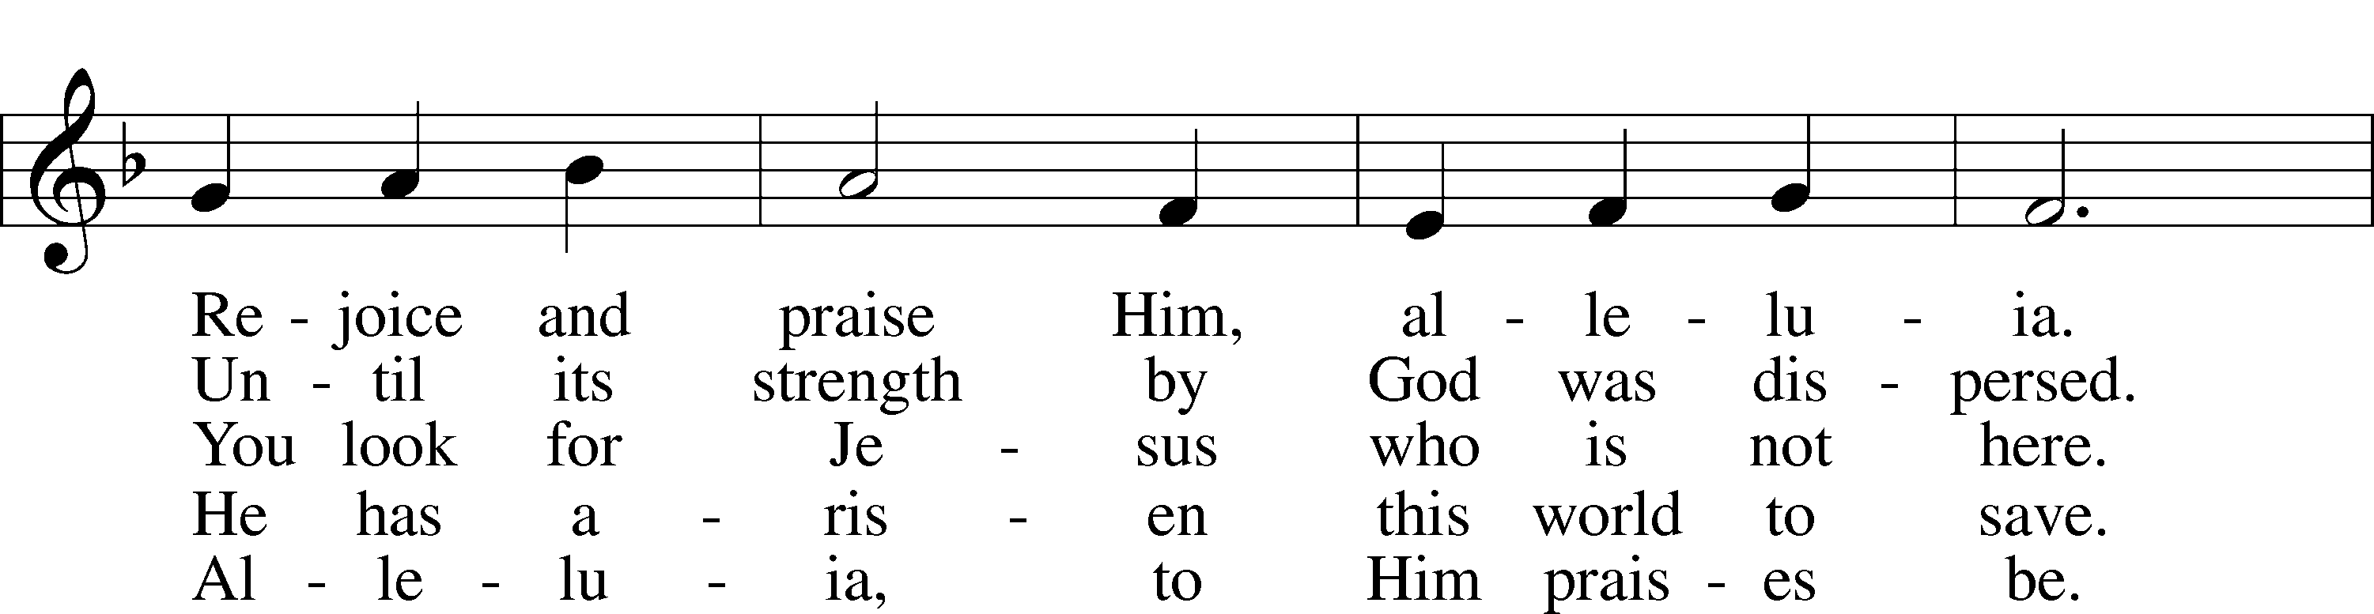
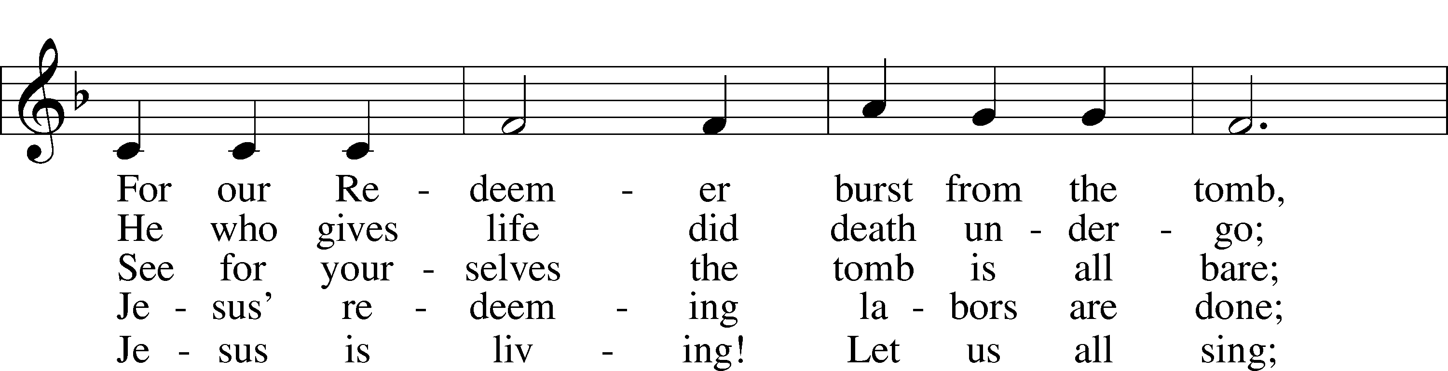
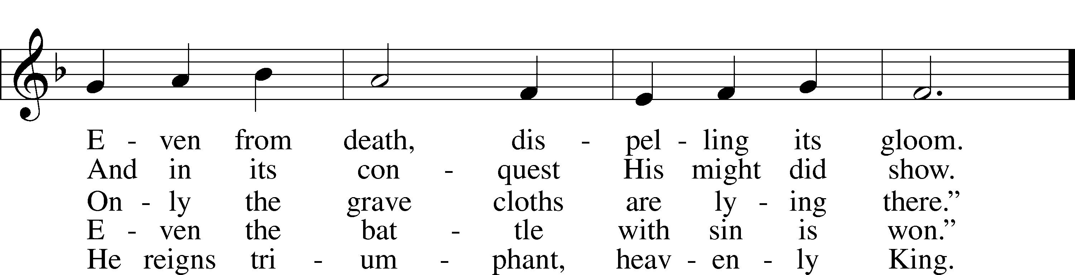
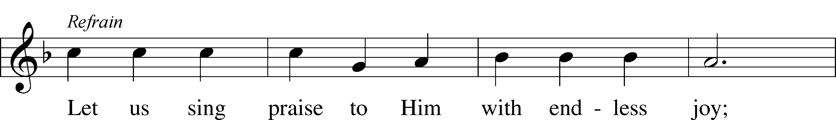
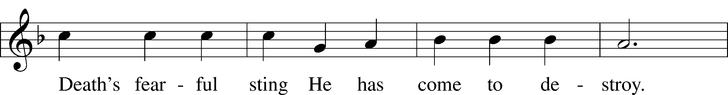
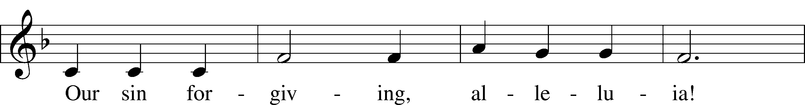
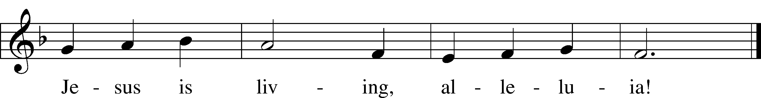
Text: Bernard Kyamanywa, 1938; tr. Howard S. Olson, 1922–2010
Tune: Tanzanian
Text: © 1977 Howard S. Olson. Used by permission: LSB Hymn License no. 110003344
Tune: Public domain
“At the Lamb’s High Feast We Sing” # 633
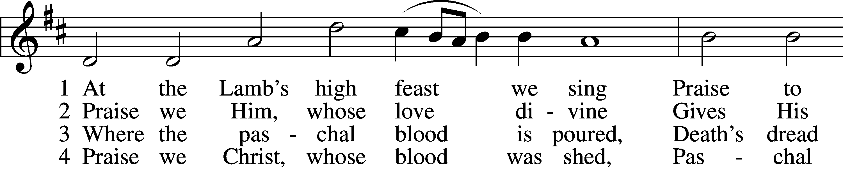
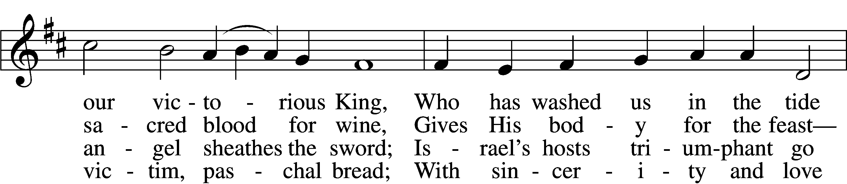
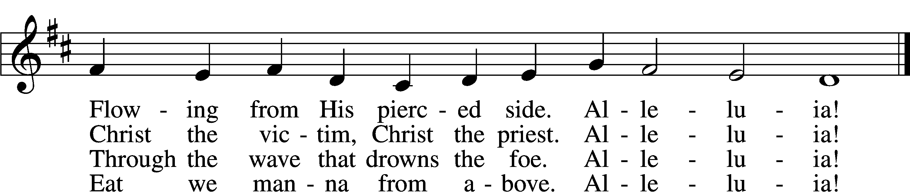

5 Mighty Victim from the sky,
Hell’s fierce pow’rs beneath You lie;
You have conquered in the fight,
You have brought us life and light.
Alleluia!

6 Now no more can death appall,
Now no more the grave enthrall;
You have opened paradise,
And Your saints in You shall rise.
Alleluia!

7 Easter triumph, Easter joy!
This alone can sin destroy;
From sin’s pow’r, Lord, set us free,
Newborn souls in You to be.
Alleluia!

D 8 Father, who the crown shall give,
Savior, by whose death we live,
Spirit, guide through all our days:
Three in One, Your name we praise.
Alleluia!
Text: Latin, c. 5th–10th cent.; tr. Robert Campbell, 1814–68, alt.
Tune: Kirchengeseng, 1566, Ivancice
Text and tune: Public domain

Distribution Hymn
“Awake, My Heart, with Gladness” # 467
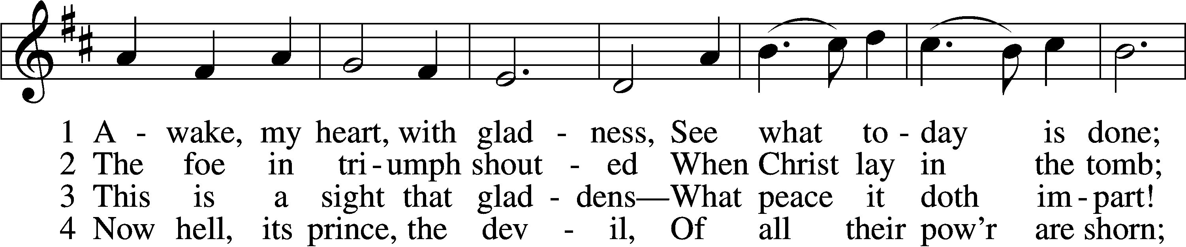
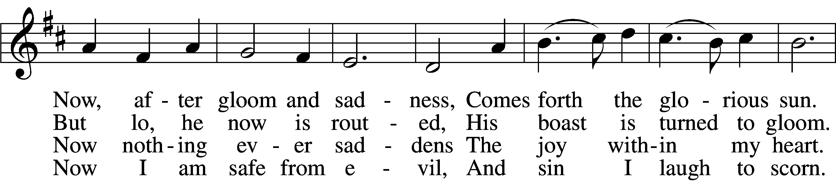
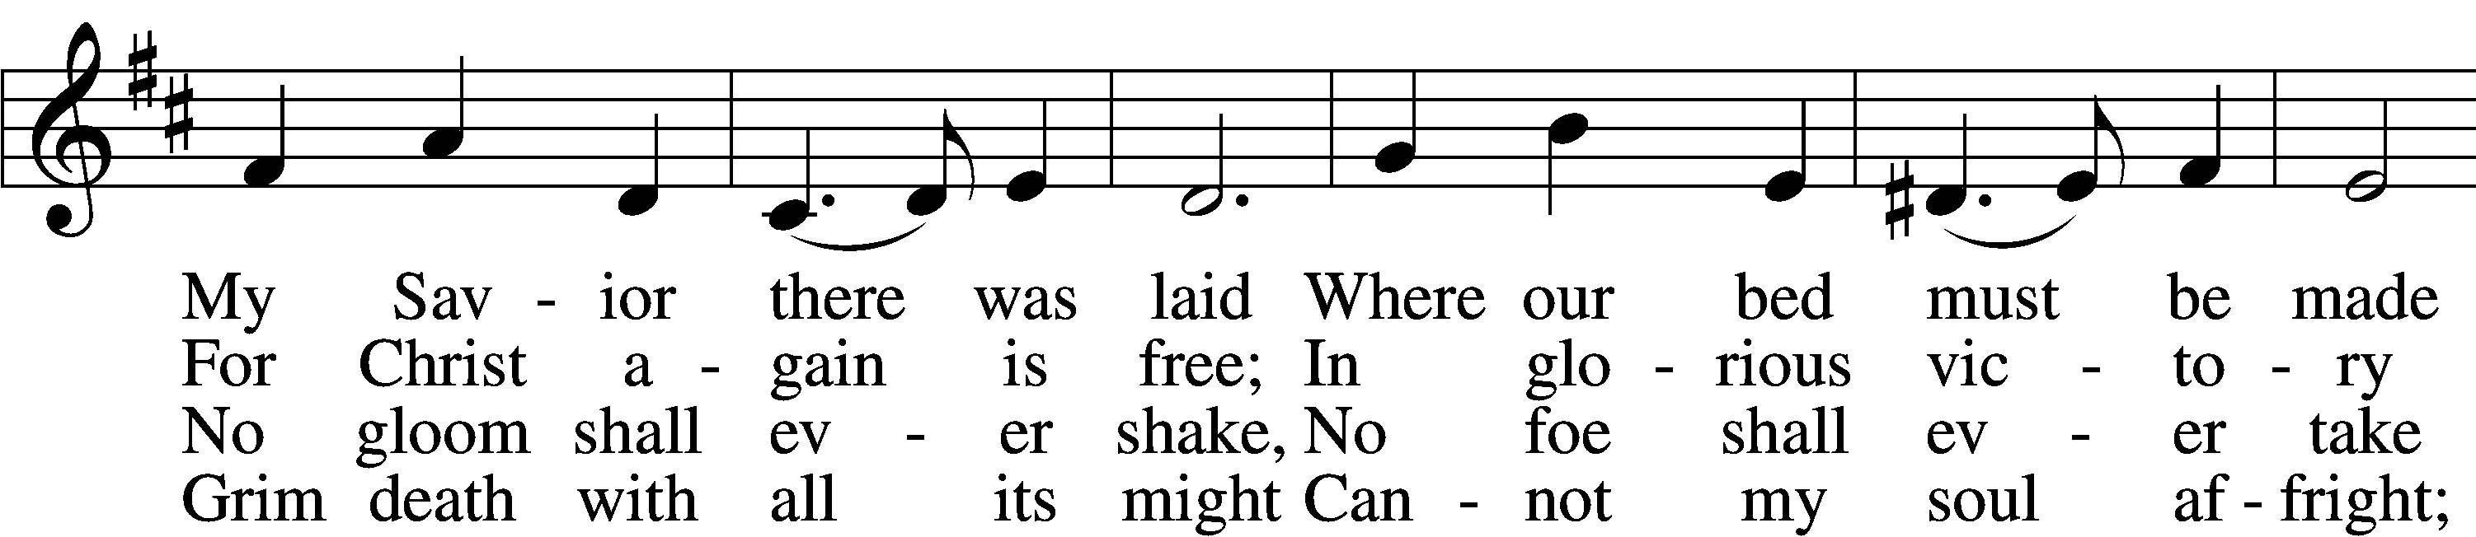
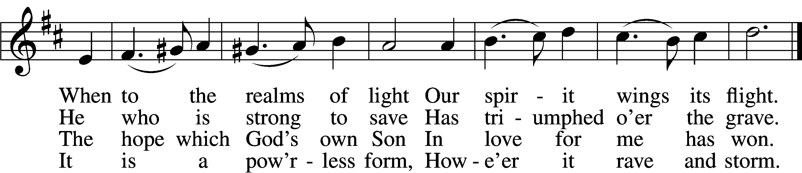

5 The world against me rages,
Its fury I disdain;
Though bitter war it wages,
Its work is all in vain.
My heart from care is free,
No trouble troubles me.
Misfortune now is play,
And night is bright as day.

6 Now I will cling forever
To Christ, my Savior true;
My Lord will leave me never,
Whate’er He passes through.
He rends death’s iron chain;
He breaks through sin and pain;
He shatters hell’s grim thrall;
I follow Him through all.

7 He brings me to the portal
That leads to bliss untold,
Whereon this rhyme immortal
Is found in script of gold:
“Who there My cross has shared
Finds here a crown prepared;
Who there with Me has died
Shall here be glorified.”
Text: Paul Gerhardt, 1607–76; tr. John Kelly, 1833–90, alt.
Tune: Johann Crüger, 1598–1662
Text and tune: Public domain

Stand
Post-Communion Canticle “Thank the Lord” p. 164
C Thank the Lord and sing His praise; tell ev’ryone what He has done.
Let all who seek the Lord rejoice and proudly bear His name.
He recalls His promises and leads His people forth in joy
with shouts of thanksgiving. Alleluia, alleluia.

Post-Communion Collect p.166
P We give thanks to You, almighty God, that You have refreshed us through this salutary gift, and we implore You that of Your mercy You would strengthen us through the same in faith toward You and in fervent love toward one another; through Jesus Christ, Your Son, our Lord, who lives and reigns with You and the Holy Spirit, one God, now and forever.
C Amen.

Benediction p. 166
P The Lord bless you and keep you.
The Lord make His face shine on you and be gracious to you.
The Lord look upon you with favor and T give you peace.
C Amen.
Closing Hymn “I Know That My Redeemer Lives” #461
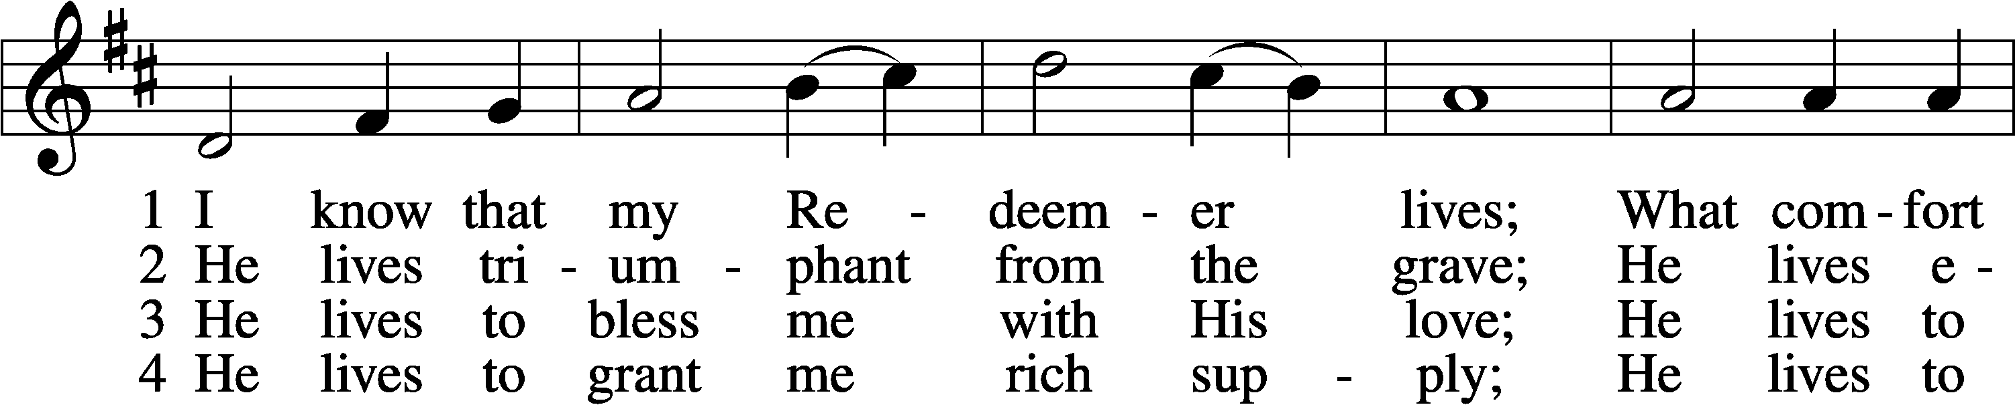
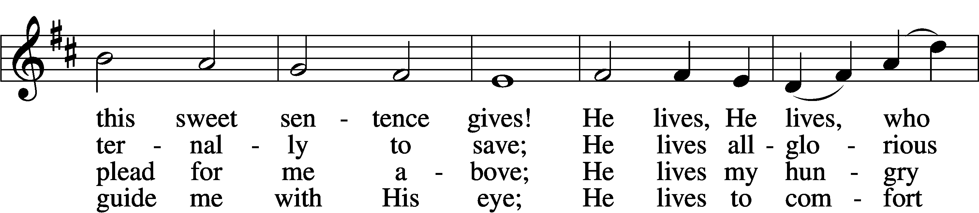
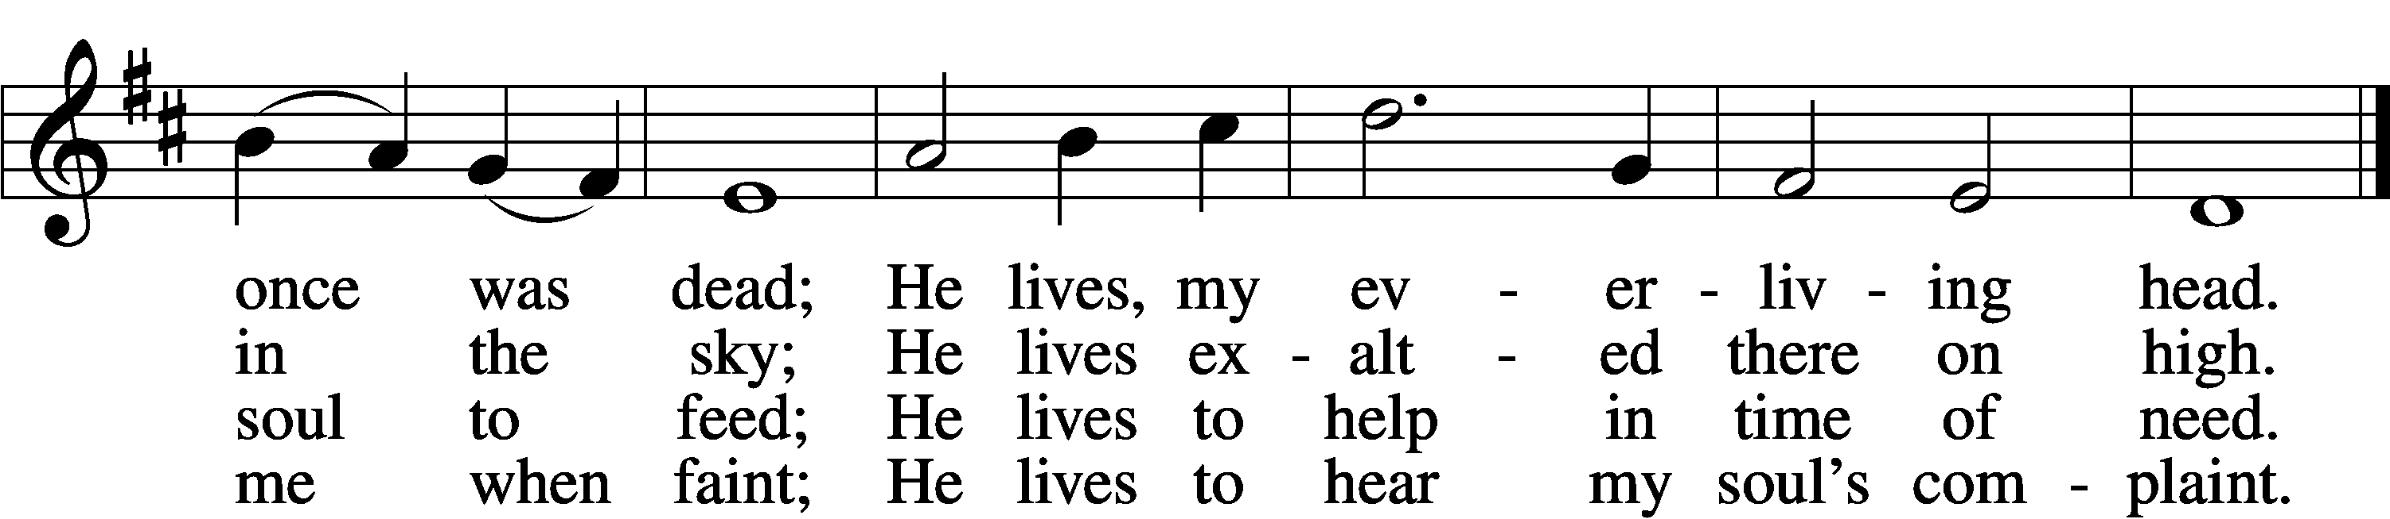

5 He lives to silence all my fears;
He lives to wipe away my tears;
He lives to calm my troubled heart;
He lives all blessings to impart.

6 He lives, my kind, wise, heav’nly friend;
He lives and loves me to the end;
He lives, and while He lives, I’ll sing;
He lives, my Prophet, Priest, and King.

7 He lives and grants me daily breath;
He lives, and I shall conquer death;
He lives my mansion to prepare;
He lives to bring me safely there.

8 He lives, all glory to His name!
He lives, my Jesus, still the same;
Oh, the sweet joy this sentence gives:
I know that my Redeemer lives!
Text: Samuel Medley, 1738–99, abr.
Tune: attr. John C. Hatton, d. 1793
Text and tune: Public domain

Acknowledgments
Unless otherwise indicated, Scripture quotations are from the ESV® Bible (The Holy Bible, English Standard Version®), copyright © 2001 by Crossway, a publishing ministry of Good News Publishers. Used by permission. All rights reserved.
Created by Lutheran Service Builder © 2022 Concordia Publishing House.
Sit
Announcements
After the announcements, please stand for the closing Doxology.

Doxology #805
Praise God, from whom all blessings flow;
Praise Him, all creatures here below;
Praise Him above, ye heav’nly host:
Praise Father, Son, and Holy Ghost. Amen.

Go and Serve the Lord
Acknowledgments Unless otherwise indicated, all scripture quotations are from The Holy Bible, English Standard Version, copyright © 2001 by Crossway Bibles, a division of Good News Publishers. Used by permission. All rights reserved. Created by Lutheran Service Builder © 2006 Concordia Publishing House.

The Liturgist & Preacher: Pastor Matthew Roeglin
The Brass:
The Choir:
The Organist: Mrs. Donna Boyd

Altar Flowers- The Easter Lilies and Hydrangea’s are placed by members of Blessed Savior to the Glory of God.

The Bossaller Family
“He Is Risen Indeed! Alleluia!”

Ray & Cheryl Ehrhard
“For God’s gift of our risen Savior and all His blessings. Alleluia! He is Risen!”

Brenda & Jim Martin
“In loving memory of Gene & Helen Martin and for God’s many blessings.”

Susan Johnston
“In loving memory of her father, Gerald Johnston.”

Wanda Johnston
“In loving memory of her husband, Gerald Johnston.”

Dan & Donna Boyd
“In loving memory of Jean Aurich”

Norman Soehl
“To the Glory of our Risen Lord”

Shirley McCabe
“Easter Blessings!”

Mark & Darlene Bradshaw
“In loving memory of all of our loved ones who reached heaven before us”

Jim & Joyce Wooliver
“Easter Blessings”

Lynn & Martha Oth
“Easter Blessings”

John & Danette Blank
“Easter Blessings”

Retha & Bradley Taylor
“To the Glory of God”

BLESSED SAVIOR’S CALENDAR
March 31 – April 7, 2024

TODAY:
Easter NO 8:15 a.m. Bible Class (McKenna)
Sunday 8:00 a.m. Easter Breakfast (potluck)
9:30 a.m. Worship Service w/Holy Communion
Mar. 31 NO 10:45 a.m. Bible Classes & Sunday School

MONDAY: Office Closed
Apr. 01

TUESDAY:
Apr. 02

WEDNESDAY: 2:30 a.m. Pastor’s Adult Bible Study
Apr. 03 6:00 p.m. Bible Study (McKenna)

THURSDAY:
Apr. 04

FRIDAY: Pastor - Day with family
Apr. 05

SATURDAY:
Apr. 06

NEXT 8:15 a.m. Adult Bible Study (McKenna)
SUNDAY 9:30 a.m. Worship Service w/Holy Communion
10:45 a.m. Adult Bible Class (Pastor)
10:45 a.m. Sunday School & High School
Apr. 07 Noon – LWML Lights Meeting

Mar. 31 The Resurrection of Our Lord John 20:1
“Now on the first day of the week ...” All is made new by the resurrection of Jesus! Even the day of worship has transitioned from the Old Testament’s Sabbath (Saturday) to the Lord’s Day of the New Testament (Sunday). For the Lord has made all things new: In rising from the dead as the new Adam, He has begun a new week for a new creation. We are also made new in Him — a new heart, a new life, new desires, a new outlook toward God. All this comes from our risen Lord’s grace. Especially after the sort of year we’ve had since last Easter, it sure is good news to hear that the Lord makes all things start afresh!

Our Response to God’s Love – March 24, 2024
Lent 3/20/24……….. 17
Sunday (9:30)………. 68
Sem Students/family......
Visitors…………..…
Communed….52
Total……………... 85
Sunday School…………
Sun. School/Bible Staff...
Bible Study/Youth……...
Bible Study/Y.Adults….
Bible Study I ………….
Bible Study II ………..
Adult/Confirm…….
Wednesday Morning …...

General Offerings…. $ 1,942.00
Misc. $ 0.00
Total response for week of: March 24 $ 1,942.00
Weekly Budget Needed $- 3,800.00
Deficit $- 1,858.00

Blessings Upon Blessings
Anniversary Campaign- Update
Wk of 3/17-24/24 YTD
Debt Reduction $ 0.00 $ 4,160.00
Improvement/Banners $ 20.00 $ 1,615.00
$ 20.00 $ 5,775.00

Our Special Prayers and Intercessions
Steve Haynes – heart issues
Nancy Stocker – health issues
Ted Stocker- health issues
Jim Laughlin – open heart surgery
Kim – cancer
Mary S. – cancer
Jeannie Firoved – health issues
Sara – health
Tiffany Connor – health issues
Connor Stretch – Health issues
Mike – Liver failure
Andrew – Guidance
Wanda Johnston – recovering from hip
Surgery
David Hogenmiller – health
Rev. Gary Shack – health
Jim Grimes – health issues
Cheryl Ehrhard – recovering- knee surgery
JoAnn Roellig - hospice

Kyle – renewal of faith
Heather – strengthening of faith
Pastor Struve- hospitalized
Marge Struve – health issues
Pastor Eric Carlson – Leukemia
Anneliese Wenger – health issues
Charlotte Taggert – health issues
Jessica Parish – MS
Rita Kirk – health issues
Mary Peacock – health
Debbie – home recovering
Lindsay – health
Wendy DeSanto – health issues
Patti Henneman – health issues
Laurie Moore – health issues
William – health issues
Doris Boyd – health issues
David Kuhl – health
Mike Wilder – cancer
Tom Murphy – health
Kelly - health
Retha Taylor – health
Caitlyn – health

Serving in our Armed Forces – Andrew Mack, Paul Hackett, Jay Warren, Michael Rice, Caleb McElyea, Jeff Throgmorton, Adam Guercio, Chance Glover, Cody Guercio, Danny Chung, Zayne Glatz, Alanna Kreppert, James Adelhardt, Sean Bentrup, Wesley Peach, Jordan Rolf, Anne Heintzelman, Austin Dreckshage, Ken Leppert II, Shelby Croghan & Richard Vengels.

*Please note: Those who are named in our special prayers and intercessions list are placed there by members of our congregation. St. Paul tells us in 1Timothy 2:1-2: “I urge, then, first of all, that requests, prayers, intercessions and thanksgivings be made for everyone – for kings and all those in authority, that we may live peaceful and quiet lives in all godliness and holiness. This is good, and pleases God our Savior.” Those named remain joyfully in our prayers until the person who requested our prayers removes them or until the Lord resolves their need. Therefore, as St. Paul tells us in Philippians 4:6 “Do not be anxious about anything, but in everything, by prayer and petition, with thanksgiving, present your request to God.

