Opening Hymn “Come, You Faithful, Raise the Strain” # 487
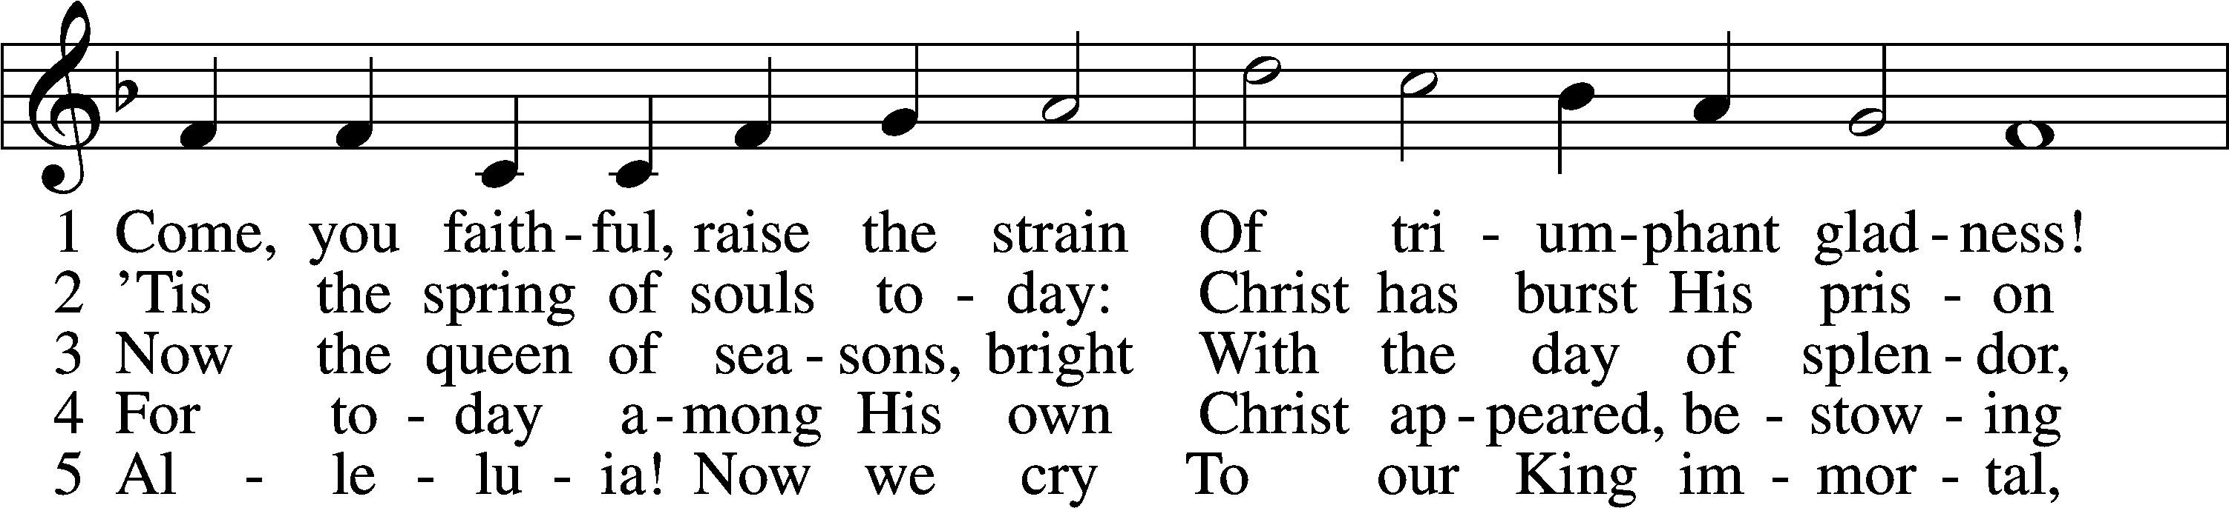
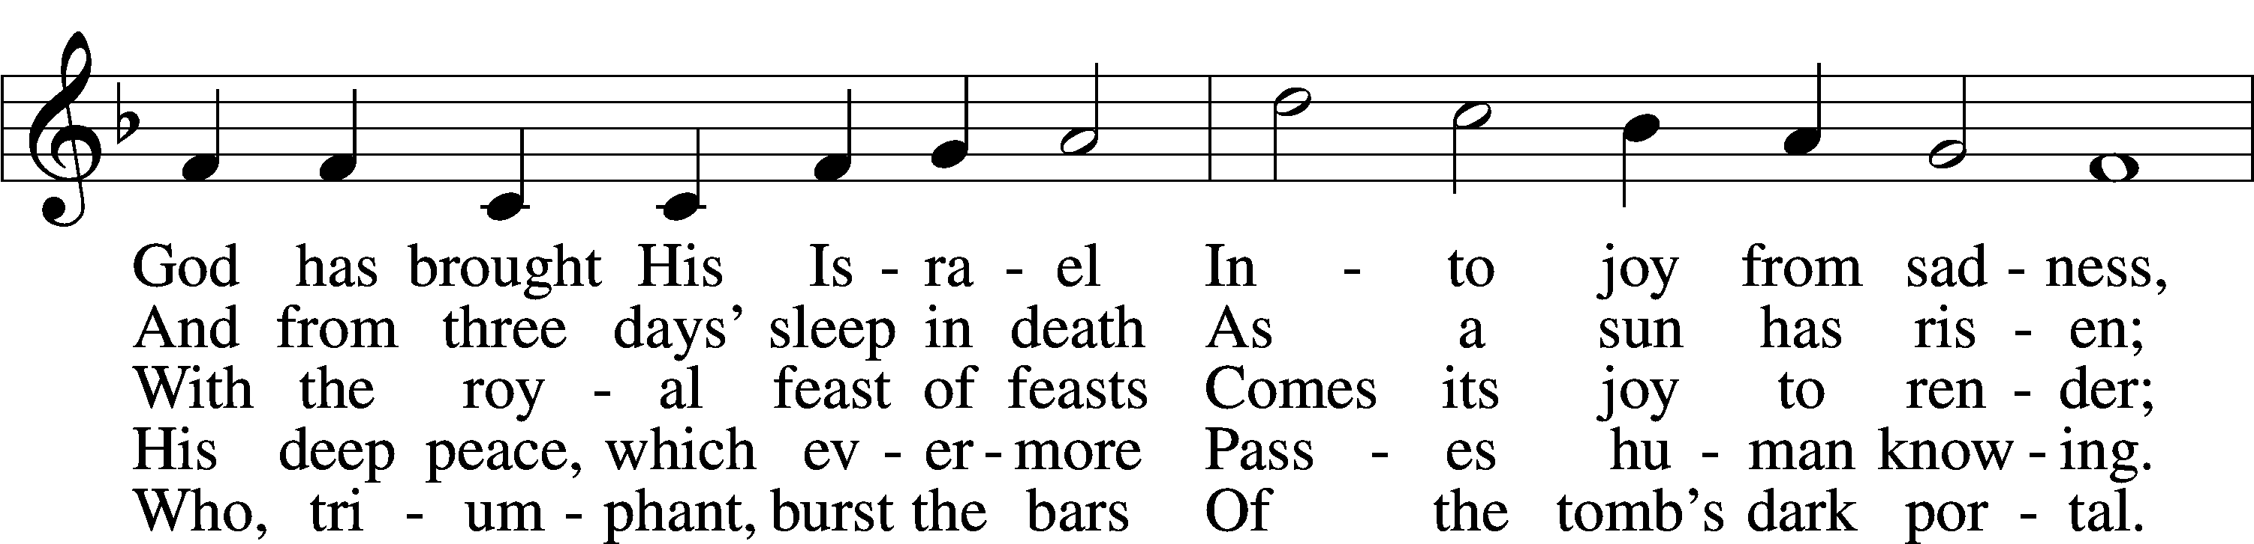
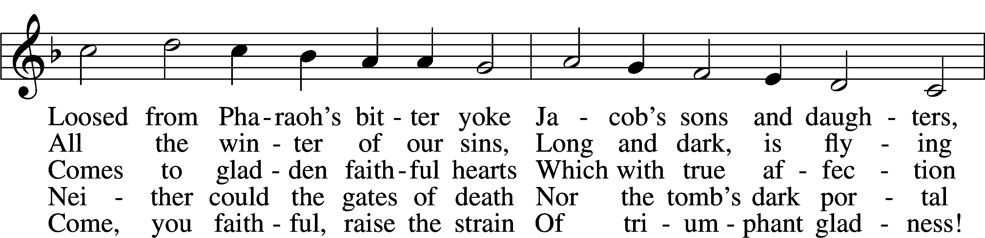
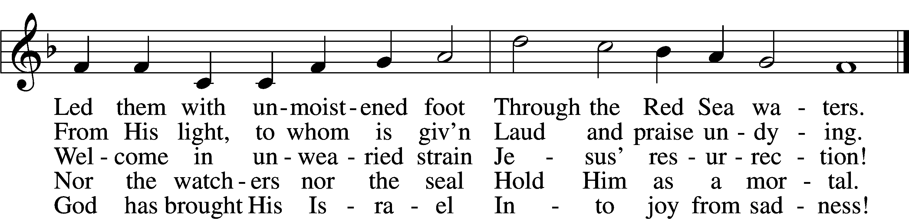
Text: John of Damascus, c. 696–c. 754; tr. John Mason Neale, 1818–66, alt.
Tune: Johann Horn, c. 1490–1547
Text and tune: Public domain

Sermon Hymn “O Sons and Daughters of the King” # 470
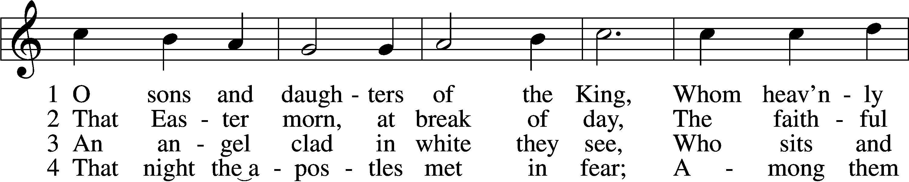
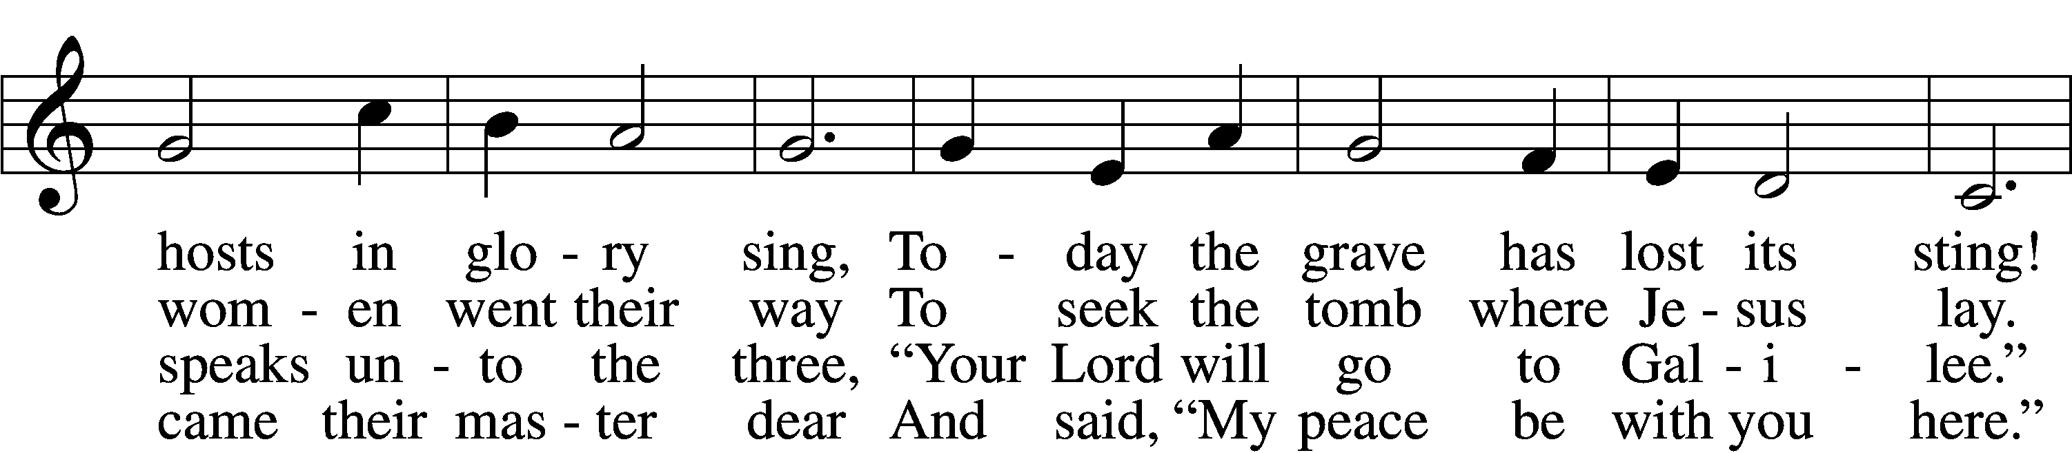
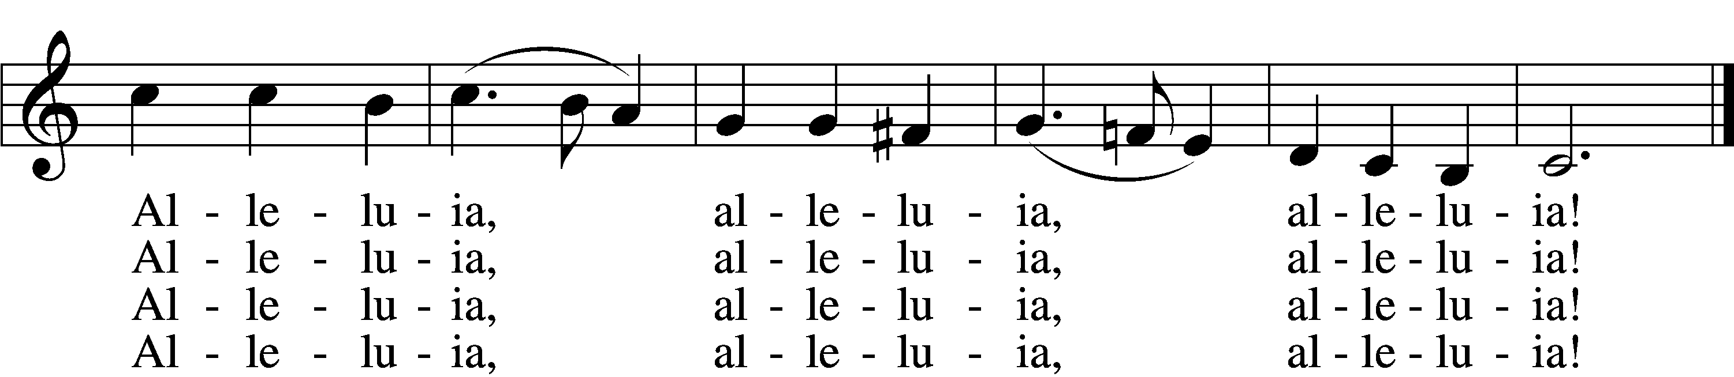

5 When Thomas first the tidings heard
That they had seen the risen Lord,
He doubted the disciples’ word.
Alleluia, alleluia, alleluia!

6 “My piercèd side, O Thomas, see,
And look upon My hands, My feet;
Not faithless but believing be.”
Alleluia, alleluia, alleluia!

7 No longer Thomas then denied;
He saw the feet, the hands, the side;
“You are my Lord and God!” he cried.
Alleluia, alleluia, alleluia!

8 How blest are they who have not seen
And yet whose faith has constant been,
For they eternal life shall win.
Alleluia, alleluia, alleluia!

9 On this most holy day of days
Be laud and jubilee and praise:
To God your hearts and voices raise.
Alleluia, alleluia, alleluia!
Text: attr. Jean Tisserand, d. 1494; tr. John Mason Neale, 1818–66, alt.
Tune: Melchior Vulpius, c. 1570–1615
Text and tune: Public domain

Distribution Hymn “Awake, My Heart, with Gladness” # 467
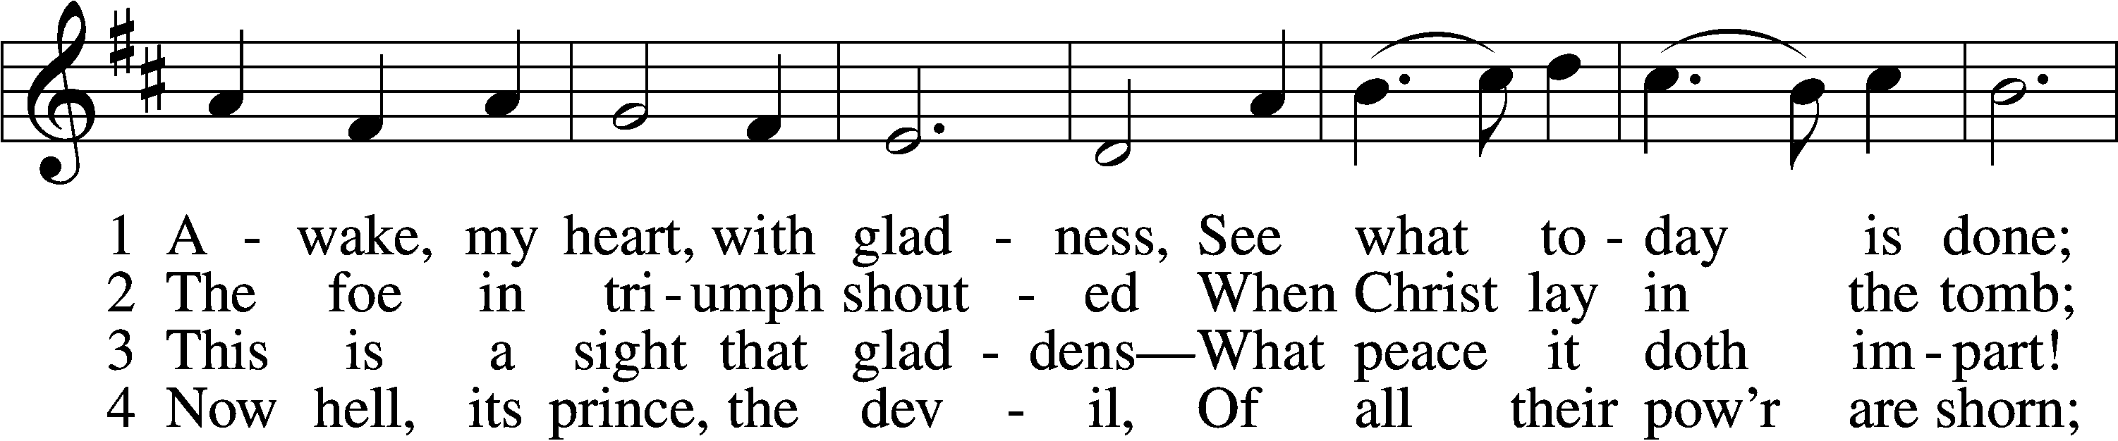
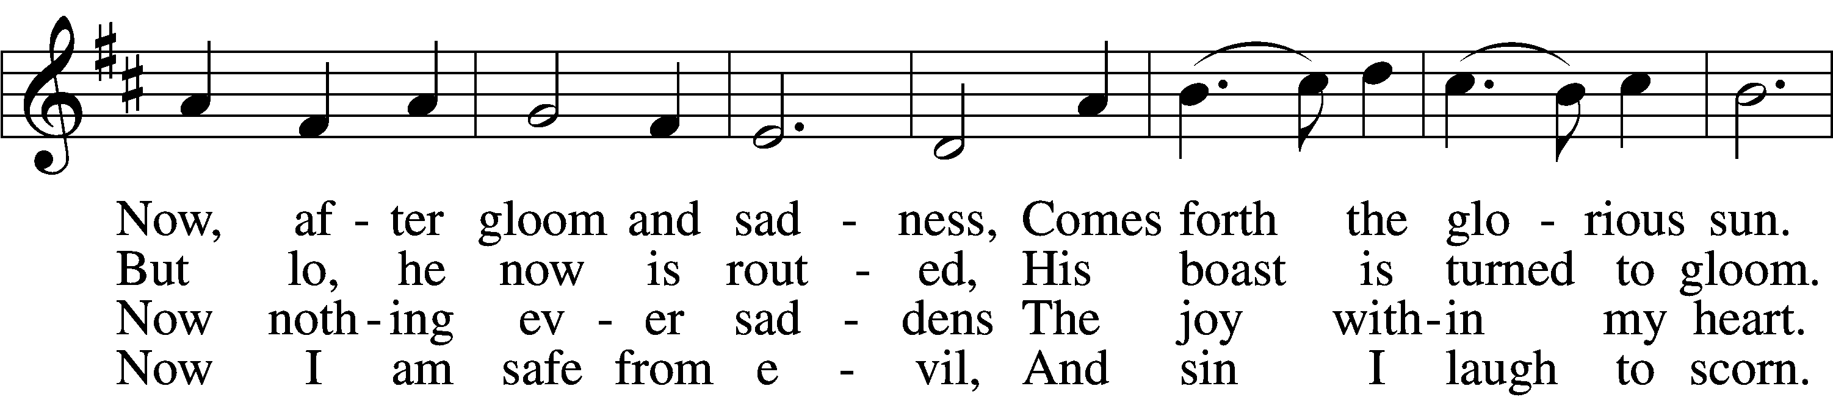
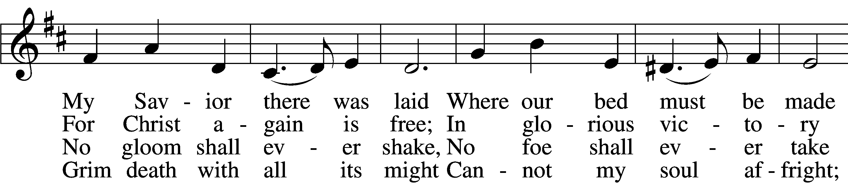
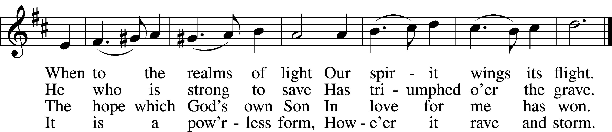

5 The world against me rages,
Its fury I disdain;
Though bitter war it wages,
Its work is all in vain.
My heart from care is free,
No trouble troubles me.
Misfortune now is play,
And night is bright as day.

6 Now I will cling forever
To Christ, my Savior true;
My Lord will leave me never,
Whate’er He passes through.
He rends death’s iron chain;
He breaks through sin and pain;
He shatters hell’s grim thrall;
I follow Him through all.

7 He brings me to the portal
That leads to bliss untold,
Whereon this rhyme immortal
Is found in script of gold:
“Who there My cross has shared
Finds here a crown prepared;
Who there with Me has died
Shall here be glorified.”
Text: Paul Gerhardt, 1607–76; tr. John Kelly, 1833–90, alt.
Tune: Johann Crüger, 1598–1662
Text and tune: Public domain

Distribution Hymn “When Peace, like a River” # 763
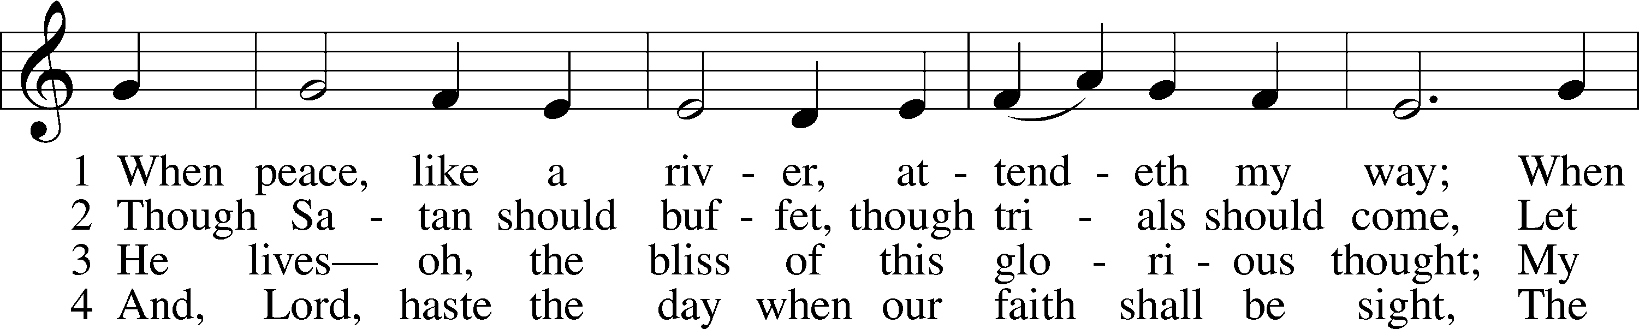
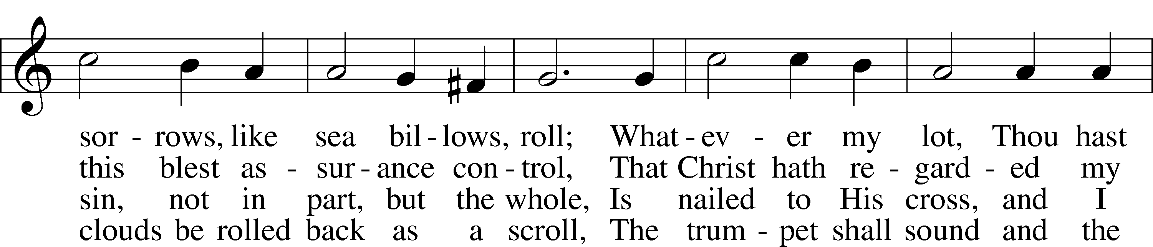
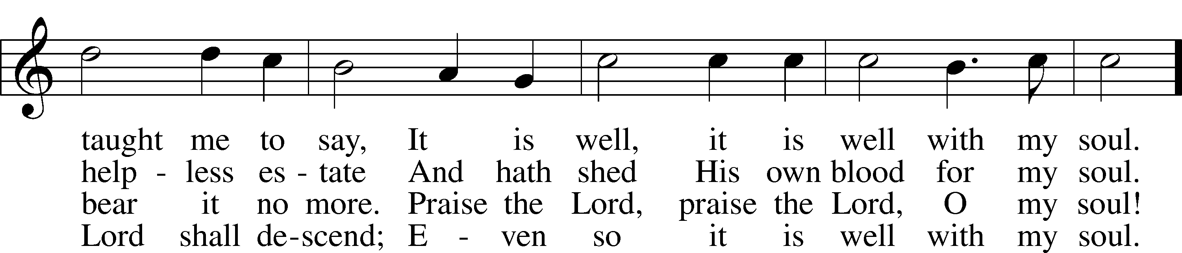
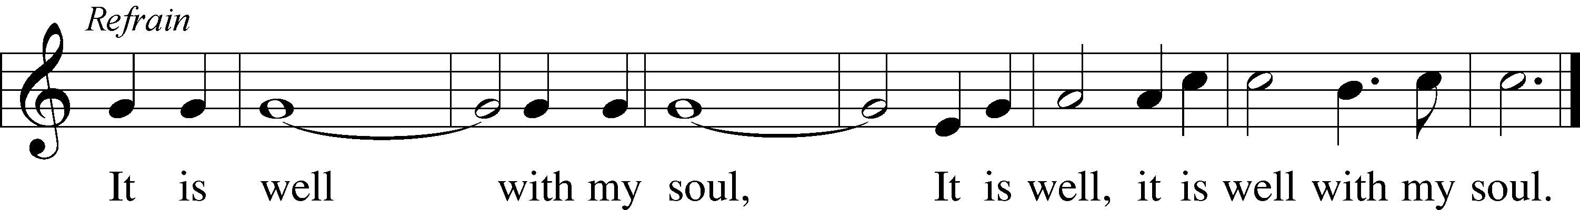
Text: Horatio G. Spafford, 1828–88, alt.
Tune: Philip P. Bliss, 1838–76
Text and tune: Public domain

Distribution Hymn “The Strife Is O’er, the Battle Done” # 464
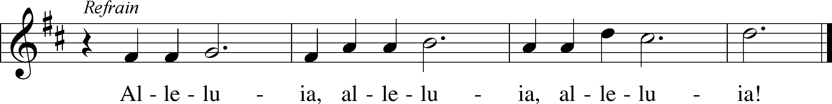
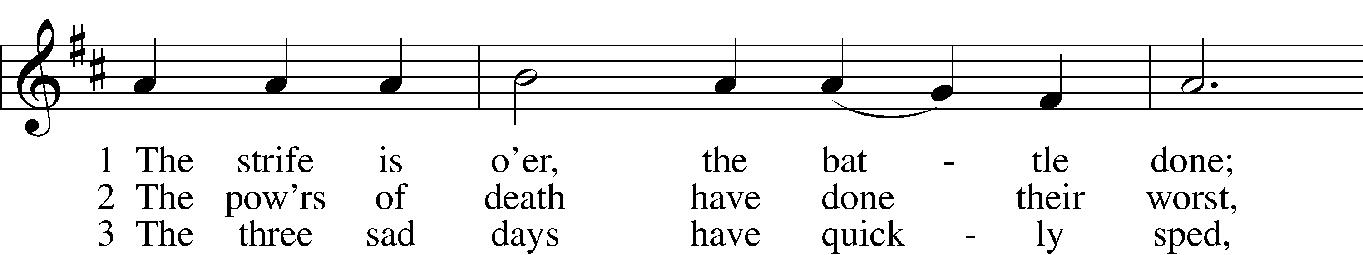
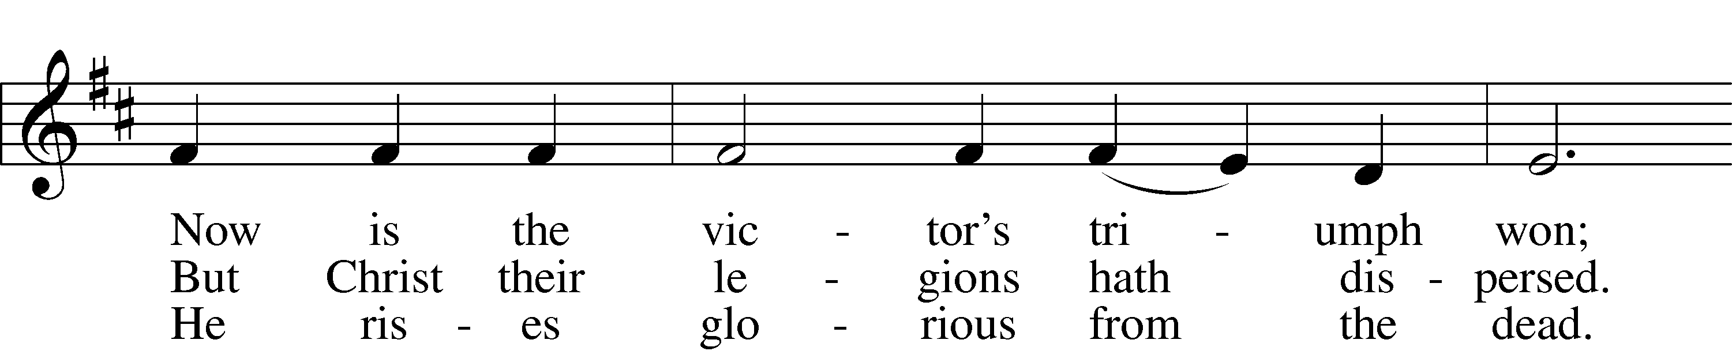
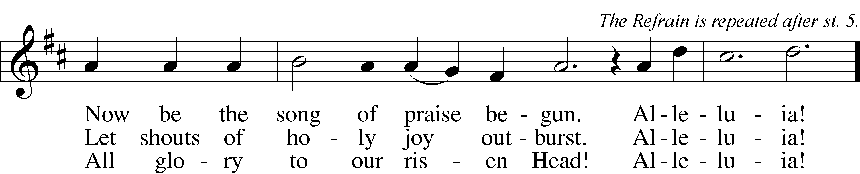

4 He broke the age-bound chains of hell;
The bars from heav’n’s high portals fell.
Let hymns of praise His triumph tell.
Alleluia!

5 Lord, by the stripes which wounded Thee,
From death’s dread sting Thy servants free
That we may live and sing to Thee.
Alleluia! Refrain
Text: Symphonia Sirenum Selectarum, 1695, Köln; tr. Francis Pott, 1832–1909, alt.
Tune: Giovanni P. da Palestrina, c. 1525–1594, adapt.
Text and tune: Public domain

Closing Hymn “He’s Risen, He’s Risen” # 480
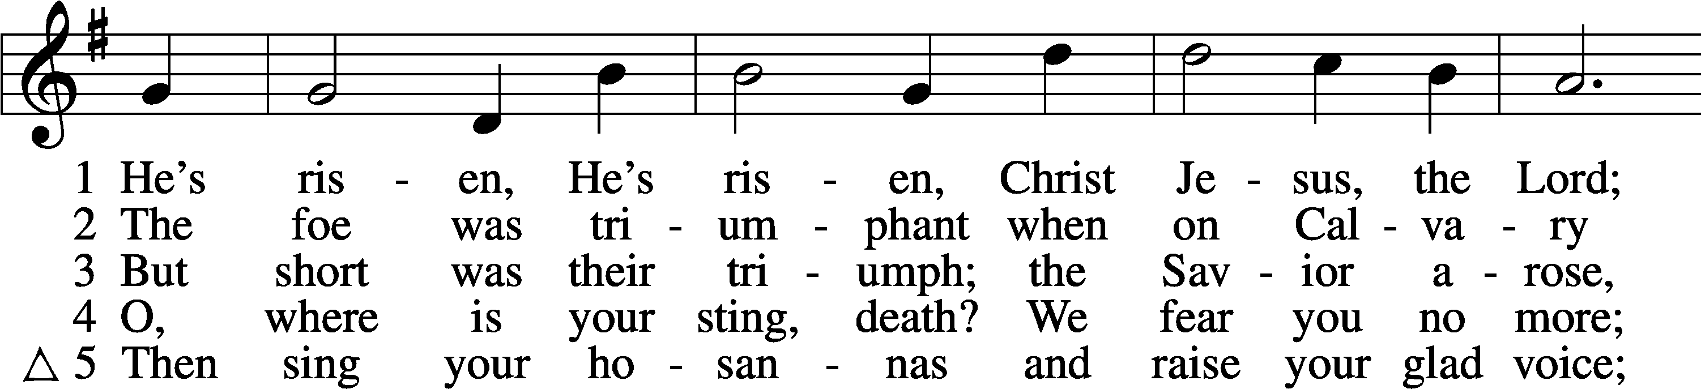
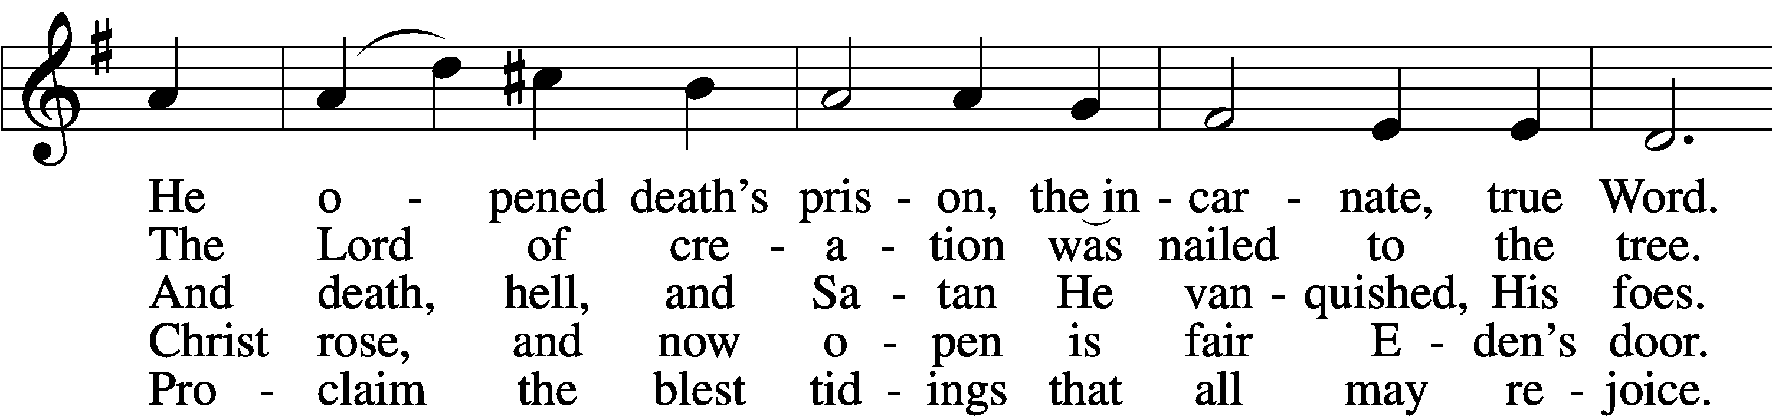
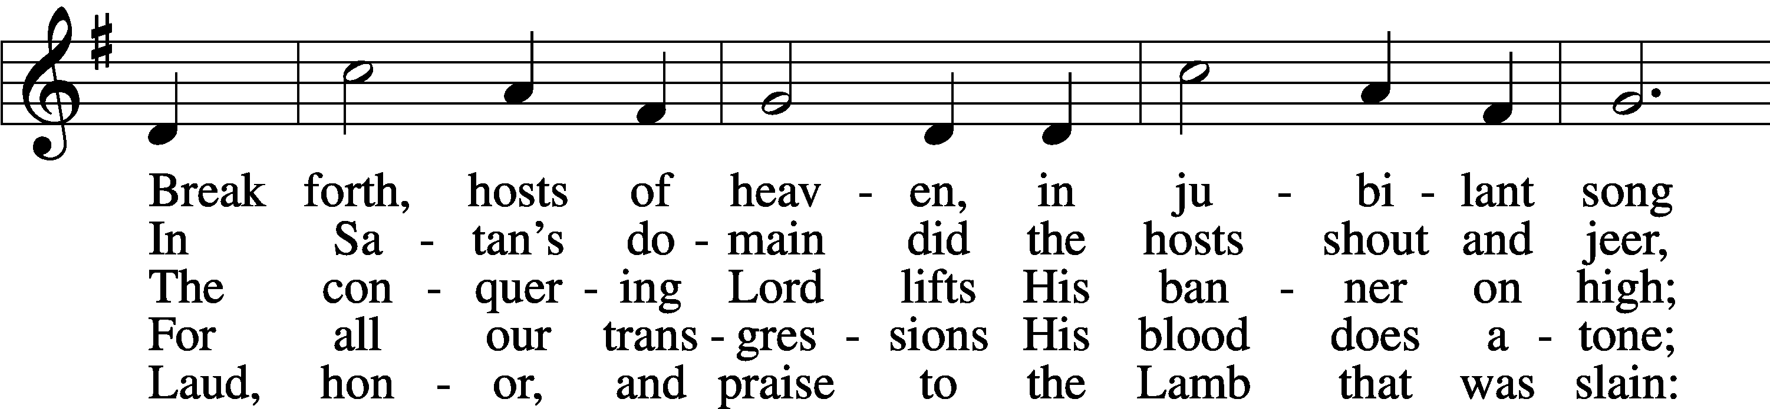
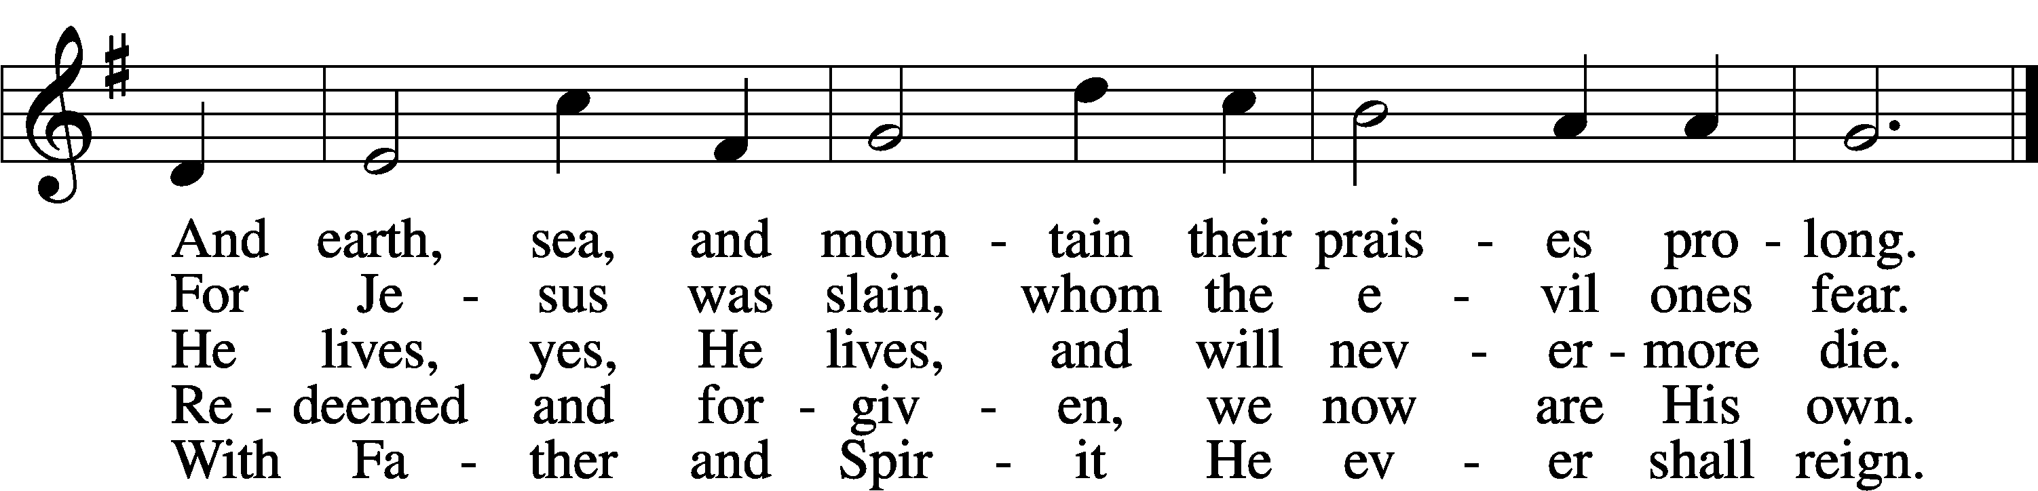
Text: C. F. W. Walther, 1811–87, abr.; tr. Anna M. Meyer, 1867–1941, alt.
Tune: C. F. W. Walther, 1811–87
Text: © 1941 Concordia Publishing House. Used by permission: LSB Hymn License no. 110003344
Tune: Public domain

