Opening Hymn “Christ Is Risen, Christ Is Living” # 479
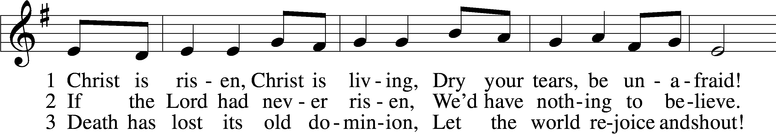
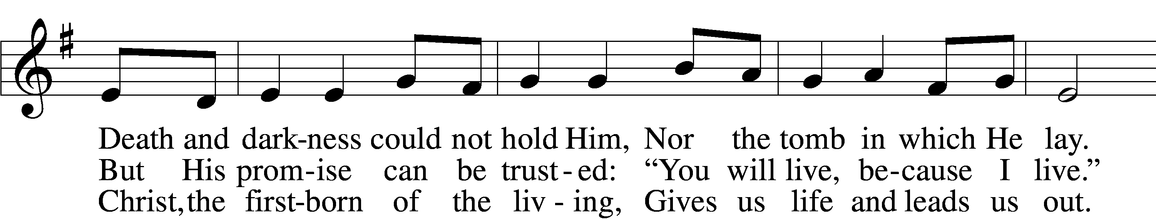
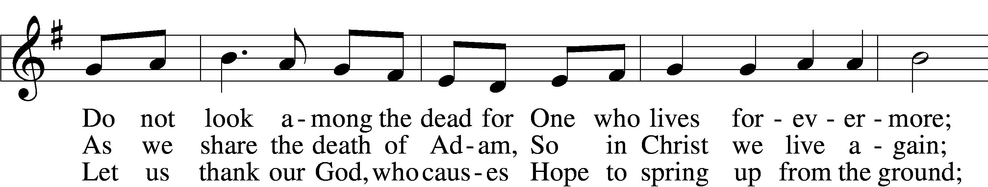
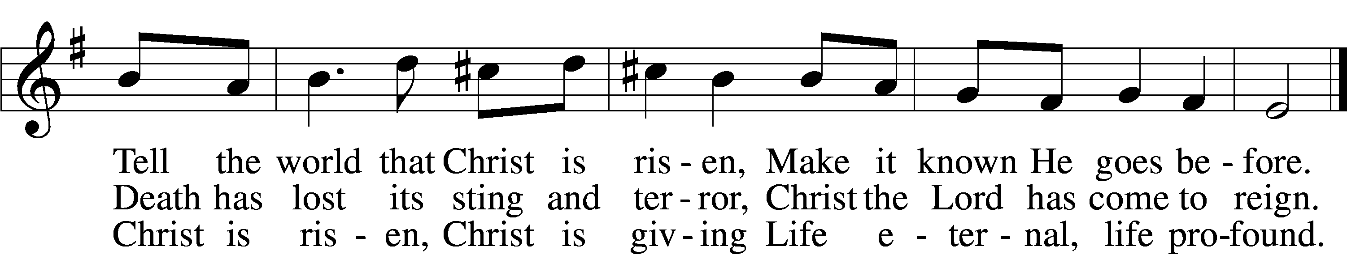
Text: Nicholas Martinez, 1917–72; tr. Fred Kaan, 1929–2009
Tune: Pablo D. Sosa, 1933
Text: © 1974 Hope Publishing Co. Used by permission: LSB Hymn License no. 110003344
Tune: © 1962 GIA Publications, Inc. Used by permission: LSB Hymn License no. 110003344

Sermon Hymn “With High Delight Let Us Unite” # 483
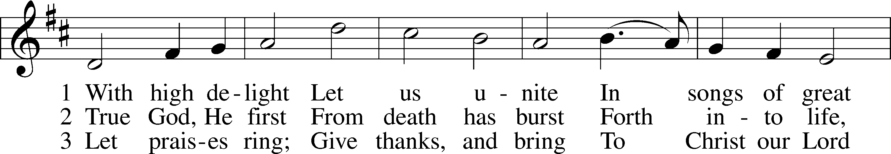

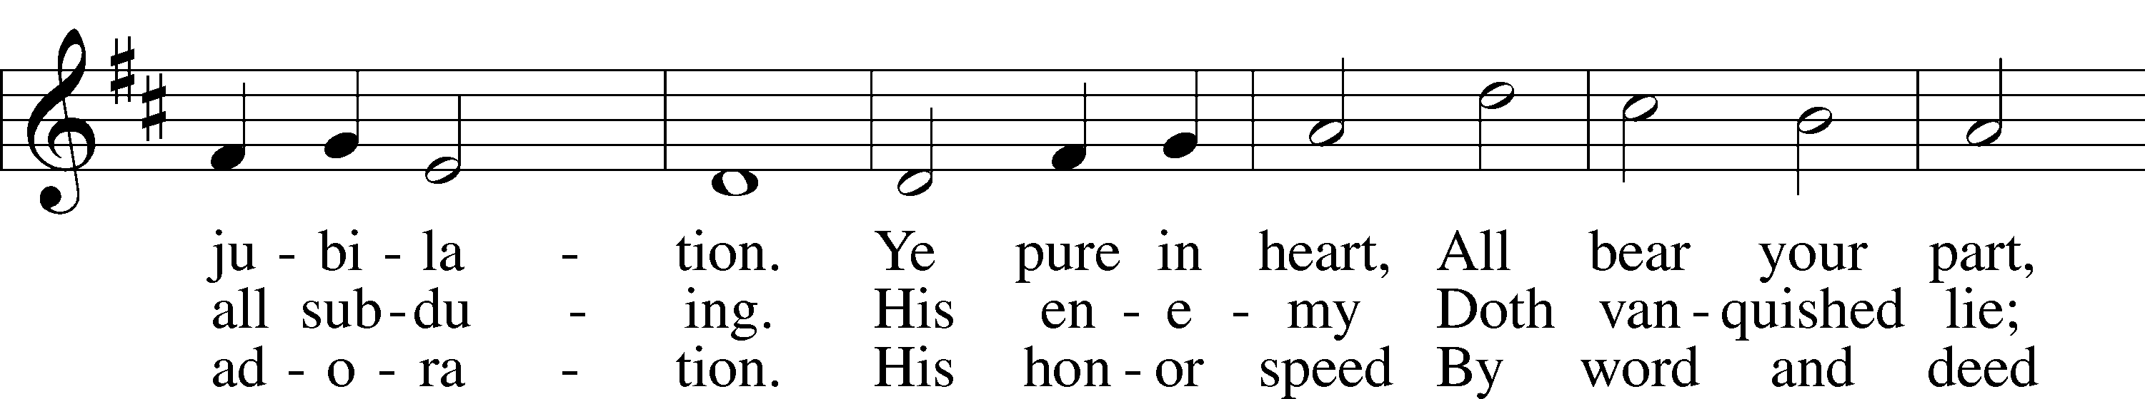
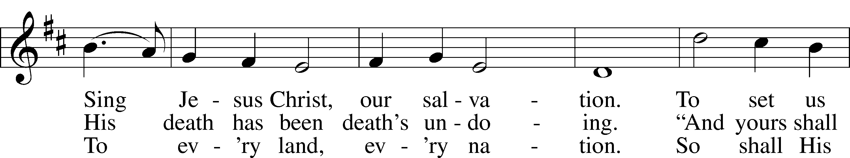

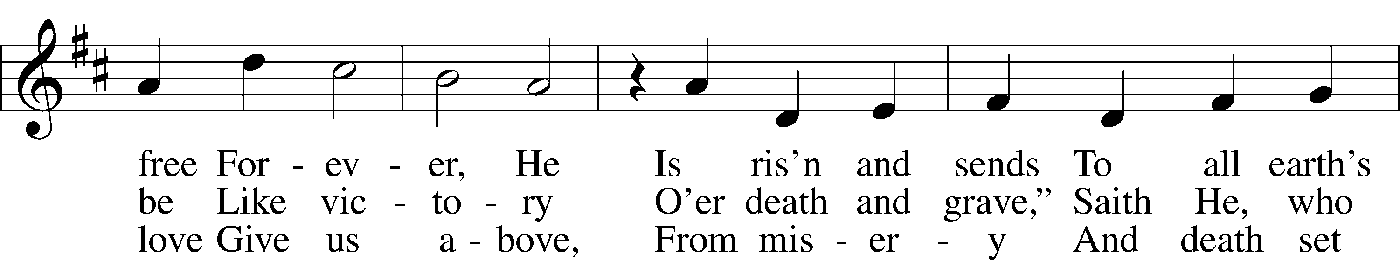

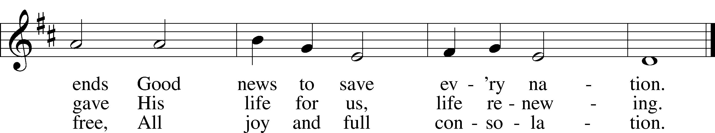

Text: Georg Vetter, 1536–99; tr. Martin H. Franzmann, 1907–76
Tune: Cinquante Pseaumes, 1543, Geneva
Text: © 1969 Concordia Publishing House. Used by permission: LSB Hymn License no. 110003344
Tune: Public domain

Closing Hymn “This Joyful Eastertide” # 482
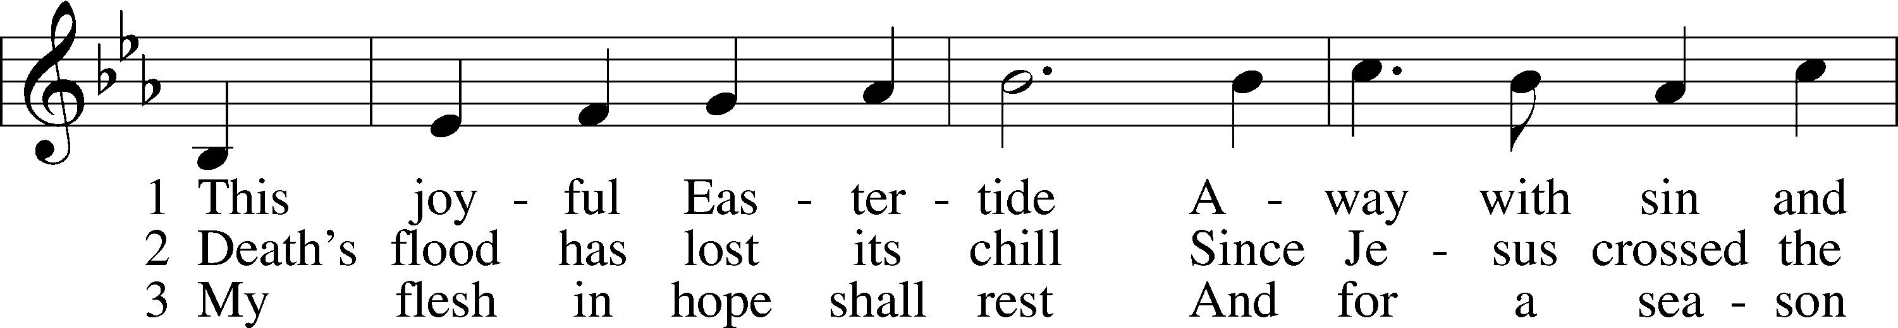
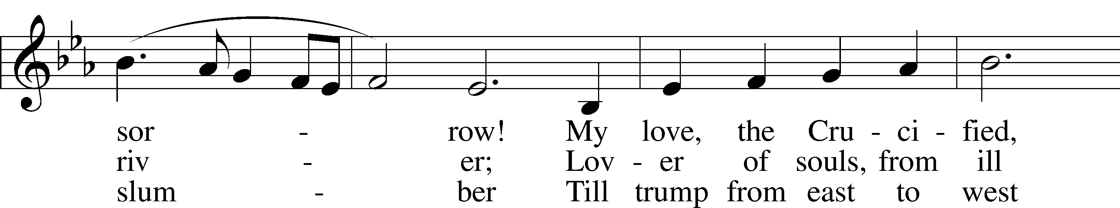
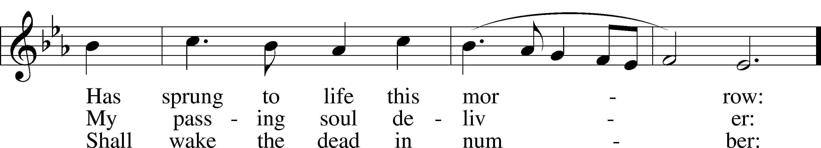
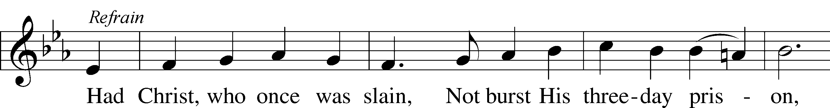
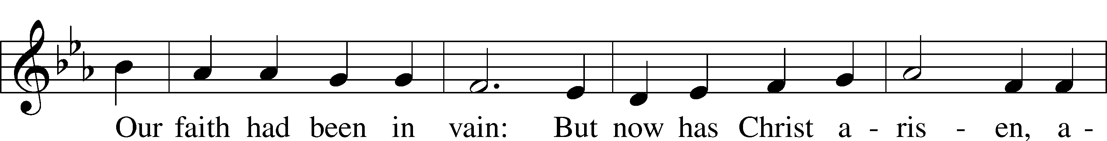
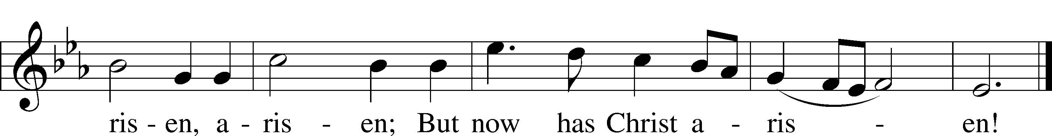
Text: George R. Woodward, 1848–1934
Tune: Davids Psalmen, 1684, Amsterdam
Text and tune: Public domain

