Blessed Savior Lutheran Church
Florissant, Missouri

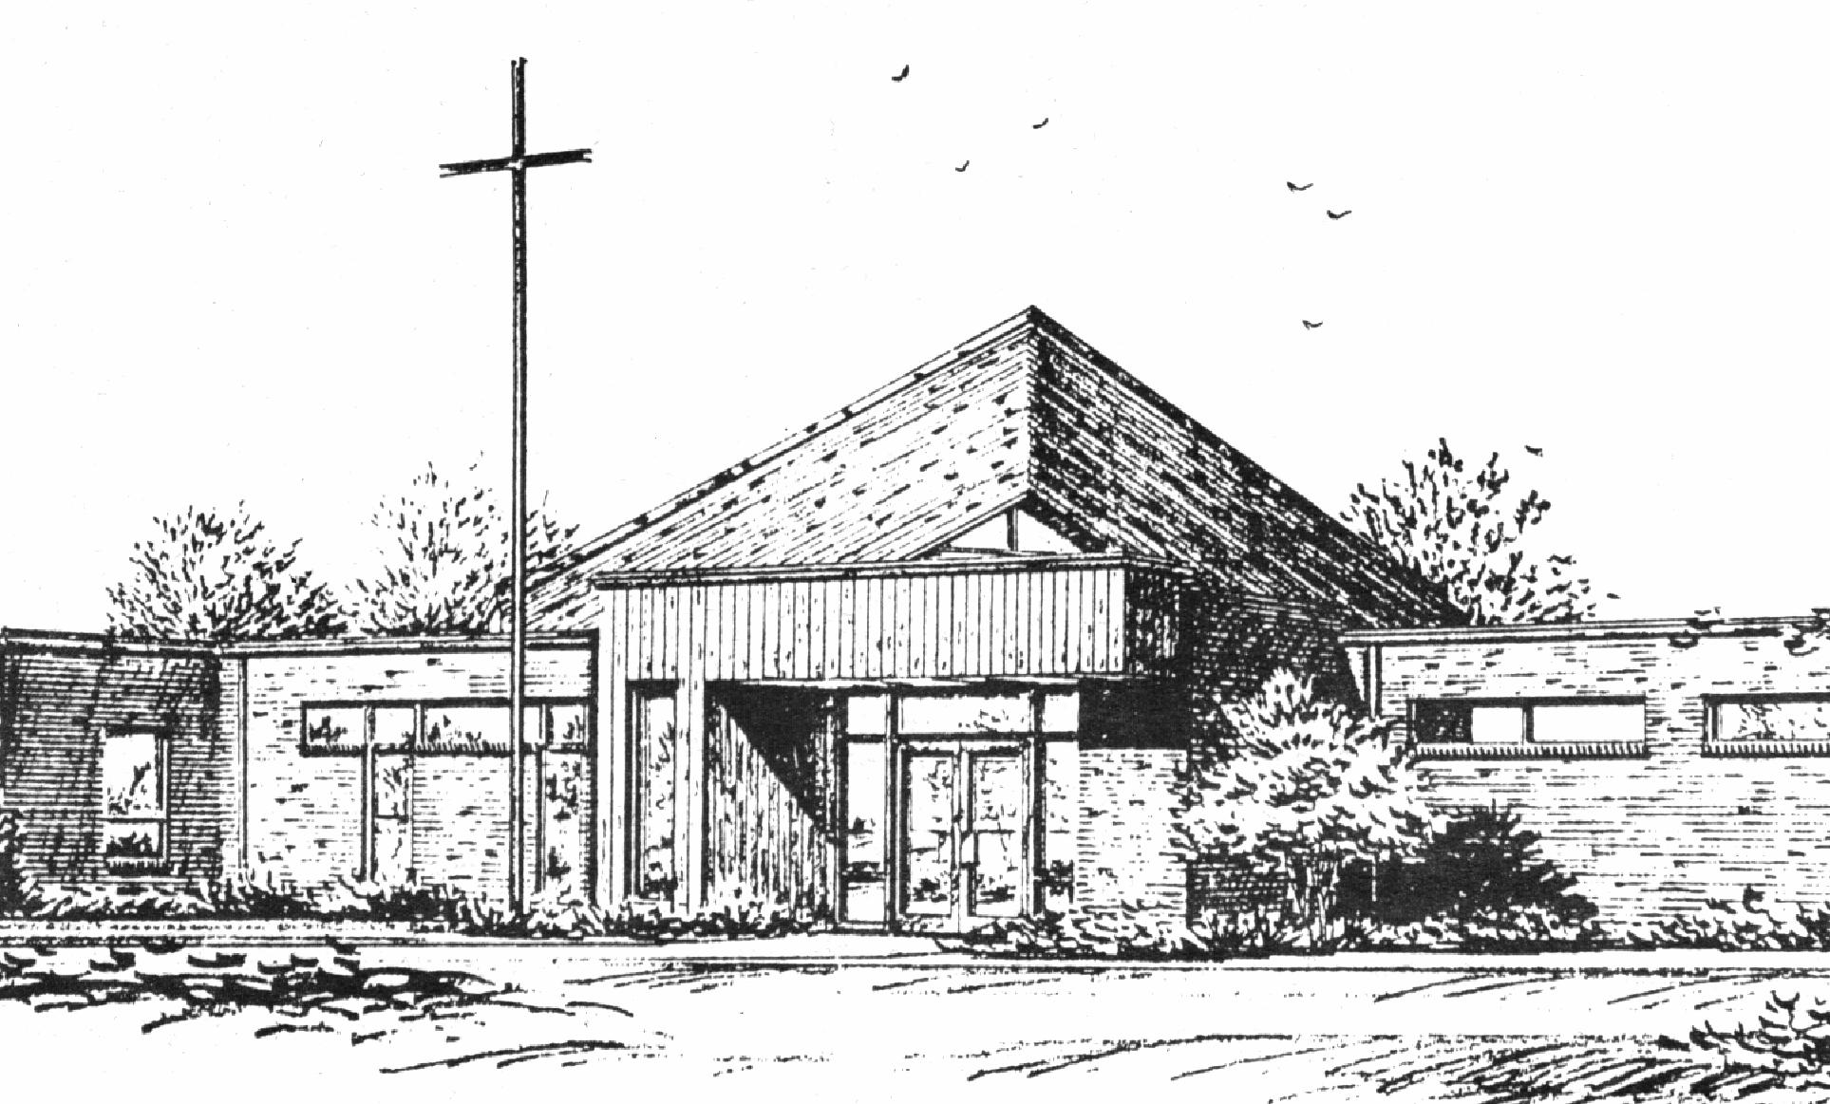
“Empowered by God’s Holy Word,
we joyfully share the love of Jesus with all people;
through worship, teaching, fellowship,
service and witnessing.”

Fifth Sunday of Easter
April 28, 2024

The Lutheran Church-Missouri Synod

BLESSED SAVIOR LUTHERAN CHURCH
2615 Shackelford Road
Florissant, Missouri 63031-2005
Telephone: 831-1300
www.blessedsavior-lcms.org
Pastor Matthew Roeglin
+ + + + + + + + + + + +
Third Sunday of Easter
Sunday, April 14, 2024

WE WELCOME YOU to our worship service this morning. We pray God’s rich blessings upon you as you hear His Word and praise His holy name. We ask our members and visitors to please use the friendship pad found on the pew. Kindly hand the friendship pad to the person sitting next to you. The Ushers will collect them after the service. Thank You.

THIS WORSHIP FOLDER / CHURCH BULLETIN is prepared for your convenience and contains the entire order of worship with all spoken and sung responses. However, if you are more comfortable using the hymnal, you may use the order of worship found in the front pages of Lutheran Service Book where all the melodies are shown for the sung responses of the congregation.

Divine Service 3 p.184

Greeting of Peace The people may greet one another in the name of the Lord, saying, “Peace be with you,” as a sign of reconciliation and of the unity of the Spirit in the bond of peace. (Matt. 5:22-24; Eph. 4:1-3).

Opening Hymn
“When Morning Gilds the Skies” # 807

Stand

Confession and Absolution
The sign of the cross may be made by all in remembrance of their Baptism.

P In the name of the Father and of the T Son and of the Holy Spirit.
C Amen.

P Beloved in the Lord! Let us draw near with a true heart and confess our sins unto God our Father, beseeching Him in the name of our Lord Jesus Christ to grant us forgiveness.

P Our help is in the name of the Lord,
C who made heaven and earth.
P I said, I will confess my transgressions unto the Lord,
C and You forgave the iniquity of my sin.

Silence for reflection on God’s Word and for self-examination.

P O almighty God, merciful Father,
C I, a poor, miserable sinner, confess unto You all my sins and iniquities with which I have ever offended You and justly deserved Your temporal and eternal punishment. But I am heartily sorry for them and sincerely repent of them, and I pray You of Your boundless mercy and for the sake of the holy, innocent, bitter sufferings and death of Your beloved Son, Jesus Christ, to be gracious and merciful to me, a poor, sinful being.

P Upon this your confession, I, by virtue of my office, as a called and ordained servant of the Word, announce the grace of God unto all of you, and in the stead and by the command of my Lord Jesus Christ I forgive you all your sins in the name of the Father and of the T Son and of the Holy Spirit.
C Amen.

Stand

Service of the Word
Introit Psalm 145:1–2, 8, 10, 21; antiphon: John 16:16
A little while, and you will see me no | longer;*
and again a little while, and you will | see me.
I will extol you, my | God and King,*
and bless your name forever and | ever.
Every day I will | bless you*
and praise your name forever and | ever.
The Lord is gracious and | merciful,*
slow to anger and abounding in | steadfast love.
All your works shall give thanks to you, | O Lord,*
and all your saints shall | bless you!
My mouth will speak the praise | of the Lord,*
and let all flesh bless his holy name forever and | ever.
Glory be to the Father and | to the Son
and to the Holy | Spirit;
as it was in the be- | ginning,
is now, and will be forever. | Amen.
A little while, and you will see me no | longer;*
and again a little while, and you will | see me.

Kyrie p. 186
C Lord, have mercy upon us.
Christ, have mercy upon us.
Lord, have mercy upon us.

Gloria in Excelsis p. 187
P Glory be to God on high:
C and on earth peace, goodwill toward men.
We praise Thee, we bless Thee, we worship Thee,
we glorify Thee, we give thanks to Thee, for Thy great glory.
O Lord God, heav’nly King, God the Father Almighty.
O Lord, the only-begotten Son, Jesus Christ;
O Lord God, Lamb of God, Son of the Father,
that takest away the sin of the world, have mercy upon us.
Thou that takest away the sin of the world, receive our prayer.
Thou that sittest at the right hand of God the Father, have mercy upon us.
For Thou only art holy; Thou only art the Lord.
Thou only, O Christ, with the Holy Ghost,
art most high in the glory of God the Father. Amen.

Salutation and Collect of the Day
P The Lord be with you.
C And with thy spirit.

P Let us pray.
C O God, You make the minds of Your faithful to be of one will. Grant that we may love what You have commanded and desire what You promise, that among the many changes of this world our hearts may be fixed where true joys are found; through Jesus Christ, Your Son, our Lord, who lives and reigns with You and the Holy Spirit, one God, now and forever. Amen.

Sit

Reading Acts 8:26–40
26An angel of the Lord said to Philip, “Rise and go toward the south to the road that goes down from Jerusalem to Gaza.” This is a desert place. 27And he rose and went. And there was an Ethiopian, a eunuch, a court official of Candace, queen of the Ethiopians, who was in charge of all her treasure. He had come to Jerusalem to worship 28and was returning, seated in his chariot, and he was reading the prophet Isaiah. 29And the Spirit said to Philip, “Go over and join this chariot.” 30So Philip ran to him and heard him reading Isaiah the prophet and asked, “Do you understand what you are reading?” 31And he said, “How can I, unless someone guides me?” And he invited Philip to come up and sit with him. 32Now the passage of the Scripture that he was reading was this:
“Like a sheep he was led to the slaughter
and like a lamb before its shearer is silent,
so he opens not his mouth.
33In his humiliation justice was denied him.
Who can describe his generation?
For his life is taken away from the earth.”
34And the eunuch said to Philip, “About whom, I ask you, does the prophet say this, about himself or about someone else?” 35Then Philip opened his mouth, and beginning with this Scripture he told him the good news about Jesus. 36And as they were going along the road they came to some water, and the eunuch said, “See, here is water! What prevents me from being baptized?” 38And he commanded the chariot to stop, and they both went down into the water, Philip and the eunuch, and he baptized him. 39And when they came up out of the water, the Spirit of the Lord carried Philip away, and the eunuch saw him no more, and went on his way rejoicing. 40But Philip found himself at Azotus, and as he passed through he preached the gospel to all the towns until he came to Caesarea.

A This is the Word of the Lord.
C Thanks be to God.

Gradual adapt. from Matthew 28:7; Hebrews 2:7; Psalm 8:6
C Christ has risen from the dead.
God the Father has crowned him with glory and honor. He has given him dominion over the works of his hands; he has put all things under his feet.

Epistle 1 John 4:1–21
1Beloved, do not believe every spirit, but test the spirits to see whether they are from God, for many false prophets have gone out into the world. 2By this you know the Spirit of God: every spirit that confesses that Jesus Christ has come in the flesh is from God, 3and every spirit that does not confess Jesus is not from God. This is the spirit of the antichrist, which you heard was coming and now is in the world already. 4Little children, you are from God and have overcome them, for he who is in you is greater than he who is in the world. 5They are from the world; therefore they speak from the world, and the world listens to them. 6We are from God. Whoever knows God listens to us; whoever is not from God does not listen to us. By this we know the Spirit of truth and the spirit of error.
7Beloved, let us love one another, for love is from God, and whoever loves has been born of God and knows God. 8Anyone who does not love does not know God, because God is love. 9In this the love of God was made manifest among us, that God sent his only Son into the world, so that we might live through him. 10In this is love, not that we have loved God but that he loved us and sent his Son to be the propitiation for our sins. 11Beloved, if God so loved us, we also ought to love one another. 12No one has ever seen God; if we love one another, God abides in us and his love is perfected in us.
13By this we know that we abide in him and he in us, because he has given us of his Spirit. 14And we have seen and testify that the Father has sent his Son to be the Savior of the world. 15Whoever confesses that Jesus is the Son of God, God abides in him, and he in God. 16So we have come to know and to believe the love that God has for us. God is love, and whoever abides in love abides in God, and God abides in him. 17By this is love perfected with us, so that we may have confidence for the day of judgment, because as he is so also are we in this world. 18There is no fear in love, but perfect love casts out fear. For fear has to do with punishment, and whoever fears has not been perfected in love. 19We love because he first loved us. 20If anyone says, “I love God,” and hates his brother, he is a liar; for he who does not love his brother whom he has seen cannot love God whom he has not seen. 21And this commandment we have from him: whoever loves God must also love his brother.

A This is the Word of the Lord.
C Thanks be to God.

Stand
Alleluia p. 190
C Alleluia. Alleluia. Alleluia.

Holy Gospel John 15:1–8
P The Holy Gospel according to St. John, the fifteenth chapter.
C Glory be to Thee, O Lord.

1Jesus said: “I am the true vine, and my Father is the vinedresser. 2Every branch of mine that does not bear fruit he takes away, and every branch that does bear fruit he prunes, that it may bear more fruit. 3Already you are clean because of the word that I have spoken to you. 4Abide in me, and I in you. As the branch cannot bear fruit by itself, unless it abides in the vine, neither can you, unless you abide in me. 5I am the vine; you are the branches. Whoever abides in me and I in him, he it is that bears much fruit, for apart from me you can do nothing. 6If anyone does not abide in me he is thrown away like a branch and withers; and the branches are gathered, thrown into the fire, and burned. 7If you abide in me, and my words abide in you, ask whatever you wish, and it will be done for you. 8By this my Father is glorified, that you bear much fruit and so prove to be my disciples.”

P This is the Gospel of the Lord.
C Praise be to Thee, O Christ.

Apostles’ Creed
C I believe in God, the Father Almighty,
maker of heaven and earth.

And in Jesus Christ, His only Son, our Lord,
who was conceived by the Holy Spirit,
born of the virgin Mary,
suffered under Pontius Pilate,
was crucified, died and was buried.
He descended into hell.
The third day He rose again from the dead.
He ascended into heaven
and sits at the right hand of God the Father Almighty.
From thence He will come to judge the living and the dead.

I believe in the Holy Spirit,
the holy Christian Church,
the communion of saints,
the forgiveness of sins,
the resurrection of the body,
and the life T everlasting. Amen.

Sit

Children's Message
Sermon Hymn “Alleluia! Jesus Is Risen” # 474
Sermon

Offering
Stand
Offertory p. 192
C Create in me a clean heart, O God, and renew a right spirit within me.
Cast me not away from Thy presence, and take not Thy Holy Spirit from me.
Restore unto me the joy of Thy salvation, and uphold me with Thy free spirit. Amen.

Prayer of the Church
After each petition of the prayers:
P | Lord, In Your mercy.
C | Hear our prayer.
After the final petition:
P | One God, now and forever.
C | Amen.

Lord’s Prayer p. 196
C Our Father who art in heaven,
hallowed be Thy name,
Thy kingdom come,
Thy will be done on earth as it is in heaven;
give us this day our daily bread;
and forgive us our trespasses as we forgive those who trespass against us;
and lead us not into temptation,
but deliver us from evil.
For Thine is the kingdom and the power and the glory forever and ever. Amen.

Benediction p.202

P The Lord bless you and keep you.
The Lord make His face shine upon you and be gracious unto you.
The Lord lift up His countenance upon you and T give you peace.
C Amen, amen, amen.

Closing Hymn “Where Charity and Love Prevail” # 845

Acknowledgments
Unless otherwise indicated, Scripture quotations are from the ESV® Bible (The Holy Bible, English Standard Version®), copyright © 2001 by Crossway, a publishing ministry of Good News Publishers. Used by permission. All rights reserved.
Created by Lutheran Service Builder © 2024 Concordia Publishing House.

Sit
Announcements
After the announcements, please stand for the closing Doxology.

Doxology #805
Praise God, from whom all blessings flow;
Praise Him, all creatures here below;
Praise Him above, ye heav’nly host:
Praise Father, Son, and Holy Ghost. Amen.

Go and Serve the Lord
Acknowledgments Unless otherwise indicated, all scripture quotations are from The Holy Bible, English Standard Version, copyright © 2001 by Crossway Bibles, a division of Good News Publishers. Used by permission. All rights reserved. Created by Lutheran Service Builder © 2006 Concordia Publishing House.

The Liturgist & Preacher: Pastor Matthew Roeglin
The Acoloyte: Sunday 9:30 a.m. Madalyn Beach
The Sound System: Bradley Taylor & Justin Grimes
The Organist: Mrs. Donna Boyd

Altar Flowers – are placed by Martha & Lynn Oth in thanksgiving for their family and friends and for all of God’s many blessings.

Altar Flowers needed for: May 5 and June 2, 16 & 30

LWML-Lights Bake Sale – We have a date for our bake sale! Our sale will take place on June 23 – the sale will start before the 8:15 a.m. Adult Bible Study. The Bake Sale Volunteer sign-up sheet is located on the table in the back of the church. If you are not a baker or goodie maker, we can still use your help during the sale. And, if you are unable to help with baking home-made goodies or during the sale, a cash or check donation will support our efforts as well. All proceeds from our sale will benefit our missionary Rev. Hanson.

LWML–Lights Meeting will be next Sunday, May 5 at noon. All ladies are welcome!

Prayers for our Church and Community Week of April 21st (front) & 28th (Back). Each week we pray for members of our Church and our Community. At the end of the service the Ushers will pass out the new prayer list.

Concordia University – Wisconsin “Kammerchor Spring Tour 2024” will be at Chapel of the Cross, 11645 Benham Rd., St. Louis, MO on Tuesday, May 7th at 7:00 p.m.

BLESSED SAVIOR’S CALENDAR
April 28 – May 5, 2024

TODAY:
Sunday 8:15 a.m. Bible Class (McKenna)
9:30 a.m. Worship Service
10:45 a.m. Bible Class (Pastor)
Apr. 28 10:45 a.m. Sunday School & High School

MONDAY:
Apr. 29

TUESDAY:
Apr. 30

WEDNESDAY: 2:30 p.m. Pastor’s Adult Bible Study
May 01 6:00 p.m. Bible Study (McKenna)

THURSDAY:
May 02

FRIDAY: Pastor - Day with family
May 03

SATURDAY: 10:00 a.m. Drive Thru Prayers
May 04 Pizza Lunch to Follow

NEXT 8:15 a.m. Adult Bible Study (McKenna)
SUNDAY 9:30 a.m. Worship Service w/Holy Communion
10:45 a.m. Adult Bible Class (Pastor)
10:45 a.m. Sunday School & High School
May 05 12:00 p.m. LWML – Lights Meeting

Please Join Us
You are cordially invited to join in with
the members of your Board of
Evangelism as we reach out to our
neighbors in a simple but very
meaningful way!
Let them know how much God
loves them and that we love them too:
SPRING DRIVE-THRU PRAYER EVENT
Saturday
May 4, 2024
10:00 AM – 12:00 PM
Pizza Lunch to Follow
Our drive-thru prayers are a simple activities in which we invite passing motorists to pull into our parking lot to pray with us. As they drive in, they are met by one of our volunteers who explains that we are there to pray with them about any concerns, challenges, needs, etc. they may have, thus letting them know how much God and Blessed Savior’s members love them. We also invite them to a special prayer service where our members pray for them again.
This is an easy and effective way to reach out to our neighbors with God’s love, and you don’t need to pray if you are uncomfortable praying with strangers. We also need volunteers to hand out drinks and snacks to our neighbors, hold signs inviting them in, etc.

First of all, then, I urge that supplications, intercessions, and thanksgivings be made for all people,
1 Timothy 2:1
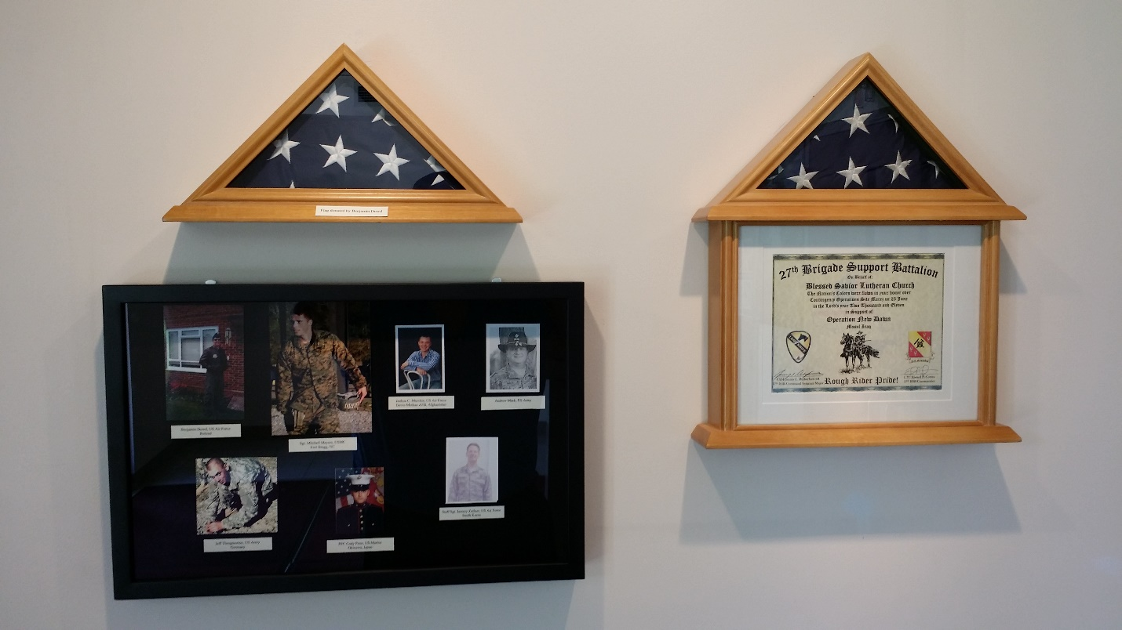

Military Display

We honor the members of our congregation and members of their family who are in active military service in our military display found in the narthex. (During the month of November, we honor and remember our military veterans.) If we do not have someone from your family who is currently active in the military, please share that information with Paula so that we can include them! It is simple to do, just provide your name, service member's name, service member's relationship to you (nephew, granddaughter, etc.), what branch of the service they are in, and year service member entered the military. Please provide a photo as well. Thank you for helping us recognize those individuals who are serving in our military.

April 28 5th Sunday of Easter John 15:2 “Every branch of mine that does not bear fruit he takes away, and every branch that does bear fruit he prunes, that it may bear more fruit.” God is interested in the fruit that we bear in good works, and He even prunes us so that we may bring forth more fruit. Trusting in our Lord’s work for us, being grafted by grace into His vine, we desire to be more like Him, to grow into His image. That’s growth in fruit bearing — and it always comes with some pruning.

Our Response to God’s Love – April 21, 2024
Sunday (9:30)………. 37
Sem Students/family......
Visitors…………..…
Communed….36
Total……………... 37
Sunday School…………
Sun. School/Bible Staff...
Bible Study/Youth……...
Bible Study/Y.Adults….
Bible Study I ………….8
Bible Study II ………..
Adult/Confirm…….
Wednesday Morning …... 5

General Offerings…. $ 2,521.00
Misc. $ 0.00
Total response for week of: April 21 $ 2,521.00
Weekly Budget Needed $- 3,800.00
Deficit $- 1,279.00

Blessings Upon Blessings
Anniversary Campaign- Update
Wk of 4/21 YTD
Debt Reduction $ 0.00 $ 4,210.00
Improvement/Banners $ 10.00 $ 1,645.00
$ 10.00 $ 5,855.00

Our Special Prayers and Intercessions
Jim Laughlin – open heart surgery
Kim – cancer
Mary S. – cancer
Jeannie Firoved – health issues
Sara – health
Tiffany Connor – health issues
Connor Stretch – Health issues
Mike – Liver failure
Andrew – Guidance
Wanda Johnston – recovering from hip
Surgery
David Hogenmiller – health
Rev. Gary Shack – health
Jim Grimes – health issues
Cheryl Ehrhard – recovering- knee surgery
JoAnn Roellig - hospice
Martha Oth – upcoming surgery
Lindsay Jaco – car accident
Debbie Bacon – hospitalized
Allan Joellenbeck – health
Dan Boyd – health
Bonnie Zeiszler – hospice
Luella Gavisk - hospice

Kyle – renewal of faith
Heather – strengthening of faith
Pastor Struve- hospitalized
Marge Struve – health issues
Pastor Eric Carlson – Leukemia
Anneliese Wenger – health issues
Charlotte Taggert – health issues
Jessica Parish – MS
Rita Kirk – health issues
Mary Peacock – health
Debbie – home recovering
Lindsay – health
Wendy DeSanto – health issues
Patti Henneman – health issues
Laurie Moore – health issues
William – health issues
Doris Boyd – health issues
David Kuhl – health
Mike Wilder – cancer
Tom Murphy – health
Kelly - health
Retha Taylor – health
Caitlyn – health
Steve Haynes – heart issues
Nancy Stocker – health issues
Ted Stocker- health issues

Serving in our Armed Forces – Andrew Mack, Paul Hackett, Jay Warren, Michael Rice, Caleb McElyea, Jeff Throgmorton, Adam Guercio, Chance Glover, Cody Guercio, Danny Chung, Zayne Glatz, Alanna Kreppert, James Adelhardt, Sean Bentrup, Wesley Peach, Jordan Rolf, Anne Heintzelman, Austin Dreckshage, Ken Leppert II, Shelby Croghan, Richard Vengels & Brandon Wing.

*Please note: Those who are named in our special prayers and intercessions list are placed there by members of our congregation. St. Paul tells us in 1Timothy 2:1-2: “I urge, then, first of all, that requests, prayers, intercessions and thanksgivings be made for everyone – for kings and all those in authority, that we may live peaceful and quiet lives in all godliness and holiness. This is good, and pleases God our Savior.” Those named remain joyfully in our prayers until the person who requested our prayers removes them or until the Lord resolves their need. Therefore, as St. Paul tells us in Philippians 4:6 “Do not be anxious about anything, but in everything, by prayer and petition, with thanksgiving, present your request to God.

